MSE Walls

I Introduction

- Course Objectives

They seem to crop up everywhere, like cell phone towers. Mechanically stabilized earth (MSE) retaining walls are growing in popularity. Variations on the basic design, including curves, tiers, railings, stairs, walkways and the like are making them more and more attractive to designers and architects.

In this course you will find examples of the design of these walls and the principles which underlie those designs. You'll also become aware of some of the problems to avoid. The course assumes you already know how to design other types of earth retaining structures and that you understand some principles of soil mechanics. If you feel you need a refresher course, PDH Center offers an excellent course entitled Retaining and Flood Walls (C116) which covers MSE walls and many other types.

This course emphasizes practical solutions for the day to day problems facing the practicing engineer or architect. Theories of earth science are mentioned but it is the application of those theories which is the focus of the course. The author is not an expert in geology but links to expert help are also provided in the course.

- Types of Walls

Both earth retaining and water retaining walls are discussed. Each type is comprised of three principle elements: segmental block units made of concrete, woven geotextile fabric used to strengthen the earth backfill materials, and the native or imported earthen or rock material to be retained or stabilized. All three elements are essential and create a gravity wall when held together.

Here is a generic cross section of a typical earth wall.

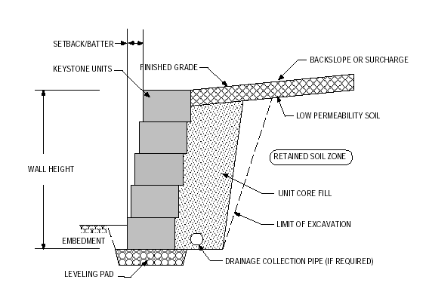

II Mechanically Stabilized Earth Retaining Walls

- Basic Earth Pressure Theory

You'll recall from your college soil mechanics classes the Coulomb (1776) and Rankine (1857) theories of active earth pressure. For wall design either theory may be used and will give similar results. The Rankine theory is favored by transportation professionals (AASHTO), while the NCMA prefers the Coulomb approach.

Both theories postulate a failure surface through the backfill which allows a wedge of earth to move slightly downward and outward. As illustrated below, this obviously requires that the wall itself move or tip a small distance. When that happens, the pressures and forces may be calculated using either theory.

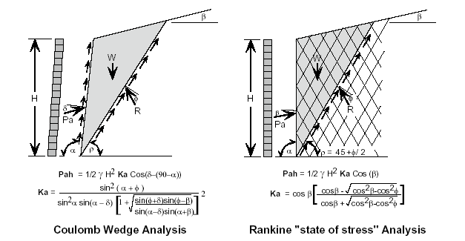
Source: Keystone Retaining Wall Systems
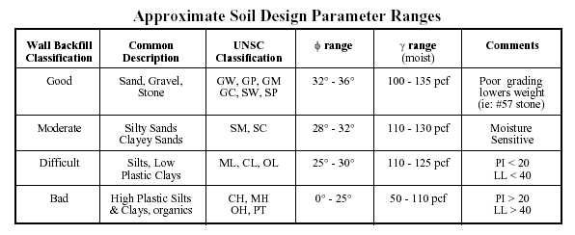
Source: Keystone Retaining Wall Systems

Ultimate Bearing Capacity of Various Soils

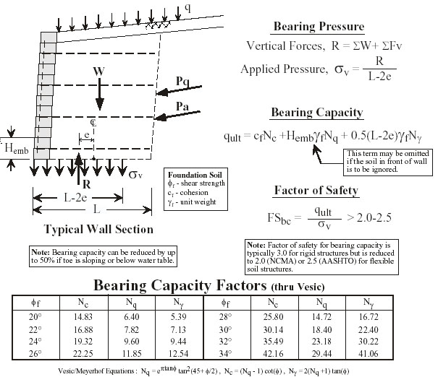
Source: Keystone Wall Systems

As you'll see in the examples, we will need to check the bearing capacity of the soils beneath the wall. Here's a brief example on the use of the Table:

Assume: φ = 26° c = 0 γ = 120 pcf and e= 1 foot L = 8 feet H_{emb} = 1 foot

q_{u} = 0 + (1)(11.85)(120) + 0.5(8-2)(12.54)(120) = 5936 psf

Although some Building Codes may not allow such high bearing pressures, it is clear that bearing capacity increases rapidly with depth and footing width.

Most of the examples in this course will use the Rankine theory but the basic procedures are the same in either case. For Example 1, in fact, the results would be identical.

Modes of Failure

As in all structural work, it is useful to look at the ways in which an MSE wall might fail. Here are a few illustrations of the most common types of failure.
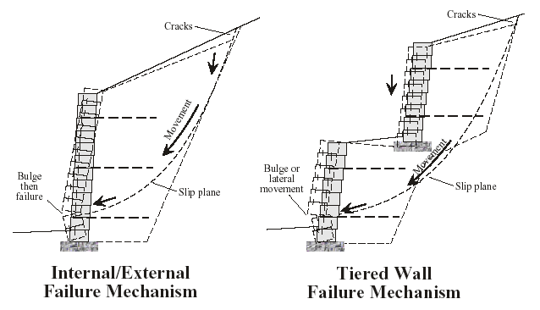

Basic Failure Modes

In addition to these basic modes of failure MSE walls, especially tall ones, may fail "globally". That is, the entire soil mass behind the wall may fail due to a zone of weakness or other non-uniformity. This case is illustrated below.
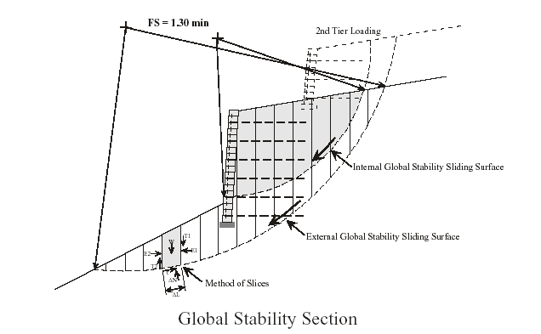
Global failure is discussed in more detail later. For now, note that the failure surface lies
beyond the walls and reinforced earth masses.

There are, of course many other reasons an MSE wall might fail. These include poor drainage, high surcharge loads, failure in tension of the reinforcing material or pullout of that material.

A. Example 1 Simple Earth Wall with Level Backfill and Surcharge

The detailed calculations for internal stability of the MSE mass with regard to reinforcement stresses and required length for pullout are not addressed here. For current information in this area, see the AASHTO Standard Specification for Highway Bridges or the NCMA Design Manual for Segmental Retaining Walls.

The following page shows the hand calculations done for preliminary design of the wall.
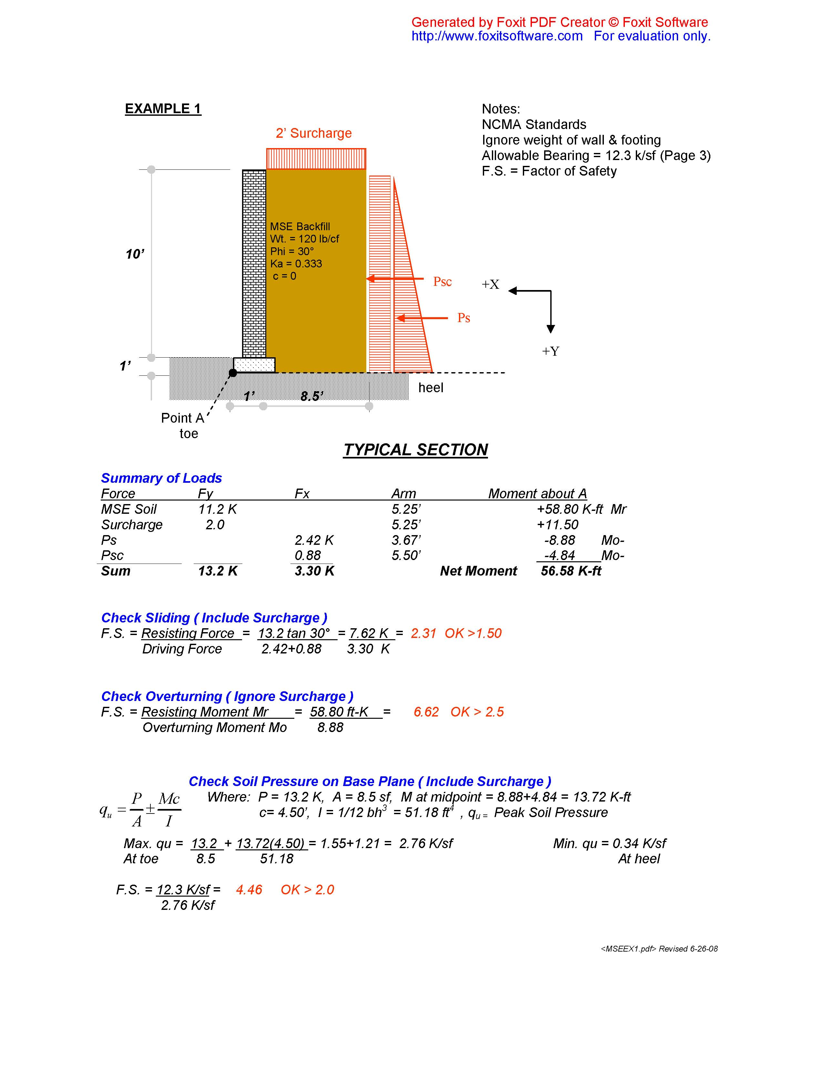

These hand calculations provide a preliminary design and a quick check on stability. They do not give us all the information we need, however. For that, fortunately there is a lot of software available. Among these are :

Keystone Wall Systems : Keywall 2001
NCMA: MSE Retaining Wall Design Software
Anchor Wall: Anchorwall
Allen Block: ABWall

Here is Example 1 as designed using Keywall 2001:

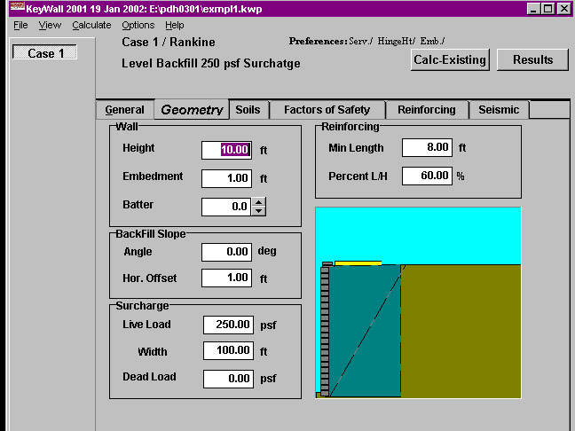

The screen shot above is of the input screen. A brief version of the results of the analysis is shown the following page.

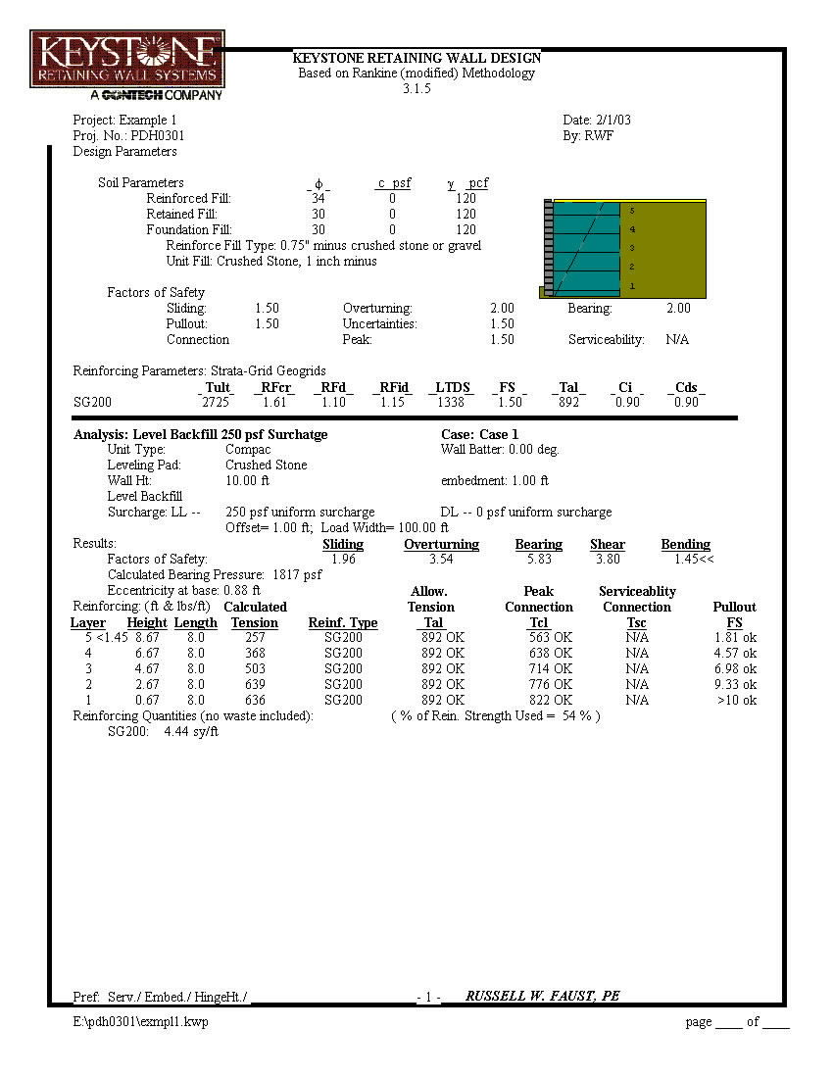

Example 2 Simple Wall with 2:1 Sloping Backfill

For this example we'll use Keywall 2001 again to do all of the calculations. As you'll see, the program can deliver a lot of detailed information.

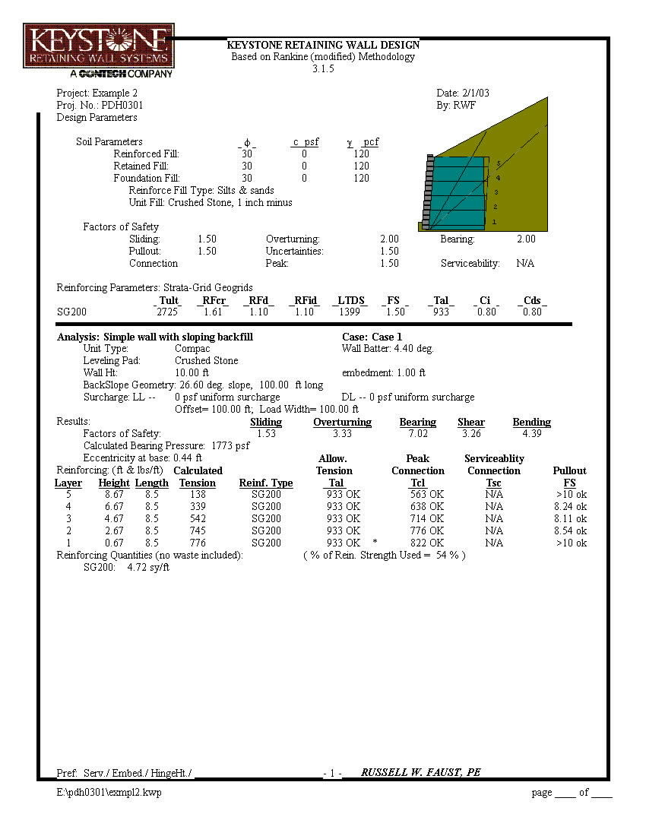

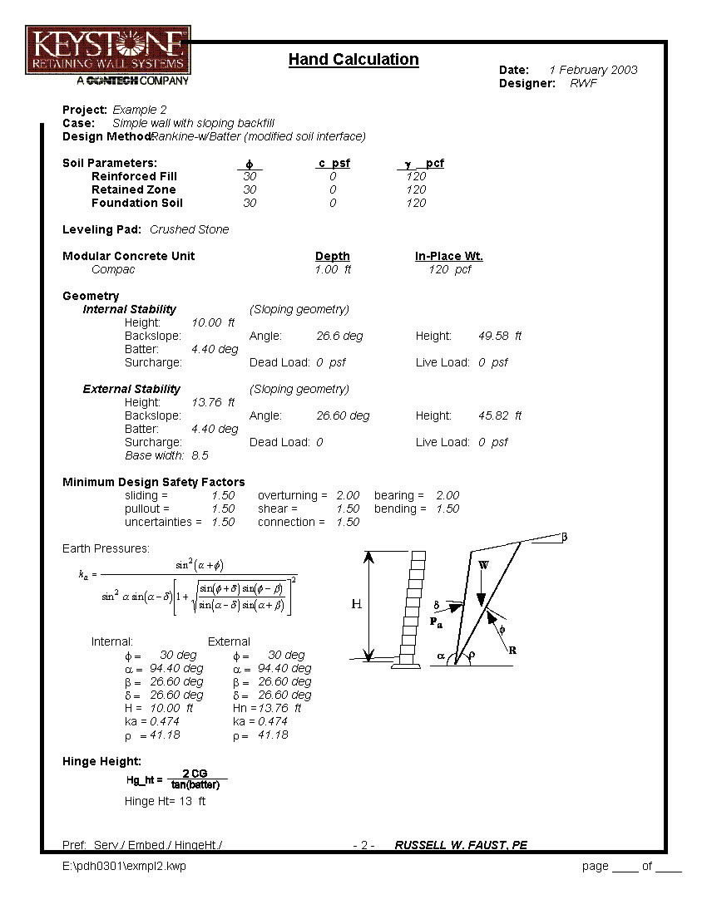

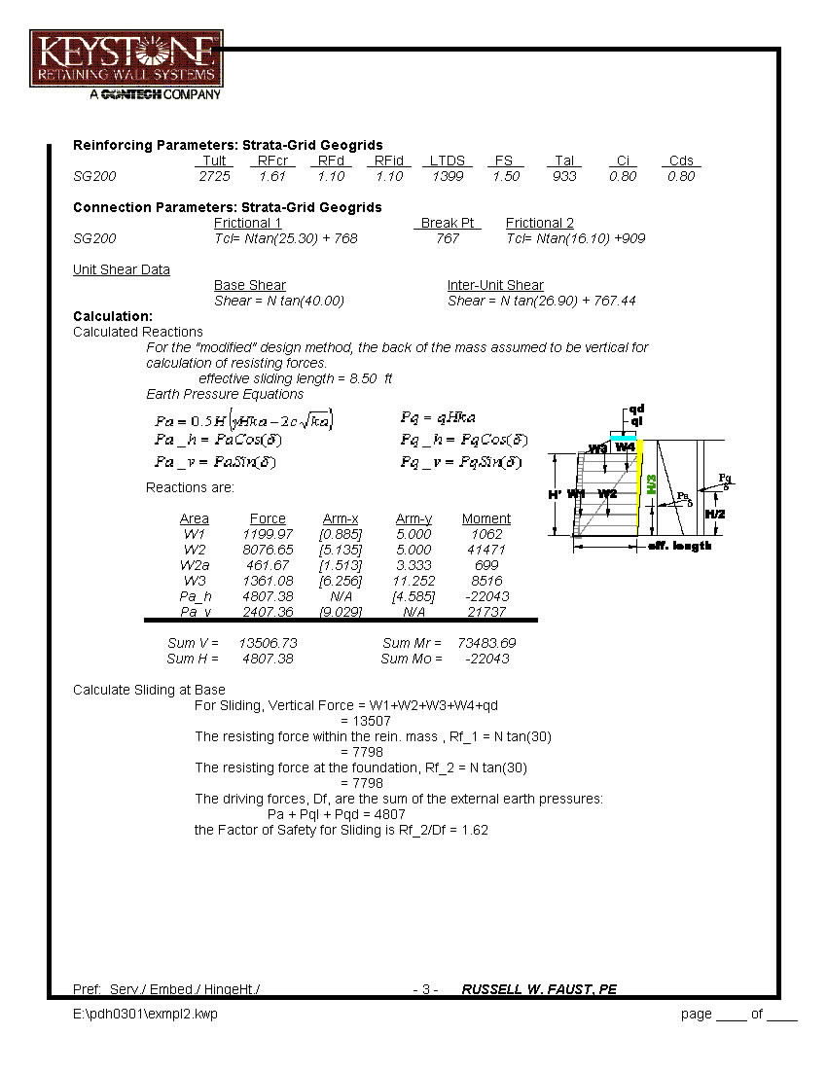

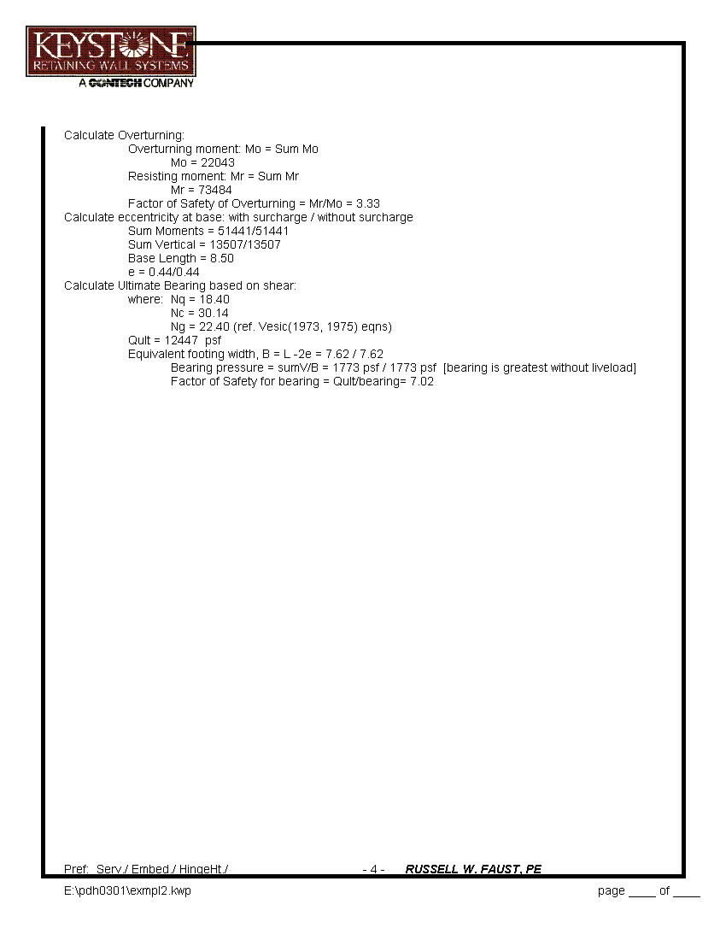

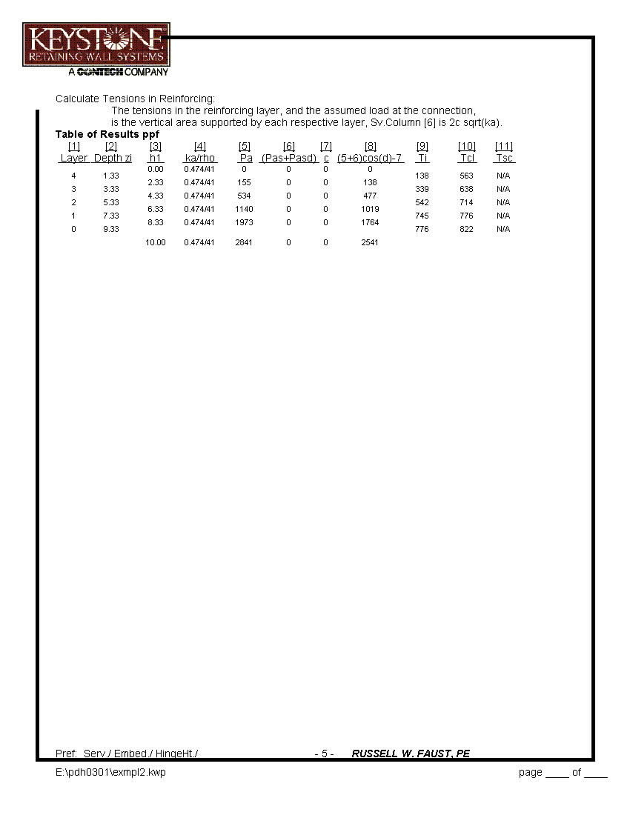
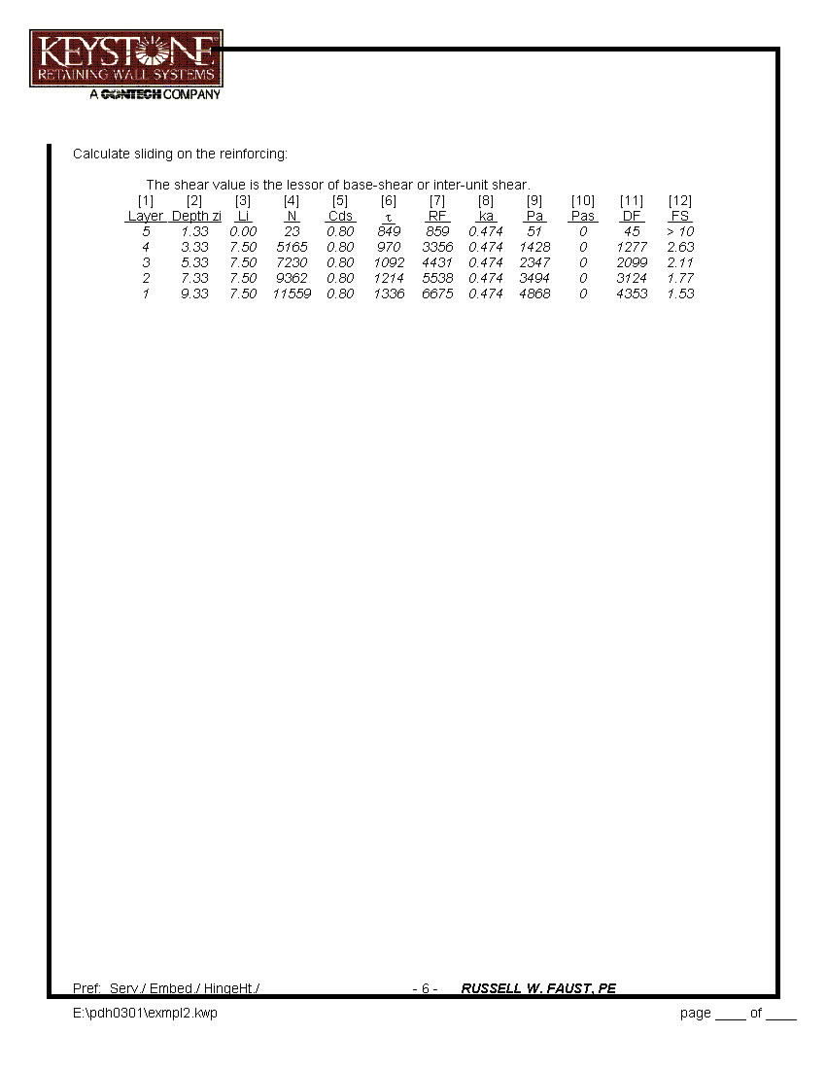
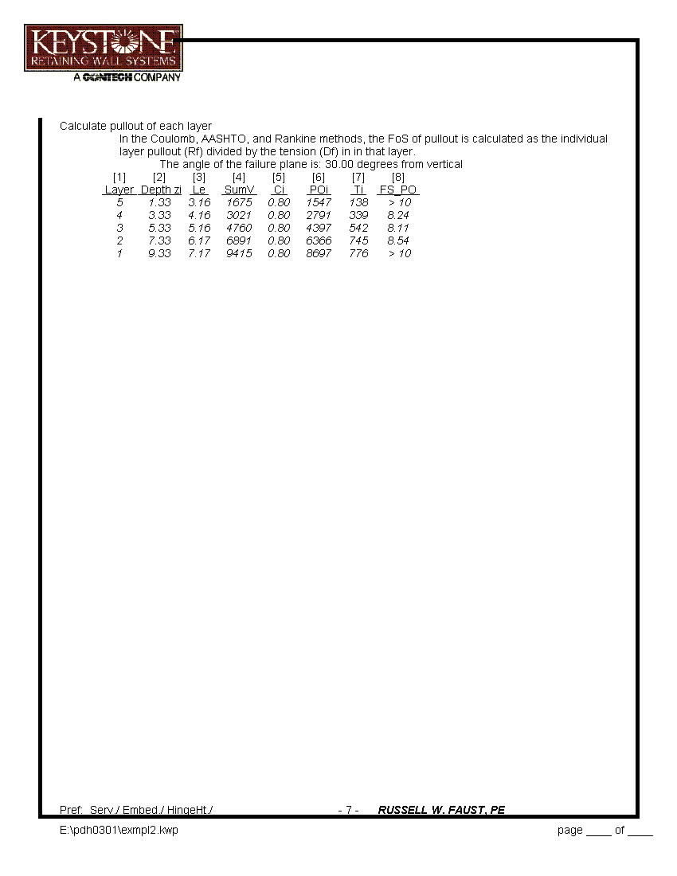
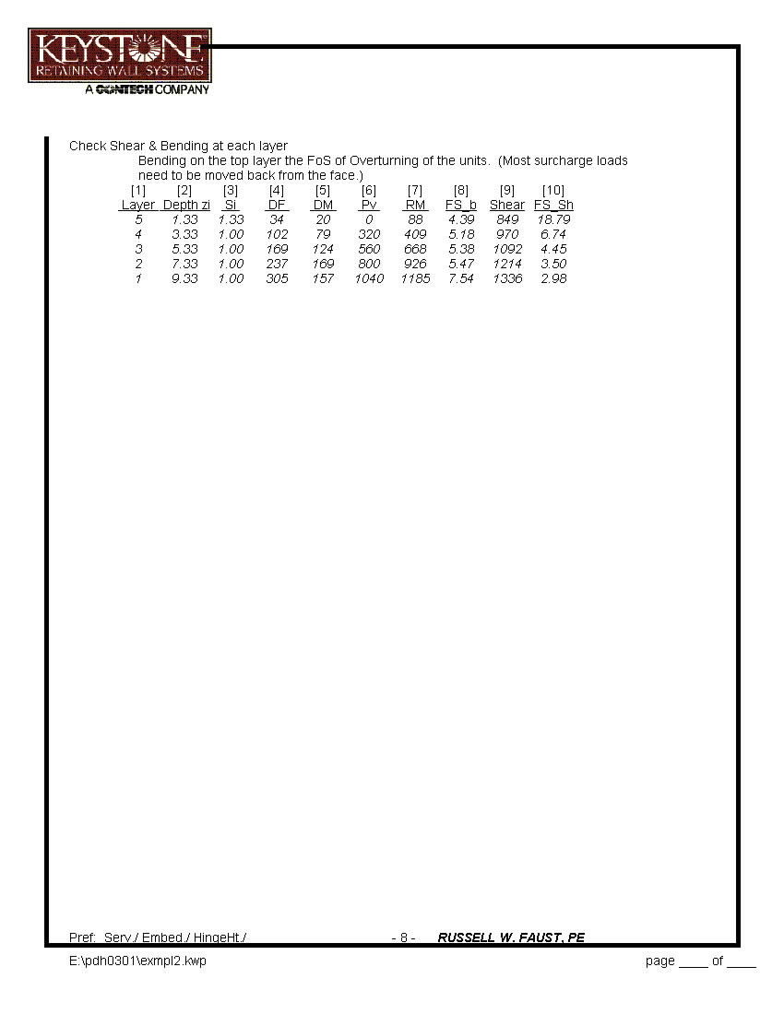
IV Flood Walls and Water Applications

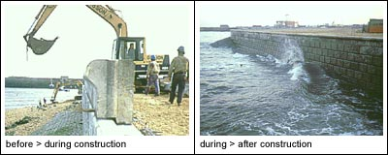
Source: Anchor Wall Systems

Not all flood walls will face conditions as severe as the one pictured above but water has an effect on the wall design in several ways. To see some of those effects here is a simple example assuming a placid pond on one side of the wall.

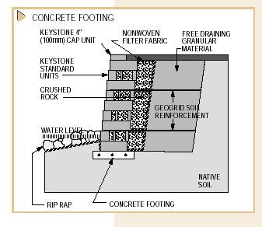
- Simple Wall with Water and Earth
Source: Keystone Wall Systems

In water applications there are additional factors to consider including:

- Water level range
- Velocity of flow
- Erosion potential
- Seepage
- Effects of rapid drawdown
- Filter fabric selection
- Wave action

In the design above you'll note that the reinforced soil mass is protected by a non-woven filter fabric to prevent a loss of fine grained material. A concrete bearing pad is used and riprap is placed to guard against the erosion which might cause loss of material at the toe. Backfill is free draining and topped with impermeable material to minimize hydraulic or water pressures behind the wall.

If you choose to use an MSE wall as a channel lining Keystone Wall Systems recommends a Manning's "n" value of about 0.023. This is similar to corrugated metal pipe but smoother than many natural channels.

- Wave Action

If the wall is to be truly a seawall, designed to resist heavy wave action, then additional measures need to be taken. Such designs are beyond the scope of this course but you will find the links at the end of this course will lead you sources of design guidance and software.

You may also wish to see the PDHCenter course cited above which will provide much information developed over the years by the US Army Corps of Engineers, and others.
V Tiered Walls

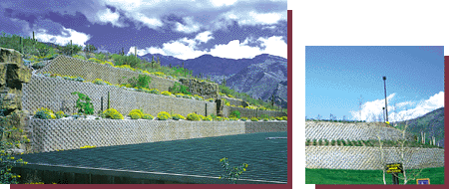

- Spaced Tiered Walls

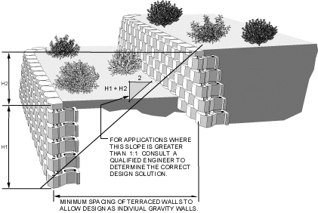

MSE walls are wonderful for making terraced landscapes and similar aesthetic designs. Unfortunately, many such walls are built each year by homeowners, landscapers and inexperienced contractors with disastrous results. Probably the only other cause of failure which is more common is neglecting to install proper drainage behind the wall.

The illustration above may be used as a guide. The better the material between the walls, i.e. the higher internal friction angle, the closer the walls may be spaced. It is easy to see that the upper wall imposes load on the lower wall. If the lower wall fails, the upper wall will also fail. Also note that both walls may fail globally if they are tall and/or soils are poor.

- Closely Spaced Walls

When it is necessary to place walls closer to each other than recommended you have several choices. You might reinforce the soils between the two walls using a stronger geogrid or you could use imported fill material which can be compacted to the required density. These options can only take you so far however and you might be faced with using a different type of wall entirely.

In such cases, a global stability analysis is clearly called for using very conservative estimates of soil properties.

VI Surcharges

Loads, in addition to the earth pressures, are called surcharges. They may be either "live" or "dead" loads. Most often they are live loads caused by vehicle traffic and they can be very large in certain situations. For example, in a rock quarry, 100,000 lb vehicles are common. Alongside a railroad very large surcharges may occur.

Also remember that for many walls the greatest loads and surcharges occur during construction. This is often the most critical time in the life of any wall structure.

VII Global Stability Analysis

You might be able to do a global stability analysis by "hand calculation" but it would be very time consuming and error prone. The solution is a trial and error process with many sub-steps so a good computer program is needed to bring the solution time down to a reasonable level. This can be done with a good spreadsheet but if you have many analyses to do you may wish to invest in a good program designed specifically to solve this problem. Here's a description of one such program:

"STABL is a computer program written in FORTRAN for the general
solution of slope stability problems by two-dimensional limiting
equilibrium methods. Its latest version, PCSTABL6, allows also the
analysis of reinforced soil slopes with geosynthetics, nailing, and tiebacks.

"The calculation of the factor of safety against instability of a slope is
done using one of the following methods: Bishop Simplified Method
(applicable to circular shaped failure surfaces), Janbu Simplified Method
(applicable to failure surfaces of general shape), and Spencer's Method
(applicable to any type of surface). The Janbu Simplified Method has an option
to use a correction factor, developed by Janbu, which can be applied to the
factor of safety to reduce the conservatism produced by the assumption
of no interstice forces.

"STABL features unique random techniques for generation of potential
failure surfaces for subsequent determination of the more critical surfaces
and their corresponding factors of safety. One technique generates circular;
another, surfaces of sliding block character; and a third, more general
irregular surfaces of random shape. Specific trial failure surface can
also be specified by the user."

These programs are not cheap and they do require some time to learn and some judgement in interpreting the results.

Also, because the solution is iterative it takes some experience and judgement to make one's initial guesses reasonable so that the program will converge in fewer iterations saving computation time.

VIII Geotextiles

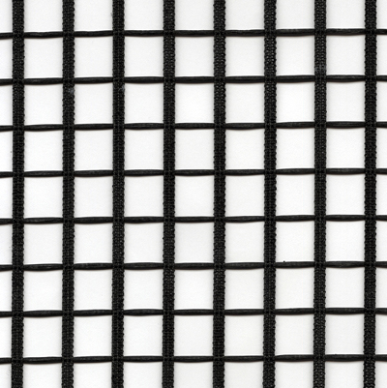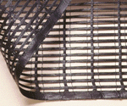

Stratagrid 200 Miragrid 5T by Mirafi

In MSE wall design the geogrid is the element that keeps the facing and retained earth together to act as a single mass. The two examples pictured above are typical of the many geogrids available. There are so many on the market that almost any design condition can be met. Links to the principle suppliers are provided at the end of this course where you can obtain all the physical data needed to select and use geogrids.

The single most important property of the geogrid is, of course, it's tensile strength, followed by measures of durability.

For water applications you will also need filter fabric geotextiles. These are generally available from the same sources.

On the following page you will see the wide variety of geogrids available from many manufacturers.
l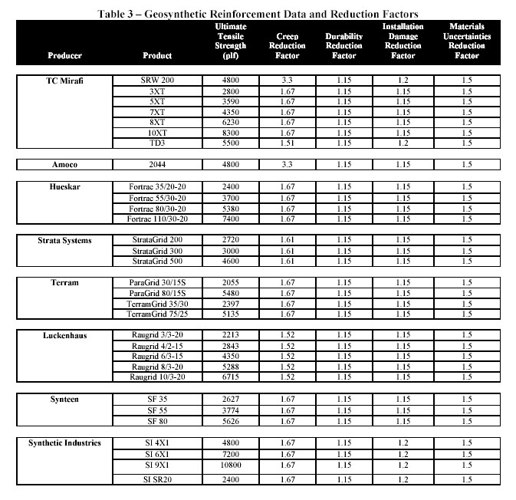
Source: Anchor Wall Systems

IX Drainage Details

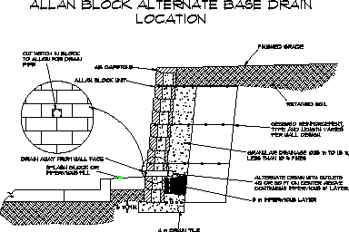

Good drainage behind an MSE wall is essential to its long-term performance. In fact, the lack of that drainage is probably the most common cause of wall failure.

X Seismic Design

Seismic design begins with a statistical estimate of the probability of a serious earthquake event occurring. The map below illustrates the range of peak ground accelerations in Oregon which might be expected to be equaled or exceeded 0.2 percent of the time in any one year. Those accelerations, in this case, range from 0.05 g to
0.60 g in the purple zone along the southern Oregon coast. ( "g" is the acceleration of gravity or 32.2 ft/sec/sec). In Oregon, earthquakes are caused by plate tectonic movement and subduction so they tend to be very destructive.

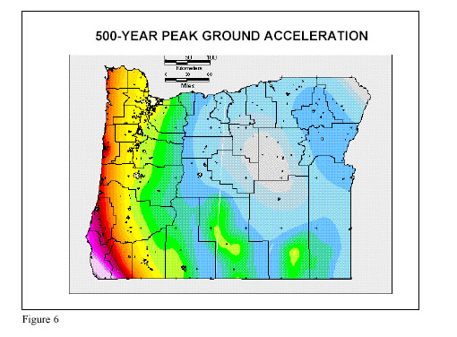
Source: Oregon Department of Geology and Mineral Industries

Similar maps should be available for your locality. Begin your search for them with your State or regional highway authority, bridge designers.

We can use Example 1 again to illustrate the only available method for testing our design for seismic resistance. The figure below illustrates the general approach known as the Mononobe-Okabe Pseudo Static Method.

For seismic design the calculations proceed in the same way as for gravity loads except that reduced factors of safety are allowed. Usually only 75% of the gravity FS is required. Also be aware that this method may only be used for peak ground accelerations of up to 0.40 g. For greater magnitudes additional, dynamic analyses may be required.

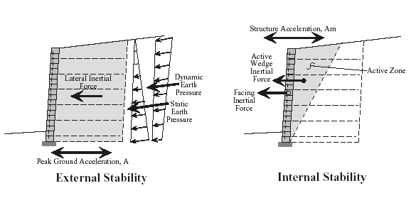
Example 1 Seismic Analysis A=0.33g

We'll use Keywall 2001 again to do the calculations. Note particularly the Factors of Safety generated by the program. They are the most important part of the output. It is important too to note that the program will not allow a solution for very high ground accelerations.

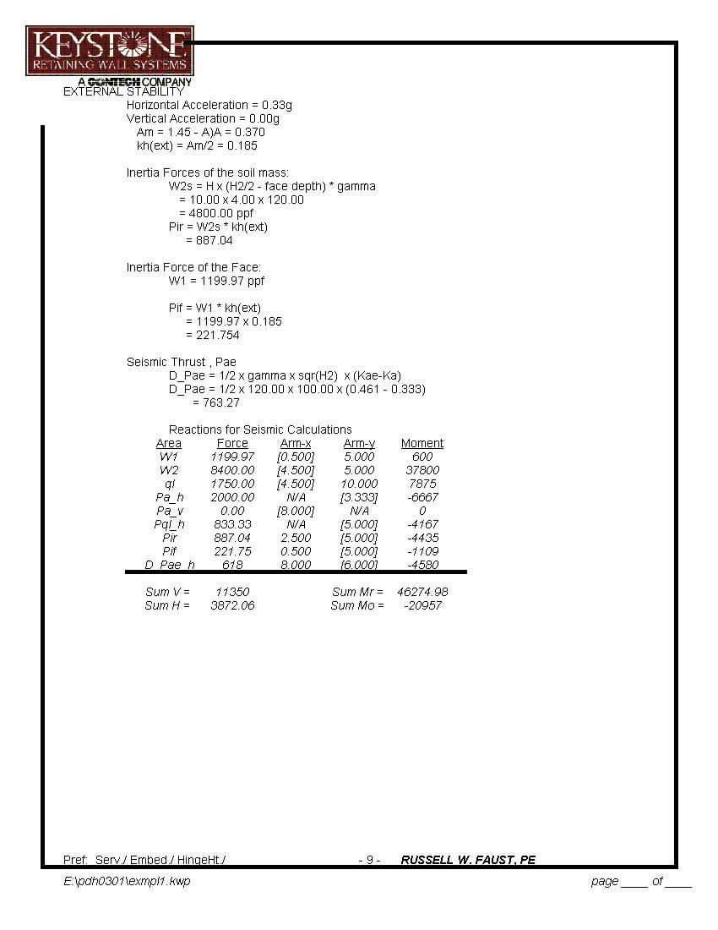
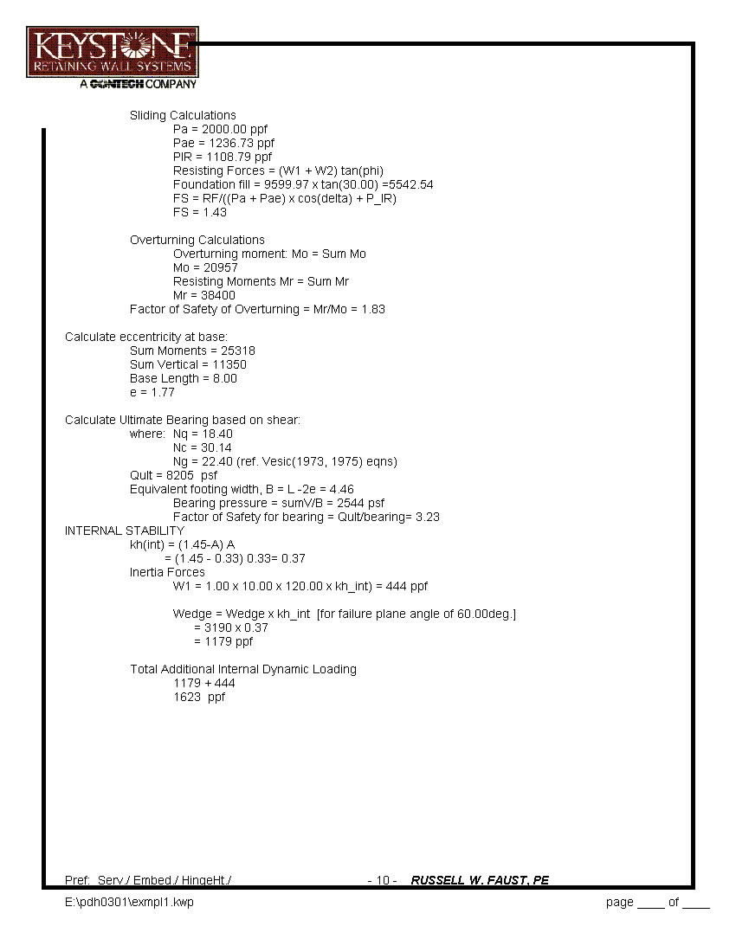
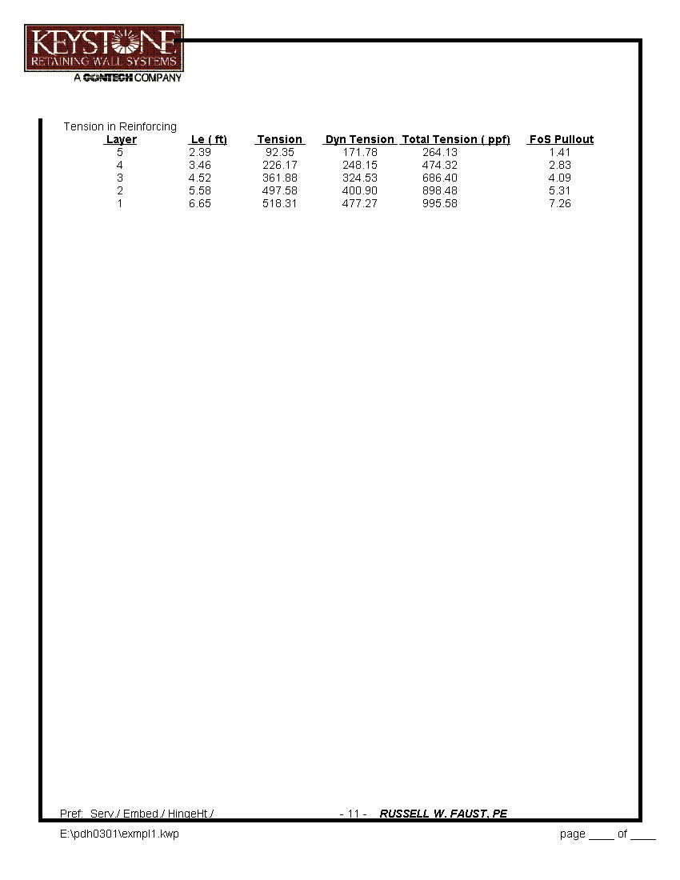
XI Aesthetics

- Curvilinear Walls

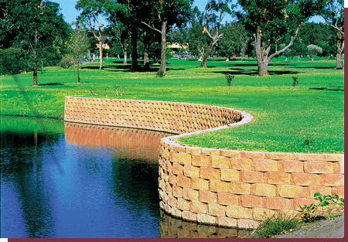

- Notched and Offset Walls

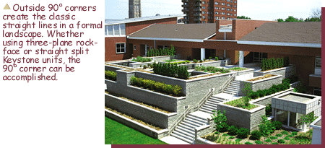

- Landscaping and Irrigation

Landscaping can add a great deal to a walls appearance as is obvious from the photos here. In addition, all these wall units come in colors, textures, shapes and with many special features. Irrigation behind walls must be treated with special care however since all soils are very sensitive to moisture content so good drainage is imperative.

XII Building Code Requirements

As use of MSE walls increase Building Codes in many areas have begun to take note of them and approvals, subject to special inspections is becoming the norm. In addition, many local and State agencies are developing "standards" for their design and construction. The most common way MSE walls gain approval under the Uniform Building Code is through a process called ICBO Evaluation Reports. Here is an excerpt from on such ER:

IANCHOR DIAMOND PRO SEGMENTAL RETAINING
WALL (SRW)
ANCHOR WALL SYSTEMS, INC.
5959 BAKER ROAD, SUITE 390
MINNETONKA, MINNESOTA 55345
PAVESTONE COMPANY
4835 LBJ FREEWAY, SUITE 700
DALLAS, TEXAS 75244-6072
1.0 SUBJECT
Anchor Diamond Pro Segmental Retaining Wall (SRW).
2.0 DESCRIPTION
2.1 General:
Anchor Diamond Pro Segmental Retaining Wall (SRW)
consists of dry-stacked concrete units and optional
geosynthetic soil-reinforcement material. Anchor Diamond
Pro SRW structures constructed without geosynthetic soilreinforcement
are gravity retaining walls that rely solely on
the weight of the dry-stacked concrete units to resist
destabilizing forces generated by the retained soil and any
surcharge or seismic loads. Refer to Figure 1A. Anchor
Diamond Pro SRW structures constructed with geosynthetic
soil-reinforcement are gravity retaining walls, having an
increased mass created by the geosynthetic reinforced-soil
mass located behind the dry-stacked concrete units, that
resist destabilizing forces generated by the retained soil and
any surcharge or seismic loads. Refer to Figure 1B.
2.2 Materials:
2.2.1 SRW Concrete Units: The Anchor Diamond Pro
SRW concrete units are available as either straight-face or
bevel-face units, as shown in Figure 2. Straight-face units
weigh 76 pounds (34 kg), and have a density of 130 pcf
(2082 kg/m3). Bevel-faced units weigh 72 pounds (33 kg),
and have a density of 130 pcf (2082 kg/m3). Refer to Figure
2 for details. The angle of wall inclination is about 7.1
degrees from vertical towards the backfill as determined by
the 1-inch (25 mm) setback per course provided by the rear
lip of the concrete unit. Both units must comply with
minimum compressive strength and maximum water
absorption requirements specified in UBC (1997 Uniform
Building Code™) Standard 21-4, where the minimum 28-
day compressive strength is 3,000 psi (21 MPa) on the net
area and the maximum water absorption is 7 percent. Block
tolerances must comply with Section 21.406 of UBC
Standard 21-4, and with the recommendations specified in
the National Concrete Masonry Association’s (NCMA)
publication titled TEK 2-4 Specification for Segmental
Retaining Wall Units.
2.2.2 Geosynthetic Material: Geosynthetic materials are
high-tensile-strength polymeric woven or knitted materials.
When installed in accordance with this report, the
geosynthetic material extends through the dry-stacked
Diamond Pro concrete units and into the compacted soil to
create a composite gravity mass structure. Geosynthetic
reinforcements must be stored at temperatures not lower
than –10EF (–23EC); and must not be in contact with wet
cement, epoxy or other adhesive materials. To prevent UV
degradation, the geosynthetic material must not be
subjected to prolonged exposure to sunlight. Geosynthetic
reinforcements that are compatible with the Anchor
Diamond Pro concrete units bear the product names Mirafi,
Raugrid, or Strata, and may be described as follows:
1. Mirafi®: The Mirafi 3XT, 5XT, and 8XT, manufactured
by TC Mirafi, consist of polyester yarns with an acrylic
latex coating, woven into a grid shape sheet.
2. Raugrid: Raugrid geogrids 3/3-20, 4/2-15, 6/3-15, and
8/3-20, manufactured by Luckenhaus North America,
Inc., consist of polyester yarns with a PVC coating,
woven into a grid shape sheet.
3. Strata: Strata geogrids 200, 300, and 500,
manufactured by Strata Systems, Inc., consist of
polyester yarns saturated with a PVC coating, precision
knitted into a dimensionally stable, grid shape sheet.
2.2.3 Backfill Soil: Backfill used in the reinforced soil
mass must consist of appropriate material placed in
compacted lifts. The backfill soil properties, lift thickness
and degree of compaction are determined by the soils
engineer. A drainage aggregate layer and drain tile must be
installed in the system to prevent buildup of hydrostatic
pressures behind the wall. The drainage provisions must
be determined by the soils engineer and approved by the
building official.
2.3 Design:
2.3.1 General: The design of gravity and reinforced-soil
retaining SRW systems must be based on the guidelines
outlined in the NCMA Design Manual for Segmental
Retaining Walls (second edition), dated 1997. A copy of the
NCMA design manual must be made available to the
building official upon request.
The design must consider both external and internal
stability, along with consideration of external loads
generated by surcharges and seismic activity. Lateral earth
pressures must be determined using the Coulomb theory.
Seismic loads must be analyzed by the method outlined in
the NCMA Segmental Retaining Walls—Seismic Design
Manual (first edition), dated 1998. A copy of the NCMA
seismic design manual must be made available to the
building official upon request.
ER-5809
Issued May 1, 2002
ICBO Evaluation Service, Inc. • 5360 Workman Mill Road, Whittier, California 90601 • www.icboes.org
Filing Category: DESIGN—Masonry
are not to be construed as representing aesthetics or any other attributes not specifically addressed, nor are they to be construed as
an endorsement of the subject of the report or a recommendation for its use. There is no warranty by ICBO Evaluation Service, Inc., express or implied,
as to any finding or other matter in this report, or as to any product covered by the report.
Copyright © 2002 Page 1 of 6……………………………

XIII Conclusions

This course has presented a brief overview of the basics of MSE wall design. Many of the applications of these kinds of walls go well beyond these basics and, as their use increases, will test your design skills. However, good design, good drainage and a healthy respect for the difficulties and unknowns associated with any earth structure should allow you to meet those tests.

XIV References and Links

- Design Manual for Segmental Retaining Walls, 2nd Edition (NCMA, 1997)
http://www.masonryinstitute.org

- American Association of State Highway and Transportation Officials

http://www.aashto.org/aashto/home.nsf/FrontPage

- Strata Systems, Inc.
http://www.geogrid.com/

- Mirafi
http://www.tcmirafi.com/

- Allan Block Company
http://www.allanblock.com/

- Anchor Wall
http://www.anchorblock.com/

- PCStabl
http://www.ecn.purdue.edu/STABL/

- Keystone Wall Systems, Inc.
http://www.keystonewalls.com

- Federal Emergency Management Agency

Coastal Hazard Analysis and Modeling Program (CHAMP)

http://www.fema.gov/mit/tsd/frm_soft.htm

- National Concrete Masonry Association
https://secure.ncma.org/source/orders/index.cfm

Note: In the summer of 2009 the NCMA expects to update both its Design Manual for Segmental Retaining Walls and its software, SRWall 4.0.

