Earthquakes: Basic Principles

Samir G. Khoury, Ph.D., P.G.

Course Content

Introduction

Earthquakes, sometimes also referred to as quakes, shocks, seism or temblors, are one of the most alarming and destructive natural phenomena that people can experience. It is also known and well documented that these events are distressing to animals as well, although no one knows as yet what the animals’ sense just before the occurrence of an earthquake. The occurrence of large earthquakes is often sudden, their duration is short (on the order of seconds or at most minutes) and the devastation they cause can be extensive or even total. Large earthquakes are often followed by aftershocks, which are tremors that follow a larger earthquake, or main shock. Aftershocks may be felt for several days after the main shock. The number and severity of the aftershocks contribute greatly to the sense of panic felt by the affected population.

The scientific study of earthquakes is relatively new, and a reasonable understanding of their occurrence can only be traced back for a couple of hundred years. Prior to that time, the early historical record of earthquakes is cryptic at best because people did not understand the reason for their occurrence. In fact, there are very few factual descriptions of earthquakes prior to the 18th century because before then, people believed that an earthquake was a massive punishment imposed by the gods to punish the sinners and warn the unrepentant. During these early times, the occurrence of strong earthquakes usually triggered passionate discussions between philosophers and theologians resulting in lengthy and convoluted explanations about a long overdue and deserved retribution by God in response to the pervasive problems of evil in the world. The few that looked for natural causes for these unexplained phenomena reached equally strange conclusions. For example, an early popular theory postulated that earthquakes were caused by strong winds blowing out of deep caverns within the earth.

A drastic change in attitude regarding this issue can be traced back to a strong earthquake that occurred on All Saints’ Day, November 1, 1755, near Lisbon, Portugal. Just before 10 am, the city was shaken ferociously for several minutes. The convulsions were so great that the water was sucked out of the city’s harbor and returned soon thereafter as a fifty-foot wave that contributed greatly to the destruction of the city. The survivors that had fled to the waterside were drowned by the great waves that raced on them from the Atlantic. The motion of this first earthquake had not ceased for more than a few minutes when a second shock came, only slightly less severe than the first. A third and less severe final shock occurred about two hours later. The end of this mayhem reduced virtually every building within miles of the city center to rubble. Over 60,000 people lost their lives.

For the first time in history, however, we have detailed descriptive information of what happened, soon after the earthquake struck. All over Portugal priests were asked by their bishops to document their observations in as much detail as they could. Their records are still preserved and represent the first systematic effort in history to describe the effects of an earthquake as, or soon after, it occurred. One of the many archived contemporary descriptions is given below:

“The sea rose boiling in the harbor and broke up all the crafts harbored there. The city burst into flames, and ashes covered the streets and squares. The houses came crashing down, roofs piling up on foundations, and even the foundations were smashed to pieces.”

Below is an artistic rendition of this destructive earthquake.

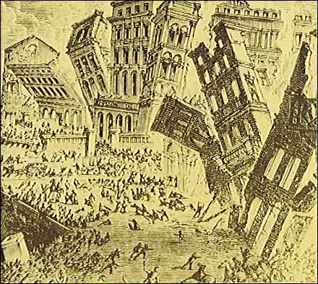

Figure 1: Artistic rendition of the effects of the 1755 Lisbon earthquake (Source: United States Geological Survey, initially published in Candide, by Voltaire).

Ever since that time detailed records have been made of the majority of large earthquakes that have occurred around the world. Today, however, our understanding of these phenomena has evolved beyond the purely descriptive realm of reciting their effects to the deeper understanding of the causes and mechanisms that trigger the occurrence of these events. In fact, It is now understood that earthquakes have punctuated the evolution of our planet since its inception, over 4 billion years ago.

This course on earthquakes will explore the advances that have been made in this field and will bring you up-to-date with the knowledge that has been developed since these early days of pure speculations.

Measuring the size of Earthquakes

By the late nineteenth century, the new discipline of seismology, which deals with the methodical study of earthquakes, had accumulated sufficient empirical observations to allow the development of novel approaches to systematically estimate the size and tabulate the effects of earthquakes. It took another fifty years, with associated improvements in seismic instrumentation, to develop a scale to record the absolute size and associated energy released by earthquakes. The history of these developments is presented below:

Development of the Intensity Scale

Using the detailed descriptions that have been recorded for over a century after the occurrence of the 1755 Lisbon earthquake, attempts have been made at developing scales to characterize the shaking severity of earthquakes. Early efforts to describe the intensity of earthquake shaking were initially based on arbitrary scales that were developed independently in 1874 in Italy and in 1878 in Switzerland. This early Italian and Swiss work culminated soon afterward in the development of the standardized Rossi-Forel scale. This first ever scale combined the work and efforts of M. S. di Rossi, Director of the Geodynamic Observatory, near Rome, and F. A. Forel, a member of the Helvetic Society of Natural Sciences for the study of earthquakes. The Rossi-Forel Scale, with intensity levels of I to X, was widely used throughout the world for over half a century after its inception. A copy of this scale is presented below:

Rossi-Forel Intensity Scale

Intensity | Effects
I | Felt only by experienced observers and rest, and recorded by instruments.
II | Felt by a small number of persons at rest.
III | Felt by several persons at rest; strong enough for the duration or direction to be appreciable.
IV | Felt by several persons in motion; disturbance of movable objects, doors, windows; creaking of floors.
V | Felt generally by everyone; disturbance of furniture and beds; ringing of some bells (of schools and churches).
VI | General awakening of those asleep; general ringing of bells; oscillation of chandeliers; stopping of clocks; visible disturbance of trees and shrubs; some startled persons leave their dwellings.
VII | Overthrow of movable objects, fall of plaster, ringing of church bells, and general panic, without damage to buildings.
VIII | Fall of chimneys, cracks in the walls of buildings.
IX | Partial or total destruction of some buildings.
X | Great disaster, ruins, disturbance of strata, fissures in the earth’s crust, rock falls from mountains.

With the passage of time, the study of earthquake intensity continued to be studied and refined. Between 1890 and 1901 Giuseppi Mercalli, an Italian geologist, made a new compilation of the shaking effects. His efforts led to the development of a standardized scale to document the variations in shaking between various locations and regions. Today, the Mercalli scale has been modified to adapt to local construction conditions and practices. In the United States it is called the “Modified Mercalli Scale”, which is the most commonly used adaptation of this scale and covers the range from “I – Not felt except by a very few under especially favorable conditions”, to “XII – Damage near total, lines of sight and level distorted”. A copy of the Modified Mercalli Scale is presented below:

Modified Mercalli Intensity Scale*

Because the performance of masonry is such an important criterion for evaluating intensity, this intensity scale specifies four qualities of masonry, brick or other construction materials, as follows:

Masonry A | Good workmanship, mortar and design reinforced, especially laterally, and bound together using steel, concrete, etc.; designed to resist lateral forces.
Masonry B | Good workmanship and mortar; reinforced, but not designed in detail to resist lateral forces.
Masonry C | Ordinary workmanship and mortar; no extreme weaknesses like failing to tie in at corners, but neither reinforced nor designed against horizontal forces.
Masonry D | Weak materials, such as adobe; poor mortar; low standards of workmanship; weak horizontally.

Intensity | Effects
I | Not Felt
II | Felt by persons at rest, on upper floors, or favorable places.
III | Felt indoors. Hanging objects swing. Vibrations like passing of light trucks. Duration estimated. May not be recognized as an earthquake.
IV | Hanging objects swing. Vibrations like passing of heavy trucks, or sensation of a jolt like a heavy bell striking the walls. Standing automobiles rock. Windows, dishes, and doors rattle. Glasses clink. Crockery clashes. In the upper range of IV, wooden walls and frame creak.
V | Felt outdoors, direction estimated. Sleepers wakened. Liquids disturbed, some spilled. Small unstable objects displaced or upset. Doors swing, close, open. Shutters, pictures move. Pendulum clocks stop, start, and change rate.
VI | Felt by all. Many frightened and run outdoors. People walk unsteadily. Windows, dishes, glassware broken. Knickknacks, books, etc. fall off shelves. Pictures fall off walls. Furniture moved or overturned. Weak plaster and Masonry D cracked. Small bells ring (church, school). Trees, bushes shaken visibly, or heard to rustle.
VII | Difficult to stand. Noticed by drivers of automobiles. Hanging objects quivers. Furniture broken. Damage to masonry D, including cracks. Weak chimneys broken at roof line. Fall of plaster, loose bricks, stones, tiles cornices, unbraced parapets and architectural ornaments. Small cracks in masonry C. Waves in ponds; water turbid with mud. Small slides and caving along sand and gravel banks. Large bells ring. Concrete irrigation ditches damaged.
VIII | Steering of automobiles affected. Damage to masonry C; partial collapse. Some damage to masonry B, none to masonry A. Fall of stucco and some masonry walls. Twisting, fall of chimneys, factory stacks, monuments, towers, and elevated tanks. Frame houses moved on foundations if not bolted down; loose panel walls thrown out. Decayed piling broken off. Branches broken from trees. Changes in flow or temperature of springs and wells. Cracks in wet ground and on steep slopes.
IX | General panic. Masonry D destroyed; masonry C heavily damaged, sometimes with complete collapse; masonry B seriously damaged. General damage to foundations. Frame cracked. Serious damage to reservoirs. Underground pipes broken. Conspicuous cracks in ground. In alluvial areas sand and mud ejected, formation of sand craters.
X | Most masonry and frame structures destroyed with their foundations. Some well-built wooden structures and bridges destroyed. Serious damage to dams, dikes, embankments. Large landslides. Water thrown on banks of canals, rivers, lakes, etc. Sand and mud shifted horizontally on beaches and flat land. Railroad tracks bent slightly.
XI | Railroad tracks bent greatly. Underground pipelines completely out of service.
XII | Damage nearly total. Large rock masses displaced. Lines of sight and level disturbed. Objects thrown into the air.

*Reference: AGI Data Sheets, American Geological Institute, Alexandria, VA 22302

Although very useful, it is obvious that this kind of descriptive evaluation is subjective and can be made only after eyewitness reports are reviewed, interpreted and tabulated. Relying on the impressions of many people is an unsatisfactory and unreliable way of compiling accurate information. In addition, the observations could lead to erroneous conclusions, because the damages to buildings are often related to the workmanship, design, and the nature of the ground, rather than on the energy released by the earthquake.

Seismograph and Seismogram

Since the earliest parts of the twentieth century, the vibrations produced by earthquakes have been detected, recorded, and measured by instruments called seismographs. The first seismographs, built between 1900 and 1910, were simple contraptions that rang a bell when the ground vibrated beneath the instrument or that sensed the ground vibrations by recording a differential change in pressure along a north-south and/or an east-west axis. The 1920s and 1930s saw the early development of the basic or standard seismograph that is still in use today.

Conceptually, a modern seismograph consists essentially of a mass attached by a spring to a support that moves with the ground. The mass, attached to the spring, remains nearly stationary but the ground and support move in step. The relative motion between the stationary mass and moving support is recorded as a zigzag line by a stylus contacting a piece of paper attached to a rotating drum (analog recording). Alternately, the waves can be recorded by electronic equipment and saved on a storage device (digital recording). The wavy line, which is made by a seismograph, is called a seismogram. A seismogram, therefore, shows waves of varying amplitude that decay as time passes. Depending on the amplification factor of a seismograph, these records (analog or digital) can be used to measure the amplitude of seismic waves with some degree of precision. Figure 2 below shows a conceptual representation of a vertical motion seismograph and the resulting diagrammatic seismogram recorded during an earthquake. A clock coupled to the instrument marks off the time on the seismogram.

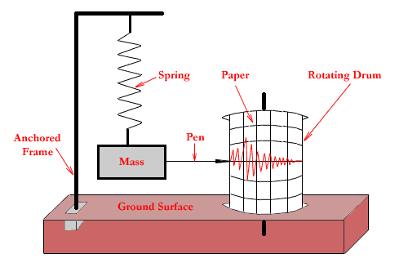
Figure 2: Conceptual representation of a simple vertical motion seismograph. The mass suspended on the spring tends to stand still while the support and drum move during an earthquake. In this case motion is measured up and down, in a vertical direction.

In general, at a given location, a modern seismographic station will have a set of seismographs for measuring three components of motion: up down, north south and east west. The up and down recording represents the vertical component of movement, whereas the north south and east west recordings represent the horizontal components of movement. For illustration, the seismograms of an Alaskan earthquake as recorded by a seismographic station in New York State is presented below:

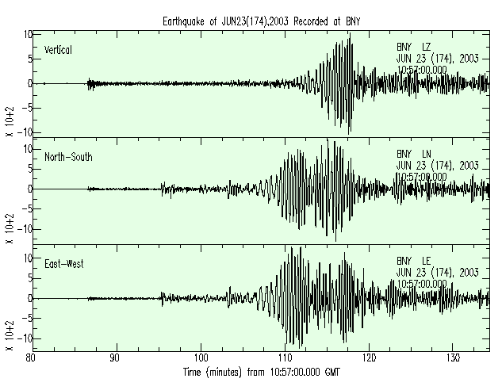
Figure 3: Seismograms of an Alaskan magnitude 6.9 earthquake which occurred on Monday Jun 23 12:12:35 2003 UTC (Universal Time) at: latitude 51.58N, longitude 176.67E, Depth 30km, as recorded by the Binghamton Seismic station, New York.

Hypocenter and Epicenter

Geologists have found that earthquakes tend to occur along faults that correspond to zones of weakness in the crust of the earth. A fault is a fracture that separates two blocks of the crust that have slipped with respect to each other. An earthquake is triggered at the actual moment of slip initiation on the fault surface. The hypocenter is the position within the earth from which the motion and energy of an earthquake originates. The epicenter of an earthquake is the point on the earth’s surface directly above the focus, or hypocenter. The following diagram illustrates the spatial relationship between the fault, that generates an earthquake, the focus (or hypocenter) and the epicenter:

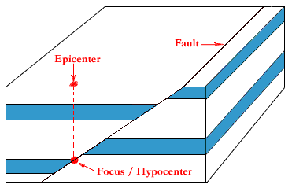
Figure 4: Diagram showing the relationship between the focus, or hypocenter, and the epicenter. The hypocenter is directly located on the fault plane, while the epicenter is the vertical projection of the hypocenter onto the ground surface.

Development of the Magnitude Scale

As explained in a preceding section, seismographs record the amplitude of the ground oscillations beneath the instrument. Sensitive seismographs, which greatly magnify these ground motions, can detect earthquakes from sources anywhere in the world. Currently, the size of an earthquake is measured objectively, with some degree of precision, by seismographs deployed around the globe.

Charles F. Richter and Beno Gutenberg, both of the California Institute of Technology, developed the magnitude scale in 1935 as a mathematical device to measure and compare the absolute size of earthquakes. The scale ascribes to each earthquake a number, called the earthquake magnitude, which is also an index of the energy released at the source of that earthquake. The magnitude is defined as the logarithm of the maximum amplitude of the signal that is traced on a standard seismograph located at 100 kilometers from the epicenter. On the Richter scale, magnitude is expressed in whole numbers and decimal fractions. For example, a magnitude 5.5 earthquake may be computed for a moderate earthquake, whereas a magnitude 7.5 earthquake may be calculated for a strong earthquake. Because of the logarithmic basis of the scale, each whole number increase in magnitude represents a tenfold increase in measured amplitude. As an estimate of energy, however, each whole number step in the magnitude scale corresponds to the release of about 31 times more energy than the amount associated with the preceding whole number value.

Richter’s method has proven to be so convenient that the measurement of magnitude as a means of classifying earthquakes is accepted universally, and is now simply known as the Richter Scale. An earthquake at any distance from a seismograph can now be assigned a single number that is reflective of its size. As it was originally defined, first arrival amplitude of one millimeter on a short period horizontal seismograph (Wood-Anderson model) recorded at 100 kilometers from an earthquake is considered to be zero (0) magnitude. According to this scheme, we can have earthquakes smaller than magnitude 0. In fact, the smallest magnitude that has been determined is about –3, essentially a barely discernible deflection on the seismic record. In theory there is no upper limit to the magnitude of an earthquake. But, the strength of the earth materials produces an actual upper limit of less than 10. So far, the largest magnitude on record for an earthquake is 9.5 for the May 22, 1960, Chile event. The epicenter of that earthquake was located at latitude 39.5 south, longitude 74.5 west. So, in one sense, the magnitude scale can be considered an arbitrary measure of the earth trembling.

According to the Richter Scale, magnitude 1 to 3 earthquakes are recorded by local seismographs, but are not generally felt. Magnitude 3 to 4 earthquakes are often felt, but generally do not cause damage. A magnitude 5 earthquake is felt widely and generally causes slight damage near the epicenter. A magnitude 6 earthquake causes damage to poorly constructed buildings and other structures within tens of kilometers from the epicenter. A magnitude 7 earthquake is considered major and causes serious damage up to about 100 kilometers from the epicenter. A magnitude 8 earthquake is considered great and causes extensive destruction and loss of life over several hundred of kilometers from the epicenter. A Magnitude 9 and larger earthquakes are relatively rare and they cause major damage over very large regions of up to one thousand kilometer from the epicenter.

Unlike the Intensity Scales, The Richter Scale is not used to express damage. An earthquake in a densely populated area, which results in many deaths and considerable damage, may have the same magnitude as a shock in a remote area that humans may not even feel. Humans may not also feel large-magnitude earthquakes that occur beneath the oceans, at large distances from continents. However, irrespective of where they occur, seismographs that are deployed around the world record all of these earthquakes and a magnitude can be computed for each of these events. On the average, about 10 to 20 earthquakes of magnitude 7.0 or greater occur every single year somewhere around the world. By contrast, about 1,000 earthquakes of magnitude 2.0 to 2.9 are recorded every single day somewhere around the world.

The mathematical relationships used to compute the Richter magnitude and the amount of energy released by an earthquake are presented in an Appendix at the end of this course.

Major Earthquakes of North America

The major earthquakes that have affected North America, namely the 1811-1812 New Madrid, Missouri, the 1886 Charleston, South Carolina, and the 1906 San Francisco, California, earthquakes are described in the following sections.

The New Madrid, Missouri, Earthquakes of 1811-1812

The most widely felt earthquakes in the history of the Lower 48 States was a series of temblors that occurred in 1811-1812 near New Madrid, Missouri. At 2 am on December 16, 1811 loud noises and the toppling of chimneys awakened the people of New Madrid. Trees crashed to the ground and great fissures tore open the ground. When the frightened inhabitants ran outside, the undulating ground made it difficult for them to stand. It is now believed that this initial earthquake, which had an estimated magnitude of about 8.6, was the first shock of two major earthquakes that occurred on that day. These two events were followed by numerous aftershocks that continued until a third major earthquake, with an estimated magnitude of 8.4, occurred on January 23, 1812. But, after about two weeks of relative calm, another severe shock, with an estimated magnitude of 8.7, struck the same region on February 7, 1812. This last event was followed by sizeable aftershocks that occurred over a period of several days and continued to be felt in decreasingly smaller intensities for over one year.

The largest of these quakes was felt from Canada to the Gulf of Mexico and from the Rocky Mountains to the Atlantic Ocean. The course of the lower part of the Mississippi River was altered by these events. The ground motions were so strong that chimneys were toppled in Cincinnati, Ohio, and church bells rang in Boston, Massachusetts. However, because the most intense effects were in a sparsely populated region, the destruction and loss of human life was slight. If these same earthquakes were to occur in the same area today, it would cause severe damage to many cities in the central Mississippi Valley.

The Charleston, South Carolina, Earthquake of 1886

In the Charleston, South Carolina region, there had been warnings since the beginning of the1886 summer. Several tremors had been felt in the city, but these had attracted little attention at the time. A larger shock had been felt on August 27 at Summerville, about 20 miles north of Charleston. On August 28, at 4:45 p.m. there was another shock at Summerville which was also felt in Charleston, where there was a slight rocking of houses and rattling of windows. However, no one was prepared for what followed on the evening of August 31. Presented below is an eye witness account of what happened as recorded by the curator of the Charleston Museum at the time:

“At the hour of 9:50 p.m., there was suddenly heard a rushing roaring sound compared by some to a train of cars at no great distance, by others to a clatter produced by two or more omnibuses moving at a rapid rate over a paved street; by others again to an escape of steam from a boiler. It was followed immediately by a thumping and beating of the earth underneath the houses, which rocked and swayed to and fro. Furniture was violently moved and dashed to the floor, pictures were swung from the walls and, in some cases, completely turned with their backs to the front, and every movable thing was thrown into extraordinary convulsions. It was probably then, during the period of the greatest sway that so many chimneys were broken off at the junction with the roof. The number was afterwards counted and found to be almost 14,000. The duration of this severe shock is thought to have been from 35 to 40 seconds.”

The San Francisco, California, Earthquake of 1906

The most famous and destructive earthquake of the 20th century in North America was the April 18, 1906 San Francisco event. At 5:12 a.m., local time, a foreshock occurred with sufficient force to be felt widely throughout the San Francisco Bay area. The great earthquake, with an epicenter near San Francisco, shook the area some 20 to 25 seconds later. Violent shocks punctuated the strong shaking which lasted some 45 to 60 seconds. In the public's mind, this earthquake is most remembered for the fire it ignited in San Francisco. The deaths by the destruction and fire that left the city in ruins were initially estimated at 700 people. However, it is now believed that the total loss of life was underestimated by a factor of 3 or 4. Most of the fatalities occurred in San Francisco. The earthquake was felt from southern Oregon to south of Los Angeles and inland as far as central Nevada.
Charles Richter in 1958 estimated an initial magnitude of 8.3 for this earthquake. It is now believed, however, that a magnitude of 7.7 to 7.9 is a better estimate.

Today, the importance of the 1906 San Francisco earthquake is recognized more from the wealth of scientific knowledge derived from it than from its sheer size. This event ruptured the northernmost 430 kilometers of the San Andreas Fault from northwest of San Juan Bautista to Cape Mendocino. This earthquake confounded contemporary geologists with its large, horizontal displacements and great rupture length. Analysis of the 1906 displacements and strain in the surrounding crust led Harry F. Reid to formulate in 1910 his elastic-rebound theory of earthquake generation. According to this theory, tectonic forces induce the accumulation of elastic strain energy in a body of rock. As the strain accumulates, it eventually exceeds the frictional forces that prevent slippage, and movement along a fault is suddenly initiated. Once started, movement propagates from the point of initiation in one or both directions along the fault resulting in the displacement of rocks and the generation of an earthquake. His theory remains today the principal model of earthquake generation. Figure 5, below, is a diagrammatic representation of this process.

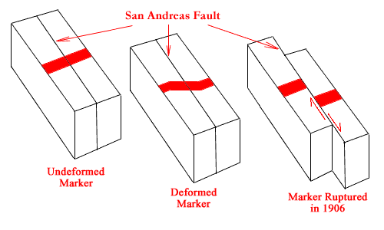

Figure 5: An imaginary painted straight band on the rocks across the San Andreas Fault (left), is slowly distorted over a period of time (center). In 1906, so much strain had built up that the fault ruptured, and the rock (with the imaginary painted band) on either side snapped back into a relatively undeformed, but unaligned, position (right). As a result, the San Francisco block, on the left-hand side of the fault, moved northward with respect to the North American Continent, on the right-hand side of the fault.

Attenuation of Ground Shaking

Figure 6, below, shows the areas of the North American continent that were affected by the 1811-1812 New Madrid, the 1886 Charleston, and the 1906 San Francisco earthquakes. Inspection of this figure indicates that seismic shaking attenuates as one moves away from the epicenter of the disturbance. In addition, the figure also clearly shows that at the same intensity level, the effects of ground shaking extend over a much larger area in the Eastern United States than in the Western United States. Therefore, it can be concluded that the earth’s crust of the Eastern United States is significantly more efficient at transmitting seismic waves over longer distances than that of the Western United States.

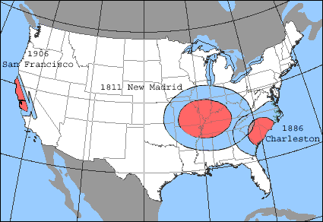
Figure 6: Map of the United States showing the areas shaken by Modified Mercalli Intensities VII or greater (red), and intensities of VI-VII (blue) for the 1811 New Madrid, the 1886 Charleston, and the 1906 San Francisco earthquakes. As can be noted, ground shaking extends over a much larger area in the Eastern Unites States than in the Western United States. (modified from an early map prepared by the late Otto Nuttli of St.Louis University).

Great Earthquakes of the World

Some of the largest magnitude earthquakes in the World since 1900 are the 1960 Chile earthquake, the 1964 Alaska earthquake and the 2004 South East Asia earthquake. Their locations are shown on Figure 7, below.

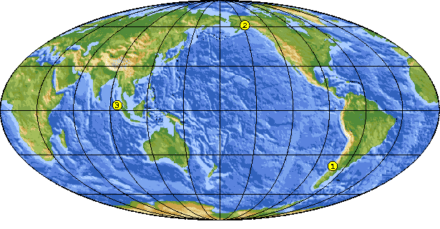
Figure 7: Map of the world showing the locations of the 1960 Chilean earthquake (1), the 1964 Alaska earthquake (2), and the 2004 South East Asia Earthquake (3).

It is interesting to note that these three earthquakes occurred beneath the ocean, in proximity to a continental mass. Because of the large underwater disturbances they caused, all three earthquakes triggered large gravitational sea waves that caused widespread devastation. These unusual sea waves are called tsunamis and are characterized by their long wavelength, long period, low amplitude on the open sea, and great speed of propagation. On entering shallow water along an exposed coast the tsunami waves can pile up to heights that may exceed 50 feet, reeking havoc to the coastal towns. The word tsunami is Japanese standing for “tsu” = port and “nami” = wave. The subject of tsunami generation and propagation will be addressed in another course.

The Great Chilean Earthquake of 1960

In May 1960, a series of large and damaging earthquakes shook southern Chile. The first earthquake, which occurred at 10:02 GMT (UTC) on the 21st of May 1960, had a magnitude of 8.0. Between this initial event and December 1960 eight more earthquakes, all of magnitude greater than 7.0, jolted the region. The worst of these events occurred at 19:10 UTC on the 22nd of May 1960. It had a magnitude of 9.5, the highest magnitude ever assigned to an earthquake in the 20th century. A map of Southern Chile showing the epicenter of the 22nd of May 1960 event is presented below.

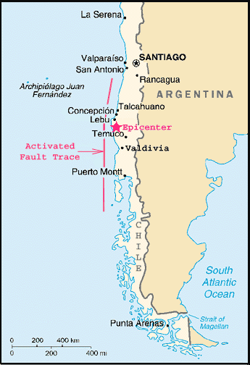
Figure 8: Map of Southern Chile showing the epicenter of the 22nd of May, 1960 earthquake.

The succession of large destructive earthquakes in the space of a few hours made it impossible to draw accurate Mercalli-Intensity maps for each earthquake. Nonetheless, it was estimated that the first shock of May 21 caused major damage at Concepcion, especially in the lower parts of the town (intensity IX). Damage was also observed at Talcahuano (intensity IX), and Lebu (intensity X). The shock of May 22 caused major damage in Valdivia (intensity X), Puerto Montt (lower town) (intensity X-XI), and Temuco (intensity VIII). Figure 9 is an example of the catastrophic damage recorded in Valdivia.

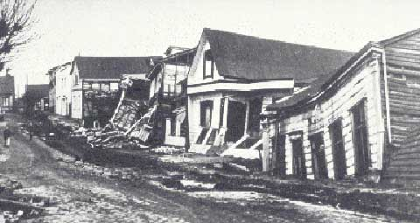
Figure 9: Valdivia suffered severe damage because of its proximity to the epicenter of the May 22, 1960 earthquake.

Important modifications to the coastal relief were also observed. The 1960 earthquake tectonically lowered the coastal landscape by about 1.5 m. and the subsidence killed forests and changed pastures into tidal flats. In addition, significant rock falls and massive landslides occurred in the Andes. Figure 10, below, is an example of the coastal flooding that occurred in Puerto Montt.

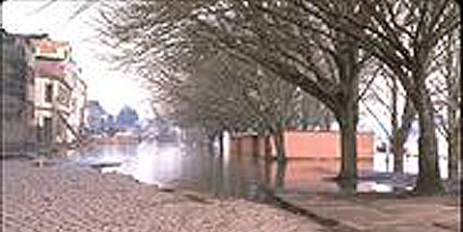
Figure 10: Coastal flooding in Puerto Montt caused by the earthquake of May 22, 1960.

In addition, the earthquake generated a major tsunami that struck the coast of South America and proceeded to cross the Pacific, where it struck the coasts of Australia, New Zealand, Japan, the Philippines, the western U.S., and Hawaii. In Japan, 138 people were killed on the Eastern Shore of Honshu and Hokkaido. The city of Ofunato was devastated. More than 855 were injured and 1,678 homes were destroyed. The wave had a maximum run-up of 6 meters. In the Philippines 32 people were killed.

The tsunami was also experienced along the western coast of the United States. The largest wave height in California, measured at the Crescent City tide gage, was 1.7 m, and the amplitude was more than 1.4 m at Santa Monica. The tsunami was recorded widely further north along the pacific coast with amplitudes less than 1 m.

Chile has seen many earthquakes both before the 1960 record-setting temblor and after it. There are records indicating that sizable historical events have occurred in 1575, 1737, and 1837. It also appears that the 1575 event was of the same order of magnitude as the giant 1960 event. Two very large contenders also occurred on March 3, 1985, and on July 30, 1995. These earthquakes both had a magnitude of about 8. In summary, Chilean earthquakes are neither rare nor small. Large earthquakes in Chile seem, through history, to occur about every 25 to 100 years. These earthquakes will continue to occur as long as the geologic processes that are pushing the Pacific Ocean floor under the South American Continent are active. The geologic processes that are responsible for this instability will be addressed in another course.

The Great Alaska Earthquake of 1964

One of the largest earthquakes to have occurred during the 20th century is the 1964 Prince William Sound, Alaska event. It occurred on Good Friday, March 27, 1964 at 05:36:14 p.m. local time (March 28 03:36:14 UTC). This earthquake was assigned a Magnitude 9.2 and was felt over 500,000 square miles. The epicenter, shown on Figure 11, was located at Latitude 61.04N, Longitude 147.73W. The hypocenter was located at a depth of approximately 25 kilometers.

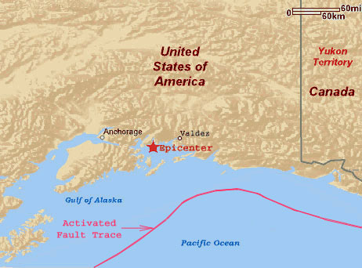
Figure 11: Map of Alaska showing the epicenter of the Good Friday, 1964 earthquake (Base map modified from MapQuest, Inc.).

The ground motion near the epicenter, above the origin of the earthquake, was so violent that the tops of trees were snapped off. About 125 people died as a result of this event. Had Alaska been more populated, certainly a lot more people would have lost their lives.

Anchorage sustained the most severe damage to property. About 30 blocks of dwellings and commercial buildings were damaged or destroyed in the downtown area. The schools in Anchorage were completely devastated. The Government Hill Elementary School, sitting astride a large landslide, was severely damaged. The duration of the shock there was estimated at 3 minutes. Following is a picture of the damage suffered by the school:

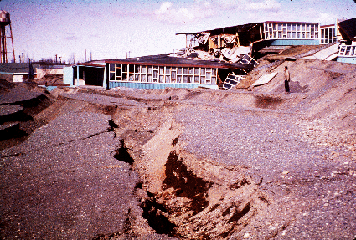
Figure 12: Government Hill Elementary School in Anchorage, Alaska, destroyed by the 1964 earthquake (Source: United States Geological Survey).

The 1964 event disturbed the ocean floor and generated a powerful tsunami that traveled across the Pacific Ocean at speeds as great as 600 to 650 miles per hour and reached the coasts of Hawaii and Japan where they caused damage there too. On the Island of Oahu the maximum-recorded run-up was 4.8 meters (about 15 feet). The tsunami also devastated many towns along the Gulf of Alaska, and caused serious damage as far south as Kodiak and at several locations along the Western Coast of North America (15 killed). Below is a picture of the damage inflicted along the waterfront at Resurrection Bay, Kodiak, 450 kilometers (about 300 miles) southwest of the epicenter.

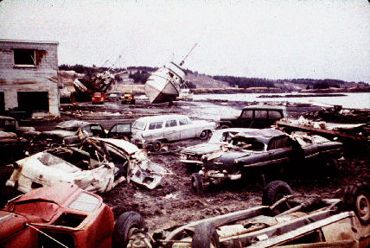
Figure 13: View of the tsunami damage along the waterfront at Resurrection Bay, Kodiak Island, Alaska (Source: United States Geological Survey).

The Great Southeast Asia Earthquake of 2004

A great earthquake of magnitude 9.0 occurred at 00:58:53 (UTC), on Sunday, December 26, 2004 off the West Coast of Northern Sumatra. The epicenter was 255-km (160 miles) SSE of Banda Aceh, Sumatra, Indonesia, 315-km (195 miles) W of Medan, Sumatra, Indonesia, 1260-km (790 miles) SSW of Bangkok, Thailand, and 1590-km (990 miles) NW of Jakarta, Java, Indonesia.

The earthquake was caused by the release of large accumulated stresses that disturbed the ocean floor along a segment of a trench (fault trace) that lies offshore of Java and Sumatra and extends past the Nicobar and Andaman Islands. The sea floor overlying this oceanic trench (fault zone) was uplifted by several meters along the entire length of the break forming a tsunami with sustained waves of enormous dimensions that started racing at great speed across the Bay of Bengal and beyond. The locations of the epicenter and the segment of the fault trace that ruptured and triggered the tsunami are presented below:

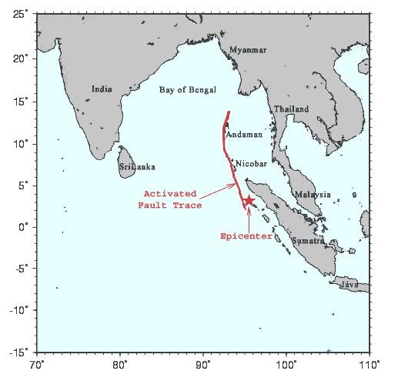
Figure 14: Map showing the epicenter of the epicenter of the magnitude 9.0, Southeast Asia earthquake of 2004. The red line represents the extent of the fault break that triggered the devastating tsunami that was triggered by the earthquake.

The tsunami that was triggered by this event was one of the largest ever in terms of casualties because it hit heavily populated low-lying coastal areas that were not well prepared. The lack of a warning system meant that most people were caught by surprise. It had been a long time since a tsunami occurred in this region. The last one to have occurred was not triggered by an earthquake, but by the August, 1883 eruption of the Krakatoa volcano.

People on the western shores of Sumatra and Thailand (Figure 14) reported seeing the ocean pull back, exposing the sea floor and then returning as a swift rise in the sea level, like an extremely high tide, inundating villages near the coast. The wave then pulled back, sucking houses, trees, people and everything in its path out to sea. These waves have a long period, so other waves returned after several minutes and continued to pound the same areas over and over until all the energy dissipated.

Presented below are two aerial photographs of a portion of the coastline of Banda Aceh, the capital city of the province of Aceh, located at the northern tip of Sumatra, just before and just after the disaster hit the island. These photographs, which were published in the popular press, help the reader visualize the real extent of the damage.

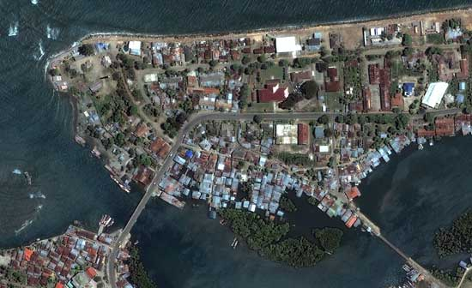
Figure 15: Aerial view of a stretch of the Banda Aceh shoreline photographed on June 23, 2004, Well before the occurrence of the earthquake and tsunami of December 26, 2004 (Source: Digital Globe Aerial Photos).

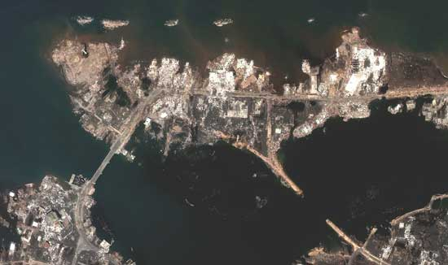
Figure 16: Same aerial view of Banda Aceh shown on figure 15, photographed on December 28, 2004, two days after the disaster struck. The photo shows the missing shoreline that was wiped out by the tsunami (Source: Digital Globe Aerial Photos).

The waves struck tourist resorts at the peak of the tourist and holiday season. The tsunami, reported as 15-20 feet high waves in open water, fanned out over the Indian Ocean at high speed causing severe and sudden flooding to the coastal areas of many countries. Whole fishing villages were washed away along the coastlines of many countries. Affected were Indonesia (Sumatra, over 166,000 dead), Thailand (over 2,500 dead), Malaysia, the Andaman and Nicobar Islands, Myanmar, Bangladesh, and Sri Lanka (over 30,000 dead), India (over 7,000 dead). The Maldives and countries as far away as Somalia, Tanzania and Kenya, along the East Coast of Africa, also suffered many deaths. In the entire region casualties have been very high, with over 220,000 having lost their lives mostly from the tsunami triggered by the earthquake. Up to five million people have also been left homeless. To put these figures in perspective, the total number of deaths surpassed the combined number of people that were killed by the two World War II atomic bombs that were dropped on Japan. The Hiroshima bomb killed an estimated 140,000 people, and the Nagasaki bomb killed an estimated 70,000 people.

Most Destructive Earthquakes in the World

As compiled by the United States Geological Survey the most destructive known earthquakes on record in the world with 50,000 or more deaths are listed in the following table. For events that precede the development of the magnitude scale, the magnitude value is estimated based on inferences from the historical records.

Date | Location | Deaths | Magnitude | Comments
December 22, 856 | Iran, Damghan | 200,000
March 23, 893 | Iran, Ardabil | 150,000
August 9, 1138 | Syria, Aleppo | 230,000
January 23, 1556 | China, Shansi | 830,000 | ~8
Year1268 | Asia Minor, Silicia | 60,000
September, 1290 | China, Chihli | 100,000
November, 1667 | Caucasia, Shemakha | 80,000
January 11, 1693 | Italy, Sicily | 60,000
November 18, 1727 | Iran, Tabriz | 77,000
November 1, 1755 | Portugal, Lisbon | 70,000 | 8.7 | Great tsunami.
February 4, 1783 | Italy, Calabria | 50,000
December 28, 1908 | Italy, Messina | 70,000 to 100,000  (estimated) | 7.2 | Deaths from earthquake and tsunami.
December 16, 1920 | China, Gansu | 200,000 | 8.6 | Major fractures and landslides.
September 1, 1923 | Japan, Kwanto | 143,000 | 7.9 | Great Tokyo fire.
May 22, 1927 | China, near Xining | 200,000 | 7.9 | Large fractures.
December 25, 1932 | China, Gansu | 70,000 | 7.6
May 30, 1935 | Pakistan, Quetta | 30,000 to 60,000 | 7.5 | Quetta almost completely destroyed.
October 5, 1948 | USSR  (Turkmenistan, Ashgabat) | 110,000 | 7.3
May 31, 1970 | Peru | 66,000 | 7.9 | Great rock slide and floods.
July 27, 1976 | China, Tangshan | 255,000  (official) | 7.5 | Estimated death toll as high as 655,000.
June 20, 1990 | Iran | 50,000 | 7.7 | Landslides.
December 26, 2004 | Sumatra | 220,000 | 9.0 | Great tsunami affected 12 countries.

Note that the earthquakes listed above are not necessarily the largest ever recorded, but rather the most destructive in terms of lives lost because they occurred in relative proximity to highly populated centers.

Largest Earthquakes in the World

As compiled by the United States Geological Survey the largest magnitude earthquakes in the World since 1900 are listed in the following table and their locations are shown on Figure 17, below.

Date | Location | Magnitude | Latitude | Longitude
1. May 22, 1960 | Chile | 9.5 | 38.24 S | 73.05 W
2. March 28, 1964 | Prince William Sound, Alaska | 9.2 | 61.02 N | 147.65 W
3. March 09, 1957 | Andreanof Islands, Alaska | 9.1 | 51.56 N | 175.39 W
4. November 04, 1952 | Kamchatka | 9.0 | 52.76 N | 160.06 E
5. December 26, 2004 | Off the Coast of N. Sumatra | 9.0 | 03.30 N | 095.78 E
6. January 31, 1906 | Off the Coast of Ecuador | 8.8 | 01.00N | 81.50 W
7. February 04, 1965 | Rat Islands, Alaska | 8.7 | 51.21 N | 178.50 E
8. August 15, 1950 | Assam - Tibet | 8.6 | 28.50 N | 96.50 E
9. February 03, 1923 | Kamchatka | 8.5 | 54.00 N | 161.00 E
10. February 01, 1938 | Banda Sea, Indonesia | 8.5 | 5.05 S | 131.62 E
11. October 13, 1963 | Kuril Islands | 8.5 | 44.90 N | 149.60 E

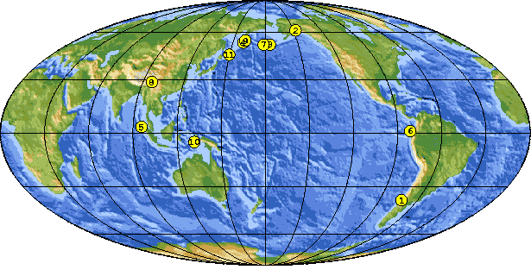
Figure 17: World map showing the location of the largest earthquakes that occurred since 1900 (Source: United States Geological Survey).

Summary

In this course you have learned how our knowledge about earthquakes has evolved through the ages from the fanciful, mysterious and mythical perceptions that people had to the solid scientific knowledge that we have developed today about these natural events. Specifically you studied how the descriptions of the effects of earthquake shaking have been standardized and used to develop the Rossi-Forel and the Modified Mercalli intensity scales.

With the development of instruments capable of capturing and recording the vibrations of the ground you found out how the Richter magnitude scale was developed. You have learned about faults and should be able to understand the geometrical relationship between the fault plane, the hypocenter (or focus) and the epicenter of an earthquake. You also followed the concepts expressed as basic equations used to compute the Richter magnitude and the total energy released during an earthquake.

You have learned that the 1906 San Francisco earthquake produced a wealth of recorded observations allowing the formulation of a universal theory for the triggering of earthquakes. You have been exposed to the empirical observation that earthquakes that generate the same level of shaking intensity are felt over significantly larger areas in the Eastern U.S. than in the Western U.S. This observation leads to the conclusion that the earth’s crust of the Eastern United States is significantly more efficient at transmitting seismic waves over longer distances than that of the Western United States.

You have also learned that large earthquakes that affect the ocean floor are capable of generating immense sea waves called “tsunamis”, a Japanese word for “port wave”. These tsunami waves can travel across oceans at great speed inflicting significant damage to distant coastal towns.

APPENDIX
The Richter Magnitude Scale

C. F. Richter first defined local magnitude as the logarithm, to the base 10, of the amplitude in microns of the largest trace deflection observed on a standard seismograph (Wood-Anderson type) at a distance of 100 kilometers from the epicenter.

The Richter magnitude is defined by the following relationship:

M = log A – log A0

In this equation, A is the recorded trace amplitude for a given earthquake at a given distance written by a seismograph (Wood-Anderson type), and A0 is the trace amplitude for a reference earthquake selected as a standard, the zero of the scale which is arbitrarily fixed. As mentioned in the body of the course: the zero (0) magnitude earthquake has a first arrival amplitude of one millimeter on a short period horizontal seismograph (Wood-Anderson model) recorded at 100 kilometers from an earthquake.

Sometimes the magnitude relationship is given as:

M = log A – log A0 + S

Where S is a station correction term, since the seismic measuring stations are usually on different types of ground. This factor is determined empirically (by trial and error and experience) and has a range of + or – 0.2.
Because the seismic waves radiating from the focus travel along different paths to various instruments, the path effect to different stations may be quite different. The magnitude determined at individual stations may, therefore, disagree by as much as 0.5.

Richter gave an approximate relationship between magnitude M and the Energy E released in the form of:

Log E = C + BM

The constants C and B have been revised several times. For large magnitude earthquakes, the values of C = 7.5 and B = 2.0 can be used. The energy term E in this relationship is expressed in ergs.

Glossary of Terms and Acronyms used in this Course

Aftershock: A tremor that follows a larger earthquake, or main shock, that originates at or near the focus of the larger earthquake. Generally major earthquakes are usually followed by many aftershocks, which gradually decrease in frequency and magnitude with time. Depending on the size of the main event, aftershocks may last from days to several months.

Amplitude: Half the distance between the crest of a wave or ripple and the adjacent trough.

Elastic strain: The change in the shape or volume of a body, which disappears when the deforming forces are removed.

Epicenter: The point on the earth’s surface that is directly above the focus, or point of origin of the earthquake.

Erg: Unit of energy expressed in centimeter-gram-second. Also, equal to the work done by a force imparting to a mass of one gram an acceleration of one centimeter per second per second.

Fault: A fracture that separates two blocks of the earth’s crust that have slipped with respect to each other parallel to the fracture.

Focus/Hypocenter: The initial rupture point of an earthquake at some depth within the earth.

Foreshock: A small tremor that commonly, but not always, precedes a larger earthquake, or main shock, that originates at or near the focus of the larger earthquake.

Intensity Scale: A measure of the severity of the shaking effects of an earthquake at a given place. Intensity effects depend on the geology and tend to decrease with distance from the earthquake.

Magnitude Scale: A measure of the strength of an earthquake as determined by seismographic information. C. F. Richter was the first to define the method to determine the magnitude (see course content for more detailed information).

Period: The interval of time required for the completion of a cyclic motion, such as the time between two consecutive similar phases of a wave.

Plate (Tectonic): A rigid segment of the earth’s crust that moves with respect to other adjoining plates. Seismic activity usually occurs along and marks the boundary between two such plates.

Seismograph: An instrument that detects, magnifies and records the vibrations of the earth during the occurrence of earthquakes.

Seismogram: The permanent record of an earthquake as recorded by instruments called seismographs.

Strain: The change in the shape or volume of a body as a result of applied stress.

Stress: The force per unit area acting on the surface of a solid. It is expressed, for example, as pounds per square inch.

Trench (Oceanic): A narrow and elongate deep depression in the ocean floor oriented parallel to an adjacent continental margin. A trench may be thousand of kilometers long and usually marks the boundary between two rigid plates of the earth’s crust. It is along such boundaries that one plate descends into the interior of the earth underneath the other plate.

Tsunami: A gravitational sea wave produced by any large scale, short-duration disturbance of the ocean floor. Although caused primarily by shallow submarine earthquakes, large submarine earth movement or volcanic eruption may also cause it. It is characterized by great speed of propagation, long wavelength, long period, low amplitude on the open sea, and may pile up to heights exceeding 50 feet on entering shallow water along an exposed coast.

