PDH Course L117

Coordinates

Jan Van Sickle, PLS

2011

PDH Online | PDH Center

5272 Meadow Estates Drive
Fairfax, VA 22030-6658
Phone & Fax: 703-988-0088
www.PDHonline.org
www.PDHcenter.com
Coordinates

Jan Van Sickle, PLS

Module 1

Coordinates without a specified datum, are vague. It means that questions like “Height above what?”, “Where is the origin?” and “On what surface do they lay?” go unanswered. When that happens coordinates are of no use really. An origin, a starting place, is a necessity for them to be meaningful. Not only must they have an origin, they must be on a clearly defined surface. These foundations constitute the datum.

Without a datum, coordinates are like checkers without a checkerboard, you can arrange them, analyze them, move them around, but absent the framework, you never really know what you’ve got. In fact, datums very like checkerboards have been in use for a long time. They are generally called Cartesian.

René Descartés
Cartesian systems get their name from René Descartés, a mathematician and philosopher. In the world of the seventeenth century he was also known by the Latin name Renatus Cartesius, which might explain why we have a whole category of coordinates known as Cartesian coordinates. Descartes did not really invent the things, despite a story of him watching a fly walk on his ceiling and then tracking the meandering path with this system of coordinates. Long before, around 250 B.C. or so the Greek, Eratosthenes, used a checkerboard-like grid to locate positions on the Earth and even he was not the first. Dicaearchus had come up with the same basic idea before him. Nevertheless, Descartes was probably the first to use graphs to plot and analyze mathematical functions. He set up the rules we use now for his particular version of a coordinate system in two dimensions defined on a flat plane by two axes.

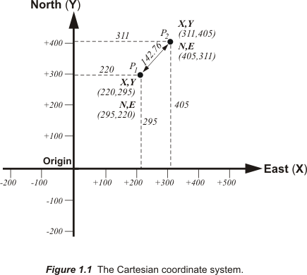

Cartesian Coordinates

Cartesian coordinates are expressed in ordered pairs. Each element of the coordinate pair is the distance measured across a flat plane from the point. The distance is measured along the line parallel with one axis that extends to the other axis. If the measurement is parallel with the x-axis it is called the x-coordinate, and if the measurement is parallel with the y-axis it is called the y-coordinate.

Figure 1.1 shows two axes perpendicular to each other labeled x and y. This labeling is a custom established by Descartes. His idea was to symbolized unknown quantities with letters at the end of the alphabet, x, y, z and etc. This leaves letters at the beginning available for known values. Coordinates became so often used to solve for unknowns the principle was established that Cartesian axes have the labels x and y. The fancy names for the axes are the abscissa, for x, and ordinate, for y. Surveyors, cartographers and mappers call them north and east, but back to the story.

These axes need not be perpendicular with each other. They could intersect at any angle, though they would obviously be of no use if they were parallel. But so much convenience would be lost using anything other than a right-angle, it has become the convention. Another convention is the idea that the units along the x-axis are identical with the units along the y-axis, even though there is no theoretical requirement that this be so. Finally, on the x axis, any point to the west, that is left, of the origin is negative, and any point to the east, to the right, is positive. Similarly, on the y axis, any point north of the origin is positive; and south, negative. If these principles are held, then the rules of Euclidean geometry are true and the off-the-shelf CAD and GIS software on your PC have no trouble at all working with these coordinates, a most practical benefit.

For example, the distance between these points can be calculated using the coordinate geometry you learned in high school. The x and y coordinates for the points in the illustration are, the origin point, P₁ (220, 295) and point, P₂ (311, 405) therefore where:

X₁ = 220
Y₁ = 295
and
X₂ = 311
Y₂ = 405

Distance = [(X₁) -(X₂)]² + [(Y₁) -(Y₂)] ²
Distance = [(220) -(311)]² + [(295) -(405)] ²
Distance = (-91) ² + (-110) ²
Distance = 8,281 + 12,100
Distance = 20,381
Distance = 142.76

The system works. It is convenient. But unless it has an attachment to something a bit more real than these unit-less numbers it is not very helpful, which brings up an important point about datums.

Attachment to the Real World

The beauty of datums is that they are errorless, at least in the abstract. On a datum every point has a unique and accurate coordinate. There is no distortion. There is no ambiguity. For example, the position of any point on the datum can be stated exactly, and it can be accurately transformed into coordinates on another datum with no discrepancy whatsoever. All of these wonderful things are possible only as long as a datum has no connection to anything in the physical world. In that case it is perfectly accurate, and perfectly useless.

But suppose you wished to assign coordinates to objects on the floor of a very real rectangular room. A Cartesian coordinate system could work, if it is fixed to the room with a well-defined orientation. For example, you could put the origin at the southwest corner, stipulate that the walls of the room are oriented in cardinal directions and use the floor as the reference plane.

With this datum you not only have the advantage that all of the coordinates are positive, but you can define the location of any object on the floor of the room. The coordinate pairs would consist of two distances, the distance east and the distance north from the origin in the corner. As long as everything stays on the floor, you are in business. In this case there is no error in the datum, of course, but there are inevitably errors in the coordinates. These errors are due to the less than perfect flatness of the floor, the impossibility of perfect measurement from the origin to any object, the ambiguity of finding the precise center of any of the objects being assigned coordinates, etc. In short, as soon as you bring in the real world, things get messy.

Cartesian coordinates and the Earth

Cartesian coordinates then are rectangular, or orthogonal if you prefer, defined by perpendicular axes from an origin, along a specifically oriented reference surface. These elements can define a datum, or framework, for meaningful coordinates

As a matter of fact, two-dimensional Cartesian coordinates are an important element in the vast majority of coordinate systems; State Plane coordinates in the United States, the Universal Transverse Mercator, UTM, coordinate system and most others. The datums for these coordinate systems are well established. But there are also local Cartesian coordinate systems whose origins are often entirely arbitrary. For example, if surveying, mapping or other work is done for the construction of a new building there may be no reason for the coordinates used to have any fixed relation to any other coordinate systems. In that case a local datum may be chosen for the specific project with north and east fairly well defined and the origin moved far to the west and south of the project to ensure that there will be no negative coordinates. Such an arrangement is good for local work, but it does preclude any easy combination of such small independent systems. Large-scale Cartesian datums, on the other hand, are designed to include positions across significant portions of the Earth’s surface into one system. Of course, these are also designed to represent our decidedly round planet on the flat Cartesian plane, no easy task.

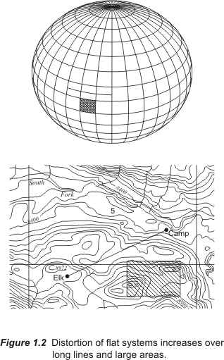

But how would a flat Cartesian datum with two axes represent the Earth? There is obviously distortion inherent in the idea. If the planet were flat it would do nicely of course, and across small areas that very approximation, a flat Earth, works reasonably well. That means that even though the inevitable warping involved in representing the Earth on a flat plane cannot be eliminated, it can be kept within well-defined limits as long as the region covered is small and precisely defined. If the area covered becomes too large distortion does defeat it. So the question is, “Why go to all the trouble to work with plane coordinates?” Well, here is a short example.

It is certainly possible to calculate the distance from station Youghall to station Karns using latitude and longitude, also known as geographic coordinates, but it is easier for your computer, and for you, to use Cartesian coordinates. Here are the geographic coordinates for these two stations, Youghall at latitude 40º 25’ 33.39258” North and longitude 108º 45’ 57.78374” West and Karns at latitude 40º 26’ 06.36758” North and longitude 108º 45’ 57.56925” West in the North American Datum 1983 (NAD83). Here are the same two stations positions expressed in Cartesian coordinates.

Youghall
Northing = Y₁ = 1,414,754.47
Easting = X₁ = 2,090,924.62

Karns
Northing= Y₂ = 1,418,088.47
Easting = X₂ = 2,091,064.07

The Cartesian system used here is called state plane coordinates in Colorado’s North Zone, and the units are survey feet, more about those later. The important point is this; these coordinates are based on a simple two-axes Cartesian system operating across a flat reference plane.

As before the distance between these points using the plane coordinates is easy to calculate.

Distance = (X₁ – X₂)² + (Y₁ – Y₂) ²
Distance = (2,090,924.62-2,091,064.07) ² + (1,414,754.47 - 1,418,088.47) ²
Distance = (-139.45) ² + (-3334.00) ²
Distance = (19,445.3025) + (11,115,556.0000)
Distance = 11,135,001.30
Distance = 3336.91 feet

It is 3336.91 ft. The distance between these points calculated from their latitudes and longitudes is slightly different, it is 3337.05 ft. Both of these distances are the result of inverses, which means they were calculated between two positions from their coordinates. Comparing the results between the methods shows a difference of about 0.14 feet, a bit more than a tenth of a foot. In other words, the spacing between stations would need to grow more than 7 times, to about 4 1 /2 miles, before the difference would reach 1 foot. So part of the answer to the question, “Why go to all the trouble to work with plane coordinates?” is this, they are easy to use and the distortion across small areas is not severe.

This rather straightforward idea is behind a good deal of the conversion work done with coordinates. Geodetic coordinates are useful but somewhat cumbersome at least for conventional trigonometry. Cartesian coordinates on a flat plane are simple to manipulate but inevitably include distortion. Moving from one to the other it is possible to gain the best of both. The question is, “How do you project coordinates from the nearly spherical surface of the Earth to a flat plane? Well, first you need a good model of the Earth.

The Shape of the Earth
People have been proposing theories about the shape and size of the planet for a couple of thousand years.
Despite the fact that local topography is obvious to an observer standing on the Earth, efforts to grasp the more general nature of the planet's shape and size have been occupying scientists for at least 2,300 years. There have, of course, been long intervening periods of unmitigated nonsense on the subject. Ever since 200 B.C. when Eratosthenes almost calculated the planet's circumference correctly, geodesy has been getting ever closer to expressing the actual shape of the Earth in numerical terms.

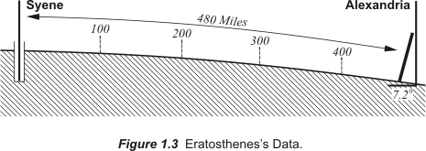

At noon the reflection of the midsummer sun was there in the water of a deep well at Syene. The sun was directly overhead. On the same day, measurement of the noon shadow cast by a pillar at Alexandria. It showed that the sunbeam strikes the earth at an angle of 7.2 degrees off the vertical. The angle between Alexandria and Syene must be 7.2 degrees- one fiftieth of the 360 degrees circle. Syene is 480 miles south of Alexandria and a great circle must therefore be 50 times 480 miles in length- 24,000 miles. In fact, the circumference of the earth is around 24,900 miles.

A real breakthrough came in 1687 when Newton suggested that the Earth shape was ellipsoidal in the first edition of his Principia . The idea was not entirely without precedent. Years earlier astronomer J. Richter found the closer he got to the equator the more he had to shorten the pendulum on his one-second clock. It swung more slowly in French Guiana than it did in Paris. When Newton heard about it he speculated that the force of gravity was less in South America than in France. He explained the weaker gravity by the proposition that when it comes to the Earth there is simply more of it around the equator. He wrote, "The Earth is higher under the equator than at the poles, and that by an excess of about 17 miles" (Philosophiae naturalis principia mathematica, Book III, Proposition XX). He was pretty close to right; the actual distance is only about 4 miles less than he thought.

Some supported Newton’s idea that the planet bulged around the equator and flattened at the poles, but others disagreed, the director of the Paris Observatory, Jean Dominique Cassini, for example. Even though he had seen the flattening of the poles of Jupiter in 1666, neither he nor his son Jacques were prepared to accept the same idea when it came to the Earth. And it appeared they had some evidence on their side.

For geometric verification of the Earth model, scientists had employed arc measurements since the early 1500s. First they would establish the latitude of their beginning and ending points astronomically. Next they would measure north along a meridian and find the length of one degree of latitude along that longitudinal line. Early attempts assumed a spherical Earth and the results were used to estimate its radius by simple multiplication. In fact, one of the most accurate of the measurements of this type, begun in 1669 by the French abbé J. Picard, was actually used by Newton in formulating his own law of gravitation. However, Cassini noted that close analysis of Picard's arc measurement, and others, seemed to show the length along a meridian through one degree of latitude actually decreased as it proceeded northward. If that was true then the Earth was elongated at the poles, not flattened.

The argument was not resolved until Anders Celsius a famous Swedish physicist on a visit to Paris suggested two expeditions. One group, led by Moreau de Maupertuis, went to measure a meridian arc along the Tornio River near the Arctic Circle, 66º 20' North Latitude, in Lapland. Another expedition went to what is now Ecuador, to measure a similar arc near the equator, 01º 31' South Latitude. The Tornio expedition reported that one degree along the meridian in Lapland was 57,437.9 toises, about 69.6 miles. A toise is approximately 6.4 feet. A degree along a meridian near Paris had been measured as 57,060 toises, 69.1 miles. This shortening of the length of the arc was taken as proof that the Earth is flattened near the poles. Even though the measurements were wrong, the conclusion was correct. Maupertuis published a book on the work in 1738, The King of France gave Celsius a yearly pension of 1,000 livres and Newton's was proved right. I wonder which of them was the most pleased.

Since then there have been numerous meridian measurements all over the world, not to mention satellite observations, and it is now settled that the Earth most nearly resembles an oblate spheroid. An oblate spheroid is an ellipsoid of revolution. In other words, it is the solid generated when an ellipse is rotated around its shorter axis and then flattened at its poles. The flattening is only about one part in 300. Still the ellipsoidal model, bulging at the equator and flattened at the poles, is the best representation of the general shape of the Earth. If such a model of the Earth were built with an equatorial diameter of 25 feet the polar diameter would be about 24 feet 11 inches, almost indistinguishable from a sphere

It is on this somewhat ellipsoidal Earth model that latitude and longitude have been used for centuries. The idea of a nearly spherical grid of imaginary intersecting lines has helped people to navigate around the planet for more than a thousand years and is showing no signs of wearing down. It is still a convenient and accurate way of defining positions.

LATITUDE AND LONGITUDE

Latitude and longitude are coordinates that represent a position on the surface of the Earth with angles instead of distances. Usually the angles are measured in degrees, but grads and radians are also used. Depending on the precision required the degrees, 360 degrees comprising a full circle, can be subdivided into 60 minutes of arc, which are themselves divided into 60 seconds of arc. In other words, there are 3600 seconds in a degree. Seconds can be subsequently divided into decimals of seconds. Typically, the arc is dropped from their names, since it is usually obvious that the minutes and seconds are in space rather than time. In any case these subdivisions are symbolized by ° for degrees, ‘ for minutes and " for seconds. The system is called sexagesimal. A radian is the angle subtended by an arc equal to the radius of a circle. A full circle is 2π radians and a single radian is 57°17’44.8”.

In the European centesimal system a full circle is divided into 400 grads. These units are also known as grades and gons. A radian is the angle subtended by an arc equal to the radius of a circle. A full circle is 2π radians and a single radian is 57°17’44.8”.

Lines of latitude and longitude, always cross each other at right angles, as do the lines of a Cartesian grid, but latitude and longitude exist on a curved rather than a flat surface. There is imagined to be an infinite number of these lines on the ellipsoidal model of the Earth. In other words any and every place has a line of latitude and a line of longitude passing through it and it takes both of them to fully define a place. If the distance from the surface of the ellipsoid is then added to the latitude and longitude you one type of three-dimensional coordinate. This distance component is sometimes the elevation above the ellipsoid, also known as the ellipsoidal height, and sometimes it is measured all the way from the center of the ellipsoid, more about this later. But for the moment the discussion will just be concerned with positions right on the ellipsoidal model of the Earth. There the height component can be set aside for the moment with the assertion that all positions are on the surface of the model.

In mapping, latitude is usually represented by the small Greek letter phi, φ. Longitude is usually represented by the small Greek letter lambda, λ. In both cases the angles originate at a plane that is imagined to intersect the ellipsoid. In both latitude and longitude the planes of origination are intended to include the center of the Earth. Angles of latitude most often originate at the plane of the equator and angles of longitude originate at the plane through an arbitrarily chosen place, now Greenwich, England. Latitude is an angular measurement of the extent a particular point lays north or south of the equatorial plane measured in degrees, minutes, seconds and usually decimals of a second. Longitude is also an angle measured in degrees, minutes, seconds and decimals of a second east and west of the plane through the chosen prime, or zero, position.

Between the Lines
On the Earth any two lines of longitude, for example west longitude 89°00’00” and west longitude 90°00’00”, are farthest from each other at the equator but as they proceed north and south to the poles they become closer. In other words, they converge. It is interesting to note that the length of a degree of longitude and the length of a degree of latitude are just about the same in the vicinity of the equator. They are both about 60 nautical miles, around 111 kilometers or 69 miles. But if you imagine going north or south along a line of longitude toward either the North or the South Pole a degree of longitude becomes progressively shorter. At 2/3rds of the distance from the equator to the pole, that is at 60° north and south latitudes, a degree of longitude shrinks to about 55.5 kilometers or 34.5 miles - half the length it had at the equator. And as one proceeds northward or southward a degree of longitude continues to shrink until it fades away to nothing as shown in Figure 1.4.
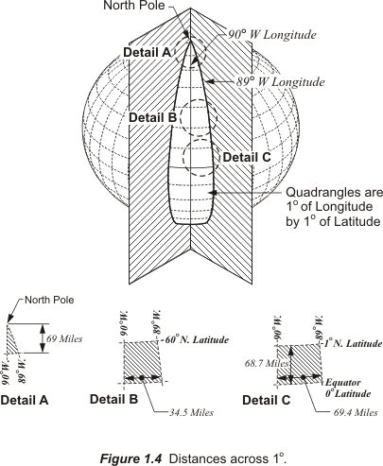

On the other hand, lines of latitude do not converge on the Earth; they are always parallel with one another and the equator. In fact, as one approaches the poles, where a degree of longitude becomes small, a degree of latitude actually grows slightly. This small increase is due to the flattening near the poles mentioned in the discussion of the oblate shape of the planet earlier. The increase in the size of a degree of latitude would not happen if the Earth were a sphere; in that case the length of a degree of latitude would consistently be approximately 110.6 km or 68.7 miles as it is near the equator. However, since the Earth is an oblate spheroid, as Newton predicted, a degree of latitude actually gets a bit longer at the poles. It grows to about 111.7 km or 69.4 miles in that region, which is what all those scientists were trying to measure back in the 18th century.

Longitude
Longitude is an angle between two planes. It is a dihedral angle. In other words it is an angle measured at the intersection of two planes which are themselves perpendicular to the equator. In the case of longitude, the first plane passes through the point of interest, the place whose longitude you wish to know, and the second plane passes through an arbitrarily chosen point representing zero longitude. Today, that place is Greenwich, England. The measurement of angles of longitude is imagined to take place where the two planes meet, and that place is the line known as the polar axis. As it happens that line is also the axis of rotation of the aforementioned ellipsoidal model of the Earth. And where they intersect that ellipsoidal model they create an elliptical line on its surface. This elliptical line is then divided into two meridians at the polar axis. One half becomes a meridian of east longitude, which is labeled E or given a positive (+) values, and the other half a meridian of west longitude, which is labeled W or given a negative
(-) value as shown in Figure 1.5.
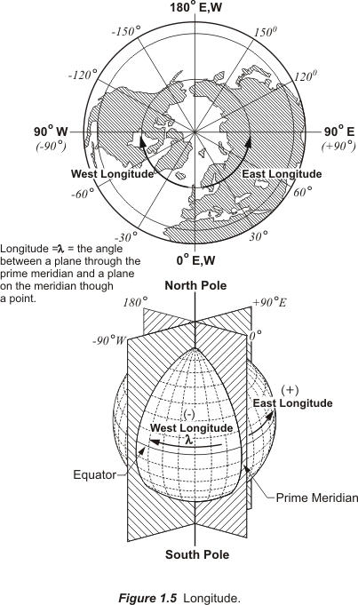

The zero meridian through Greenwich is called the prime meridian. From there meridians range +0º to +180º E longitude and -0° to -180° W longitude. Taken together these meridians cover the entire 360 degrees around the Earth. This arrangement was one of the decisions made by consensus of 25 nations in 1884.

The location of the prime meridian is arbitrary. The idea that it passes through the principal transit instrument, the main telescope, at the Observatory at Greenwich, England was formally established at the International Meridian Conference in Washington, D.C. There it was decided that there would be a single zero meridian rather than the many used before. There were several other decisions made at the meeting, and among them was the agreement that all longitude would be calculated both east and west from this meridian up to 180°, east longitude is positive and west longitude negative.

The 180° meridian is a unique longitude, like the prime meridian it divides the Eastern Hemisphere from the Western Hemisphere, but it also represents The International Date Line. The calendars west of the line are one day ahead of those east of the line. This division could theoretically occur anywhere on the globe but it is convenient for it to be 180° from Greenwich in a part of the world mostly covered by ocean. Even though the line does not actually follow the meridian exactly, it avoids dividing populated areas; it illustrates the relationship between longitude and time. Since there are 360 degrees of longitude and 24 hours in a day it follows that the Earth must rotate at a rate of 15 degrees per hour. This is an idea that is inseparable from the determination of longitude.

Latitude
Two angles are sufficient to specify any location on the reference ellipsoid representing the Earth. Latitude is an angle between a plane and a line through a point.

Imagine a flat plane intersecting an ellipsoidal model of the Earth. Depending on exactly how it is done the resulting intersection would be either a circle or an ellipse, but if the plane is coincident or parallel with the equator the result is always a parallel of latitude. The equator is a unique parallel of latitude that also contains the center of the ellipsoid as shown in Figure 1.6.
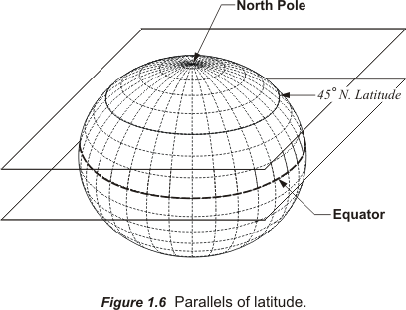
The equator is 0º latitude, and the North and South Poles +90º north and -90º south latitude, respectively. In other words, values for latitude range from a minimum of 0º to a maximum of 90º. The latitudes north of the equator are positive and those to the south are negative.
Lines of latitude are called parallels because they are always parallel to each other as they proceed around the globe. They do not converge as meridian do or cross each other.

Categories of Latitude and Longitude
When positions given in latitude and longitude are called geographic coordinates this general term really includes several types. For example there are geocentric and geodetic versions of latitude and longitude.
The geodetic longitude of a point is the angle between the plane of the Greenwich meridian the plane of the meridian that passes through the point of interest, both planes being perpendicular to the equatorial plane. Since they have the same zero meridian and the same axis, geodetic longitude and geocentric longitude are equivalent, but when it comes to latitude that is not the case.
It is the ellipsoidal nature of the model of the Earth that contributes to the difference. For example, these are just a few special circumstances on an ellipsoid where a line from a particular position can be both perpendicular to the ellipsoids surface and also pass through the center. Lines from the poles and lines from the equatorial plane can do that but in every other case a line can either be perpendicular to the surface of the ellipsoid, or it can pass through the center, but it cannot do both. And there you have the basis for the difference between geocentric and geodetic latitude.
Imagine a line from the point of interest on the ellipsoid to the center of the Earth. The angle that line makes with the equatorial plane is the point’s geocentric latitude. On the other hand geodetic latitude is derived from a line that is perpendicular to the ellipsoidal model of the Earth at the point of interest. The angle this line makes with the equatorial plane of that ellipsoid is called geodetic latitude. As you can see geodetic latitude is always just a bit larger than geocentric latitude except at the poles and the equator, where they are the same. The maximum difference between geodetic and geocentric latitude is about 11’ 44” and occurs at about 45°.

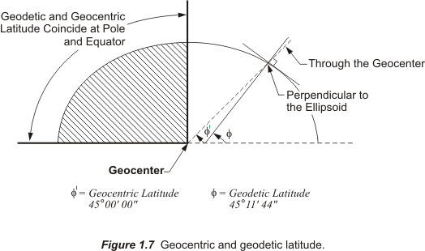

When latitude and longitude are mentioned without a particular qualifier in most cases it is best to presume that the reference is to geodetic latitude and longitude.

The Deflection of the Vertical

Down seems like a pretty straightforward idea. A hanging plumb bob certainly points down. Its string follows the direction of gravity. That is one version of the idea. There are others.

Imagine an optical surveying instrument set up over a point. If it is centered precisely with a plumb bob and leveled carefully, the plumb line and the line of the level telescope of the instrument are perpendicular to each other. In other words, the level line, the horizon of the instrument, is perpendicular to gravity. Using an instrument so oriented it is possible to determine the latitude and longitude of the point. Measuring the altitude of a circumpolar star is one good method of finding the latitude. The measured altitude would be relative to the horizontal level line of the instrument. Latitude found this way is called astronomic latitude.

One might expect that this astronomic latitude would be the same as the geocentric latitude of the point, but they are different. The difference is due to the fact that a plumb line coincides with the direction of gravity, it does not point to the center of the Earth where the line used to derive geocentric latitude originates.

Astronomic latitude also differs from the most widely used version of latitude, geodetic. The line from which geodetic latitude is determined is perpendicular with the surface of the ellipsoidal model of the Earth. That does not match a plumb line either. In other words, there are three different versions of down and each with its own latitude. For geocentric latitude down is along a line to the center of the Earth. For geodetic latitude down is along a line perpendicular to the ellipsoidal model of the Earth. For astronomic latitude down is along a line in the direction of gravity. And more often than not these are three completely different lines

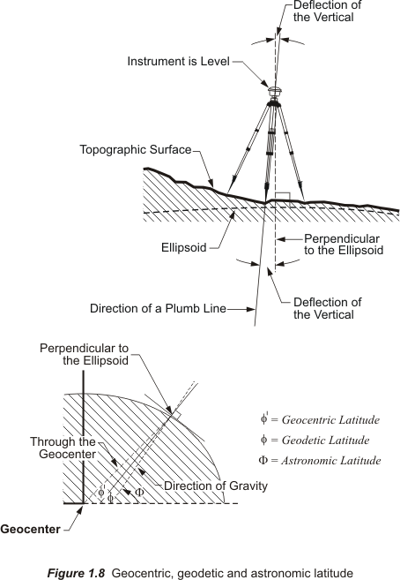

Each can be extended upward too, toward the zenith and there are small angles between them. The angle between the vertical extension of a plumb line and the vertical extension of a line perpendicular to the ellipsoid is called the deflection of the vertical. It sounds better than the difference in down. This deflection of the vertical defines the actual angular difference between the astronomic latitude and longitude of a point and its geodetic latitude and longitude. Latitude and longitude because, even though the discussion has so far been limited to latitude, the deflection of the vertical usually has both a north-south and an east-west component

It is interesting to note that that optical instrument set up so carefully over a point on the Earth cannot be used to measure geodetic latitude and longitude directly because they are not relative to the actual Earth, but rather a model of it. Gravity does not even come into the ellipsoidal version of down. On the model of the Earth down is a line perpendicular to the ellipsoidal surface at a particular point. On the real Earth down is the direction of gravity at the point. They are most often not the same thing. And since it is imaginary, it is quite impossible to actually set up an instrument on the ellipsoid. On the other hand astronomic observations for the measurement of latitude and longitude by observing stars and planets with instruments on the real Earth have a very long history indeed. And yet the most commonly used coordinates are not astronomic latitudes and longitudes, but geodetic latitudes and longitudes. So conversion from astronomic latitude and longitude to geodetic latitude and longitude has a long history as well. Therefore, until the advent of GPS geodetic latitudes and longitudes were often values ultimately derived from astronomic observations by post-observation calculation. And in a sense that is still true, the change is a modern GPS receiver can display the geodetic latitude and longitude of a point to the user immediately because the calculations can be completed with incredible speed. But a fundamental fact remains unchanged, the instruments by which latitudes and longitudes are measured are oriented to gravity, the ellipsoidal model on which geodetic latitudes and longitudes are determined is not. And that is just as true for the antenna of a GPS receiver, an optical surveying instrument, a camera in an airplane taking aerial photography, or even the GPS satellite themselves.

As a matter of illustration of the effect of the deflection of the vertical on latitude and longitude here are station Youghall’s astronomical latitude and longitude labeled with capital phi (Φ) and capital lambda (Λ), the standard Greek letters commonly used to differentiate them from geodetic latitude and longitude:

Φ = 40°25’36.28”N
Λ = 108° 46’ 00.08”W

Now the deflection of the vertical can be used to convert these coordinates to a geodetic latitude and longitude. Unfortunately the small angle is not usually conveniently arranged. It would be helpful if the angle between the direction of gravity and the perpendicular to the ellipsoid would follow just one cardinal direction, north-south or east-west. For example, if the angle observed from above Youghall was oriented north or south along the meridian, then it would affect only the latitude, not the longitude and would be very easy to apply. But that is not the case. The two normals, that is the perpendicular lines that constitute the deflection of the vertical at a point are usually neither north-south nor east-west of each other. Looking down on a point one could imagine that the angle they create between them stands in one of the four quadrants, northeast, southeast, southwest or northwest. Therefore, in order to express its true nature it is broken down into two components, one north-south and the other east-west. There are almost always some of both. The north-south component is known by the Greek letter xi (ξ). It is positive (+) to the north and negative (-) to the south. The east-west component is known by the Greek letter eta (η). It is positive (+) to the east and negative (-) to the west.
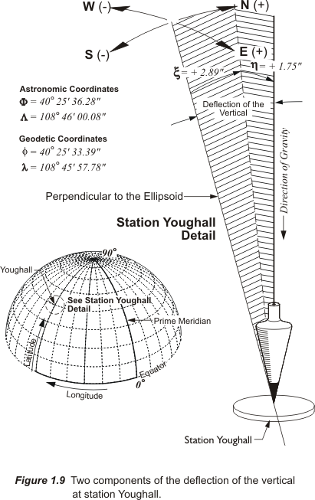

For example, the components of the deflection of the vertical at Youghall are:

North-south = xi = ξ = +2.89”
East-west = eta = η = +1.75

In other words, if an observer held a plumb bob directly over the monument at Youghall the upper end of the string would be 2.89 arc seconds north and 1.75 arc seconds east of the line that is perpendicular to the ellipsoid.

The geodetic latitude and longitude can be computed from the astronomic latitude and longitude given above using the following formulas:

φ = Φ – ξ
φ = 40°25’36.28” – (+2.89”)
φ = 40°25’33.39”

λ = Λ - η/cos φ
λ = 108° 46’ 00.08” - (+1.75”)/cos 40°25’33.39”
λ = 108° 46’ 00.08” - (+1.75”)/0.7612447
λ = 108° 46’ 00.08” - (+2.30”)
λ = 108° 45’ 57.78”

where:
φ = geodetic latitude
λ = geodetic longitude

Φ = astronomical latitude
Λ = astronomical longitude

and the components of the deflection of the vertical are:
North-south = xi = ξ
East-west = eta = η

DIRECTIONS

Azimuths

An azimuth is one way to define the direction from point to point on the ellipsoidal model of the Earth, on Cartesian datums and others. On some Cartesian datums an azimuth is called a grid azimuth, referring to the rectangular grid on which a Cartesian system is built. Grid azimuths are defined by a horizontal angle measured clockwise from north.

Azimuths can be either measured clockwise from north through a full 360° or measured +180° in a clockwise direction from north and -180° in a counterclockwise direction from north. Bearings are different.

Bearings

Bearings, another method of describing directions, are always acute angles measured from 0° at either north or south to 90° to either the west or the east. They are measured both clockwise and counterclockwise. They are expressed from 0° to 90° from north in two of the four quadrants, the northeast, 1, and northwest, 4. Bearings are also expressed from 0° to 90° from south in the two remaining quadrants, the southeast, 2, and southwest, 3 as shown in Figure 1.10.
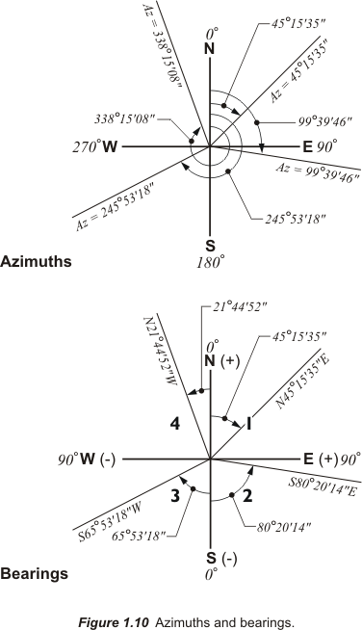

In other words, bearings use four quadrants of 90° each. A bearing of N45°15’35”E is an angle measured in a clockwise direction 45°15’35” from north toward the east. A bearing of N21°44’52”W is an angle measured in a counterclockwise direction 21°44’52” toward west from north. The same ideas work for southwest bearings measured clockwise from south and southeast bearing measured counterclockwise from south.
Directions —– azimuths and bearings —– are indispensable. They can be derived from coordinates with an inverse calculation. If the coordinates of two points inversed are geodetic then the azimuth or bearing derived from them is also geodetic, if the coordinates are astronomic then the direction will be astronomic and so on. If the coordinates from which a direction is calculated are grid coordinates, the resulting azimuth will be a grid azimuth, and the resulting bearing will be a grid bearing.
Both bearings and azimuths in a Cartesian system assume the direction to north is always parallel with the y-axis, the north-south axis. On a Cartesian datum there is no consideration for convergence of meridional, north-south, lines. One result of the lack of convergence is the bearing or azimuth at one end of a line is always exactly 180° different from the bearing or azimuth at the other end of the same line. But if the datum is on the ellipsoidal model of the Earth directions do not quite work that way. For example, consider the difference between an astronomic azimuth and a geodetic azimuth.

Astronomic and Geodetic Directions

If it were possible to point an instrument to the exact position of the north celestial pole a horizontal angle turned from there to an observed object on the Earth would be the astronomic azimuth to that object from the instrument. But it is rather difficult to measure an astronomic azimuth that way because there is nothing to point to at the celestial North Pole but a lot of sky. Polaris, the North Star, appears to follow an elliptical path around the celestial North Pole which is the northward prolongation of the Earth’s axis. Even so, Polaris and several other celestial bodies for that matter, serve as good references for the measurement of astronomic azimuths, albeit with a bit of calculation. Still optical instruments used to measure astronomic azimuths must be oriented to gravity, and it is usual for the azimuths derived from celestial observations to be converted to geodetic azimuths. Geodetic azimuths are the native form on an ellipsoid. So as it was with the astronomic latitudes and longitudes conversion to geodetic coordinates, the deflection of the vertical is applied to convert astronomic azimuths to geodetic azimuths.

For example, the astronomic azimuth between two stations, from Youghall to Karns, is 00° 17’ 06.67”. Given this information, the geodetic latitude of Youghall, 40°25’33.39N, and the east-west component of the deflection of the vertical, eta = η = +1.75, it is possible to calculate the geodetic azimuth from Youghall and Karns using the following formula:

α = Α - η tan φ
α = 00° 17’ 06.67”- (+1.75”) tan 40°25’33.39”
α = 00° 17’ 06.67”- (+1.75”) 0.851847724
α = 00° 17’ 06.67”- 1.49
α = 00° 17’ 05.18”

where:
α = geodetic azimuth
Α = astronomical azimuth
η = the east-west component of the deflection of the vertical
φ = geodetic latitude

But as always, there is another way to calculate the difference between an astronomic azimuth and a geodetic azimuth. Here is the formula and a calculation using the data at Youghall:

Φ = 40°25’36.28”N
Λ = 108° 46’ 00.08”W

φ = 40º 25’ 33.39”N
λ = 108º 45’ 57.78”W

α_{A}- α_{G} = +(Λ - λ)sin φ
α_{A}- α_{G} = +(108° 46’ 00.08” - 108° 45’ 57.78”)sin 40° 25’ 33.39”
α_{A}- α_{G} = +(2.30”)sin 40° 25’ 33.39”
α_{A}- α_{G} = +(2.30”)0.64846
α_{A}- α_{G} = +1.49”

where:
α_{A} = astronomic azimuth
α_{G} = geodetic azimuth
Λ = astronomic longitude
λ = geodetic longitude
φ = geodetic latitude

Even without specific knowledge of the components of the deflection of the vertical it is possible to calculate the difference between an astronomic azimuth and a geodetic azimuth. The required information is in the coordinates of the point of interest. Knowing the astronomic longitude and the geodetic latitude and longitude of the position is all that is needed. This method of deriving a geodetic azimuth from an astronomic observation is convenient for surveyors to use to derive the LaPlace correction, which is the name given to the right side of the above equation.

North
The reference for directions is north. And each category refers to a different north. Geodetic north differs from astronomic north, which differs from grid north, which differs from magnetic north. The differences between the geodetic azimuths and astronomic azimuths are a few seconds of arc at a given point. Variations between these two are small indeed compared to those found between grid azimuths and magnetic azimuths. For example, while there might be a few seconds between astronomic north and geodetic north, there is usually a difference of several degrees between geodetic north and magnetic north.

Magnetic North
Magnetic north is used throughout the world as the basis for magnetic directions in both the Northern and the Southern Hemispheres, but it will not hold still. The position of the magnetic North Pole is somewhere around 79° N latitude, and 106° W longitude, a long way from the geographic North Pole. To make matters even more interesting the magnetic North Pole is moving at a rate of about 15 miles per year, just a bit faster than it used to. In fact, it has moved more than 600 miles since the early 19th century.
The Earth’s magnetic field is variable. For example, if the needle of a compass at a particular place points 15° west of geodetic north. There is said to be a west declination of 15°. At the same place 20 years later that declination may have grown to 16° west of geodetic north. This is the kind of movement is called secular variation. It is a change that occurs over long periods and is probably caused by convection in the material at the Earth's core. Declination is one of the two major categories of magnetic variation. The other magnetic variation is called daily or diurnal variation.
Daily variation is probably due to the affect of the solar wind on the Earth’s magnetic field. As the Earth rotates a particular place alternately moves toward and away from the constant stream of ionized particles from the Sun. Therefore, it is understandable that the daily variation swings from one side of the mean declination to the other over the course of a day. For example, if the mean declination at a place were 15° west of geodetic north, it might be 14.9° at 8am, 15.0° at 10am, 15.6° at 1pm and again 15.0° at sundown. Such a diurnal variation would be somewhat typical, but in high latitudes it can grow as large as 9°.

Grid North
The position of magnetic north is governed by natural forces, but grid north is entirely artificial. In Cartesian coordinate systems, whether known as State Plane, Universal Transverse Mercator, a local assumed system or any other, the direction to north is established by choosing one meridian of longitude. The meridian that is chosen is usually in the middle of the area, the zone, that is covered by the coordinate system. That is why it is frequently known as the central meridian. Thereafter, throughout the system, at all points, grid north is along a line parallel with that central meridian. This arrangement purposely ignores the fact that a different meridian passes through each of the points and all the meridians inevitably converge with one another. Actually, grid north and geodetic north only agree at points along the central meridian, everywhere else in the coordinate system there is an angular difference between the two directions. That angular difference is known as the convergence. East of the central meridian grid north is east of geodetic north and the convergence is positive. West of the central meridian grid north is west of geodetic north and the convergence is negative. The approximate grid azimuth of a line is its geodetic azimuth minus the convergence. Therefore it follows that east of the central meridian the grid azimuth of a line is smaller than its geodetic azimuth. West of the central meridian the grid azimuth of a line is larger than the geodetic azimuth as shown in 1.11.

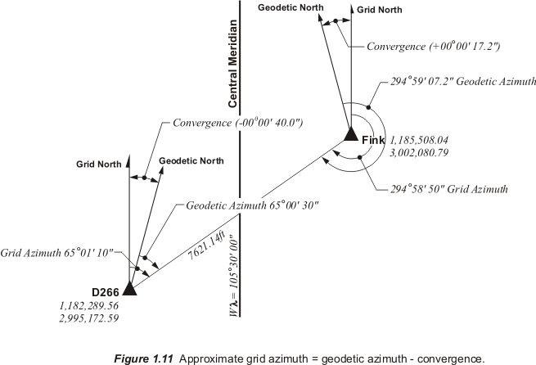

POLAR COORDINATES
There is another way of looking at a direction. It can be one component of a coordinate.
A procedure familiar to surveyors using optical instruments involves the occupation of a station with an established coordinate. A back sighting is taken either on another station with a coordinate on the same datum or some other reference such as Polaris. With two known positions, the occupied and the sighted, a beginning azimuth or bearing is calculated. Next, a new station is sighted ahead, fore-sighted, on which a new coordinate will be established. The angle is measured from the back sight to the fore sight, fixing the azimuth or bearing from the occupied station to the new station. A distance is measured to the new station. And this direction and distance together can actually be considered the coordinate of the new station. They constitute what is known as a polar coordinate. In surveying, polar coordinates are very often a first step toward calculating coordinates in other systems.

There are coordinates that are all distances — Cartesian coordinates for example. There are coordinates that are all angles — latitude and longitude for example. Then there are coordinates that are an angle and a distance — polar coordinates, as shown in Figure 1.12.
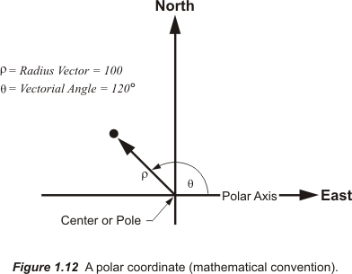

A polar coordinate defines a position with an angle and distance. As in a Cartesian coordinate system they are reckoned from an origin, which in this case is also known as the center or the pole. The angle used to define the direction is measured from the polar axis, which is a fixed line pointing to the east, in the configuration used by mathematicians. It is notable that many disciplines presume east as the reference line for directions, computer aided drafting utilities, for example. Mappers, cartographers and surveyors tend to use north as the reference for directions in polar coordinates.
In the typical format for recording polar coordinates the Greek letter rho, ρ indicates the length of the radius vector, that is the line from the origin to the point of interest. The angle from the polar axis to the radius vector is represented by the Greek letter theta, θ and is called the vectorial angle, the central angle or the polar angle. These values ρ and θ are given in ordered pairs, like Cartesian coordinates. The length of the radius vector is first and the vectorial angle second — for example (100,220°).
There is a significant difference between Cartesian coordinates and polar coordinates. In an established datum using Cartesian coordinates one and only one ordered pair can represent a particular position. Any change in either the northing or the easting and the coordinate represents a completely different point. However, in the mathematician’s polar coordinates the same position might be represented in many different ways, with many different ordered pairs of ρ and θ standing for the very same point. For example, (87, 45°) can just as correctly be written (87,405°) as illustrated in (i) in Figure 1.13. Here the vectorial angle swings through 360° and continues past the pole another 45°. It could also be written as (87,-315) as illustrated in (ii) in Figure 1.11. When θ has a clockwise rotation from the polar axis in this arrangement it is negative. Another possibility is a positive or counterclockwise rotation from the polar axis to a point 180° from the origin and the radius vector is negative (-87,225°). The negative radius vector indicates that it proceeds out from the origin in the opposite direction from the end of the vectorial angle as shown in Figure 1.11.
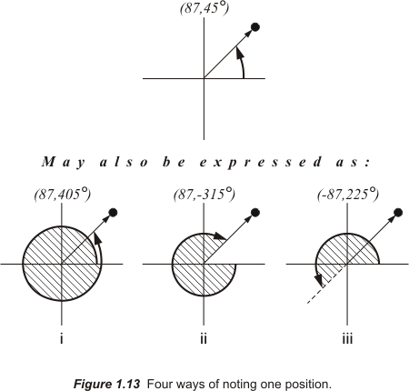

In other words there are several ways to represent the same point in polar coordinates. This is not the case for rectangular coordinates nor is it the case for the polar coordinate system as used in surveying, mapping and cartography.

In mapping and cartography directions are consistently measured from north and the polar axis points north as shown in Figure 1.14.

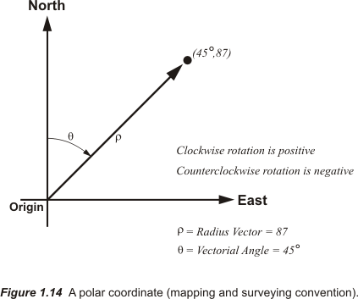

In the mathematical arrangement of polar coordinates a counterclockwise vectorial angle θ is positive and a clockwise rotation is negative. In the surveying, mapping and cartography arrangement of polar coordinates the opposite is true. A counterclockwise rotate is negative and clockwise is positive. The angle may be measured in degrees, radians or grads, but if it is clockwise, it is positive.

In the mathematical arrangement the radius vector can be positive or negative. If the point P lies in the same direction as the vectorial angle it is considered positive. If the point P lies in the opposite direction back through the origin the radius vector is considered negative. In the surveying, mapping and cartography arrangement of polar coordinates the radius vector always points out from the origin and is always positive.

Summary

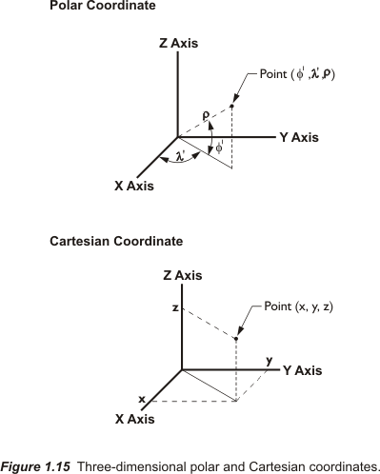

Positions in three-dimensional space can be expressed in both Cartesian coordinates and polar coordinates by the addition of a third axes, the z-axis. The z-axis is perpendicular to the plane described by the x-axis and the y-axis. The addition of a third distance in the Cartesian system, or the addition of a second angle in the polar coordinate system completes the three-dimensional coordinates of a point.

The letters φ’ and λ’ represent the two angles in Figure 1.15. If the origin of the axes are placed at the center of an oblate ellipsoid of revolution the result is a substantially correct model of the Earth from which three dimensional polar coordinates can be derived. Of course, there is a third element to the polar coordinate here represented by rho, ρ. However, if every position coordinated in the system is always understood to be on the surface of the Earth, or a model of the Earth, this radius vector can be dropped from the coordinate without creating ambiguity. And that is conventionally done, so one is left with the idea that each latitude and longitude comprises a three-dimensional polar coordinate with only two angular parts. In Figure 1.15 they are a geocentric latitude and longitude.

If the three-dimensional polar coordinates represent points on the actual surface of the Earth the irregularity of the planet’s surface presents problems. If they represent points on an ellipsoidal model of the Earth they are on a regular surface, but that surface does not stand at a constant radial distance from the center of the figure. There is also a difficulty regarding the origin. If the intersection of the axes is at the geocenter one can derive geocentric latitude and longitude directly. However, the vector perpendicular to the surface of the ellipsoid that represents the element of a geodetic latitude and longitude of a point does not pass through the geocenter, unless the point is at a pole or on the equator. For these reasons and others it is often convenient to bring in the coordinate system that was presented at the beginning of this module, the Cartesian coordinate system. However, this time it is used in its three-dimensional form as shown in Figure 1.15.

A three-dimensional Cartesian coordinate system can be built with its origin at the center of mass of the Earth. The third coordinate, the z-coordinate, is added to the x- and y-coordinates which are both in the plane of the equator. This system can be and is used to describe points on the surface of an ellipsoidal model of the Earth, on the actual surface of the Earth, or satellites orbiting the Earth. This system is sometimes known as the Earth Centered Earth Fixed, ECEF coordinate system, more about that in Module 2.

In Figure 1.16 the relationship between the three-dimensional Cartesian coordinates of two points P₁ and P_{2,} and their three-dimensional polar coordinates are illustrated on a reference ellipsoid. Under the circumstances the polar coordinates are geocentric latitudes and longitudes. The basic relationship between the geodetic and grid azimuths are also shown in the figure. These elements outline a few of the fundamental ideas involved in commonly used coordinate systems on the Earth. Subsequent modules will expand on these basics.

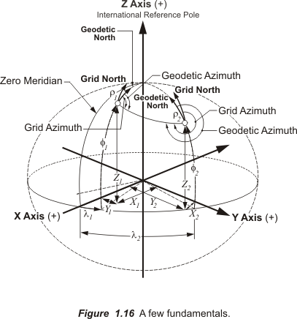

Module 2

The actual surface of the Earth is not very cooperative. It’s bumpy. There is not one nice smooth figure that will fit it perfectly. It does resemble an ellipsoid somewhat, but an ellipsoid that fits Europe may not work for North America. And one applied to North America may not be suitable for other parts of the planet. That’s why, in the past, several ellipsoids were invented to model the Earth. There are about 50 or so still in regular use for various regions of the Earth. They have been, and to a large degree still are, the foundation of coordinate systems around the world. But things are changing. And many of the changes have been perpetrated by advancements in measurement. In other words, we have a much better idea of what the Earth actually looks like today than ever before, and that has made quite a difference.

Legacy geodetic surveying
In measuring the Earth, accuracy unimagined until recent decades has become available from the Global Positioning System (GPS) and other satellite technologies. These advancements have, among other things, reduced the application of some geodetic measurement methods of previous generations. For example, land measurement by triangulation, once the preferred approach in geodetic surveying of nations across the globe, has lessened dramatically, even though coordinates derived from it are still relevant.

Triangulation was the primary surveying technique used to extend networks of established points across vast areas. It also provided information for the subsequent fixing of coordinates for new stations. The method relied heavily on the accurate measurement of the angles between the sides of large triangles. It was the dominant method because angular measurement has always been relatively simple compared to the measurement of the distances.

In the eighteenth and nineteenth centuries, before GPS, before the electronic distance measurement (EDM) device even before invar tapes, the measurement of long distances, now virtually instantaneous, could take years. It was convenient then that triangulation kept the direct measurement of the sides of the triangles to a minimum. From just a few measured baselines a whole chain of braced quadrilaterals, could be constructed (see Figure 2.1). These quadrilaterals were made of four triangles each, and could cover great areas efficiently with the vast majority of measurements being angular.

With the quadrilaterals arranged such that all vertices were intervisible, the length of each leg could be verified from independently measured angles instead of laborious distance measurement along the ground. And when the measurements were completed, the quadrilaterals could be adjusted by least squares. This approach was used to measure thousands and thousands of chains of quadrilaterals and these datasets are the foundations on which geodesists calculated the parameters of ellipsoids now used as the reference frames for mapping around the world.

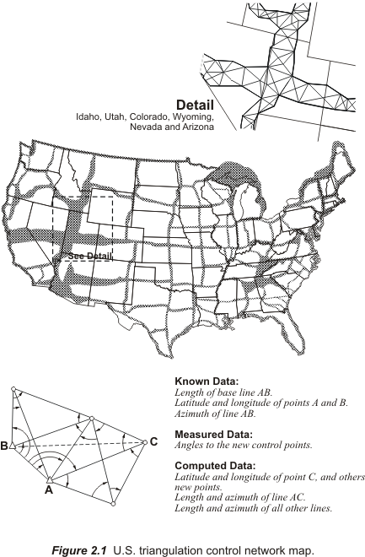

Ellipsoids
They each have a name, often the name of the geodesist that originally calculated and published the figure, accompanied by the year in which it was established or revised. For example, Alexander R. Clarke used the shape of the Earth he calculated from surveying measurements in France, England, South Africa, Peru, Lapland, including M. Struve’s work in Russia and Colonel Everest’s in India to establish his Clarke 1866 ellipsoid. And even though Clarke never actually visited the United States that ellipsoid became the standard reference model for North American Datum 1927 (NAD27) during most of the twentieth century. Despite the familiarity of Clarke’s 1866 ellipsoid, it is important to specify the year when discussing it, which is true of many ellipsoids. The same British geodesist is also known for his ellipsoids of 1858 and 1880. And these are just a few of the reference ellipsoids out there.

Supplementing this variety of regional reference ellipsoids are the new ellipsoids with wider scope, such as the Geodetic Reference System 1980 (GRS80). It was adopted by the International Association of Geodesy, IAG during the General Assembly 1979 as a reference ellipsoid appropriate for worldwide coverage. But as a practical matter such steps do not render regional ellipsoids irrelevant any more than GPS measurements make it possible to ignore the coordinates derived from classical triangulation surveys. Any successful GIS requires a merging of old and new data, and an understanding of legacy coordinate systems is, therefore, essential.

It is also important to remember that while ellipsoidal models provide the reference for geodetic datums, they are not the datums themselves. They contribute to the datum’s definition. For example the figure for the OSGB36 datum in Great Britain is the Airy 1830 reference ellipsoid just as the figure for the NAD83 datum in the United States is the GRS80 ellipsoid. The reference ellipsoid for The European Datum 1950 is International 1924. The reference ellipsoid for the German DHDN datum is Bessel 1841. And just to make it more interesting there are several cases where an ellipsoid was used for more than one regional datum, for example the GRS67 ellipsoid was the foundation for both the Australian Geodetic Datum 1966 (now superseded by GDA94), and the South American Datum 1969.

Ellipsoid definition
To elaborate on the distinction between ellipsoids and datums it might help to take a look at the way geodesists have defined ellipsoids. It has always been quite easy to define the size and shape of a biaxial ellipsoid— that is an ellipsoid with two axes. At least it is easy after the hard work is done, that is once there are enough actual surveying measurements available to define the shape of the Earth across a substantial part of its surface. Two geometric specifications will do it.

The size is usually defined by stating the distance from the center to the ellipsoid’s equator. This number is known as the semimajor axis, and is usually symbolized by a (see Figure 2.2).

The shape can be described by one of several values. One is the distance from the center of the ellipsoid to one of its poles. That is known as the semiminor axis, symbolized by b. Another parameter that can be used to describe the shape of an ellipsoid is the first eccentricity, or e. And finally a ratio called flattening, f, will also do the job of codifying the shape of a specific ellipsoid. Sometimes it’s reciprocal is used instead.

The definition of an ellipsoid then is accomplished with two numbers. It usually includes the semimajor and one of the others mentioned. For example, here are some pairs of constants that are usual; first, the semimajor and semiminor axes in meters; second, the semimajor axis in meters with the flattening, or its reciprocal; and third, the semimajor axis and the eccentricity.

Using the first method of specification the semimajor and semiminor axes in meters for the Airy 1830 ellipsoid are 6,377,563.396m and 6,356,256.910m respectively. The first and larger number is the equatorial radius. The second is the polar radius. The difference between them, 21,307.05 m, is equivalent to about 13 miles, not much across an entire planet.

Ellipsoids can also be precisely defined by their semimajor axis and flattening. One way to express the relationship is the formula:
$$f=1−\frac{b}{a}$$
Where f = flattening, a = semimajor axis, and b = semiminor axis. The flattening for Airy 1830 is calculated:
$$f=1−\frac{b}{a}$$
$$f=1−\frac{6,\text{356},\text{256}\text{.}\text{910}m}{6,\text{377},\text{563}\text{.}\text{396}m}$$
$$f=\frac{1}{\text{299}\text{.}\text{3249646}}$$

In many applications some form of eccentricity is used, rather than flattening. In a biaxial ellipsoid (an ellipsoid with two axes), the eccentricity expresses the extent to which a section containing the semimajor and semiminor axes deviates from a circle. It can be calculated as follows:

$$e^{2}=2f−f^{2}$$
Where f = flattening, e = eccentricity. The eccentricity, also known as the first eccentricity, for Airy 1830 is calculated:

$$e^{2}=2f−f^{2}$$
$$e^{2}=2(0\text{.}\text{0033408506})−(0\text{.}\text{0033408506})^{2}$$
$$e^{2}=0\text{.}\text{0066705397616}$$
$$e=0\text{.}\text{0816733724}$$

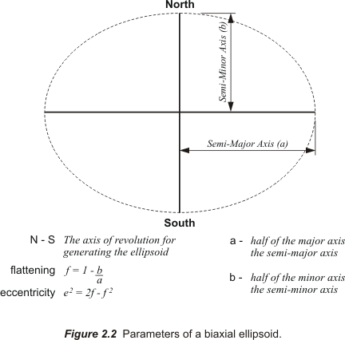

Figure 2.2 illustrates the plane figure of an ellipse with two axes that is not yet imagined as a solid ellipsoid. To generate the solid ellipsoid that is actually used to model the Earth the plane figure is rotated around the shorter axis of the two, the polar axis. The result is illustrated in Figure 2.3, where the length of the semimajor axis is the same all along the figure’s equator. This sort of ellipsoid is known as an ellipsoid of revolution.

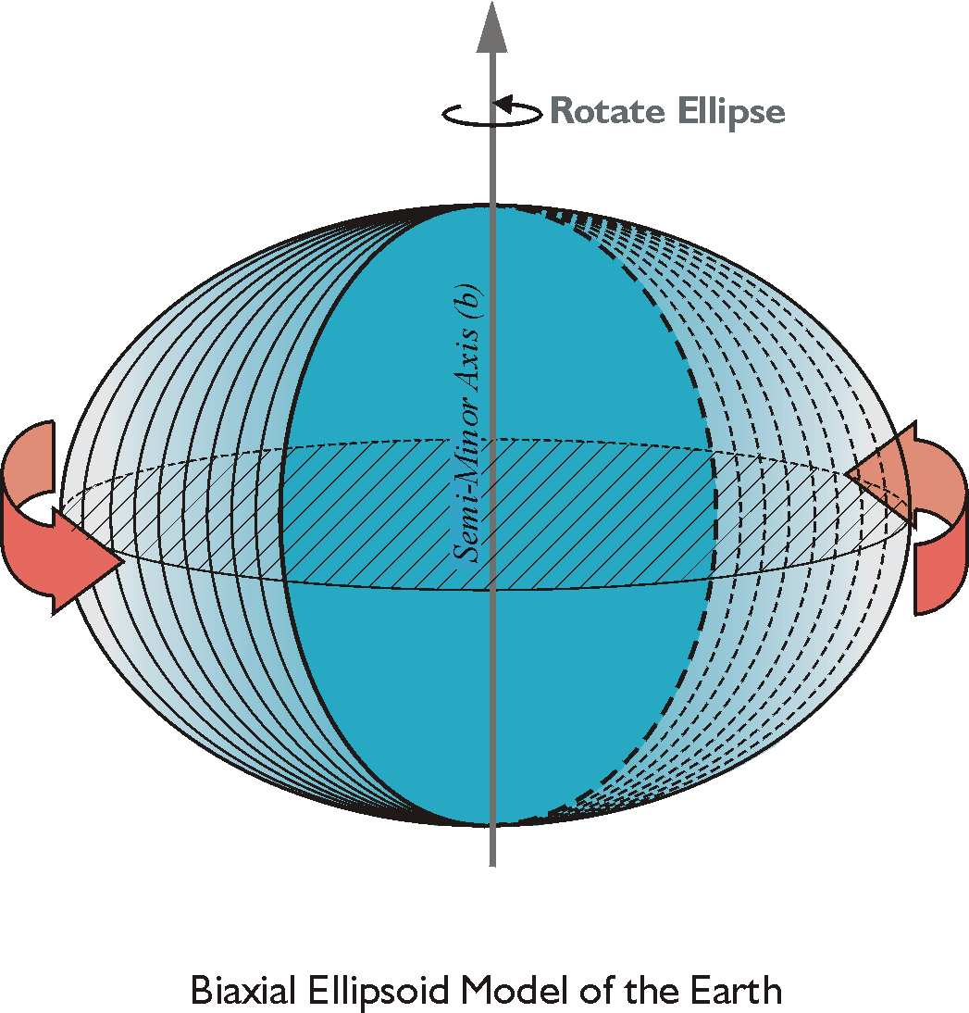

Figure 2.3 Biaxial ellipsoid model of the Earth

The length of the semimajor axis is not constant in triaxial ellipsoids, which are also used as models for the Earth. This idea has been around a long time. Captain A. R. Clarke wrote the following to the Royal Astronomical Society in 1860, “The earth is not exactly an ellipsoid of revolution. The equator itself is slightly elliptic.”

Therefore, a triaxial ellipsoid has three axes with flattening at both the poles and the equator so that the length of the semimajor axis varies along the equator. For example, the Krassovsky (1940), aka Krasovski (1940), ellipsoid is used in most of the nations formerly within the USSR.

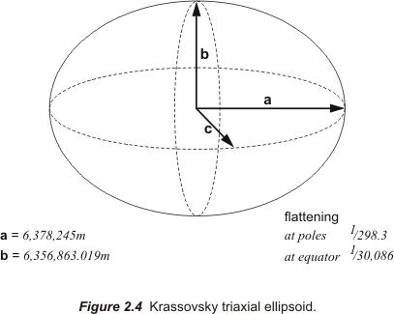

Its semimajor axis, a, is 6,378,245 meters with a flattening at the poles of 1/298.3. Its semiminor axis, b, is 6,356,863.019 meters with a flattening along the equator of 1/30,086. On a triaxial ellipsoid there are two eccentricities, the meridional and the equatorial. The eccentricity, the deviation from a circle, of the ellipse formed by a section containing both the semimajor and the semiminor axes is the meridional eccentricity. The eccentricity of the ellipse perpendicular to the semiminor axis and containing the center of the ellipsoid is the equatorial eccentricity.

Ellipsoid orientation
Assigning two parameters to define a reference ellipsoid is not difficult, but defining the orientation of the model in relation to the actual Earth is not so straightforward. And it is an important detail. After all, the attachment of an ellipsoidal model to the Earth
makes it possible for an ellipsoid to be a geodetic datum. And the geodetic datum can, in turn, become a Terrestrial Reference System, once it has actual physical stations of known coordinates easily available to users of the system.

Connection to the real Earth destroys the abstract, perfect, and errorless conventions of the original datum. They get suddenly messy. Because not only is the Earth’s actual shape too irregular to be exactly represented by such a simple mathematical figure like an ellipsoid, but the Earth’s poles wander, its surface shifts, and even the most advanced measurement methods are not perfect.

The initial point
In any case, when it comes to fixing an ellipsoid to the Earth there are definitely two methods, the old way and the new way. In the past, the creation of a geodetic datum included fixing the regional reference ellipsoid to a single point on the Earth’s surface. It is good to note that the point is on the surface. The approach was to attach the ellipsoid best suited to a region at this initial point.

Initial points were often chosen at the site of an astronomical observatory, since their coordinates were usually well known and long established. The initial point required a known latitude and longitude. Observatories were also convenient places from which to determine an azimuth from the initial point to another reference point, another prerequisite for the ellipsoid’s orientation. These parameters, along with the already mentioned two dimensions of the ellipsoid itself made five in all. Five parameters were adequate to define a geodetic datum in this approach. The evolution of NAD27 followed this line.

The New England Datum 1879 was the first geodetic datum of this type in the United States. The reference ellipsoid was Clarke 1866 mentioned earlier, with a semimajor axis, a, of 6378.2064 km and a flattening, f, of 1/294.9786982. The initial point chosen for the New England Datum was a station known as Principio in Maryland, near the center of the region of primary concern at the time. The dimensions of the ellipsoid were defined, Principio’s latitude and longitude along with the azimuth from Principio to station Turkey Point were both derived from astronomic observations and the datum was oriented to the Earth by five parameters.

Then successful surveying of the first transcontinental arc of triangulation in 1899 connected it to the surveys on the Pacific coast. Other work tied in surveying near the Gulf of Mexico and the system was much extended to the south and the west. It was officially re-named the United States Standard Datum in 1901.
A new initial point at Meade’s Ranch in Kansas eventually replaced Principio. An azimuth was measured from this new initial point to station Waldo. Because even though the Clarke 1866 ellipsoid fits North America very well, it does not conform perfectly. As the scope of triangulation across the country grew the new initial point was chosen near the center of the continental United States to best distribute the inevitable distortion.

Five parameters
When Canada and Mexico agreed to incorporate their control networks into the United States Standard Datum the name was changed again to North American Datum 1913. Further adjustments were required because of the constantly increasing number of surveying measurements. This growth and readjustment eventually led to the establishment of the North American Datum 1927(NAD27).

Before, during and for some time after this period the five constants mentioned were considered sufficient to define the datum. The latitude and longitude of the initial point were two. For NAD27 the latitude of 39º13'26". 686 Nϕ and longitude of 98º32'30". 506 Wλ were specified as the coordinates of the Meade’s Ranch initial point. The next two parameters described the ellipsoid itself, for the Clarke 1866 ellipsoid these are a semimajor axis of 6,378,206.4m and a semiminor axis of 6,356,583.6m. That makes four parameters. And finally an azimuth from the initial point to a reference point for orientation was needed. The azimuth from Meade’s Ranch to station Waldo was fixed at 75º28'09". 64. Together these five values were enough to orient the Clarke 1866 ellipsoid to the Earth and fully define the NAD27 datum.

Still other values were sometimes added to the five minimum parameters during the same era, for example, the geoidal height of the initial point. The assumption was sometimes made that the minor axis of the ellipsoid was parallel to the rotational axis of the Earth. The deflection of the vertical at the initial point was also sometimes considered. For the definition of NAD27, both the geoidal height and the deflection of the vertical were assumed to be zero. That meant it was often assumed that, for all practical purposes the ellipsoid and what was known as Mean Sea Level were substantially the same. As measurement has become more sophisticated that assumption has been abandoned.

In any case, once the initial point and directions were fixed, the whole orientation of NAD27 was established. And following a major readjustment, completed in the early 1930’s, it was named the North American Datum 1927.

This old approach made sense before satellite data was available. The center of the Clarke 1866 ellipsoid as utilized in NAD27 was thought to reside somewhere around the center of mass of the Earth, but the real concern had been the initial point on the surface of the Earth not its center. As it worked out the center of NAD27 reference ellipsoid and the center of the Earth are more than 100 m apart. In other words NAD27, like most old regional datums, is not geocentric. Hardly a drawback in the early twentieth century, but today truly geocentric datums are the goal. The new approach is to make modern datums as nearly geocentric as possible.

Geocentric refers to the center of the Earth, of course, but more particularly it means that the center of an ellipsoid and the center of mass of the planet are as nearly coincident as possible. It is fairly well agreed that the best datum for modern applications should be geocentric and they should have worldwide rather than regional coverage. These two ideas are due, in large measure, to the fact that satellites orbit with the center of mass of the Earth at one focus of the elliptical paths they follow. And as mentioned earlier it is also pertinent that coordinates are now routinely derived from measurements made by the same satellite-based systems, like GPS. These developments are the impetus for many of the changes in geodesy and have made a geocentric datum an eminently practical idea. And so it has happened that satellites and the coordinates derived from them provide the raw material for the realization of modern datums.

Realization of a geodetic datum
The concrete manifestation of a datum is known as its realization. The realization of a datum involves the actual marking and collection of coordinates on stations throughout the region covered by the datum. In other words, the creation of the physical network of reference points on the actual Earth is part of the process of datum realization. A realized datum is a datum that is ready to go to work.

For example, the users of NAD27 could hardly have begun all their surveys from the datum’s initial point in central Kansas. So the Coast and Geodetic Survey (the forerunner of the National Geodetic Survey of today), as did mapping organizations around the world, produced high quality surveys that established a network of points originally monumented by small marks in bronze disks set in concrete or rock throughout the country. These disks, their coordinates and other attendant data became the realization of the datum, its transformation from an abstract idea into something real and usable. This same process continues today and it contributes to a datums maturation and evolution. Just as the surveying of chains of quadrilaterals measured by classic triangulation was the realization of The New England Datum 1879, as the measurements grew in number and quality, they drove the evolution of that datum to become NAD27. Surveying and the subsequent setting and coordination of stations on the Earth continue to contribute to the maturation of geodetic datums today.

The Terrestrial Reference Frame
The stations on the Earth’s surface with known coordinates are sometimes known collectively as a Terrestrial Reference Frame (TRF). They allow users to do real work in the real world, so it is important that they are easily accessible and their coordinate values published or otherwise easily known.

It is also important to note that there is a difference between a datum and a TRF. As stated earlier a datum is errorless. A Terrestrial Reference Frame is certainly not. A TRF is built from coordinates derived from actual surveying measurements. Actual measurements contain errors, always. Therefore, the coordinates that make up a TRF contain errors, however small. Datums do not. A datum is a set of constants with which a coordinate system can be abstractly defined not the coordinated network of monumented reference stations themselves that embody the realization of the datum.

However, instead of speaking of TRFs as separate and distinct from the datums on which they rely, the word datum is often used to describe both the framework, which is the datum, and the coordinated points themselves, the TRF. Avoiding this could prevent a good deal of misunderstanding. For example, the relationship between two datums can be defined without ambiguity by comparing the exact parameters of each, much like comparing two ellipsoids. If one were to look at the respective semimajor axes and flattening of two biaxial ellipsoids the difference between them would be as clear and concise as the numbers themselves. It is easy to express such differences in absolute terms. Unfortunately, such straightforward comparison is seldom the important question in day-to-day work.

On the other hand transforming coordinates from two separate and distinctly different TRFs that both purport to represent exactly the same station on the Earth into one or the other system is an almost daily concern. In other words, it is very likely one could have an immediate need for coordinates of stations published per NAD27 expressed in coordinates in terms of NAD83. But it is unlikely one would need to know the difference in the sizes of Clarke 1866 ellipsoid and the GRS80 ellipsoid or their orientation to the Earth. The latter is really the difference between the datums, but the coordinates speak to the relationship between the TRFs, the realization of the datums. The relationship between the datums is easily defined; the relationship between the TRFs is much more problematic. A TRF cannot be a perfect manifestation of the datum on which it lies.

The quality of the measurement technology has changed and improved with the advent of satellite geodesy. And since measurement technology, surveying and geodetic datums evolve together, so datums have grown in scope to world-wide coverage, improved in accuracy, and become as geocentric as possible.

In the past the vast majority of coordinates involved would be determined by classical surveying as described above. Originally triangulation work was done with theodolites, towers, and tapes. The measurements were Earth-bound and the resulting stations were solidly anchored to the ground too like the thousands of Ordnance Survey triangulation pillars on British hilltops, and the million or more bronze disks set across the United States. These Terrestrial Reference Frames provide users with accessible, stable references so that positioning work can commence from them.

A new geocentric datum
The relationship between the centers of reference ellipsoids and Earth’s center was not an important consideration before space-based geodesy. Regional reference ellipsoids were the rule.

Even after the advent of the first electronic distance measurement devices, the general approach to surveying still involved the determination of horizontal coordinates by measuring from point to point on the Earth's surface and adding heights, otherwise known as elevations, separately. So while the horizontal coordinates of a particular station would end up on the ellipsoid, the elevation, or height would not. In the past the precise definition of the details of this situation was not really an overriding concern. Because the horizontal and vertical coordinates of a station were derived from different operations they lay on different surfaces whether the datum was truly geocentric or not was not really pertinent. One consequence of this approach is the polar and equatorial axes of older, non-geocentric ellipsoid do not coincide with the polar axis and equatorial plane of the actual Earth. The axis of the ellipsoid and the axis of the Earth were often assumed to be parallel and within a few hundred meters of each other, but not coincident as shown in Figure 2.5.

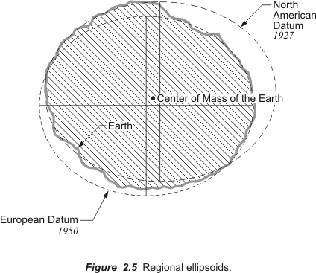

Over the last decades two objectives have emerged: ellipsoidal models that represent the entire Earth, not just regions of it and fixing such an ellipsoid very closely to the center of mass of the planet rather than an arbitrary initial point on the surface. A large part of the impetus was eminently practical. The change was necessary because the NAD27 Terrestrial Reference Frame simply could not support the dramatically improved measurement technology. The accuracy of its coordinates was just not as good as the surveying work the users of the datum were doing.
In the old datum surveyors would begin their measurements and calculations from an established station with published NAD27 coordinates. They would then move on to set a completely new project point that they required. Once that was done, they would check their work. This was done by pushing on to a yet another, a different, known station that also had a NAD27 published coordinate. Unfortunately, this checking in would too frequently reveal that their new work had created coordinates that simply did not fit in with the published coordinates at the known stations. They were often different by a considerable amount. Under such circumstances the surveyors had no choice but to adjust the surveyed measurements to match the published coordinates. New work had to fit into the existing framework of the national network of coordinates.

Satellite positioning, and more specifically GPS, made it clear that the accuracy of surveying had made a qualitative leap. It was also apparent that adjusting satellite-derived measurements to fit the less accurate coordinates available from NAD27 was untenable. A new datum was needed . . .a datum that oriented to the geocenter like the orbits of the satellites themselves . . . a datum that could support a three-dimensional Cartesian coordinate system and thereby contribute to clear defining both the horizontal and vertical aspects of the new coordinates.

So the North American Datum of 1983 replaced the North American Datum of 1927. The new datum was fundamentally different. With the advent of space geodesy, such as Satellite Laser Ranging (SLR), Lunar Laser Ranging (LLR), Very Long Baseline Interferometry (VLBI), Doppler Orbitography by Radiopositioning Integrated on Satellite (DORIS) and the Global Positioning System (GPS), tools became available to connect points and accurately determine coordinates on one global reference surface. Of the many space-based techniques that emerged in the 1980’s and matured in the 1990’s, GPS is of particular importance. The receivers are relatively small, cheap, and easy to operate. And the millimeter to centimeter level of positioning accuracy has been widely demonstrated over long baselines. Even though initially very few GPS observations were used in the establishment of NAD83

It took more than ten years to readjust and redefine the horizontal coordinate system of North America into NAD83. More than 1.7 million weighted classical surveying observations were involved, some 30,000 EDM-measured baselines, 5,000 astronomic azimuths; about 655 Doppler stations positioned using the TRANSIT satellite system and about 112 Very Long Baseline Interferometry (VLBI) vectors. In short, the North American Datum of 1983, NAD83 can be said to be the first civilian coordinate system established using satellite positioning. And it was much more accurate than NAD27.

So when NAD83 coordinates were implemented across the United States, coordinates shifted. Across a small area the coordinate shift between the two datums is almost constant, and in some areas the shift is slight. In fact the smallest differences occur in the middle of the United States. However, as the area considered grows one can see there is a significant, systematic variation between NAD27 coordinates and NAD83 coordinates. The differences can grow from about -0.7" to + 1.5" in latitude, that is up to almost 50m north-south. The change between NAD27 and NAD83 coordinates is generally larger east-west from -2.0" to about +5.0" in longitude, which means the maximum differences can be over 100m in that direction. The longitudinal shifts are actually a bit larger than that in Alaska, ranging up to 12.0” in longitude.

It is important to note that if the switch from NAD27 and NAD83 had just involved a change in surveying measurements made on the same ellipsoid, the changes in the coordinates would not have been that large. For example, had NAD83 coordinates been derived from satellite observations, but had been projected onto the same Clarke 1866 ellipsoid as had been used for NAD27 the change in coordinates would have been smaller. But, in fact, at the center the ellipsoid shifted approximately 236 meters from the non-geocentric Clarke 1866 ellipsoid to the geocentric GRS80 ellipsoid.

And the evolution of the new datum has continued. NAD83 was actually in place before GPS was operational. As GPS measurements became more common they turned out to be more accurate than the coordinates assigned to the network of control points on the ground. NAD83 needed to be refined. Frequently states took the lead and NGS participated in cooperative work that resulted in readjustments. The new refinements were referred to with a suffix, such as NAD83/91 and the term High Precision GPS Network (HPGN) was used. Today High Accuracy Reference Network (HARN) is the name most often associated with these improvements of NAD83.

The World Geodetic System 1984 (WGS84) is the geodetic reference system used by GPS. WGS84 was developed for the United States Defense Mapping Agency (DMA). The agencies name was changed to National Imagery and Mapping Agency (NIMA) and today it is known as the National Geospatial-Intelligence Agency (NGA). GPS receivers compute and store coordinates in terms of WGS84. They transform them to other datums when information is displayed. WGS84 is the default for many GIS platforms as well.

The original realization of the WGS84 was based on observations of the TRANSIT satellite system. These positions had 1 to 2 meter accuracy. But over the years the realizations have improved. It should be noted that WGS84’s ellipsoid and the GRS80 ellipsoid are very similar; they both use biaxial reference ellipsoids with only slight differences in the flattening. It has been enhanced on several occasions to a point where it is now very closely aligned to ITRF, the International Terrestrial Reference Frame.

WGS84 has been periodically improved to account for plate tectonics. The first such enhancement was in 1994 on GPS week 730 —for this purpose GPS weeks are counted from midnight January 5, 1980. This caused the name of WGS84 to acquire a suffix. It was then known as WGS84 (G730). The next update was a couple of years later when it became known as WGS84 (G873). The latest improvement along this line resulted in WGS84 (G1150).

It is important to note that these changes have caused WGS84 to drift farther and farther from NAD83. While it is often presumed that the WGS84 as originally rolled out was nearly the same as NAD83 (86) things have changed. In fact, the difference between a position in NAD83 (CORS96) and a position in WGS84 (G1150) can approach 1 or 2 meters today. At the same time WGS84 has become virtually coincident with the International Terrestrial Reference Frame. WGS84 (G730) was very close to ITRF92, WGS84 (G873) close to ITRF96 and WGS84 (G1150) is close to ITRF00. WGS84 (G1150) is also currently the reference for the GPS broadcast ephemeris

GPS information has also contributed to bringing the center of ellipsoids very close indeed to the actual center of mass of the Earth. The geocenter is a focus of the satellites orbits and the origin of the measurements derived from them. Coordinates derived directly from GPS observations are often expressed in three-dimensional Cartesian coordinates, X, Y and Z with the center of mass of the Earth as the origin.

Geocentric Three-Dimensional Cartesian Coordinates

A three-dimensional Cartesian system requires three axes, a clear definition of both their origin and their direction. If these things can be attached to the Earth, then every position on the planet, and in its vicinity, can have a unique three-dimensional Cartesian coordinate, but as mentioned in Module 1 when you bring in the real world things get messy. For example, the relationship between the surface of the Earth, its center and even its axis of rotation is not constant and unchanging.

The Earth wobbles in motions known as precession and nutation. Precession is the long-term movement of the polar axis. It moves in a circle with a period of something approximating 25,800 years. At the moment the planet’s spin axis almost points to Polaris, but in 14,000 years or so it might point to Vega. Nutation is the movement of the Earth with a cycle of about 18.6 years, mostly attributable to the moon. The Earth’s rotation rate also varies. It is a bit faster in January and slower in July. And then there is the wandering of the Earth’s axis of rotation relative to the Earth’s surface, called polar motion.

Polar motion is a consequence of the actual movement of the Earth’s spin axis as it describes an irregular circle with respect to the Earth’s surface. The circle described by this free Eulerian motion of the pole has a period of about 435 days or so. It takes approximately that long for the pole to complete a circle that has a diameter of about 12m to 15m. This part of the polar motion is known as the Chandler period, named after American Astronomer Seth C. Chandler who described it in papers in the Astronomical Journal in 1891. Another aspect of polar motion is sometimes called polar wander. It is about 0.004 seconds of arc per year as the pole moves toward Ellesmere Island. Both aspects are shown generally in Figure 2.6.

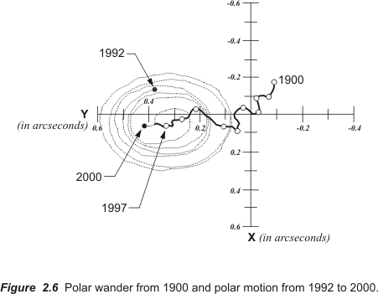

Therefore, one can say that the Earth has a particular axis of rotation, equator and zero meridian for an instant before they all change slightly in the next instant. Within all this motion how do you define the origin and direction of the three needed axes for the long term? One way is to choose a moment in time and consider them fixed as they are at that instant. That was how it was done. A moment was chosen by the Bureau International de l' Heure (BIH). It was midnight on New Year’s Eve 1983, or January 1, 1984 (UTC). It is also known as an epoch and can be written 1984.0. So we now use the axes illustrated in Figure 2.7 as they were at that moment.
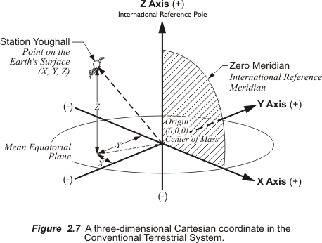

This resulting system is known as the conventional terrestrial reference system (CTRS), or just the conventional terrestrial system (CTS). The origin is the center of mass of the whole Earth including oceans and atmosphere, the geocenter. The x-axis is a line from that geocenter through its intersection at the zero meridian, also known as the International Reference Meridian (IRM), with the internationally defined conventional equator. The y-axis is extended from the geocenter along a line perpendicular from the x-axis in the same mean equatorial plane. That means that the positive end of the y-axis intersects the actual Earth in the Indian Ocean. In any case, they both rotate with the Earth around the z-axis, a line from the geocenter through the internationally defined pole known as the International Reference Pole (IRP). The three dimensional Cartesian coordinates (x, y, z) derived from this system are sometimes known as Earth-centered-Earth-fixed (ECEF) coordinates and it has been utilized in NAD83, WGS 84, and ITRF more about them later. It is a right-handed, orthogonal system and can be described by the following model. The horizontally extended forefinger of the right hand symbolizes the positive direction of the x-axis. The middle finger of the same hand extended at right angles to the forefinger symbolizes the positive direction of the y-axis. The extended thumb of the right hand, perpendicular to them both, symbolizes the positive direction of the z-axis.

In this three-dimensional right-handed coordinate system the x-coordinate is a distance from the y-z plane measured parallel to the x-axis. It is always positive from the zero meridian to 90º W longitude and from the zero meridian to 90º E longitude. In the remaining 180º the X-coordinate is negative.

The y-coordinate is a perpendicular distance from the plane of the zero meridian. It is always positive in the Eastern Hemisphere and negative in the Western Hemisphere.

The z- coordinate is a perpendicular distance from the plane of the equator. It is always positive in the Northern Hemisphere and negative in the Southern Hemisphere.

Here is an example, the position of the station Youghall expressed in three-dimensional Cartesian coordinates of this type expressed in meters, the native unit of the system:

X = -1564831.1855
Y = -4605604.7477
Z = 4115817.6900

The X-coordinate for Youghall is negative because its longitude is west of 90º W longitude. The Y-coordinate is negative because the point is west of the zero meridian. The Z-coordinate is positive because the point is in the northern hemisphere.

The system works well, but what about earthquakes, volcanic activity, tides, subsurface fluid withdrawal, crustal loading/unloading, and the many other forces that contribute to the continuous drift in tectonic plates. Certainly these cause the plates and the surface points on them to move relative to the geocenter, and relative to each other. Hence changes in the three-dimensional Cartesian coordinates are inevitable. Not only is the entirety of the Earth’s surface always in motion with respect to its center of mass, but there is also relative motion between the approximately 20 large tectonic plates that make up that surface. For example, stations on separate plates can move as much as 150 mm per year simply because the ground on which one station stands is slowly shifting in relation to the ground at the other. It was this fact, among other things, that led to the establishment of the International Earth Rotation Service, IERS; the previously mentioned Bureau International de l' Heure (BIH) was its predecessor. And the IERS introduced a heretofore unheard of and remarkable aspect to coordinates, velocity.

The IERS
The International Earth Rotation Service, IERS is an organization that began operations in Paris at the beginning of 1988 under the auspices of the International Astronomical Union and the International Union of Geodesy and Geophysics. The IERS has formally defined the International Reference Pole, International Reference Meridian, the plane of the conventional equator and the other components of the three dimensional Cartesian system just described. These are part of a broader system known as the International Terrestrial Reference System (ITRS).

Because work in crustal deformation and the movement of the planet’s axis required an extremely accurate foundation the IERS originally introduced International Terrestrial Reference System ITRS and its first realization the International Terrestrial Reference Frame of 1988 (ITRF88). As mentioned earlier a realization is the concrete manifestation of a datum by measurements made at points on the Earth. In the case of the ITRF the region covered includes the whole world. Please note that the digits appended to ITRF represent the year up to which the data sets have been used in the realization. In fact, from its beginning in 1988, and nearly every year since, IERS has published a list of new and revised positions with their velocities for more than 500 stations around the world. In other words, ITRF89, and ITRF90, etc followed ITRF88. So the IERS released ITRF89, ITRF90, ITRF91, ITRF92, ITRF93, and ITRF94. There was not a release in 1995. The next were ITRF96 and ITRF97. They were followed by ITRF00 and ITRF05, for 2000 and 2005 respectively.
This international organization does the hard work of compiling the measurements and calculating the movement of our planet. The data needed for this work comes from measurements made by the Global Positioning System (GPS), Very Long Baseline Interferometry (VLBI), Satellite Laser Ranging (SLR) and satellite radio positioning (DORIS) at a set of stations around the planet that realize the ITRF. These values are utilized more and more in part because of the high quality of the data, in part because ITRS provides an international reference system that directly addresses crustal motion at particular monumented control stations. The ITRF stations are moving, and recognized to be doing so. Therefore, they each are described by a position and a velocity and every position, every set of coordinates in these realizations refer to the stations position at a particular moment. This moment is known as the Reference Epoch (RE). For example, the RE for ITRF94 is 1993.0, or more specifically January 1, 1993 at exactly 0:00 UTC. The RE for ITRF00 is 1997.0 and the RE for ITRF05 is 2000.0. Even stations on the most stable part of the North American plate are in horizontal motion continuously at rates that range from 9 to 21 mm every year. While it must be said that these changes in coordinates are very slight indeed, they are changes nonetheless and ITRS accounts for them.

A good deal of practical application of this system has developed. The National Geodetic Service, NGS, an office of NOAA's National Ocean Service, the arm of the United States federal government that defines and manages the National Spatial Reference System, NSRS, is now utilizing ITRF data. In March of 2002 the NGS started to upgrade its published NAD83 positions and velocities of a portion of the national network known as the CORS sites to be equal to the ITRF2000 positions and velocities.

The acronym CORS stands for the network of Continuously Operating Reference Stations. GPS signals collected and archived at these sites of known position provide base data that serves as the foundation for positioning in the United States and its territories. For example, when GPS data is collected at an unknown station it can be processed with data from a CORS station to produce positions that have centimeter-level accuracy in relation to the NSRS, and now ITRF2000 as well.

Here is an illustration of the application of ITRF data. The coordinate values for the position of station AMC2 in Colorado Springs, Colorado are shown here as retrieved from the NGS database. First is the NAD83 (epoch 2002) position of the station in three-dimensional Cartesian coordinates as it was transformed from the ITRF00 position (epoch 1997.0) in March 2002:

X = -1248595.534 m
Y = -4819429.552 m
Z = 3976506.046 m

Now here is the position of the same station based upon the ITRF00 position (epoch 1997.0) as it was computed in Aug. 2006 using 1673 days of data.

X = -1248596.072 m
Y = -4819428.218 m
Z = 3976506.023 m

The question, “Where is station AMC2?” might be more correctly asked, “Where is station AMC2 now?” And, in fact, the latter question can be answered by calculating new positions for the station based on its velocities.

The location of the AMC2 station can also be stated in both three-dimensional Cartesian coordinates and latitude, longitude and height above the ellipsoid. Here is the AMC2 ITRF00 (1997.0) position calculated in August 2006 expressed in geographic coordinates and ellipsoidal height:

Latitude = 38° 48’ 11.24915” N
Longitude = 104° 31’ 28.53276” W
Ellipsoid height = 1911.393 m

Three-dimensional Cartesian coordinates and geographical coordinates with ellipsoidal heights can be converted from one another. Here are the expressions for deriving the three-dimensional Cartesian coordinates from latitude, longitude and height above the ellipsoid:
X = (N + h) cos ϕ cos λ
Y = (N +h) cos ϕ sin λ
Z = (Nb²/a² + h) sin ϕ
latitude = ϕ
longitude = λ
height above the ellipsoid = h
N = the east-west local radius of the reference ellipsoid in meters
N = a² (a² cos² ϕ + b² sin²ϕ)^{-1/2}

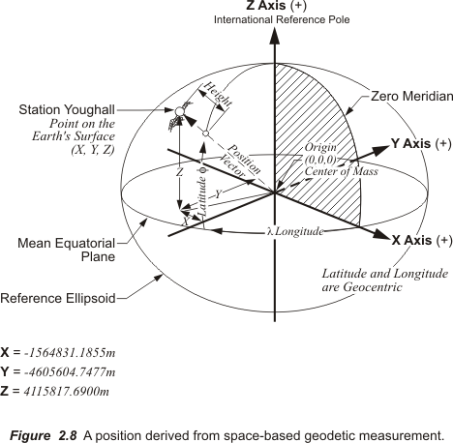

Notice in Figure 2.8 that this computation requires the introduction of an ellipsoid to represent the Earth itself. This is interesting because it means that just by looking at an x, y and z coordinate in this system one cannot be certain whether the point is on the Earth’s surface, deep inside it, or in outer space.

Transforming Coordinates
Transformations are mathematical mechanisms used to move coordinates from one datum to another, and there are several methods. And while it is true that most such work is left to computer applications today it is, at best, unwise to accept the results uncritically. Therefore, here is an outline of some of the qualities of some typical datum transformation methods.

First, datum transformations ought to be distinguished from coordinate conversions. Coordinate conversion is usually understood to mean the re-expression of coordinates from one form to another, but both resting on the same datum. For example, the calculation of a plane coordinate such as UTM (NAD83) from a point’s expression as a geographic coordinate (NAD83) would be a coordinate conversion.

Datum transformation, on the other hand, usually means the coordinates do in fact change from an original datum to a target datum. For example the alteration of a geographic coordinate on one datum, i.e. latitude and longitude NAD83, into a geographic coordinate on another datum, i.e. latitude and longitude in NAD27, would amount to a datum transformation. In this case there is actually a change from one ellipsoid to another. A further complication is presented by the fact that the center of the ellipsoid of reference for NAD83, GRS80, and the center of the ellipsoid of reference for NAD27, Clarke 1866 do not coincide. Other typical difficulties include the orientation of the axes of the original and target datums. They may require rotation to coincide, the scale of the distances between points on one datum may not be at the same scale as the distances on the target datum and etc.

Each of these changes can be addressed mathematically to bring integrity to the transformation of coordinates when they are moved from one system into another. In other words, the goal is to not degrade the accuracy of the coordinates in the terrestrial reference frame as they are transformed. However, datum transformation cannot improve those coordinate’s accuracy either. For example, if the distance between point A and point B is incorrect in the original datum it will be just as wrong when it is transformed into a target datum. The initial consistency of the coordinate network that is to be transformed, that is the accuracy with which the coordinates represent the relative positions of the actual points on the Earth, is important.

Common Points

In datum transformations it is best if some of the points involved have been surveyed in both the original datum and the target datum. These are usually called common points. A common point has, of course, one coordinate in the original datum and an entirely different coordinate in the target datum; still both represent the same position on the Earth.

The accuracy and the distribution of these coordinates in both the original and the target datum is an important factor in the veracity of a datum transformation. When it comes to datum transformation the more common points the better. And they are best if evenly distributed through the network. These factors affect the results no less than the actual method used to do a datum transformation.

Clearly some of the surveyed common points in the target datum can be used after the transformation is completed to check the work. The surveyed coordinates can then be compared to the transformed coordinates to evaluate the consistency of the operation.

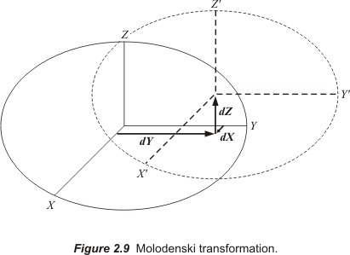

Molodenski transformation

This method is named for the mid-twentieth century Russian physicist, M.S. Molodenskij. The Molodenski transformation is sometimes known as the 3-parameter or 5-parameter transformation. It is used on-board some GPS receivers. In fact, the growth in the utilization of GPS has probably increased the number of computer applications relying on this method. In this context it is often implemented to transform coordinates from WGS84 into a local projection.

The Molodenski transformation is simple in conception and available in many standard GIS software platforms as well. It rests on shifts to the three geocentric coordinates that are applied directly to geographical coordinates. It usually requires ellipsoidal parameters from the original and the target system as well and the size of the shift in the x, y, and z geocentric coordinates. In other words, it uses simple straight-forward formulas to shift the origin from the original datum to the target datum along the x, y and z axes, (ΔX, ΔY, ΔZ) based on the averaged differences between the x, y and z coordinates of the previously mentioned common points. There is no scaling or rotation in this method.
Like all such mathematical operations the worth of this sort of transformation is dependent on the consistency of the coordinate values available, but at best it can only produce a transformation with moderate accuracy. The size of the area being transformed bears on the accuracy of the transformation.
The Molodenski transformation is based on the assumption that the axes of the original ellipsoid and the target ellipsoid are parallel to each other. That is seldom true, but if the work involved is across a small area the effect of the assumption may be insignificant. However, as the size of the area grows so does the inaccuracy of this method of transformation. In short, the Molodenski method is satisfactory if some of the work requires modest accuracy, but rotation and scale parameters are needed for more precise work.
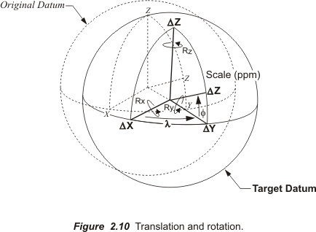

7-parameter transformation

This method is also known as Helmert or Bursa-Wolf transformation. It bears remembering that datum transformations do not improve the accuracy of the coordinates they transform. They cannot do that. However, when the number of parameters considered is increased the result is an improvement in the fit of the coordinates in the target datum.

To transform from one geocentric datum to another one could use the 7-parameters of the Bursa-Wolfe approach; 3 translations, 3 rotations and 1 scale factor. The sum of the x, y and z translations accomplish the shifting of the origin so that the origins of the original datum to and the target datum match. The shifts are usually expressed as, ΔX, ΔY, ΔZ or DX, DY, and DZ. But they are sometimes shown as u, v, and w. In any case, the three shift distances are specified in meters. Their objective is to shift the ellipsoid along each of its three axes.

Then through the rotation of each of the axes the original datum and the target datum axes are made parallel to one another. The three rotation parameters of the x, y and z axes are symbolized by EX, EY, and EZ or rX, rY, rZ. Though they are sometimes shown as x, y, z, or , , and . The three rotation parameters specify the angles. The angles are usually less than 5 arc-seconds and are calculated by producing a combined rotation matrix.

Finally, the transformation is scaled. The scale factor is usually calculated in parts per million.

This method is also known as the 3-dimensional Helmert, 3-dimensional conformal, or 3-dimensional similarity. The 7-parameter transformation ought to start with at least three coordinates of points that are common to the original and the target system; more are better.

Again the quality of the results are dependent on the consistency of the set of common coordinated points utilized by the original and target side of the work. This transformation is available in many GIS software packages and its accuracy is better than that available with the Molodenski transformation. The 7-parameter transformation does require heights for the common coordinated points in both the original and the target systems and the results depend on the consistency of the coordinates in both systems.

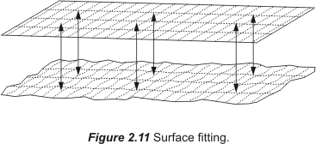

Surface Fitting

Surface fitting, illustrated in Figure 2.11, is also known as the transformation grid, bilinear gridded interpolation, or the grid-based interpolation method.

This is the best approach to datum transformation. The United States, Canada and Australia use the method. In 1986 when the datum changed in the United States it was clear there were no constant values that could easily move the geographical coordinates from the original, NAD27 on the Clarke 1866 ellipsoid, to the target datum, NAD83 on the GRS80 ellipsoid. Among the reasons were the centuries of conventional surveying that introduced unavoidable inconsistencies into the original coordinates. Under the circumstances it would have been unworkable to transform the NAD27 coordinates into NAD83 with the Molodenski method or the 7-parameter method. What was needed was an approach that was more fine-tuned and specific.

The North American Datum Conversion Utility (NADCON) was developed. The program uses grids and an error averaging strategy based on real data.

When a coordinate is input for transformation the necessary shift calculations are based on a grid expressed in a database, which contains the shifts at tens of thousands of points in an extensive grid network This grid of control points have shifts that are known and that information is used to estimate the shift at other locations.

This approach is based on the idea that it is possible to find the necessary shift in a coordinate to transform it from its original datum to a target datum by interpolation from known shifts for a number of control points in the same area. For example, a particular geographic coordinate that is to be transformed will fall within a grid cell that has points of known shifts at each of its four corners. The application of a bilinear interpolation algorithm can thereby derive the necessary shift at the given point. The interpolation uses two grid files one for the shifts in latitude and one for the shifts in longitude. This rubber-sheeting method is good but it requires an extensive grid database to be successful. Building such a database needs the devotion of significant resources and almost certainly the auspices of governmental agencies. It is a minimum curvature method and is probably the most popular transformation routine in the United States. It is a surface fitting type of transformation.

The software behind the surface fitting transformation is not based on simple formulas, but it can be operated from a simple user interface that emphasizes simple shifts in latitude and longitude. Several points common to the original and the target coordinate systems are used in the surface fitting method.

On the positive side the surface fitting transformation is quite accurate and often driven by a simple user interface. It is integral to many standard GIS software packages. On the other hand it is mathematically complex and requires that the original and the target coordinate systems have many common points.

The number of common points available and the accuracy required are important considerations in choosing the appropriate transformation method. The surface fitting or grid shift techniques like that used in NADCON provide the best results. The Molodenski transformation provides the least accuracy.

Module 3

Latitude and longitude, northing and easting, radius vector and polar angle, coordinates often come in pairs. But that is not the whole story. For a coordinate pair to be entirely accurate the point it represents must lie on a well-defined surface. It might be a flat plane or it might be the surface of a particular ellipsoid and in either case the surface will be smooth and have a definite and complete mathematical definition.

As mentioned before, modern geodetic datums rely on the surfaces of geocentric ellipsoids to approximate the surface of the Earth. But the actual Earth does not coincide with these nice smooth surfaces, even though that is where the points represented by the coordinate pairs lay. In other words, the abstract points are on the ellipsoid, but the physical features those coordinates intend to represent are, of course, on the actual Earth. Though the intention is for the Earth and the ellipsoid to have the same center, the surfaces of the two figures are certainly not in the same place. There is a distance between them.

Ellipsoid Height

The distance represented by a coordinate pair on the reference ellipsoid to the point on the surface of the Earth is measured along a line perpendicular to the ellipsoid. This distance is known by more than one name. It is called the ellipsoidal height and it is also called the geodetic height and is usually symbolized by h.

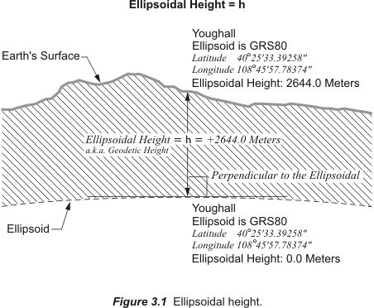

In Figure 3.1 the ellipsoidal height of station Youghall is illustrated. The reference ellipsoid is GRS80 since the latitude and longitude are given in NAD83.

The concept of an ellipsoidal height is straightforward. A reference ellipsoid may be above or below the surface of the Earth at a particular place. If the ellipsoid’s surface is below the surface of the Earth at the point the ellipsoidal height has a positive sign, if the ellipsoid’s surface is above the surface of the Earth at the point the ellipsoidal height has a negative sign. It is important to remember that the measurement of an ellipsoidal height is along a line perpendicular to the ellipsoid, not along a plumb line. Said another way, an ellipsoidal height is not measured in the direction of gravity. It is not measured in the conventional sense of down or up.

As was mentioned in Module 1, down is a line perpendicular to the ellipsoidal surface at a particular point on the ellipsoidal model of the Earth. On the real Earth down is the direction of gravity at the point. Most often they are not the same. And since a reference ellipsoid is a geometric imagining, it is quite impossible to actually set up an instrument on it. That makes it tough to measure ellipsoidal height using surveying instruments. In other words, ellipsoidal height is not what most people think of as an elevation.

Nevertheless, the ellipsoidal height of a point is readily determined using a GPS receiver. GPS can be used to discover the distance from the geocenter of the Earth to any point on the Earth, or above it for that matter. In other words, it has the capability of determining three-dimensional coordinates of a point in a short time. It can provide latitude, longitude and if the system has the parameters of the reference ellipsoid in its software it can calculate the ellipsoidal height. The relationship between points can be further expressed in the ECEF coordinates, x, y and z, or in a Local Geodetic Horizon System (LHGS) of north, east and up. Actually, in a manner of speaking, ellipsoidal heights are new, at least in common usage, since they could not be easily determined until GPS became a practical tool in the 1980's. However, ellipsoidal heights are not all the same, because reference ellipsoids or sometimes just their origins can differ. For example, an ellipsoidal height expressed in ITRF00 would be based on an ellipsoid with exactly the same shape as the NAD83 ellipsoid, GRS80; nevertheless the heights would be different because the origin has a different relationship with the Earth’s surface (see Figure 3.2.)

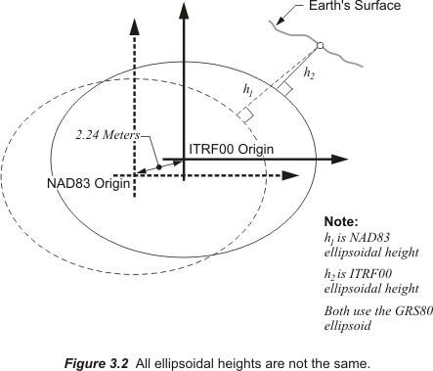

There is nothing new about heights themselves or elevations as they are often called. Long before ellipsoidal heights were so conveniently available, knowing the elevation of a point was critical to the complete definition of a position. In fact there are more than 200 different vertical datums in use in the world today. They were, and still are, determined by a method of measurement known as leveling. But it is important to note that this process measures a very different sort of height.

Both trigonometric leveling and spirit leveling depend on optical instruments. Their lines of sight are oriented to gravity not a reference ellipsoid. Therefore, the heights established by leveling are not ellipsoidal. In fact, a reference ellipsoid actually cuts across the level surfaces to which these instruments are fixed.

Trigonometric Leveling
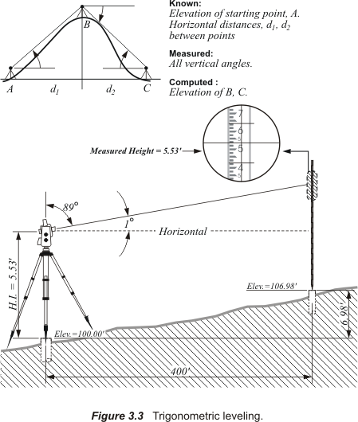

Finding differences in heights with trigonometric leveling requires a level optical instrument that is used to measure angles in the vertical plane, a graduated rod and either a known horizontal distance or a known slope distance between the two of them. As shown in Figure 3.3 the instrument is centered over a point of known elevation and the rod is held vertically on the point of unknown elevation. At the instrument one of two angles is measured, either the vertical angle, from horizontal plane of the instrument, or the zenith angle, from the instrument’s vertical axis. Either angle will do. This measured angle together with the distance between the instrument and the rod provides two known components of right triangle in the vertical plane. It is then possible to solve that triangle to reveal the vertical distance between the point at the instrument and the point on which the rod is held.

For example, suppose that the height, or elevation, of the point over which the instrument is centered is 100.00 feet. Further suppose that the height of the instrument’s level line of sight, its horizontal plane is 5.53 feet above that point. Then the height of the instrument (H.I.) would then be 105.53 feet. For convenience, the vertical angle at the instrument could be measured to 5.53 feet on the rod. If the measured angle is 1º00’00” and the horizontal distance from the instrument to the rod is known to be 400.00 feet, all the elements are in place to calculate a new height. In this case the tangent of 1º00’00” multiplied by 400.00 feet yields 6.98 feet. That is the difference in height from the point at the instrument and the point at the rod. Therefore, 100.00 feet plus 6.98 feet indicates a height of 106.98 at the new station where the rod was placed.

There are many more aspects to this process, the curvature of the Earth, refraction of light, and etc. that make it much more complex in practice than it is in this illustration. However, the fundamental of the procedure is the solution of a right triangle in a vertical plane using trigonometry, hence the name trigonometric leveling. It is faster and more efficient than spirit leveling but not as precise.

Horizontal surveying usually precedes leveling in control networks. And that was true in the early days of what has become our national network, the National Spatial Reference System, NSRS, of the United States. Geodetic leveling was begun only after triangulation networks were underway. This was also the case in many other countries. In some places around the world the horizontal work was even completed before leveling was commenced. In the United States trigonometric leveling was applied to geodetic surveying before spirit leveling. Trigonometric leveling was used extensively to provide elevations to reduce the angle observations and base lines necessary to complete triangulation networks to sea level. And the angular measurements for the trigonometric leveling were frequently done in an independent operation with instruments having only a vertical circle.

Then in 1871 Congress authorized a change for the then Coast Survey under Benjamin Peirce that brought spirit leveling to the forefront. The Coast Survey was to begin a transcontinental arc of triangulation to connect the surveys on the Atlantic coast with those on the Pacific coast. Until that time their work had been restricted to the coasts. But with the undertaking of triangulation that would cross the continent along the 39th parallel it was clear that trigonometric leveling was not sufficient to support the project. They needed more vertical accuracy than it could provide. So in 1878 at about the time the work began the name of the agency was changed from Coast Survey to U.S. Coast and Geodetic Survey and a line of spirit leveling of high precision was begun at Benchmark A in the foundation wall of the Washington County Court House in Hagerstown, Maryland. It headed west. It reached Seattle in 1907. Along the way it provided benchmarks for the use of engineers and others who needed accurate elevations, heights, for subsequent work not to mention establishing the vertical datum for the United States.

Spirit Leveling
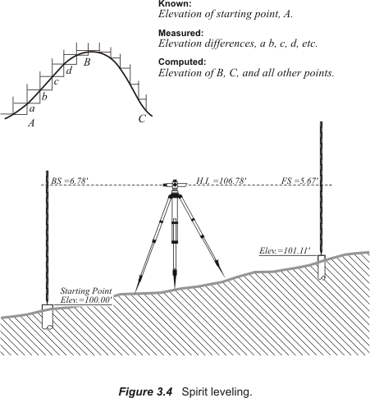

The method is simple in principle, but not in practice. An instrument called a level is used to establish a line of sight that is perpendicular to gravity, in other words, a level line. Then two rods marked with exactly the same graduations, like rulers, are held vertically resting on two solid points, one ahead and one behind the level along the route of the survey. The system works best when the level is midway between these rods. Looking at the rod to the rear through the telescope of the level, the point at which the horizontal level line of sight of the level intersects the vertical rod there is a graduation. That reading is taken and noted. This is known as the backsight (B.S.). This reading tells the height, or elevation, that the line of sight of the level is above the mark on which the rod is resting. For example, if the point on which the rod is resting is at an elevation of 100 ft. and the reading on the rod is 6.78 ft then the height of the level’s line of sight is 106.78 ft. That value is known as the H.I. Then the still level instrument is rotated to observe the vertical rod ahead and a value is read there. This is known as the foresight (F.S.) The difference between the two readings reveals the change in elevation from the first point at the backsight to the second, at the foresight. For example, if the first reading established the height of the level’s line of sight, the H.I., at 106.78 ft., and the reading on the rod ahead, the F.S., was 5.67 ft. it becomes clear that the second mark is 1.11 ft higher than the first. It has an elevation of 101.11 ft. By beginning this process from a monumented point of known height, a benchmark, and repeating it with good procedures the heights of marks can be determined all along the route of the survey.
The accuracy of level work depends on the techniques and the care used. Methods such as balancing the forward and back sights, calculating refraction errors, running new circuits twice, using one piece rods and etc. can improve results markedly. In fact, entire books have been written on the details of proper leveling techniques. Here the goal will be to mention just a few elements pertinent to coordinates generally.

It is difficult to over-state the amount of effort devoted to differential spirit level work that has carried vertical control across the United States. The transcontinental precision leveling surveys done by the Coast and Geodetic Survey from coast to coast were followed by thousands of miles of spirit leveling work of varying precision. When the 39th parallel survey reached the west coast in 1907 there were approximately 19,700 miles, 31,789 km, of geodetic leveling in the national network. That was more than doubled 22 years later in 1929 to approximately 46,700 miles, 75,159 km. As the quantity of leveling information grew so did the errors and inconsistencies. The foundation of the work was ultimately intended to be Mean Sea Level, MSL as measured by tide station gauges. Inevitably this growth in leveling information and benchmarks made a new general adjustment of the network necessary to bring the resulting elevations closer to their true values relative to Mean Sea Level.

There had already been four previous general adjustments to the vertical network across the United States by 1929. They were done in 1900, 1903, 1907 and 1912. The adjustment in 1900 was based upon elevations held to Mean Sea Level as determined at five tide stations. The adjustments in 1907 and 1912 left the eastern half of the United States fixed as adjusted in 1903. In 1927 there was a special adjustment of the leveling network. This adjustment was not fixed to Mean Sea Level at all tide stations and after it was completed, it became apparent that the Mean Sea Level surface as defined by tidal observations had a tendency to slope upwards to the north along both the Pacific and Atlantic Coasts, with the Pacific being higher than the Atlantic.

In the adjustment that established the Sea Level Datum of 1929, the determinations of Mean Sea Level at 26 tide stations, 21 in the United States and 5 in Canada, were held fixed. Sea level was the intended foundation of these adjustments and it might make sense to say a few words about the forces that shape it.

Sea Level
Both the Sun and the Moon exert tidal forces on the Earth, but the Moon’s force is greater. The Sun’s tidal force is about half of that exerted on the Earth by the Moon. The Moon makes a complete elliptical orbit around the Earth every 27.3 days. There is a gravitational force between the Moon and the Earth. Each pulls on the other. And at any particular moment the gravitational pull is greatest on the portion of the Earth that happens to be closest to the Moon. That produces a bulge in the waters on the Earth in response to the tidal force. On the side of the Earth opposite the bulge centrifugal force exceeds the gravitational force of the Earth and water in this area is forced out away from the surface of the Earth creating another bulge. But the two bulges are not stationary, they move across the surface of the Earth. They move because not only is the Moon moving slowly relative to the Earth as it proceeds along its orbit, but more importantly the Earth is rotating in relation to the Moon. And the Earth’s rotation is relatively rapid in comparison with the Moon’s movement. Therefore, a coastal area in the high middle latitudes may find itself with a high tide early in the day when it is close to the Moon, a low tide in the middle of the day when it is has rotated away from it. And this cycle will begin again with another high tide a bit more than 24 hours after the first high tide. A bit more than 24 hours because from the moment the Moon reaches a particular meridian to the next time it is there is actually about 24 hours and 50 minutes, a period is called a lunar day.

This sort of tide with one high water and one low water in a lunar day is known as a diurnal tide. This characteristic tide would be most likely to occur in the middle latitudes to the high latitudes when the Moon is near its maximum declination as you can see from Figure 3.5.

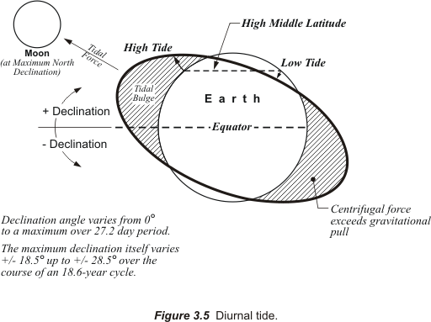

The declination of a celestial body is similar to the latitude of a point on the Earth. It is an angle measured at the center of the Earth from the plane of the equator, positive to the north and negative to the south, to the subject, which is in this case the Moon. The Moon’s declination varies from its minimum of 0º at the equator to its maximum over a 27.2-day period, and that maximum declination oscillates too. It goes from +/-18.5º up to +/-28.5º over the course of an 18.6-year cycle.
Another factor that contributes to the behavior of tides is the elliptical nature of the Moon’s orbit around the Earth. When the Moon is closest to the Earth, that is its perigee, the gravitational force between the Earth and the Moon is 20% greater than usual. At apogee, when the Moon is farthest from the Earth the force is 20% less than usual. The variations in the force have exactly the affect you would expect on the tides, making them higher and lower than usual. It is about 27.5 days from perigee to perigee.

To summarize, the Moon’s orbital period is 27.3 days. It also takes 27.2 days for the Moon to move from its maximum declinations back to 0º directly over the equator. And there are 27.5 days from one perigee to the next. You can see that these cycles are almost the same, almost, but not quite. They are just different enough that it takes from 18 to 19 years for the Moon to go through the all the possible combinations of its cycles with respect to the Sun and the Moon. And therefore, if you want to be certain that you have recorded the full range of tidal variation at a place you must observe and record the tides at that location for 19 years.

This 19-year period, sometimes called the Metonic cycle, is the foundation of the definition of Mean Sea Level. Mean Sea level, MSL, can be defined as the arithmetic mean of hourly heights of the sea at a primary-control tide station observed over a period of 19 years. The mean in Mean Sea Level refers to the average of these observations over time at one place. It is important to note that it does not refer to an average calculation made from measurements at several different places. Therefore, when the Sea Level Datum of 1929 was fixed to MSL at 26 tide stations that meant it was made to fit 26 different and distinct Local Mean Sea Levels. In other words, it was warped to coincide with 26 different elevations.

The topography of the sea changes from place to place and that means, for example, that MSL in Florida is not the same as MSL in California. The fact is Mean Sea Level varies. And the water’s temperature, salinity, currents, density, wind and other physical forces all cause changes in the sea surface’s topography. For example, the Atlantic Ocean north of the Gulf Stream’s strong current is around 1m lower than it is further south. And the more dense water of the Atlantic is generally about 40 cm lower than the Pacific. At the Panama Canal the actual difference is about 20 cm from the east end to the west end.

Evolution of the Vertical Datum
After it was formally established, thousands of miles of leveling were added to the Sea Level Datum of 1929, SLD29. The Canadian network also contributed data to the Sea Level Datum of 1929, but Canada did not ultimately use what eventually came to be known as the National Geodetic Vertical Datum of 1929, NGVD 29. The name was changed in 1973 because in the end the final result did not really coincide with Mean Sea Level. It became apparent that the precise leveling done to produce the fundamental data had great internal consistency, but when the network was warped to fit so many tide station determinations of Mean Sea Level that consistency suffered.

By the time the name was changed to NGVD29 there were more than 400,000 miles of new leveling work included. There were distortions in the network. Original benchmarks had been disturbed, destroyed or lost. The NGS thought it time to consider a new adjustment. This time there was a different approach. Instead of fixing the adjustment to tidal stations the new adjustment would be minimally constrained. That means that it would be fixed to only one station not 26. That station turned out to be Father Point/Rimouski, an International Great Lakes Datum of 1985, IGLD 85 station near the mouth of the St. Lawrence River and on its southern bank. In other words, for all practical purposes the new adjustment of the huge network was not intended to be a sea level datum at all. It was a change in thinking that was eminently practical.
While is it relatively straightforward to determine Mean Sea Level in coastal areas carrying that reference reliably to the middle of a continent is quite another matter. Therefore, the new datum would not be subject to the variations in sea surface topography. It was unimportant whether the new adjustment’s zero elevation and Mean Sea Level were the same thing or not.

The zero point
At this stage it is important to mention that throughout the years there were, and continue to be, benchmarks set and vertical control work done by official entities in federal, state and local governments other than NGS. State Departments of Transportation, city and county engineering and public works departments, the United States Army Corps of Engineers and many other governmental and quasi-governmental organizations have established their own vertical control networks. Included on this list is the United States Geological Survey, USGS. In fact, minimizing the effect on the widely used USGS mapping products was an important consideration in designing the new datum adjustment. Several of these agencies including the National Oceanic and Atmospheric Administration, NOAA, the United States Army Corps of Engineers, the Canadian Hydrographic Service, and the Geodetic Survey of Canada worked together for the development of the International Great Lakes Datum 1985, IGLD 1985. This datum was originally established in 1955 to monitor the level of the water in the Great Lakes.

Precise leveling proceeded from the zero reference established at Pointe-au-Père, Quebec in 1953. The resulting benchmark elevations were originally published in September 1961. The result of this effort was International Great Lakes Datum 1955. After nearly 30 years the work was revised. The revision effort began in 1976 and the result was IGLD 1985. It was motivated by several developments including deterioration of the zero reference point gauge location and improved surveying methods. But one of the major reasons for the revision was the movement of previously established benchmarks due to isostatic rebound. This effect is literally the Earth’s crust rising slowly, rebounding, from the removal of the weight and subsurface fluids caused by the retreat of the glaciers from the last ice age.

The choice of the tide gauge at Pointe-au-Père, Quebec as the zero reference for IGLD was logical in 1955. It was reliable. It had already been connected to the network with precise leveling. It was at the outlet of the Great Lakes. But by 1984 the wharf at Pointe-au-Père had deteriorated and the gauge was eventually moved about 3 miles to Rimouski, Quebec and precise levels were run between the two. It was there that the zero reference for IGLD 1985 and what then became a new adjustment called North American Vertical Datum 1988 ( NAVD88) was established.

The re-adjustment, known as NAVD88, was begun in the 1970s. It addressed the elevations of benchmarks all across the nation. The effort also included field work. Destroyed and disturbed benchmarks were replaced. The kilometers of leveling data increased from 75,159 km (46,701 miles) used in the establishment of NGVD29 to 1,001,500 km (622,303 miles) used in the establishment of NAVD88. NAVD88 was ready in June of 1991. The differences between elevations of benchmarks determined in NGVD29 compared with the elevations of the same benchmarks in NAVD88 vary from approximately –1.3 feet in the east to approximately +4.9 feet in the west in the 48 coterminous states of the United States. The larger differences tend to be on the coasts, as one would expect since NGVD29 was forced to fit Mean Sea Level at many tidal stations and NAVD88 was held to just one.

When comparing heights in IGLD 85 and NAVD88 it is important to consider that they are both based on the zero point at Father Point/Rimouski. There is really only one difference between the nature of the heights in the two systems. NAVD 88 values are expressed in Helmert orthometric height units and IGLD 85 elevations are given in dynamic height units. The explanation of this difference requires introduction of some important principles of the current understanding of heights.

So far there has been mention of heights based on the ellipsoidal model of the Earth and heights that use Mean Sea Level as their foundation. While ellipsoidal heights are not affected by any physical forces at all, heights based on Mean Sea Level are affected by a broad range of them. There is another surface to which heights are referenced that is defined by only one force, gravity. It is known as the geoid.

The Geoid
Any object in the Earth’s gravitational field has potential energy derived from being pulled toward the Earth. Quantifying this potential energy is one way to talk about height, because the amount of potential energy an object derives from the force of gravity is related to its height.
Here is another way of saying the same thing. The potential energy an object derives from gravity equals the work required to lift it to its current height. Imagine several objects, each with the same weight, resting on a truly level floor. In that instance they would all be possessed of the same potential energy from gravity. Their potential energies would be equal. The floor on which they were resting could be said to be a surface of equal potential, an equipotential surface.

Now suppose that each of the objects was lifted up onto a level table. It is worth mentioning that they would be lifted through a large number of equipotential surfaces between the floor and the table top, and those surfaces are not parallel with each other. In any case, their potential energies would obviously be increased in the process. Once they were all resting on the table their potential energies would again be equal, now on a higher equipotential surface, but how much higher?

There is more than one way to answer that question. One way is to find the difference in their geopotential, which is their potential energy on the floor, thanks to gravity, compared with their geopotential on the table. This is the same idea behind answering with a dynamic height. Another way to answer the question is to simply measure the distance along a plumb line from the floor to the tabletop. This latter method is the basic idea behind an orthometric height. An orthometric height can be illustrated by imagining that the floor in the example is a portion of one particular equipotential surface called the geoid.

The geoid is a unique equipotential surface that best fits Mean Sea Level. As you know, Mean Sea Level is not a surface on which the geopotential is always the same; so it is not an equipotential surface at all. Forces other than gravity affect it, forces such as temperature, salinity, currents, wind and etc. On the other hand, the geoid by definition is an equipotential surface. It is defined by gravity alone. Further, it is the particular equipotential surface arranged to fit Mean Sea Level as well as possible, in a least squares sense. Across the geoid the potential of gravity is always the same.

So while there is a relationship between Mean Sea Level and the geoid, they are not the same. They could be the same if the oceans of the world could be utterly still, completely free of currents, tides, friction, variations in temperature and all other physical forces, except gravity. Reacting to gravity alone, these unattainable calm waters would coincide with the geoid. If the water was then directed by small frictionless channels or tubes and allowed to migrate across the land, the water would then, theoretically, define the same geoidal surface across the continents, too. Of course, the 70 percent of the earth covered by oceans is not so cooperative, and the physical forces cannot really be eliminated. These unavoidable forces actually cause Mean Sea Level to deviate up to 1, even 2, meters from the geoid.

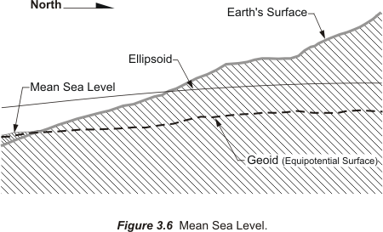

Because the geoid is completely defined by gravity it is not smooth. As shown in the exaggerated illustration Figure 3.7 it is lumpy. The geoid is lumpy because gravity is not consistent across the surface of the Earth. It undulates with the uneven distribution of the mass of the earth. It has all the irregularity that the attendant variation in gravity implies. In fact, the separation between the lumpy surface of the geoid and the smooth GRS80 ellipsoid worldwide varies from about +85 meters west of Ireland to about -106 meters, the latter in the area south of India near Ceylon.

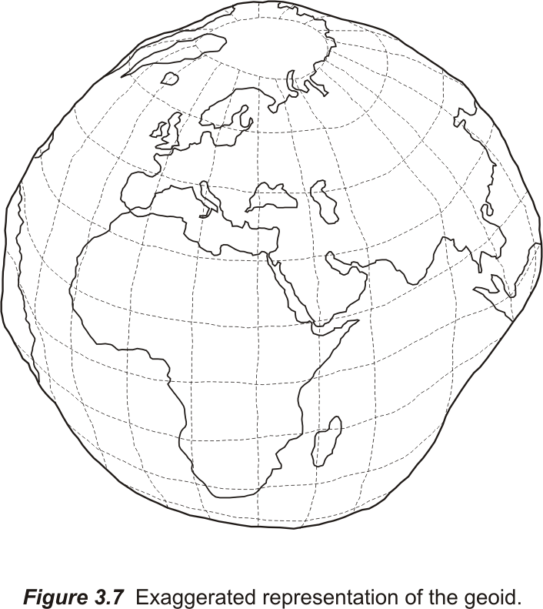

At every point gravity has a magnitude and a direction. Anywhere on the Earth, a vector can describe gravity, but these vectors do not all have the same direction or magnitude. Some parts of the Earth are denser than others. Where the Earth is denser, there is more gravity and the fact that the Earth is not a sphere also affects gravity. It follows then that defining the geoid precisely involves actually measuring the direction and magnitude of gravity at many places, but how?

Measuring Gravity
Some gravity measurements are done with a class of instruments called gravimeters, which were introduced in the middle of the last century. One sort of gravimeter can be used to measure the relative difference in the force of gravity from place to place. The basic idea of this kind of gravimeter is illustrated by considering the case of one of those weights described in the earlier analogy suspended at the end of a spring. Suppose the extension of the spring was carefully measured with the gravimeter on the table and measured again when it was on the floor. If the measurement of such a tiny difference were possible the spring would be found to be infinitesimally longer on the floor because the magnitude of gravity increases as you move lower. In practice such a measurement is quite difficult so it is the increases in the tension on the spring necessary to bring the weight back to a predefined zero point that is actually measured.

Conversely suppose the tension of the spring was carefully measured with the gravimeter on the floor and measured again on the table. The spring would be shortened and the tension on the spring would need to decrease to bring the weight back to the zero point. This is because the spinning of the Earth on its axis creates a centrifugal, center fleeing, force.

Centrifugal force opposes the downward gravitational attraction. And these two forces are indistinguishably bound up with each other. Therefore, measurements made by gravimeters on the Earth inevitably contain both centrifugal and gravitational forces. It is impossible to pry them apart. An idea called the Equivalence Principle states that the effects of being accelerated to a velocity are indistinguishable from the effects of being in a gravitational field. In other words there is no physical difference between an accelerating frame of reference and the same frame of reference in a gravitational field. So they are taken together. In any case, as you go higher the centrifugal force increases and counteracts the gravitational attraction to a greater degree than it does at lower heights and so, generally speaking, gravity decreases the higher you go.

Now please recall that the Earth closely resembles an oblate spheroid. That means that the distance from the center of the planet to a point on the equator is longer than the distance from the center to the poles. Said another way the Earth is generally higher at the equator than it is at the poles. As a consequence the acceleration of a falling object is less at the equator than at the poles. Less acceleration of gravity means that if you drop a ball at the equator the rate at which its fall would accelerate would be less than if you dropped it at one of the poles. As a matter of fact that describes the basic idea behind another kind of gravimeter. In this second kind of gravimeter the fall of an object inside a vacuum chamber is very carefully measured.

The acceleration of gravity, that is the rate at which a falling object changes its velocity, is usually quantified in gals, a unit of measurement named for Galileo, who pioneered the modern understanding of gravity. What is a gal? Well, imagine an object is dropped. At the end of the first second it is falling at 1 cm per second. Then at the end of the next second it is falling at 2 cm per second. In this thought experiment the imagined object would have accelerated 1 gal. Said another way, 1 gal is an acceleration of 1 cm per second per second.

At the equator the average acceleration of a falling object is approximately 978 gals, that is 978 cm/sec² or 32.09 ft/sec². At the poles the acceleration of a falling object increases to approximately 984 gals, which is 984 cm/sec2 or 32.28 ft/sec2. The acceleration of a falling object at 45º latitude is between these two values, as you would expect. It is 980.6199 gals. This value is sometimes called normal gravity.

Orthometric Correction

This increase in the rate of acceleration due to gravity between the equator and the poles is a consequence of the increase in the force of gravity as the Earth’s surface gets closer to the center of mass of the Earth. Imagine the equipotential surfaces that surround the center of mass of the Earth as the layers of an onion. These layers are farther apart at the equator than they are at the poles. This is because there is a larger centrifugal force at 0º Latitude compared with the centrifugal force at 90º Latitude. In other words, equipotential surfaces get closer together as you approach the poles, they converge. And the effect of this convergence becomes more pronounced as the direction of your route gets closer to north and south.
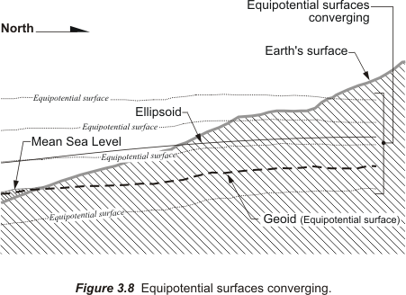

This effect was mentioned as far back as 1899. It was discovered that the precise leveling run in an east-west direction required less correction than leveling done in a north or south direction. Eventually, a value known as an orthometric correction was applied to accommodate the convergence of the equipotential surfaces. As Howard Rappleye wrote, “

The instruments and methods used in 1878 were continued in use until 1899, when, as the result of an elaborate theoretical investigation, it was found that apparently the leveling was subject to a systematic error depending on the azimuth of the line of levels. . . The leveling of the Coast and Geodetic Survey was then corrected for the systematic error.
(Rappleye 1948: 1)

In the years that led up to the establishment of NGVD 29 gravity data was mostly unavailable and the actual correction applied was based on an ellipsoidal model. The result is known as normal orthometric heights and do not take account of local variations in gravity.

The application of the orthometric correction means that the height difference derived from leveling between two points will not exactly match the difference between orthometric heights. This is a consequence of the fact that the line of sight of a properly balanced level will follow an equipotential surface, that is a level surface, but orthometric heights after their correction are not exactly on a level surface. Consider two points, two benchmarks, with the same published orthometric height, one north and one south. The orthometric height of the south benchmark as measured along a plumb line from the geoid will pass through fewer level surfaces than the same measurement to the benchmark at the north end. For example, the orthometric height of the water surface at the south end of Lake Huron seems to indicate that it is approximately 5 centimeters higher than the same equipotential surface at the north end. The orthometric heights make it look this way because the equipotential surfaces are closer together at the north end than they are at the south end. But precise levels run from the south end of the lake to the north would not reflect the 5-centimeter difference because the line of sight of the level would actually follow the equipotential surface all the way.

In other words, the convergence of equipotential surfaces prevents leveling from providing the differences between points as it is defined in orthometric heights. And the amount of the effect depends on the direction of the level circuit. The problem can be alleviated somewhat by applying an orthometric correction based on the measurement of gravity. An orthometric correction can amount to 0.04 ft per mile in mountainous areas. It is systematic and is not eliminated by careful leveling procedures.

It is worthwhile to note that NGS publishes their height data as Helmert orthometric heights. This is a particular type of orthometric height that does not take account of the gravitational effect of topographic relief. As a consequence they can lead to a certain level of misclosure between GPS determined benchmarks and the geoid model in mountainous areas.

Ellipsoid, Geoid and Orthometric Heights

The distance measured along a line perpendicular to the ellipsoid from the ellipsoid of reference to the geoid is known as a geoid height. It is usually symbolized, N. In the coterminous United States, sometimes abbreviated CONUS, geoid heights vary from about -8 meters to about -53 meters in NAD83. These are larger than those in the old NAD27 system. Please recall that its orientation at Meades Ranch, Kansas was arranged so that the distance between the Clarke 1866 ellipsoid and the geoid was zero. And across the United States the difference between them in NAD27 never grew to more than 12 meters. In fact, for all practical purposes the ellipsoid and the geoid were often assumed to coincide in that system. However, in NAD83, based on the GRS80 ellipsoid, the geoid heights are larger and negative. If the geoid is above the ellipsoid, N is positive if the geoid is below the ellipsoid, N is negative. Throughout the coterminous United the geoid is underneath the ellipsoid. In Alaska it is the other way around, the ellipsoid is underneath the geoid and N is positive.

As shown in Figure 3.9 please recall that an ellipsoid height is symbolized, h. The ellipsoid height is also measured along a line perpendicular to the ellipsoid of reference, but to a point on the surface of the Earth. An orthometric height, symbolized, H, is measured along a plumb line from the geoid to a point on the surface of the Earth.

In either case by using the formula,
H= h – N

one can convert an ellipsoidal height, h, derived say from a GPS observation, into an orthometric height, H, by knowing the extent of geoid-ellipsoid separation, the geoid height, N, at that point.
As you can see from Figure 3.9 the ellipsoid height of a particular point is actually smaller than the orthometric height throughout the coterminous United States.
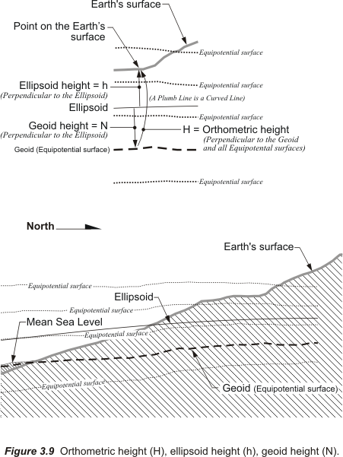

The formula H = h – N does not account for the fact that the plumb line along which an orthometric height is measured is curved as you see in Figure 3.9. Curved because it is perpendicular with each and every equipotential surface through which it passes. And since equipotential surfaces are not parallel with each other, the plumb line must be curve to maintain perpendicularity with them. This deviation of a plumb line from the perpendicular to the ellipsoid reaches about 1 minute of arc in only the most extreme cases. Therefore, any height difference that is caused by the curvature is negligible. It would take a height of over 6 miles for the curvature to amount to even 1 mm of difference in height.

It might be pertinent to ask, why use orthometric heights at all? One answer is the accommodation of GPS measurements. Orthometric elevations are not directly available from the geocentric position vectors derived from GPS measurements, however they can be rather quickly calculated using, H= h – N. That is once a geoidal model is well defined.

NGS GEOID Models

The geoid defies the certain, clear definition of, say, the GRS80 ellipsoid. It does not precisely follow Mean Sea Level, and neither does it exactly correspond with the topography of the dry land. It is irregular like the terrestrial surface, and has similar peaks and valleys, but they are due to the uneven distribution of the mass of the planet. The undulations of the geoid are defined by gravity and reflect changes in density known as gravity anomalies. Gravity anomalies are the difference between the equipotential surface of so-called normal gravity, which theoretically varies with latitude, and actual measured gravity at a place. The calculation of geoid heights using gravity anomalies, Δg, is usually done with the formula derived in 1849 by George Stokes, but its effectiveness depends on the accuracy of the modeling of the geoid around the world.

With the major improvements in the mapping the geoid on both national and global scales over the past quarter century geoid modeling has become more and more refined. To some degree this is due to improvements in data gathering. For example, gravimeter surveys on land routinely detect gravity anomalies to a precision of 1 part in a million. Surveys with a precision of 0.01 milligal, that is one hundredth of one thousandth of a gal, are common. And GPS allows the accurate positioning of gravimetric stations. Further there is the advantage that there is good deal of gravimetric information available through governmental agencies and universities around the world, though the distribution of the data may not be optimal. And new satellite altimetry missions also contribute to the refinement of geoid modeling.

New and improved data sources have led to applications built on better computerized modeling at NGS. For many years these applications have been allowing users to easily calculate values for N, the geoid height, which is the distance between the geoid and the ellipsoid, at any place as long as its latitude and longitude are available. The computer model of the geoid has been steadily improving. The latest of these to become available is known as GEOID09.

The GEOID90 model was rolled out at the end of 1990. It was built using over a million gravity observations. The GEOID93 model, released at the beginning of 1993 utilized many more gravity values. Both provided geoid heights in a grid of 3 minutes of latitude by 3 minutes of longitude and their accuracy was about 10cm. Next the GEOID96 model with a grid 2 minutes of latitude by 2 minutes of longitude was released. More recently GEOID99 was available to cover the coterminous United States, and includes U.S. Virgin Islands, Puerto Rico, Hawaii and Alaska. It was computed using 2.6 million gravity measurements. The grid was 1 minute of latitude by 1 minute of longitude. In practical terms GEOID 96 was matched to NAVD88 heights on about 3000 benchmarks with an accuracy of about +/- 5.5 cm (1-sigma), whereas GEOID 99 was matched to NAVD88 heights on about 6000 benchmarks with an accuracy of about +/- 4.6 cm (1-sigma). GEOID99 was the first of the models to combine gravity values with GPS ellipsoidal heights on previously leveled benchmarks. Therefore, users relying on GEOID99 could trust its representation of the relationship between GPS ellipsoid heights in NAD 83 with orthometric heights in the NAVD 88 datum.

GEOID03 was also a model of the coterminous United States (CONUS). It superseded the previously mentioned models. It was built with a combination of gravity data and ellipsoid heights derived from GPS at 14,185 leveled bench marks including 579 in Canada. In Alaska where there was a shortage of such information. Generally, GEOID03 provided data valid to about +/- 2.4 cm (1-sigma) for the conversion between NAD 83 GPS ellipsoidal heights and NAVD 88 orthometric heights. The state with the smallest standard deviation in this regard is Connecticut (1.3 cm) and that with the largest is Texas (5.8 cm). Nationwide GEOID03 was a 50% improvement over GEOID99. This improvement was due, in part, to the more complicated analytic function that was used in the development of GEOID03 than was available for GEOID99. Differences of 10-15 cm are possible in some coastal and mountainous areas between the two models.

GEOID09 is a one arc-minute model and that covers the continental United States, CONUS. . The GEOID09 models for the other states & territories serve a similar function with respect to the local vertical datums and have similar quality.

GEOID09 is the recognized standard for transforming between NAD 83 and NAVD 88 for most geodetic and surveying applications. It is an improvement over GEOID03 as it is based on the most recent GPS-derived ellipsoidal heights on leveled bench marks in the NGS database. The National Readjustment of 2007 (NRA2007) caused shifts in the official ellipsoidal heights of benchmarks, which were reflected in new geoid heights. These shifts caused delays in the roll-out of the new geoid. It was originally intended to be GEOID06, and then GEOID07, which became GEOID08, and finally became GEOID09.

Please note that it is always good practice to include existing bench marks in GPS surveys so that the difference between their published elevations and the heights derived through the use of the GEOID09 model can be compared. This is especially true in areas such as western states where the sparseness of data restricted the ability to refine the model and in areas where subsidence is significant.

Dynamic Heights
Now please recall that an orthometric height is a measurement along a plumb line from a particular equipotential surface to a point on the Earth’s surface. In other words, the orthometric height of that point is its distance from the reference surface, a distance that is measured along the line perpendicular to every equipotential surface in between. And these equipotential surfaces are not parallel with each other, chiefly because of gravity anomalies and the rotation and shape of the Earth. Therefore, it follows that two points could actually have the same orthometric height and not be on the same equipotential surface. A rather odd fact and it has an unusual implication. It means that water might actually flow between two points that have exactly the same orthometric height.

This is one reason that the International Great Lakes Datum of 1985 is based on dynamic heights. Unlike orthometric heights, two points with identical dynamic heights are definitely on the same equipotential surface. Two points would have to have different dynamic heights for water to flow between them. And the flow of water is a critical concern for those using that system.

Because one can rely that points with the same dynamic heights are always on the same equipotential surface they are better indicators of the behavior of water than orthometric heights.
An advantage of using dynamic heights is the sure indication of whether a water surface, or any other surface for that matter, is truly level or not. For example, the Great Lakes are monitored by tide gauges to track historical and predict future water levels in the lakes and it is no surprise then that the subsequent International Great Lakes Datum of 1985, IGLD85, heights are expressed as dynamic heights. Where the lake surfaces are level the dynamic heights are the same, and where they are not it is immediately apparent because the dynamic heights differ.
Points on the same equipotential surface also have the same geopotential numbers along with the same dynamic heights. The idea of measuring geopotential by using geopotential numbers was adopted by the International Association of Geodesy in 1955. The geopotential number of a point is the difference between the geopotential below the point, down on the geoid, and the geopotential right at the point itself. Said another way, the geopotential number expresses the work that would be done if a weight were lifted from the geoid up to the point, like the weights that were lifted onto a table in the earlier analogy. A geopotential number is expressed in geopotential units, or gpu A gpu is 1 kilogal meter.

Geopotential numbers along with a constant contribute the calculation of dynamic heights. The calculation itself is simple.
$H_{p}^{\text{dyn}}$=$\frac{C_{p}}{γ_{0}}$

Where $H_{p}^{\text{dyn}}$ is the dynamic height of a point in meters, $C_{p}$ is the geopotential number at that point in gpu, that is kilogals per meter and γ₀ is the constant 0.9806199 kgals. The constant is normal gravity at 45º latitude on GRS80.

The dynamic height of a point is found by dividing its NAVD88 geopotential number by the normal gravity value. In other words, dynamic heights are geopotential numbers scaled by a particular constant value chosen in 1984 to be normal gravity at 45º latitude on the GRS80 reference ellipsoid. The whole point of the calculation is to transform the geopotential number that is in kilogals per meter into a dynamic height in meters by dividing by the constant that is in kilogals. Here is an example calculation of the dynamic height of station M 393, an NGS benchmark.
$H^{\text{dyn}}$=$\frac{C}{γ_{0}}$
$H^{\text{dyn}}$=$\frac{\text{1660}\text{.}\text{419936}\text{gpu}}{0\text{.}\text{9806199}\text{kgals}}$
$H^{\text{dyn}}$ = 1693.235 m

The NAVD88 orthometric height of this benchmark determined by spirit leveling is 1694.931 meters and differs from its calculated dynamic height by 1.696 meters. However, using the same formula and the same geopotential number, but divided by a gravity value derived from the Helmert height reduction formula, the result would be a Helmert orthometric height for M 393, instead of its dynamic height. Note that the geopotential number stays the same in both systems. And there is a third, if the divisor were a gravity value calculated with the international formula for normal gravity, the answer would be the normal orthometric height for the point.

Rappleye, H. S. Manual of Geodetic Leveling, Special Publication No. 239, Washington, D.C.: U.S. Department of Commerce, Coast and Geodetic Survey, 1948.

Module 4

STATE PLANE COORDINATES

State Plane Coordinates rely on an imaginary flat reference surface with Cartesian axes. They describe measured positions by ordered pairs, expressed in northings and eastings, or x- and y- coordinates. Despite the fact that the assumption of a flat earth is fundamentally wrong, calculation of areas, angles and lengths using latitude and longitude can be complicated, so plane coordinates persist. Therefore, the projection of points from the Earth’s surface onto a reference ellipsoid and finally onto flat maps is still viable.

In fact, many agencies of government, particularly those that administer state, county and municipal databases prefer coordinates in their particular State Plane Coordinate System, SPCS. The systems are, as the name implies, state specific. In many states the system is officially sanctioned by legislation. Generally speaking, such legislation allows surveyors to use State Plane Coordinates to legally describe property corners. It is convenient. A Cartesian coordinate and the name of the officially sanctioned system are sufficient to uniquely describe a position. The same fundamental benefit makes the SPCS attractive to government; it allows agencies to assign unique coordinates based on a common, consistent system throughout its jurisdiction.

Map Projection

State Plane Coordinate Systems are built on map projections. Map projection means representing a portion of the actual Earth on a plane. Done for hundreds of years to create paper maps, it continues, but map projection today is most often really a mathematical procedure done in a computer. However, even in an electronic world it cannot be done without distortion.

The problem is often illustrated by trying to flatten part of an orange peel. The orange peel stands in for the surface of the Earth. A small part, say a square a quarter of an inch on the side, can be pushed flat without much noticeable deformation. But when the portion gets larger problems appear. Suppose a third of the orange peel is involved, as the center is pushed down the edges tear and stretch, or both. And if the peel gets even bigger the tearing gets more severe. So if a map is drawn on the orange before it is peeled, the map gets distorted in unpredictable ways when it is flattened. And it is difficult to relate a point on one torn piece with a point on another in any meaningful way.

These are the problems that a map projection needs to solve to be useful. The first problem is the surface of an ellipsoid, like the orange peel, is nondevelopable. In other words, flattening it inevitably leads to distortion that is very difficult to model consistently. So, a useful map projection ought to start with a surface that is developable, a surface that may be flattened without all that unpredictable deformation. It happens that a paper cone or cylinder both illustrate this idea nicely. They are illustrations only, models for thinking about the issues involved.

If a right circular cone is cut from bottom to top up one of its elements that is perpendicular from the base, the cone can then be made completely flat without trouble. The same may be said of a cylinder cut up a perpendicular from base to base.

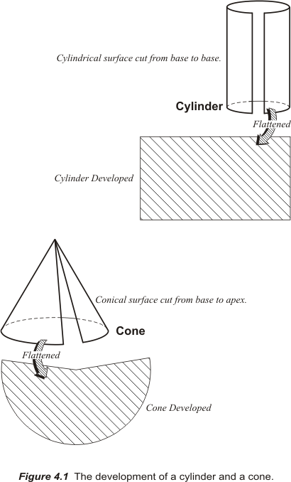

Or one could use the simplest case, a surface that is already developed, a flat piece of paper. If the center of a flat plane is brought tangent to the Earth, a portion of the planet can be mapped on it. In other words, a portion of the Earth can be projected directly onto the flat plane. In fact this is the typical method for establishing an independent local coordinate system. These simple Cartesian systems are convenient and satisfy the needs of small projects. The method of projection, onto a simple flat plane, is based on the idea that a small section of the Earth, as with a small section of the orange mentioned previously, conforms so nearly to a plane that distortion on such a system is negligible.

Subsequently, local tangent planes have been long used by land surveyors. Such systems demand little if any manipulation of the field observations and the approach has merit as long as the extent of the work is small. But the larger the plane grows the more untenable it becomes. As the area being mapped grows the reduction of survey observations becomes more complicated since it must take account of the actual shape of the Earth. This usually involves the ellipsoid, the geoid and geographical coordinates, latitude and longitude. At that point surveyors and engineers rely on map projections to mitigate the situation and limit the now troublesome distortion. However, a well-designed map projection can offer the convenience of working in plane Cartesian coordinates and still keep distortion at manageable levels.

The design of such a projection must accommodate some awkward facts. For example, while it would be possible to imagine mapping a considerable portion of the Earth using a large number of small individual planes, like facets of a gem, it is seldom done because when these planes are brought together they cannot be edge-matched accurately. They cannot be joined properly along their borders. And the problem is unavoidable because the planes, tangent at their centers, inevitably depart more and more from the reference ellipsoid at their edges. And the greater the distance between the ellipsoidal surface and the surface of the map on which it is represented, the greater the distortion on the resulting flat map. This is true of all methods of map projection. Therefore, one is faced with the daunting task of joining together a mosaic of individual maps along their edges where the accuracy of the representation is at its worst. And even if one could overcome the problem by making the distortion the same on two adjoining maps another difficulty would remain. Typically each of these planes has a unique coordinate system. The orientation of the axes, the scale and the rotation of each one of these individual local systems will not be the same as those elements of its neighbor’s coordinate system. Subsequently there are both gaps and overlaps between adjacent maps and their attendant coordinate systems. Without a common reference system the difficulties of moving from map to map are compounded.

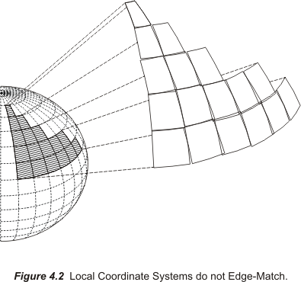

So the idea of a self-consistent local map projection based on small flat planes tangent to the Earth, or the reference ellipsoid, is convenient, but only for small projects that have no need to be related to adjoining work. And as long as there is no need to venture outside the bounds of a particular local system it can be entirely adequate. But, generally speaking, if a significant area is involved in the work another strategy is needed.

That is not to say that tangent plane map projections have no larger use. Please consider the tangent plane map projections that are used to map the polar areas of the Earth.

Polar Map Projections

These maps are generated on a large tangent plane touching the globe at a single point, the pole. Parallels of latitude are shown as concentric circles. Meridians of longitude are straight lines from the pole to the edge of the map. The scale is correct at the center. But just as the smaller local systems mentioned earlier, the farther you get from the center of the map the more they are distorted. These maps and this whole category of map projections are called azimuthal. The polar aspect of two of them will be briefly mentioned - the stereographic and the gnomonic. One clear difference in their application is the position of the imaginary light source.

A point light source is a useful device in imagining the projection of features from the Earth onto a developable surface. The rays from this light source can be imagined to move through a translucent ellipsoid and thereby project the image of the area to be mapped onto the mapping surface, like the projection of the image from film onto a screen. This is, of course, another model for thinking about map projection, an illustration.

In the case of the stereographic map projection this point light source is exactly opposite the point of tangency of the mapping surface. In Figure 4.3 the North Pole is the point of tangency. The light source is at the South Pole.
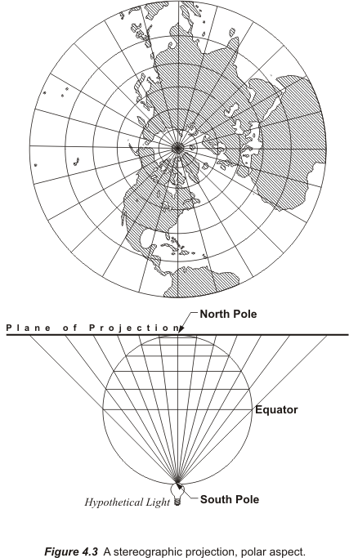

On this projection shapes are correctly shown. In other words, a rectangular shape on the ellipsoid can be expected to appear as a rectangular shape on the map with its right angles preserved. Map projections that have this property are said to be conformal.

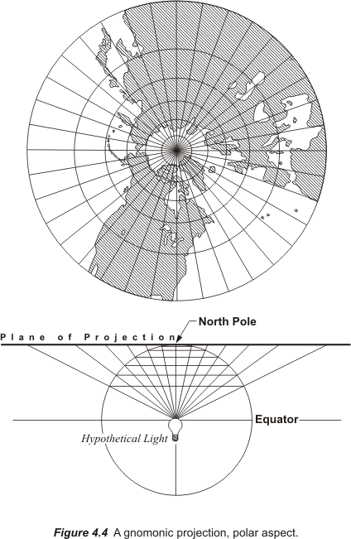

In another azimuthal projection, the gnomonic, the point light source moves from opposite the tangent point to the center of the globe. The term gnomonic is derived from the similarity between the arrangement of meridians on its polar projection and the hour marks on a sundial. The gnomon of a sundial is the structure that marks the hours by casting its shadow on those marks.

In Figure 4.3 and Figure 4.4 the point at the center of the map, the tangent point, is sometimes known as the standard point. In map projection places where the map and the ellipsoid touch are known as standard lines or points. These are the only places on the map where the scale is exact. Therefore, standard points and standard lines are the only places on a map and the resulting coordinates systems derived from them are really completely free of distortion.

As mentioned earlier, a map projection’s purpose informs its design. For example, the small individual plane projections first mentioned conveniently serve work of limited scope. Such a small-scale projection is easy to construct and can support Cartesian coordinates tailored to a single independent project with minimal calculations.

Plane polar map projections are known as azimuthal projections because the direction of any line drawn from the central tangent point on the map to any other point correctly represents the actual direction of that line. And the gnomonic projection can provide the additional benefit that the shortest distance between any two points on the ellipsoid, a great circle, can be represented on a gnomonic map as a straight line. It is also true that all straight lines drawn from one point to another on a gnomonic map represent the shortest distance between those points. These are significant advantages to navigation on air, land and sea. The polar aspect of a tangent plane projection is also used to augment the Universal Transverse Mercator projection. So there are applications for which tangent plane projections are particularly well suited, but the distortion at their edges makes them unsuitable for many other purposes.

Decreasing that distortion is a constant and elusive goal in map projection. It can be done in several ways. Most involve reducing the distance between the map projection surface and the ellipsoidal surface. One way this is done is to move the mapping surface from tangency with the ellipsoid and make it actually cut through it. This strategy produces a secant projection. A secant projection is one way to shrink the distance between the map projection surface and the ellipsoid. Thereby the area where distortion is in an acceptable range on the map can be effectively increased as shown in Figure 4.5.

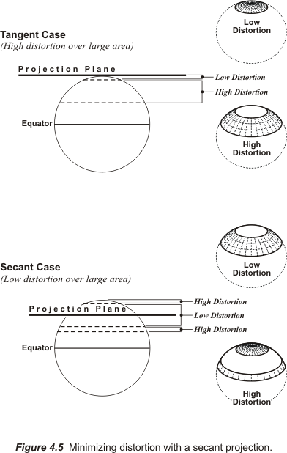

Another strategy can be added to this idea of a secant map projection plane. To reduce the distortion even more, one can use one of those developable surfaces mentioned
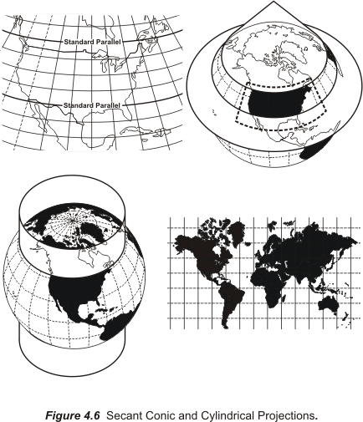

earlier, a cone or a cylinder. Both cones and cylinders have an advantage over a flat map projection plane. They are curved in one direction and can be designed to follow the curvature of the area to be mapped in that direction. Also, if a large portion of the ellipsoid is to be mapped several cones or several cylinders may be used together in the same system to further limit distortion. In that case, each cone or cylinder defines a zone in a larger coverage. This is the approach used in State Plane Coordinate systems.

As mentioned, when a conic or a cylindrical map projection surface is made secant, it intersects the ellipsoid, and the map is brought close to its surface. For example, the conic and cylindrical projections shown in Figure 4.6 cut through the ellipsoid. The map is projected both inward and outward onto it. And two lines of exact scale, standard lines, are created along the small circles where the cone and the cylinder intersect the ellipsoid. They are called small circles because they do not describe a plane that goes through the center of the Earth as do the previously mentioned great circles

Where the ellipsoid and the map projection surface touch, in this case intersect, there is no distortion. However, between the standard lines the map is under the ellipsoid and outside of them the map is above it. That means that between the standard lines a distance from one point to another is actually longer on the ellipsoid than it is shown on the map, and outside the standard lines a distance on the ellipsoid is shorter than it is on the map. Any length that is measured along a standard line is the same on the ellipsoid and on the map, which is why another name for standard parallels is lines of exact scale.

Choices

Here and in most mapping literature the cone and cylinder, the hypothetical light source and other abstractions are mentioned because they are convenient models for thinking about the steps involved in building a map projection. Ultimately, the goal is very straightforward, relating each position on one surface, the reference ellipsoid, to a corresponding position on another surface as faithfully as possible and then flattening that second surface to accommodate Cartesian coordinates. In fact, the whole procedure is in the service of moving from geographic to Cartesian coordinates and back again. These days the complexities of the mathematics are handled with computers. Of course, that was not always the case.

In the 1932, two engineers in North Carolina's highway department, O.B. Bester and George F. Syme, appealed to the then Coast and Geodetic Survey (C&GS, now NGS) for help. They had found that the stretching and compression inevitable in the representation of the curved Earth on a plane was so severe over long route surveys that they could not check into the C&GS geodetic control stations across a state within reasonable limits. The engineers suggested that a plane coordinate grid system be developed that was mathematically related to the reference ellipsoid, but could be utilized using plane trigonometry.

Dr. Oscar Adams of the Division of Geodesy, assisted by Charles Claire, designed the first State Plane Coordinate System to mediate the problem. It was based on a map projection called the Lambert Conformal Conic Projection. Dr. Adams realized that it was possible to use this map projection and allow one of the four elements of area, shape, scale or direction to remain virtually unchanged from its actual value on the Earth, but not all four. On a perfect map projection all distances, directions and areas could be conserved. They would be the same on the ellipsoid and on the map. Unfortunately, it is not possible to satisfy all of these specifications simultaneously, at least not completely. There are inevitable choices. It must be decided which characteristic will be shown the most correctly, but it will be done at the expense of the others. And there is no universal best decision. Still a solution that gives the most satisfactory results for a particular mapping problem is always available.

Dr. Adams chose the Lambert Conformal Conic Projection for the North Carolina system. On the Lambert Conformal Conic Projection parallels of latitude are arcs of concentric circles and meridians of longitude are equally spaced straight radial lines, and the meridians and parallels intersect at right angles. The axis of the cone is imagined to be a prolongation of the polar axis. The parallels are not equally spaced because the scale varies as you move north and south along a meridian of longitude. Dr. Adams decided to use this map projection in which shape is preserved based on a developable cone.

Map projections in which shape is preserved are known as conformal or orthomorphic. Orthomorphic means right shape. In a conformal projection the angles between intersecting lines and curves retain their original form on the map. In other words, between short lines, meaning lines under about 10 miles, a 45º angle on the ellipsoid is a 45º angle on the map. It also means that the scale is the same in all directions from a point; in fact, it is this characteristic that preserves the angles. These aspects were certainly a boon for the North Carolina Highway engineers and benefits that all State Plane Coordinate users have enjoyed since. On long lines, angles on the ellipsoid are not exactly the same on the map projection. Nevertheless, the change is small and systematic. It can be calculated.

Actually, all three of the projections that were used in the designs of the original State Plane Coordinate Systems were conformal. Each system was based on the North American Datum 1927, NAD27 originally. Along with the Oblique Mercator projection, which was used on the panhandle of Alaska, the two primary projections were the Lambert Conic Conformal Projection and the Transverse Mercator projection. For North Carolina, and other states that are longest east-west, the Lambert Conic projection works best. State Plane Coordinate systems in states that are longest north-south were built on the Transverse Mercator projection. There are exceptions to this general rule. For example, California uses the Lambert Conic projection even though the state could be covered with fewer Transverse Mercator zones. The Lambert Conic projection is a bit simpler to use, which may account for the choice.

The Transverse Mercator projection is based on a cylindrical mapping surface much like that illustrated in Figure 4.6. However, the axis of the cylinder is rotated so that it is perpendicular with the polar axis of the ellipsoid as shown in Figure 4.7. Unlike the Lambert Conic projection the Transverse Mercator represents meridians of longitude as curves rather than straight lines on the developed grid. The Transverse Mercator projection is not the same thing as the Universal Transverse Mercator system (UTM). UTM was originally a military system that covers the entire Earth and differs significantly from the Transverse Mercator system used in State Plane Coordinates.

The architect of both the Transverse Mercator projection, built on work by Gerardus Mercator, and the conformal conic projection that bears his name was Johann Heinrich Lambert an 18th century Alsation mathematician. His works in geometry, optics, perspective and comets are less known than his investigation of the irrationality of π. Surveyors, mappers and cartographers know Lambert’s mapping projections above all. It is especially remarkable that the projections he originated are used in every state of the United States, and both were first presented in his contribution, Beiträge zum Gebrauche der Mathematik und deren Anwendung, in 1772. Still the Lambert Conic projection was little used until the United States Coast and Geodetic Survey, encouraged by Dr. Adams and Charles Deetz, began publishing his theory and tables from which it could be applied in 1918.

In using these projections as the foundation of the State Plane Coordinate systems (SPCS) Dr. Adams wanted to have the advantage of conformality and also cover each state with as few zones as possible. A zone in this context is a belt across the state that has one Cartesian coordinate grid, with one origin and is projected onto one mapping surface. One strategy that played a significant role in achieving that end was Dr. Adams’s use of secant projections in both the Lambert and Transverse Mercator systems.

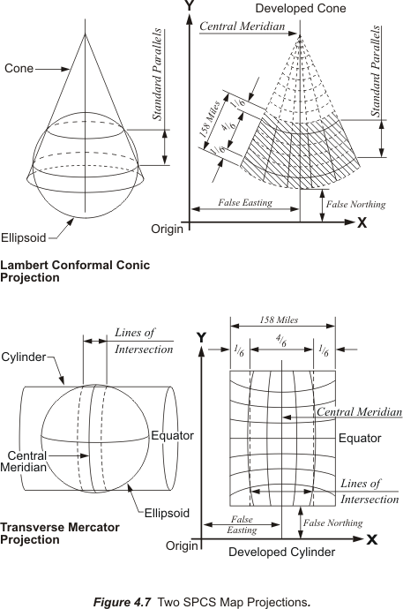

For example, using a single secant cone in the Lambert projection and limiting the extent of a zone, or belt, across a state to about 158 miles, approximately 254 km, Dr. Adams limited the distortion of the length of lines. Not only were angles preserved on the final product, but also there were minimal differences between the length of a measured line on the Earth’s surface and the length of the same line on the map projection, minimal for the measurement technology of the day. In other words, the scale of the distortion was pretty small.

As illustrated in Figure 4.7 he placed 4/6th of the map projection plane between the standard lines, 1/6th outside at each extremity. The distortion was held to 1 part in 10,000. A maximum distortion in the lengths of lines of 1 part in 10,000 means that the difference between the length of a 2-mile line on the ellipsoid and its representation on the map would only be about 1 foot at the most.

State Plane Coordinates were created to be the basis of a method that approximates geodetic accuracy more closely than the then commonly used methods of small-scale plane surveying. Today surveying methods can easily achieve accuracies beyond 1 part in 100,000 and better, but the State Plane Coordinate systems were designed in a time of generally lower accuracy and efficiency in surveying measurement. Today computers easily handle the lengthy and complicated mathematics of geodesy. But the first State Plane Coordinate System was created when such computation required sharp pencils and logarithmic tables. In fact, the original SPCS was so successful in North Carolina similar systems were devised for all the states in the Union within a year or so. The system was successful because, among other things, it overcame some of the limitations of mapping on a horizontal plane while avoiding the imposition of strict geodetic methods and calculations. It managed to keep the distortion of the scale ratio under 1 part in 10,000 and preserved conformality. It did not disturb the familiar system of ordered pairs of Cartesian coordinates and it covered each state with as few zones as possible whose boundaries were constructed to follow portions of county lines as much as possible, with some exceptions. The idea was that those relying on State Plane Coordinates could work in one zone throughout a jurisdiction.

SPCS27 to SPCS83

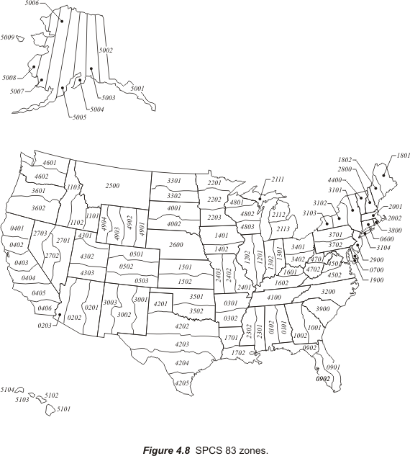

In Figure 4.8 the current boundaries of the State Plane Coordinates System zones are shown. In several instances they differ from the original zone boundaries. The boundaries shown in the figure are for SPCS83, the State Plane Coordinate System based on NAD83 and its reference ellipsoid GRS80. The foundation of the original State Plane Coordinate System, SPCS27 was NAD27 and its reference ellipsoid Clarke 1866. As mentioned in earlier modules NAD27 geographical coordinates, latitudes and longitudes, differ significantly from those in NAD83. In fact, conversion from geographic coordinates, latitude and longitude, to grid coordinates, x and y and back is one of the three fundamental conversions in the State Plane Coordinate system. It is important because the whole objective of the SPCS is to allow the user to work in plane coordinates, but still have the option of expressing any of the points under consideration in either latitude and longitude or State Plane Coordinates without significant loss of accuracy. Therefore, when geodetic control was migrated from NAD27 to NAD83 the State Plane Coordinate System had to go along.

When the migration was undertaken in the 1970s it presented an opportunity for an overhaul of the system. Many options were considered but in the end just a few changes were made. One of the reasons for the conservative approach was the fact that 37 states had passed legislation supporting the use of State Plane Coordinates. Nevertheless some zones got new numbers and some of the zones changed. The zones in Figure 4.8 are numbered in the SPCS83 system known as FIPS. FIPS stands for Federal Information Processing Standard, and each SPCS83 zone has been given a FIPS number. These days the zones are often known as FIPS zones. SPCS27 zones did not have these FIPS numbers. As mentioned earlier the original goal was to keep each zone small enough to ensure that the scale distortion was 1 part in 10,000 or less. However, when the SPCS83 was designed that scale was not maintained in some states.

In five states some SPCS27 zones were eliminated altogether and the areas they had covered consolidation into one zone or added to adjoining zones. In three of those states the result was one single large zone. Those states are South Carolina, Montana and Nebraska. In SPCS27 South Carolina and Nebraska had two zones, in SPCS83 they have just one, FIPS zone 3900 and FIPS zone 2600 respectively. Montana previously had three zones. It now has one, FIPS zone 2500. Therefore, because the area covered by these single zones has become so large they are not limited by the 1 part in 10,000 standard. California eliminated zone 7 and added that area to FIPS zone 0405, formerly zone 5. Two zones previously covered Puerto Rico and the Virgin Islands. They now have one. It is FIPS zone 5200. In Michigan three Transverse Mercator zones were entirely eliminated.

In both the Transverse Mercator and the Lambert projection the positions of the axes are similar in all SPCS zones. As you can see in Figure 4.7 each zone has a central meridian. These central meridians are true meridians of longitude near the geometric center of the zone. Please note that the central meridian is not the y-axis. If it were the y-axis negative coordinates would result. To avoid them the actual y-axis is moved far to the west of the zone itself. In the old SPCS27 arrangement the y-axis was 2,000,000 feet west from the central meridian in the Lambert Conic projection and 500,000 feet in the Transverse Mercator projection. In the SPCS83 design those constants have been changed. The most common values are 600,000 meters for the Lambert Conic and 200,000 meters for the Transverse Mercator. However, there is a good deal of variation in these numbers from state to state and zone to zone. In all cases however, the y-axis is still far to the west of the zone and there are no negative State Plane Coordinates. No negative coordinates, because the x-axis, also known as the baseline, is far to the south of the zone. Where the x-axis and y- axis intersect is the origin of the zone and that is always south and west of the zone itself. This configuration of the axes ensures that all State Plane Coordinates occur in the first quadrant and are, therefore, always positive.
There is sometimes even further detail in the name of particular State Plane Coordinates. As refinements are made to NAD83 the new adjustments are added as a suffix to the SPCS83 label. For example, SPCS83/99 would refer to State Plane Coordinates that were based on a revision to NAD83 from 1999.

It is important to note that the fundamental unit for SPCS27 is the U.S. survey foot and for SPCS it is the meter. The conversion from meters to U.S. survey feet is correctly accomplished by multiplying the measurement in meters by the fraction 3937/1200.

In the following sections the most typical conversions used in State Plane Coordinates will be addressed:
- Conversion from geodetic lengths to grid lengths.
- Conversion from geographic coordinates, latitude and longitude, to grid coordinates.
- Conversion from geodetic azimuths to grid azimuths.
- Conversion from SPCS to ground coordinates.

Geodetic Lengths to Grid Lengths

This brings us to the scale factor, also known as the K factor and the projection factor. It was this factor that the original design of the State Plane Coordinate system sought to limit to 1 part in 10,000. As implied by that effort scale factors are ratios that can be used as multipliers to convert ellipsoidal lengths, also known as geodetic distances, to lengths on the map projection surface, also known as grid distances, and vice versa. In other words, the geodetic length of a line, on the ellipsoid, multiplied by the appropriate scale factor will give you the grid length of that line on the map. And the grid length multiplied by the inverse of that same scale factor would bring you back to the geodetic length again.

While referring to Figure 4.7 it is interesting to note that on the projection used most on states that are longest from east to west, that is the Lambert Conic, the scale factor for east-west lines is constant. In other words, the scale factor is the same all along the line. One way to think about this is to recall that the distance between the ellipsoid and the map projection surface never changes east to west in that projection. On the other hand along a north-south line the scale factor is constantly changing on the Lambert Conic. And it is no surprise then to see that the distance between the ellipsoid and the map projection surface is always changing north to south line in that projection. But looking at the Transverse Mercator projection, the projection used most on states longest north to south, the situation is exactly reversed. In that case, the scale factor is the same all along a north-south line, and changes constantly along an east-west line.

Both the Transverse Mercator and the Lambert Conic used a secant projection surface and originally restricted the width to 158 miles. These were two strategies used to limit scale factors when the State Plane Coordinate systems were designed. Where that was not optimum the width was sometimes made smaller, which means the distortion was lessened. As the belt of the ellipsoid projected onto the map narrows, the distortion gets smaller. For example, Connecticut is less than 80 miles wide north to south. It has only one zone. Along its northern and southern boundaries, outside of the standard parallels, the scale factor is 1 part in 40,000, a four-fold improvement over 1 part in 10,000. And in the middle of the state the scale factor is 1 part in 79,000, nearly an eight-fold improvement. On the other hand, the scale factor was allowed to get a little bit smaller that 1 part in 10,000 in Texas. By doing that the state was covered completely with five zones. And among the guiding principles in 1933 was covering the states with as few zones as possible and having zone boundaries follow county lines. Still it requires ten zones and all three projections to cover Alaska.

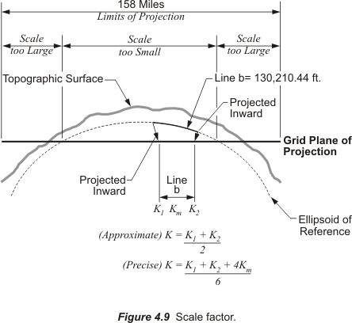

In Figure 4.9 a typical 158-mile State Plane Coordinate zone is represented by a grid plane of projection cutting through the ellipsoid of reference. As mentioned earlier between the intersections of the standard lines, the grid is under the ellipsoid. There, a distance from one point to another is longer on the ellipsoid than on the grid. This means that right in the middle of a SPCS zone the scale factor is at its minimum. In the middle a typical minimum SPCS scale factor is not less than 0.9999, though there are exceptions. Outside of the intersections the grid is above the ellipsoid where a distance from one point to another is shorter on the ellipsoid than it is on the grid. There at the edge of the zone a maximum typical SPCS scale factor is generally not more than 1.0001.

When SPCS 27 was current scale factors were interpolated from tables published for each state. In the tables for states in which the Lambert Conic projection was used scale factors change north-south with the changes in latitude. In the tables for states in which the Transverse Mercator projection was used scale factors change east-west with the changes in x-coordinate. Today scale factors are not interpolated from tables for SPCS83. For both the Transverse Mercator and the Lambert Conic projections they are calculated directly from equations.

There are several software applications that can be used to automatically calculate scale factors for particular stations. Perhaps the most convenient is that available free online at http://www.ngs.noaa.gov/PC_PROD/pc_prod.shtml. This is a link to the U.S. National Geodetic Survey, NGS, page where one can locate several programs that provide geodetic computational help. The program SPCS83 is available for download there. It can be used to convert latitudes and longitudes to State Plane Coordinates. Given the latitude and longitude of the stations under consideration part of the available output from the program are the scale factors for those stations. Scale factors for control stations are also available from NGS geodetic control datasheets.

To illustrate the use of these factors please consider line b in Figure 4.9 to have a length on the ellipsoid of 130,210.44 feet, a bit over 24 miles. That would be its geodetic distance. Suppose that a scale factor for that line was 0.9999536, then the grid distance along line b would be:

$\text{Geo}\text{det}\text{ic} \text{Dis}\text{tan}\text{ce}∗\text{Scale} \text{Factor}=\text{Grid} \text{Dis}\text{tan}\text{ce}$
$$\text{130},\text{210}\text{.}\text{44}\text{ft}\text{.}∗0\text{.}\text{999953617}=\text{130},\text{204}\text{.}\text{40}\text{ft}\text{.}$$

The difference between the longer geodetic distance and the shorter grid distance here is a little more than 6 feet. That is actually better than 1 part in 20,000; please recall that the 1 part in 10,000 ratio was considered the maximum. Distortion lessens and the scale factor approaches 1 as a line nears a standard parallel.

Please recall that on the Lambert projection an east-west line, which is a line that follows a parallel of latitude, has the same scale factor at both ends and throughout. However, a line that bears in any other direction will have a different scale factor at each end. A north-south line will have a great difference in the scale factor at its north end compared with the scale factor of its south end. In this vein, please note the approximate formula near the bottom of Figure 4.9:
$$K=\frac{K_{1}+K_{2}}{2}$$
Where K is the scale factor for a line, K₁ is the scale factor at one end of the line and
K₂ is the scale factor at the other end of the line. Scale factor varies with the latitude in the Lambert projection. For example, suppose the point at the north end of the 24-mile line is called Stormy and has a geographic coordinate of:
37º46’00. 7225”N latitude
103º46’35.3195”W longitude

and at the south end the point is known as Seven with a geographic coordinate of:
37º30’43.5867”N latitude
104º05’26.5420”W longitude

The scale factor for point Seven 0.99996113 and the scale factor for point Stormy is 0.99994609. It happens that point Seven is further south and closer to the standard parallel than is point Stormy, and it therefore follows that the scale factor at Seven is closer to 1. It would be exactly 1 if it were on the standard parallel, which is why the standard parallels are called lines of exact scale. The typical scale factor for the line is the average of the scale factors at the two end points:
$$K=\frac{K_{1}+K_{2}}{2}$$
$$0\text{.}\text{99995361 }=\frac{0\text{.}\text{99996113 }+0\text{.}\text{99994609}}{2}$$
Deriving the scale factor at each end and averaging them is the usual method for calculating the scale factor of a line. The average of the two is sometimes called K_{m}. In Figure 4.9 there is another formula for calculating a more precise scale factor by using a weighted average. In this method K₁ is given a weight of 1, K_{m} a weight of 4 and K₂ a weight of 1. No matter which method is used the result is still called the scale factor.

But that is not the whole story when it comes to reducing distance to the State Plane Coordinate grid. Measurement of lines must always be done on the topographic surface of the Earth, and not on the ellipsoid. Therefore the first step in deriving a grid distance must be moving a measured line from the Earth to the ellipsoid. In other words, converting a distance measured on the topographic surface to a geodetic distance on the reference ellipsoid. This is done with another ratio that is also used as a multiplier. Originally, this factor had a rather unfortunate name. It used to be known as the sea level factor in SPCS27. It was given that name because as you may recall from Modules 2 and 3 when NAD27 was established using the Clarke 1866 reference ellipsoid the distance between the ellipsoid and the geoid was declared to be zero at Meades Ranch in Kansas. That meant that in the middle of the country the “sea level” surface, the geoid, and the ellipsoid were coincident by definition. And since the Clarke 1866 ellipsoid fit the United States quite well the separation between the two surfaces, the ellipsoid and geoid only grew to about 12 meters anywhere in the country. With such a small distance between them many practitioners at the time took the point of view that, for all practical purposes, the ellipsoid and the geoid were in the same place. And that place was called “sea level.” Hence reducing a distance measure on the surface of the Earth to the ellipsoid was said to be reducing it to “sea level.”

Today that idea and that name for the factor is misleading because, of course, the GRS80 ellipsoid on which NAD83 is based is certainly not the same as Mean Sea Level. Now the separation between the geoid and ellipsoid can grow as large as –53 meters. And technology by which lines are measured has improved dramatically. Therefore, in SPCS83 the factor for reducing a measured distance to the ellipsoid is known as the ellipsoid factor. In any case, both the old and the new name can be covered under the name the elevation factor.

Regardless of the name applied to the factor, it is a ratio. The ratio is the relationship between an approximation of the Earth's radius and that same approximation with the mean ellipsoidal height of the measured line added to it. For example, please consider station Boulder and station Peak illustrated in Figure 4.10.

Boulder
39º59’29.1299” N latitude
105º15’39.6758” W longitude

Peak
40º01’19.1582” N latitude
105º30’55.1283” W longitude

The distance between these two stations is 72,126.21 feet. This distance is sometimes called the ground distance, or the horizontal distance at mean elevation. In other words it is not the slope distance but rather the distance between them corrected to an averaged horizontal plane, as is common practice. For practical purposes then this is the distance between the two stations on the topographic surface of the Earth. On the way to finding the grid distance Boulder to Peak there is the interim step, calculating the geodetic distance between them, that is the distance on the ellipsoid. We need the elevation factor and here is how it is determined.

The ellipsoidal height of Boulder, h_{1,} is 5437 feet. The ellipsoidal height of Peak, h₂, is 9099 feet. The approximate radius of the Earth, traditionally used in this work, is 20,906,000 feet. The elevation factor is calculated:
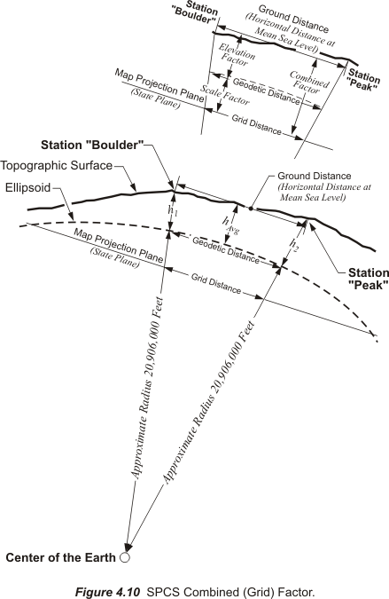
$$\text{Elevation} \text{Factor}=\frac{R}{R +h_{\text{avg}}}$$

$$\text{Elevation} \text{Factor}=\frac{\text{20},\text{906},\text{000}\text{ft}\text{.}}{\text{20},\text{906},\text{000}\text{ft}\text{.} +\text{7268}\text{ft}\text{.}}$$
$$\text{Elevation} \text{Factor}=\frac{\text{20},\text{906},\text{000}\text{ft}\text{.}}{\text{20},\text{913},\text{268}\text{ft}\text{.}}$$
$$\text{Elevation} \text{Factor}=0\text{.}\text{99965247}$$
This factor then is the ratio used to move the ground distance down to the ellipsoid, down to the geodetic distance.
$\text{Ground} \text{Dis}\text{tan}\text{ce} \text{Boulder} \text{to} \text{Peak}=\text{72},\text{126}\text{.}\text{21}\text{feet}$$\text{Geo}\text{det}\text{ic} \text{Dis}\text{tan}\text{ce}=\text{Ground} \text{Dis}\text{tan}\text{ce}∗\text{Elevation} \text{Factor}$
$$\text{Geo}\text{det}\text{ic} \text{Dis}\text{tan}\text{ce}=\text{72},\text{126}\text{.}\text{21}∗0\text{.}\text{99965247}$$
$$\text{Geo}\text{det}\text{ic} \text{Dis}\text{tan}\text{ce}=\text{72},\text{101}\text{.}\text{14}\text{feet}$$

It is possible to refine the calculation of the elevation factor by using an average of the actual radial distances from the center of the ellipsoid to the end points of the line, rather than the approximate 20,906,000 feet. In the area of stations Boulder and Peak the average ellipsoidal radius is actually a bit longer, but within the continental United States such variation will not cause a calculated geodetic distance to differ significantly. However, it is worthwhile to take care to use the ellipsoidal heights of the stations when calculating the elevation factor, rather than the orthometric heights.

In calculating the elevation factor in SPCS27 no real distinction is made between ellipsoid height and orthometric height. However, in SPCS83 the averages of the ellipsoidal heights at each end of the line can be used for h_{avg} . If the an ellipsoid height is not directly available it can be calculated from the formula

h = H + N
where:
h = ellipsoid height
H = orthometric height
N = geoid height

As mentioned previously converting a geodetic distance to a grid distance is done with an averaged scale factor:
$$K=\frac{K_{1}+K_{2}}{2}$$
In this instance the scale factor at Boulder is 0.99996703 and at Peak it is 0.99996477.
$$0\text{.}\text{99996590}=\frac{0\text{.}\text{99996703 }+0\text{.}\text{99996477}}{2}$$
Using the scale factor it is possible to reduce the geodetic distance 72,101.14 feet to a grid distance:

$$\text{Geo}\text{det}\text{ic} \text{Dis}\text{tan}\text{ce}∗\text{Scale} \text{Factor}=\text{Grid} \text{Dis}\text{tan}\text{ce}$$
$$\text{72},\text{101}\text{.}\text{14}\text{ft}\text{.}∗0\text{.}\text{99996590}=\text{72},\text{098}\text{.}\text{68}\text{ft}\text{.}$$

There are two steps, first from ground distance to geodetic distance using the elevation factor and second from geodetic distance to grid distance using the scale factor. These two steps can be combined into one. Multiplying the elevation factor and the scale factor produces a single ratio that is usually known as the combined factor or the grid factor. Using this grid factor the measured line is converted from a ground distance to a grid distance in one jump. Here is how it works. In the example above the elevation factor for the line from Boulder to Peak is 0.99965247 and the scale factor is 0.99996590:

$$\text{Grid} \text{Factor}=\text{Scale} \text{Factor}∗\text{Elevation} \text{Factor}$$
$$0\text{.}\text{99961838}=0\text{.}\text{99996590}∗0\text{.}\text{99965247}$$

Then using the grid factor the ground distance is converted to a grid distance

$$\text{Grid} \text{Dis}\text{tan}\text{ce}=\text{Grid} \text{Factor}∗\text{Ground} \text{Dis}\text{tan}\text{ce}$$
$$\text{72},\text{098}\text{.}\text{68}\text{ft}\text{.}=0\text{.}\text{99961838}∗\text{72},\text{126}\text{.}\text{21}\text{ft}\text{.}$$

Also the grid factor can be used to go the other way. If the grid distance is divided by the grid factor it is converted to a ground distance.
$\text{Ground} \text{Dis}\text{tan}\text{ce}=\frac{\text{Grid} \text{Dis}\text{tan}\text{ce}}{\text{Grid} \text{Factor}}$
$$\text{72},\text{126}\text{.}\text{21}\text{ft}\text{.}=\frac{\text{72},\text{098}\text{.}\text{68}\text{ft}\text{.}}{0\text{.}\text{99961838}}$$

Geographic Coordinates to Grid Coordinates
Please consider again two previously mentioned stations, Stormy and Seven.
Stormy has an NAD83 geographic coordinate of:

Latitude 37º46’00.7225” N latitude
Longitude 103º46’35.3195” W longitude

and Seven has an NAD83 geographic coordinate of:

Latitude 37º30’43.5867” N latitude
Longitude 104º05’26.5420” W longitude

Finding the State Plane Coordinates of these stations can be accomplished online. The NGS website http://www.ngs.noaa.gov/TOOLS provides several programs, and among them is one named State Plane Coordinates. It has two convenient routines that allow the user to convert a station from SPCS to latitude and longitude and vice versa in both NAD27 and NAD83 and discover its scale factor and convergence angle. It is interesting to note that the site also includes free routines for conversion from SPCS27 to SPCS83. The conversion is actually done in a three-step process. The SPCS27 coordinate is converted to an NAD27 geographic coordinate, a latitude and longitude. Next the NAD27 geographic coordinate is transformed into an NAD83 geographic coordinate and finally the NAD83 geographic coordinate becomes a SPCS83 coordinate. This procedure is common to nearly all GIS software. In any case using the State Plane Coordinates software it is possible to find the SPCS83 coordinates for these two stations:

Stormy: N 428,305.869
E 1,066,244.212

Seven: N 399,570.490
E 1,038,989.570

Both of these are in meters, the native unit of SPCS83. The original SPCS27 design was based on the use of the US Survey foot as its unit of measurement. That remains the appropriate unit for that system today. However, SPCS83 is a bit more complicated in that regard. While the fundamental unit for SPCS83 is the meter, when it comes to converting coordinates from meters to feet, one of two conversions is called for. One is the conversion from meters to US Survey feet. The other conversion is from meters to International feet. The International foot, so named because an international agreement was established to define one inch equal to 2.54 centimeters exactly, is equal to 0.3048 meters. And that version of the foot was adopted across the United States, except at the United States Coast and Geodetic Survey. In 1959 instead of forcing the USC&GS to refigure and re-publish all the control station coordinates across the country it was given a reprieve under the Federal Register Notice 24 FR 5348. The agency was allowed to retain the old definition of the foot, which is the US Survey foot, in which one meter is 39.37 inches exactly. Another way of saying it is a US Survey foot is 1200/3937 meters.

It was decided that the USC&GS could continue to use the US Survey foot until the national control network was readjusted, but following the adjustment the agency was to switch over to the International foot. Things did not quite work out that way. When NAD83 was fully established the agency that had replaced the USC&GS, the NGS, mandated that the official unit of all the published coordinate values would be the meter. Then in 1986 NGS declared it would augment its publication of State Plane Coordinates in meters with coordinates for the same stations in feet. Which foot? The version legislated by the state in which the station was found.

In practical terms this means that in states such as the 11 that have chosen the US Survey foot and the 6 that have chosen the International foot it is clear which should be used. However, 14 states do not specify the version of the foot that is official for their SPCS. And the remaining 19 states have no legislation on the State Plane Coordinates at all.

The difference between the two foot-units may seem an academic distinction, but please consider the conversion of station Stormy. It happens that the station is in the Colorado Zone 0503, or South Zone, and that state has chosen US Survey feet. It follows that the correct coordinate values for the station in US Survey feet are:

Stormy: N 1,405,200.17
E 3,498,169.55

However, if the metric coordinates for Stormy were mistakenly converted to International feet, they would be N 1,405,202.98 and E 3,498,176.55. The distance between the correct coordinate and the incorrect coordinate is more than 7 ½ feet with the largest difference occurring in the easting.

Conversion from geodetic azimuths to grid azimuths

As was mentioned in Module 1 meridians of longitude converge and that fact has an effect on the directions of lines in SPCS. To illustrate the rate of that convergence, please consider the east and west sides of a one square mile figure somewhere in the middle of the coterminous United States. Suppose that the two sides were both meridians of longitude on the surface of the Earth and the direction of both lines were the same, geodetic north. However, when that square mile figure is projected onto a Lambert Conic or Transverse Mercator SPCS their directions would no longer be equal. Their azimuths would suddenly differ by about 1-minute of arc. And unless one of the sides happens to follow the central meridian of the zone, neither of their azimuths would be grid north.

In SPCS the direction known as grid north is always parallel to the central meridian for the zone. The east and west lines of the square mile in the example follow meridians on the surface of the Earth. Meridians converge at the pole; they are not parallel to one another. In SPCS north is grid north and the lines of the grid are parallel to each other. They must also be parallel to the one another and the central meridian of the zone, so clearly geodetic north and grid north are not the same. In fact, it is only on that central meridian that grid north and geodetic north coincide. Everywhere else in the zone they diverge from one another and there is an angular distance between them. In SPCS27 that angular distance was symbolized with the Greek letter theta, θ, in the Lambert Conic projection and with delta alpha, Δα, in the Transverse Mercator projection. However, in SPCS83 convergence is symbolized with gamma, γ, in both the Lambert Conic and the Transverse Mercator projections.

In both map projections, east of the central meridian grid north is east of geodetic north and the convergence angle is positive. West of the central meridian grid north is west of geodetic north and the convergence angle is negative.

The angle between geodetic and grid north, the convergence angle, grows as the point gets further from the central meridian. It also gets larger as the latitude of the point increases. The formula for calculating the convergence in the Transverse Mercator projection is:

γ = (λ_{cm} –λ) sin φ

where:

λ_{cm =} the longitude of the central meridian
λ = the longitude through the point
φ ₌ the latitude of the point

The formula for calculating the convergence angle in the Lambert Conic projection is very similar it is:

γ = (λ_{cm} –λ) sin φ_{o}
where:

λ_{cm =} the longitude of the central meridian
λ = the longitude through the point
φ_{o =} the latitude of the center of the zone

As an example, here is the calculation of the convergence angle for station Stormy. It is in the Colorado South Zone on a Lambert Conic projection where the longitude of the central meridian is Longitude 105°30’00” West and φ_{o} is Latitude 37°50’02.34” North

γ = (λ_{cm} –λ) sin φ_{o}
γ = (105°30’00” –103º46’35.3195”) sin 37°50’02.34”
γ = (01°43’24.68”) sin 37°50’02.34”
γ = (1°43’24.68”) 0.6133756
γ = +1°03’25.8”

The angle is positive as expected east of the central meridian.

The formula used to convert a geodetic azimuth to a grid azimuth includes the convergence angle, and another element.

grid azimuth = geodetic azimuth – convergence + the second term

Another way of stating the same formula is:

t = α – γ + δ

in which
t = grid azimuth
α = geodetic azimuth
γ = the convergence angle
δ = the second term

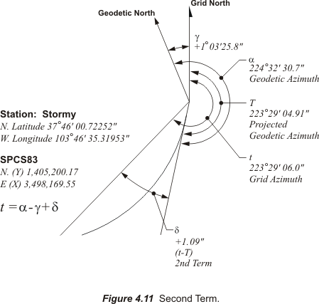

The second term is included because lines between stations on the ellipsoid are curved and that curvature is not completely eliminated when the geodetic azimuth line is projected onto the SPCS grid.

Several things affect the extent of the curve of the projected geodetic azimuth line on the grid. The direction of the line and the particular map projection from which the grid was created are two of those elements. For instance, a north-south line does not curve at all when projected onto the Lambert Conic grid and neither does an east-west line when projected onto the Transverse Mercator grid. However, in both cases the more a line departs from these cardinal courses the more it will curve on the grid. In fact the maximum curvature in each projection occurs on lines that are parallel to their standard lines. That means that an east-west line would have the largest curve in a Lambert Conic projection and a north-south line would have the largest in a Transverse Mercator projection.

Another factor that affects the size of the curve is the distance of the line from the center of the zone. In a Transverse Mercator projection the farther a line is from the central meridian the more it will curve. In the Lambert Conic projection the farther a line is from the central parallel of latitude through the center of the zone, φ_{o,} the more it will curve. Finally, in both map projections the longer the line the more it will curve. It follows, therefore, that long lines at the boundaries between zones depart the most from straight lines on the grid. A 2-mile north-south line in a Transverse Mercator SPCS will deviate about 1 arc-second from a straight line. In the Lambert Conic SPCS an east-west line of that length will deviate about 1 arc-second from a straight line.

Even though the distance between station Seven and station Stormy is approximately 24 miles, the departure from a chord between the two is only about 1” at Stormy and 2” at Seven. Please note, however, that the grid bearing of the line between the two is approximately N431/2°E rather than east-west.

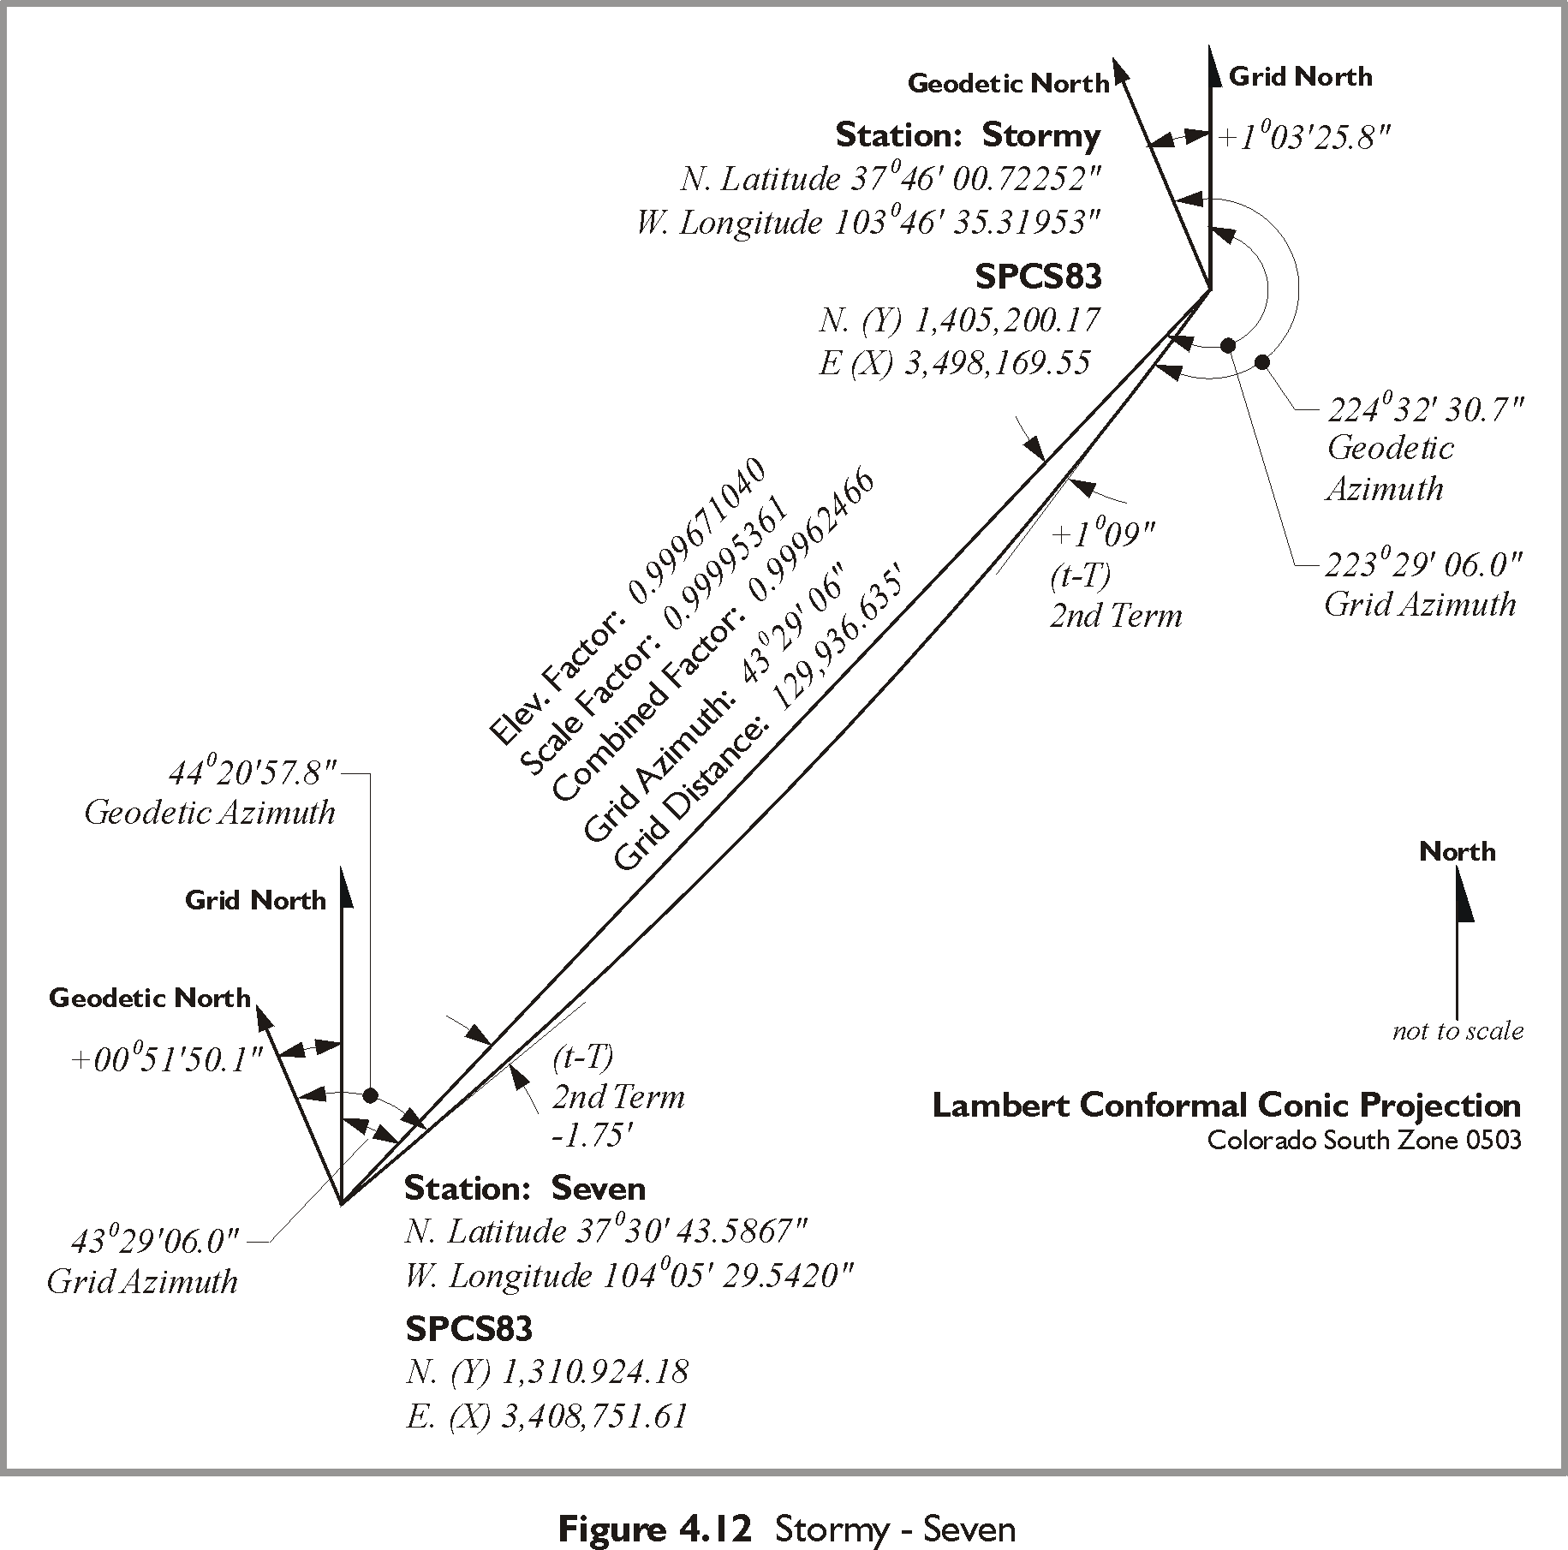

This correction for curvature is sometimes known as t-T, the arc to chord correction and the second term. The correction is small and pertinent to the most precise work. However, it is important to note that like the convergence itself, the second term comes into play only when there is a need to convert a conventionally observed azimuth into a grid azimuth in SPCS. Where optical surveying data is used that will almost certainly be required. On the other hand, if the work is done with GPS observations, or where field observations are not involved at all convergence and the second term are not likely to affect the calculation of the work.

SPCS to Ground Coordinates
When a State Plane Coordinate is assigned to a station on the Earth the coordinate is not really on the station itself. As described above, the coordinate is on a grid. The grid is most often below and sometimes above the actual location of the point it intends to represent. Simply put the point is on the Earth and the coordinate is not. This rather inconvenient fact can be, and sometimes is, ignored. However, it is valuable to remember that while SPCS is generally designed to provide scale distortion no worse than 1 part in 10,000 or so, modern measurement is routinely better than that. It is therefore common for users of the system to find that their measurement from one place to another turns out to be longer, or shorter, than an inverse between the SPCS coordinates indicates. Such results sometimes lead to an assumption that the whole system is shot through with unacceptable inaccuracies. That is certainly not the case. It is also usual that once the actual cause of the difference between ground and grid dimensions is fully understood a convenient resolution is sought. Frequently, the resolution is bringing the State Plane Coordinates from the grid to the ground.
This is done by extending the idea mentioned at the end of the section on conversion from geodetic lengths to grid lengths. The idea is dividing the grid distance by the grid, or combined, factor to find the ground distance. This concept is sometimes applied to more than the single line where the particular grid factor is actually correct. It is used to convert many lines and many points over an entire project. In those instances a single grid factor calculated near the center of a project is used. This one grid factor is intended to convert grid distances between points to the ground distances ignoring the changes in the scale factor and the elevation factor from point to point.

The coordinates that result from this approach are not State Plane Coordinates, and are often truncated to avoid being confused with actual SPCS. The typical truncation is dropping the first two digits from the northings and eastings of these project coordinates. This strategy in some ways defeats the purpose of the SPCS, which when used correctly offers a reasonably accurate approximation of geodetic positions that is consistent over a large area. However, fixing one grid factor for a project returns a user to the sort of tangent plane system mentioned earlier. Such a project coordinate system cannot be joined along its edges with a neighboring system without difficulty. This difficulty cannot be avoided because the plane created near the elevation of the center of the project inevitably departs more and more from the reference ellipsoid at the edges. The advantages of a large secant map projection plane are removed. Therefore, as long as one stays within the now local system the work can progress smoothly, but outside of the area it will not match other systems.

It is interesting to note that some governmental organizations have established localized projections, often at the county level, to bring grid coordinates closer to the ground. The objective has been to provide a coordinate basis that is more convenient for building their GIS.

Common Problems with State Plane Coordinates
As mentioned earlier the official native format of SPCS83 coordinates is meters. However, reporting in feet is often required. Many states prefer US Survey feet i.e. Nebraska, Wyoming, Colorado, California Connecticut, Indiana, Maryland, North Carolina and Texas. Other states specify International feet i.e. Arizona, Michigan, Montana, Oregon, South Carolina and Utah. Still others have taken no official action on the issue. Nevertheless, clients in any state may request coordinates in either format.
If an error is suspected in converting SPCS83 coordinates from meters to feet look to the easting of the coordinate. Since the false easting in SPCS is quite large, it is there that the discrepancy will be most obvious as was illustrated in the example conversion of station Stormy.
Another common problem stems from the periodic readjustments performed by NGS. As mentioned in Module 2 NAD83 has been subject to refinements since it replaced NAD27. These improvements are largely due to the increasing amount of GPS information available and are denoted with a suffix, such as NAD83/91, the latter number referring to the year of the readjustment. Since SPCS83 is based on NAD83 these adjustments result in new State Plane Coordinates as well. It is therefore feasible that one county may use say NAD83/86 coordinates and an adjoining county may use NAD83/94 coordinates. The result may be a different coordinate assigned to the same station, both in NAD83, but differing as the result of each being in a different adjustment. The solution is to take care with the year of adjustment when using published coordinates.

When there is a discrepancy of millions of meters or feet between the eastings of coordinates of points that are certainly not hundreds of miles apart, the error may be attributable to SPCS27 coordinates among SPCS83 coordinates or vice versa. There were substantial changes made to the false easting when the datums were changed. Another possible culprit for the condition could be the coordinates of one SPCS83 zone being combined with coordinates from the adjoining zone.

UTM COORDINATES

A plane coordinate system that is convenient for GIS work over large areas is the Universal Transverse Mercator, or UTM system. UTM with the Universal Polar Stereographic system covers the world in one consistent system. In terms of scale it is four times less accurate than typical State Plane Coordinate systems. Yet the ease of using UTM and its worldwide coverage makes it very attractive for work that would otherwise have to cross many different SPCS zones. For example nearly all National Geospatial Intelligence Agency (NGA) (formerly National Imagery and Mapping Agency, NIMA and formerly the Defense Mapping Agency) topographic maps, USGS quad sheets, and many aeronautical charts show the UTM grid lines.

It is often said that UTM is a military system created by the United States Army. In fact, several nations, and the North Atlantic Treaty Organization, NATO, played roles in its creation after World War II. At that time the goal was to design a consistent coordinate system that could promote cooperation between the military organizations of several nations. Before the introduction of UTM allies found that their differing systems hindered the synchronization of military operations.

Conferences were held on the subject from 1945 to 1951 with representatives from Belgium, Portugal, France and Britain and the outlines of the present UTM system were developed. By 1951 the United States Army introduced a system that was very similar to that currently used.

The UTM projection divides the world into 60 zones. Actually one could say there are 120 zones since each of the 60 zones are divided into a Northern Hemisphere portion and Southern Hemisphere portion at the equator. The numbering of the zones begins at longitude 180, the International Date Line, and increases sequentially toward the east. Zone 1 is from 180°W longitude to 174°W longitude, zone 2 is from 174° W longitude to the 168°W longitude and so on. The coterminous United States are within UTM zones 10 to 19. Each zone has a central meridian in the middle. The central meridian of the zones is exactly in the middle. For example, in Zone 1 from 180° W longitude to the 174°W longitude the central meridian is 177°W longitude so each zone extends 3 degrees east and west from its central meridian. The central meridian for zone 2 is 171°W longitude.

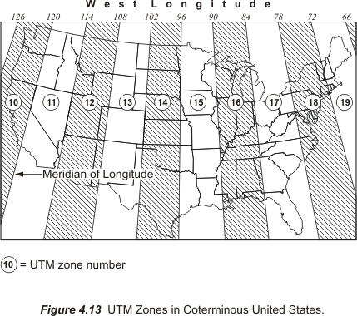

Here is a convenient way to find the zone number for a particular longitude. Consider west longitude negative and east longitude positive, add 180° and divide by 6. Any answer greater than an integer is rounded to the next highest integer and you have the zone. For example, Denver, Colorado is near 105° W. Longitude, -105°.
-105° + 180° = 75°
75°/ 6 = 12.50
Round up to 13
Therefore, Denver, Colorado is in UTM zone 13.

All UTM zones have a width of 6° of longitude. From north to south the zones extend from from 84° N latitude to 80° S latitude. Originally the northern limit was at 80° N latitude and the southern 80° S latitude. On the south the latitude is a small circle that conveniently traverses the ocean well south of Africa, Australia and South America. However, 80° N latitude was found to exclude parts of Russia and Greenland and was extended to 84° N latitude.

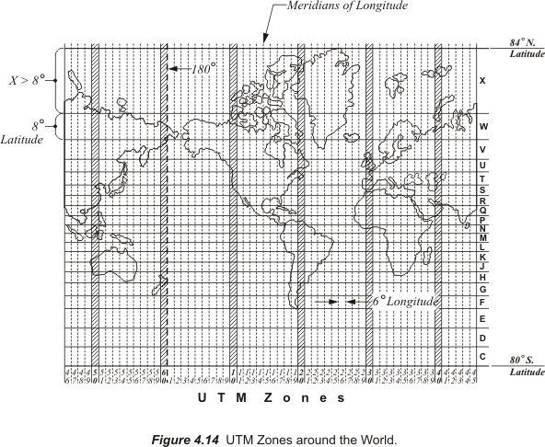

These zones nearly cover the Earth, except the Polar Regions which are covered by two azimuthal polar zones called the Universal Polar Stereographic, UPS projection. The foundation of the UTM zones is a secant Transverse Mercator projection very similar to those used in some State Plane Coordinate systems. The UTM secant projection gives approximately 180 kilometers between the lines of exact scale where the cylinder intersects the ellipsoid. The scale factor grows from 0.9996 along the central meridian of a UTM zone to 1.00000 at 180 km to the east and west. Please recall that SPCS zones are usually limited to about 158 miles and, therefore, have a smaller range of scale factors than do the UTM zones. In state plane coordinates, the scale factor is usually no more than 1 part in 10,000. In UTM coordinates it can be as large as 1 part in 2,500.

The reference ellipsoids for UTM coordinates vary among five different figures, but in the United States it is the Clarke 1866 ellipsoid. However, one can obtain 1983 UTM coordinates by referencing the UTM zone constants to the GRS 80 ellipsoid of NAD 83.

As mentioned earlier, unlike any of the systems previously discussed every coordinate in a UTM zone occurs twice, once in the Northern Hemisphere and once in the Southern Hemisphere. This is a consequence of the fact that there are two origins in each UTM zone. The origin for the portion of the zone north of the equator is moved 500 km west of the intersection of the zone’s central meridian and the equator. This arrangement ensures that all of the coordinates for that zone in the Northern Hemisphere will be positive. The origin for the coordinates in the Southern Hemisphere for the same zone is also 500 km west of the central meridian, but it is not at its intersection with the equator, it is 10,000 km south of it, close to the South Pole. This orientation of the origin guarantees that all of the coordinates in the Southern Hemisphere are in the first quadrant and are positive. In both hemispheres and for all zones the easting (the x-value) of the central meridian is 500,000m at the central meridian as shown in Figure 4.15. The developed UTM grid is defined in meters.

In fact, in the official version of the UTM system there are actually more divisions in each UTM zone than the north-south demarcation at the equator. As shown in Figure 4.14 each zone is divided into 20 subzones. Each of the subzones covers 8° of latitude and is lettered from C on the south to X on the north. Actually, subzone X is a bit longer than 8°; remember the extension of the system from 80° N latitude to 84° N latitude. That all went into subzone X. It is also interesting that I and O are not included. They resemble one and zero too closely.

There are free utilities online to convert UTM coordinates to Latitude and Longitude at http://www.ngs.noaa.gov/cgi-bin/utm_getgp.prl, and one to convert Latitude and Longitude to UTM coordinates at http://www.ngs.noaa.gov/cgi-bin/utm_getut.prl, both courtesy of NGS.

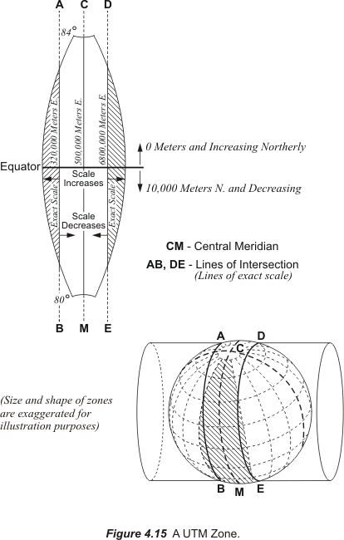

A word or two about the polar zones that round out the UTM system. The Universal Polar Stereographic, UPS are conformal azimuthal stereographic projections like those mentioned earlier. The projection has two zones. The north zone covers the North Pole and the south zone the South Pole. The projection is on a plane tangent at a pole and perpendicular to the minor axis of the reference ellipsoid. The projection lines originate from the opposite pole. As shown in Figure 4.16, the minimum scale factor is 0.994 at the pole. It increases to 1.0016076 at 80° latitude from each pole. The scale factor is constant along any parallel of latitude. The line of exact scale is at 81°06'52.3” N latitude at the North Pole and 81°06'52.3” S latitude at the South Pole. In both cases the pole is given a false easting and northing: the x-coordinate (easting) of the pole is 2,000,000m and the y-coordinate (northing) of the pole is 2,000,000m. The reference ellipsoid at both the North and South Poles is the International Ellipsoid.

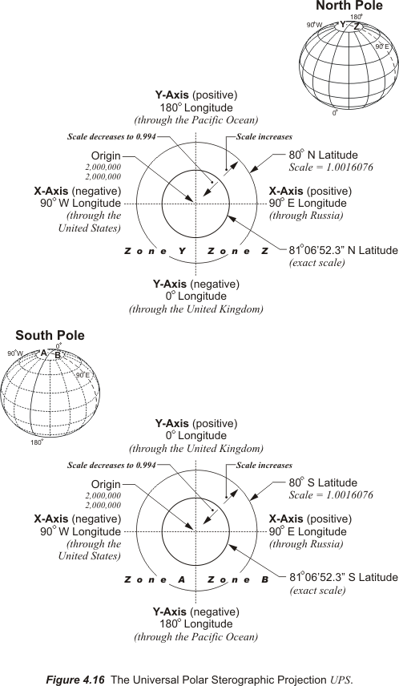

At the North Pole and at the South Pole the X-axis lies along the meridians 90°W and 90°E . The easting values start at 2,000,000 at the pole and increase along the 90°E meridian. At the North Pole the Y-axis lies along the meridians 0° and 180°and the northings start from 2,000,000 at the pole and increase along the 180° meridian. At the South Pole Y-axis also lies along the meridians 0° and 180°and the northings start from 2,000,000 at the pole but increase along the 0° meridian.

