PDHonline Course L118 (4 PDH)

Basic Public Lands

Jan Van Sickle, PLS

2012

PDH Online | PDH Center

5272 Meadow Estates Drive
Fairfax, VA 22030-6658
Phone & Fax: 703-988-0088
www.PDHonline.org
www.PDHcenter.com
Basic Public Lands

Jan Van Sickle, PLS

From the very beginning of the Public Land Surveying System it has always been the policy of the Federal Government that land in the public domain must be surveyed before it is sold to others, that is before it is patented. Therefore, more than 200 years ago the United States embarked on the most extensive surveying project ever undertaken under the Land Ordinance Act. The work began in Ohio in the autumn of 1785. On April 25, 1812 the Congress created the General Land Office (GLO) to survey and administer the PLSS. Under the GLO the work was done under a contract system. The contractors were Deputy Surveyors that worked for Surveyors General across the country. The surveying was not actually done by government employees until 1910. Later, the Bureau of Land Management was created in the Department of the Interior in 1946. It has been in charge of the system since.

The PLSS was and is an eminently practical attempt to cover a large portion of the curved surface of the Earth with a Cartesian grid with one-mile squares, sections. The degree to which it has succeeded can be most clearly seen when flying over the central and western United States. The orderly patchwork quality of the landscape is a testament to those who created and those who maintain the Rectangular System.

It has had a prominent place in the definition of the lands in the thirty states that were created from the public domain. These lands were acquired by purchase, treaty or cession and once amounted to over 1.8 billion acres. The majority of that land has now been laid out into sections and passed from the Federal Government into other hands, but its measurement is still, in most cases, governed by the rules of the PLSS.

The Public Land Surveying System is a huge subject. The small portion of it that will be presented here is intended to offer just a basic understanding of a few elements of the topic. Even though the application of the system can be complex, the design has always been straightforward and practical. And it is that design, as currently practiced, that will be the emphasis here.

The Initial Points
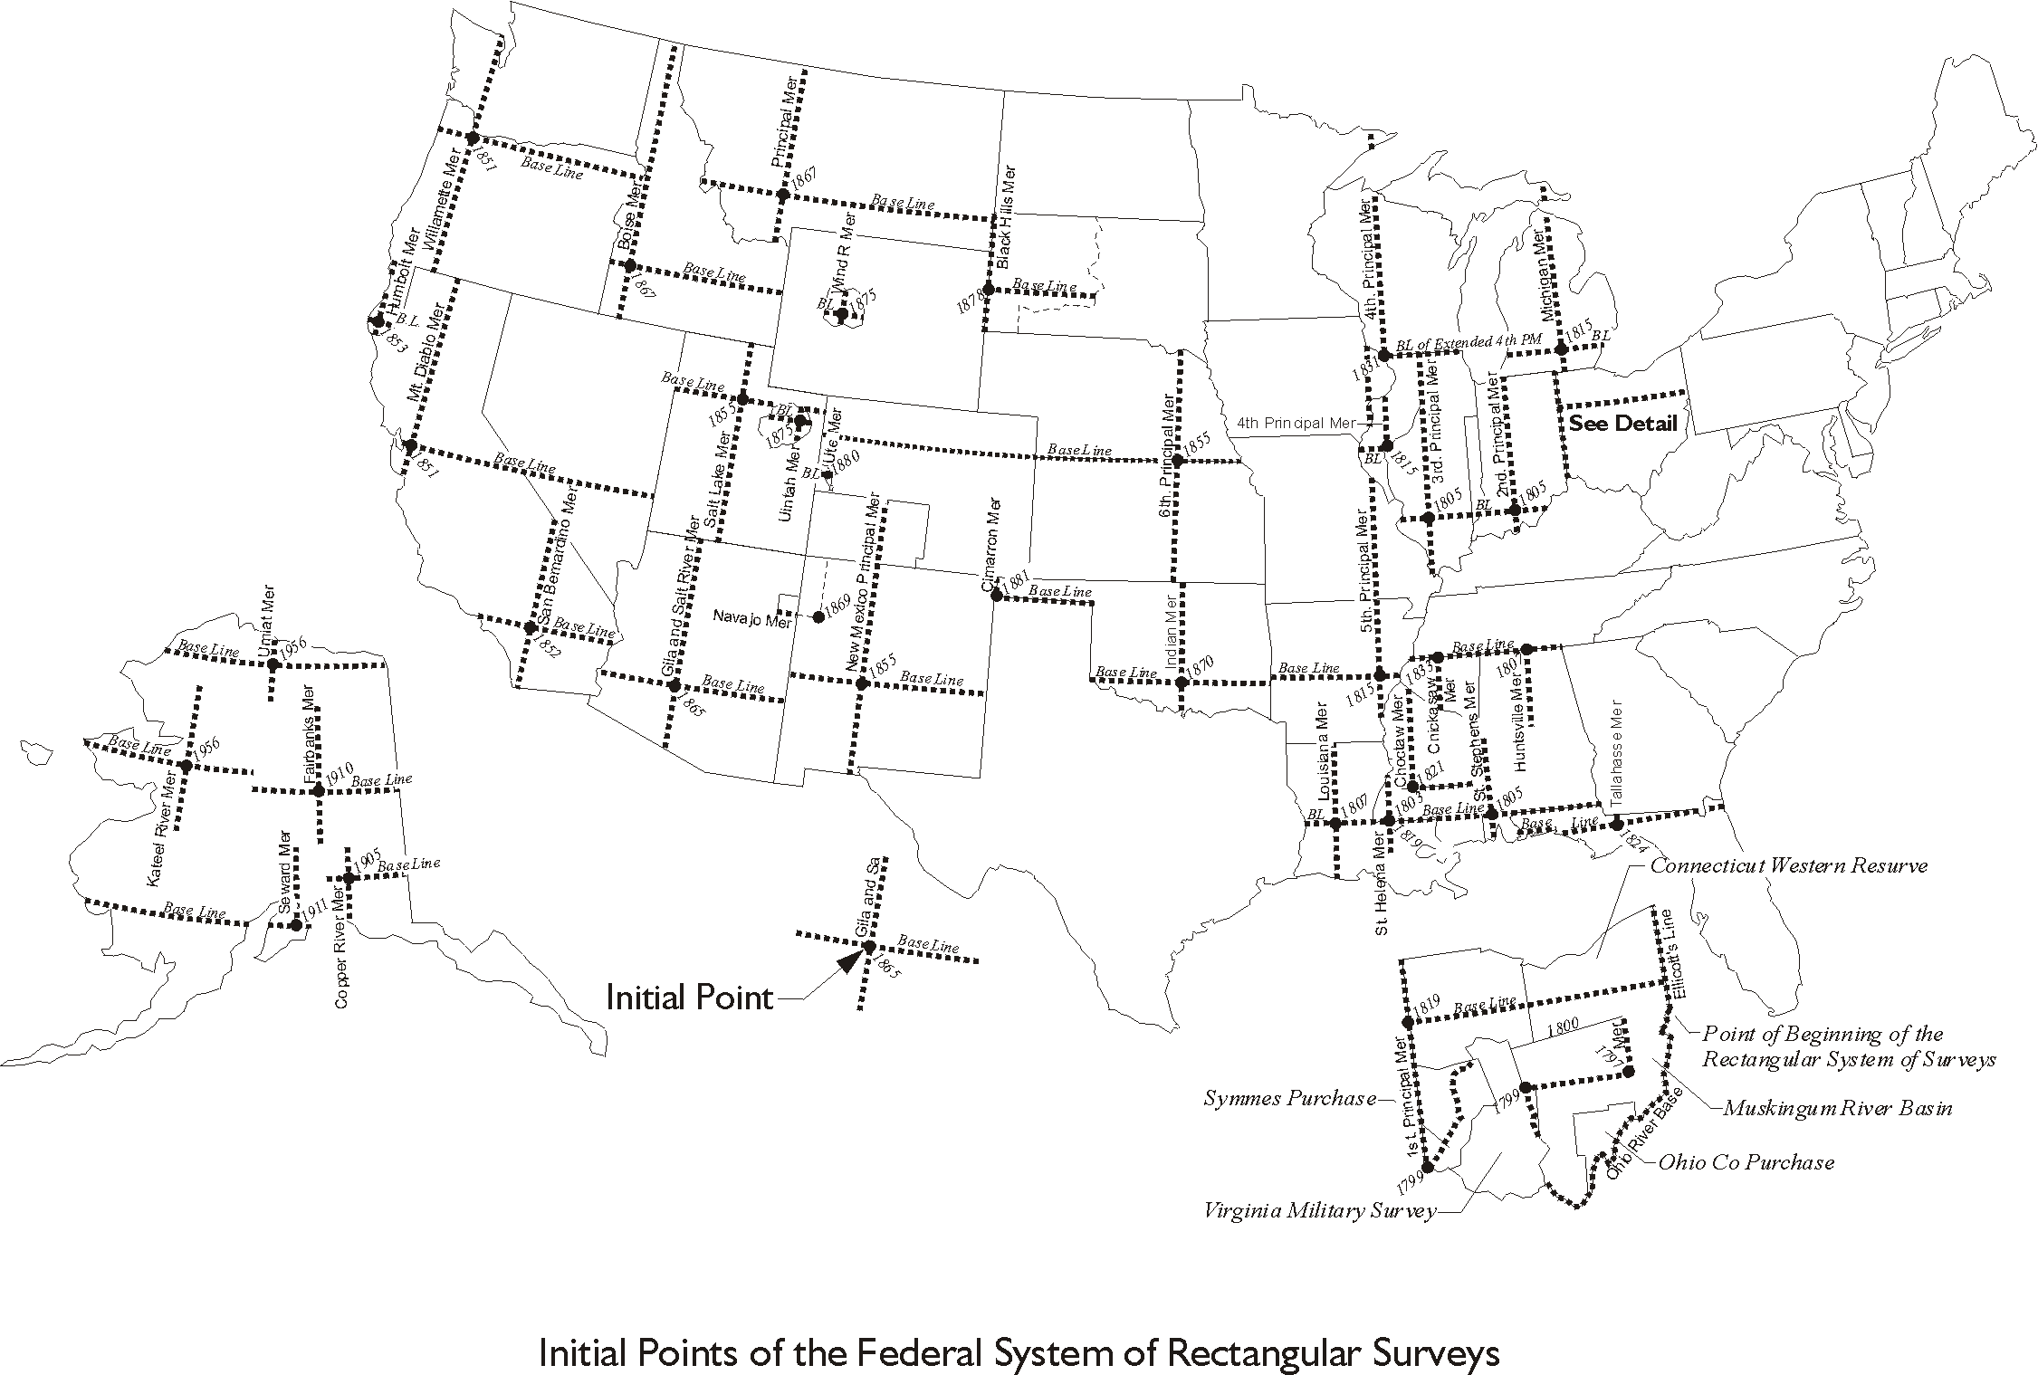

Figure 1.1

In a sense, initial points are the origins of the PLSS. They represent the intersection of
two axes. There are 32 initial points in the coterminous United States and there are 5 in Alaska. Initial points were first mentioned in the written Manuals of Instructions in 1881. There were several of these manuals. The first official version was issued by the GLO in 1851. They were the vehicles by which the Commissioner of the GLO communicated the methods of survey to the Surveyors General. They reflect the evolution of the system’s surveying procedures. However, by the time the establishment of initial points was mentioned in a manual many of the 37 in place today had already been set, nevertheless, it said,

Initial points from which the lines of the public surveys are to be extended must be established whenever necessary under such special instructions as may be prescribed by the Commissioner of the General Land Office. The locus of such initial points must be selected with great care and due consideration for their prominence and easy identification, and must be established astronomically.
(GLO 1881: 35)

In other words, they were set somewhat arbitrarily, as needed and were assigned latitudes and longitudes derived astronomically.

East and west from the initial point a Baseline was laid out. This base line was intended to follow an astronomically determined parallel of latitude. And it did so as nearly as possible with corner monuments being established every half-mile, that is every 40 chains. The chain was, and is, the native unit of the PLSS system. A Gunter’s chain is 66 feet long, and therefore, 40 chains is 2640 feet, or half a mile. It is also important to note that 10 square chains is 1 acre, a convenient relationship.

A Principal Meridian was extended north and south from the initial point following a meridian of longitude, again astronomically determined, on which corner monuments were set every half mile, every 40 chains. While the initial point and the Baseline are not usually named, it is common for the Principal Meridian to have a name such as, the Wind River Principal Meridian, the Ute Principal Meridian or the 6th Principal Meridian.

These two lines, the Baseline and the Principal Meridian are the fundamental axes and the foundation from which the PLSS was extended across the country. They are by no means abstract historical curiosities. By their monumentation these lines are a real physical presence today. And the Baselines and Principal Meridians are geographical lines, each as nearly a parallel of latitude and a meridian of longitude as the practical measurement technology of their day could achieve.

However, bear in mind that much of the early surveying in the PLSS was done with a solar compass and a linked chain. The discrepancies between the design and the reality of the monumented corners may be larger than would be expected if the work were done today with modern equipment. Despite that caveat the original work was remarkably good. Whether good or bad, however, there is no question it takes precedence over subsequent retracements or resurveys. The monuments set during the execution of the original survey, and the boundary lines they describe are correct and inviolable by law. It is an important principle of the Public Land Survey System and is mentioned, among other places in federal statute:

All the corners marked in the surveys returned by the Secretary of the Interior or such agency as he may designate, shall be established as the proper corners of the sections or subdivision of sections they were intended to designate. . .The boundary lines, actually run and marked in the surveys returned by the Secretary of the Interior or such agency as he may designate, shall be established as the proper boundary lines of the sections, or subdivisions, for which they were intended . . .
(BLM 2009: 13)

It is possible to think that since most of the public domain is no longer under the jurisdiction of the Federal Government the quoted statute does not necessarily apply to lands in private hands. However, the laws and courts in most states that were created from public domain follow the line that the rules established by Federal Statutes and elaborated in the various Manuals of Instructions will hold sway over the lands in state and private ownership under their jurisdiction.

At the intersection of the Principal Meridian and the Baseline there is an initial point, which is also represented by an actual monument. In fact, in the Manual of Instructions of 1902 not only stipulated that initial points should be set in conspicuous locations that are visible from a distance, but that they should be perpetuated by indestructible monuments like a copper bolt set in a rock ledge. Monuments perpetuate the initial points, most have been re-monumented, but the original monuments of 8 of the 37 initial points are still standing. The Baselines and Principal Meridians that extend in cardinal directions from them often, though not always, terminate at a state line. Once these axes were in place the next step was the creation of quadrangles.

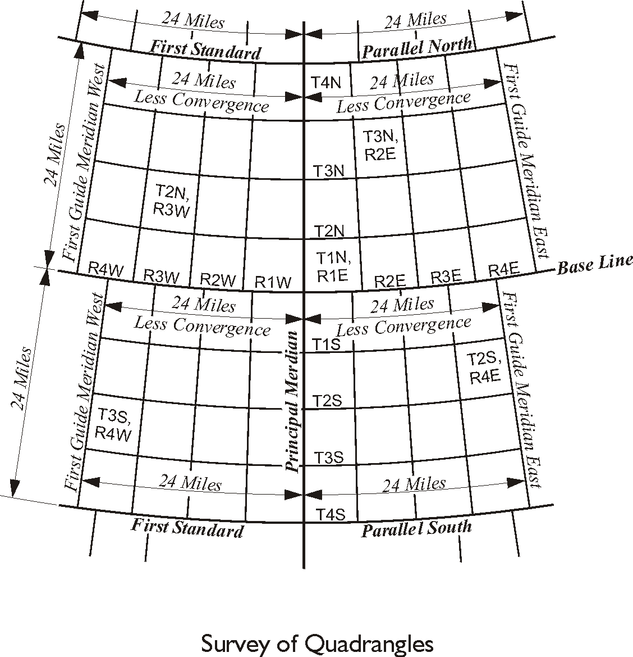
Quadrangles

Figure 1.2
Quadrangles in the PLSS are large rectangular areas bounded by meridians of longitude and parallels of latitude. They are 24 miles on a side by current design, though that has not always been the dimension used. At each initial point a Principal Meridian on one side, a Baseline on another bound four such quadrangles and on the other two sides there is a guide meridian and a standard parallel, as illustrated in Figure 1.2. The lines around a quadrangle are known as standard lines.

A guide meridian was intended to follow a meridian of longitude. A standard parallel was intended to follow a parallel of latitude. And they both were established astronomically with corner monuments set every 40 chains, each half-mile, just as was done to create the Principal Meridian and the Baseline. Over a broad area of the PLSS there is just one Baseline and one Principal Meridian originating from one initial point, but there are many quadrangles built from them. And so these standard lines are numbered as you see in Figure 1.2. At a distance of 24 miles north from the Baseline there is the First Standard Parallel North, and 24 miles south from the Baseline there is the First Standard Parallel South. East from the Principal Meridian 24 miles there is the First Guide Meridian East, and to the west 24 miles there is the First Guide Meridian West. This logical system of numbering was and is carried through the whole region governed by a particular Principal Meridian and Baseline forming 24-mile quadrangles bounded by geographic, standard, lines.

The reason for this approach was explained in the Manual of Instructions of 1890,

Standard parallels shall be established at intervals every 24 miles, north and south of the base line, and guide meridians at intervals of every 24 miles east and west of the Principal Meridian; the object being to confine the errors resulting from the convergence of meridians, and inaccuracies in measurements, within the tracts of lands bounded by the lines so established.
(GLO 1890: 18)

Since the guide meridians were laid out following astronomically derived meridians of longitude they converged. Even though the First Guide Meridian East may have been 24 miles east of the Principal Meridian at the Baseline by the time it has run north for 24 miles and intersected the First Standard Parallel North that guide meridian was considerably closer to the Principal Meridian than when it started the trip. And convergence was unavoidable because the Principal Meridian and the First Guide Meridian, the Second Guide Meridian, the Third and so on were all meridians of longitude. Therefore, as described in the 1890 Manual, and illustrated in Figure 1.2, the guide meridians were not then and are not today continuous. They were designed to stop at each standard parallel, and the Baseline so they could be corrected back to their original 24-mile spacing.

At the south end of each of its segments a guide meridian was intended to be 24 miles from the Principal Meridian, or neighboring guide meridian. But at its north end, where it terminated at the standard parallel or Baseline, the spacing between meridians was inevitably less than 24 miles. It was less per the convergence of the meridians. As a consequence that segment of the guide meridian stopped there. A new segment was begun, but before that next segment of the guide meridian proceeded north for the next 24 miles it was shifted back to the correct spacing. It was corrected at the standard parallel to again be 24 miles from the Principal Meridian, or its neighboring guide meridian. In this way, it was ensured that the south end of the each segment of a guide meridian was then and is today 24 miles east or west from its neighboring guide meridian at its south end. But at the north end of each segment of a guide meridian was and is less than 24 miles from the next guide meridian because of convergence. And this is the reason that standard parallels are also known as correction lines. They are the lines at which guide meridians are corrected for convergence.

It is sensible then that the process of actually laying out guide meridians proceeded from the south to north. Corner monuments were set every 40 chains along the way, just as they had been done on the Principal Meridian and the Baseline. When the guide meridian finally intersected the standard parallel a closing corner monument was set. A closing corner was set where a surveyed boundary, here the guide meridian, intersected a previously established boundary, here the standard parallel or Baseline. Any excess or deficiency in the measurement that had accumulated in the work along the guide meridian was placed in the last half-mile preceding its intersection with the east-west standard line. So the last half-mile at the north end of a segment of a guide meridian may be more or it may be less than 40 chains. But more importantly the cardinal direction of the guide meridian was maintained all the way to its intersection with the standard parallel or Baseline. And therefore that intersection could not possibly fall on the already established corner monument on the parallel it was intersecting, because the guide meridian was no longer at the 24-mile spacing it had when it started.

Before the guide meridian was run a standard corner had been set on the standard parallel or Baseline 24 miles from the Principal Meridian or guide meridian to serve as a corner of that quadrangle. But as it turns out that standard corner could only be the correct corner of the quadrangle to the north, because when the guide meridian was closed on the standard parallel or Baseline the intersection of the two lines certainly fell somewhat west or east of the standard corner because of convergence. So in the end there was a standard corner and a closing corner at every corner of a quadrangle and they were some distance from each other. Well, with the exception of quadrangle corners set on the Principal Meridian, including the initial point. But in every other case there was a closing corner monument set. It was and is the corner for the quadrangles to the south. The corner monument for the quadrangle to the north will usually be a standard corner.
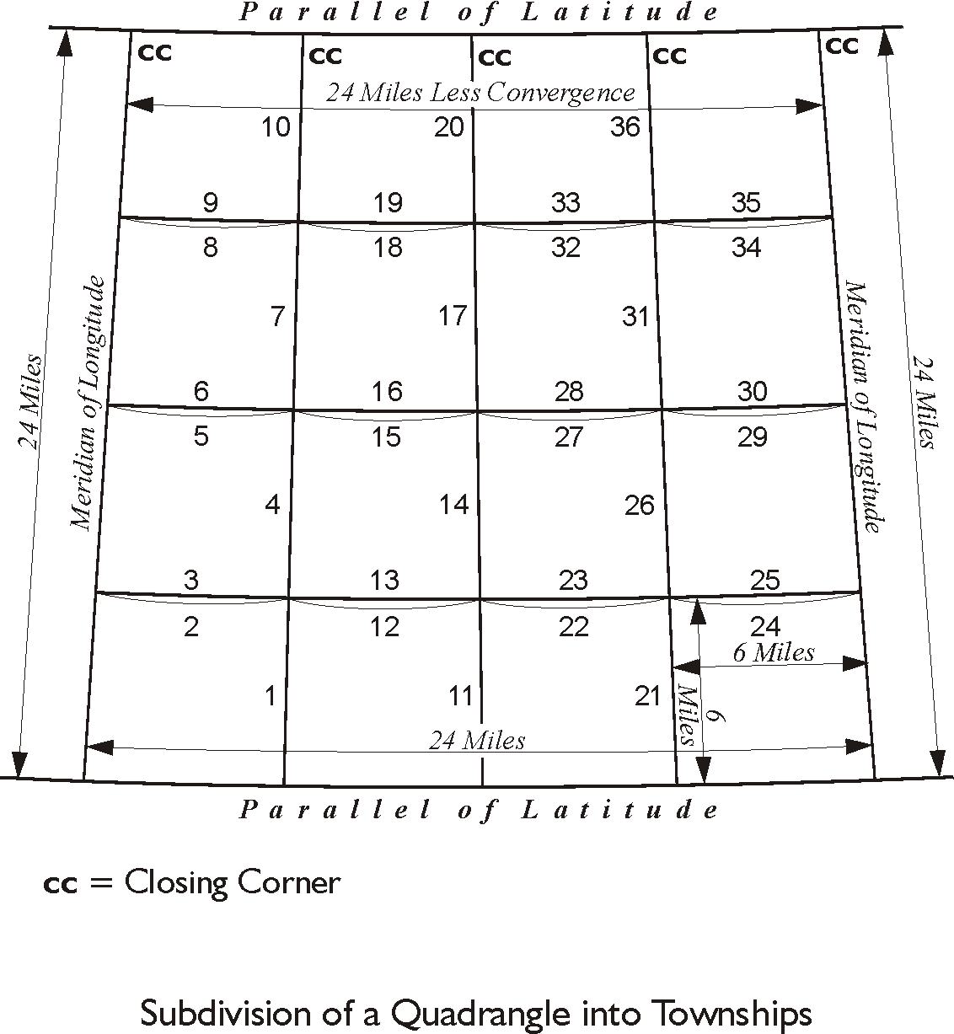

Figure 1.3

Townships

The quadrangle then became the framework enclosing the land from which 16 townships could be created. Townships are the unit of survey of the PLSS. A township is approximately 6 miles on a side and is designed to include 36 sections. The boundaries of a township are intended to follow meridians of longitude and latitudinal lines.

Please recall that as the standard lines around the quadrangle were run corner monuments were set at increments of half a mile, 40 chains. Some of those corner monuments were destined to become township corners. These were those set every 6 miles, 480 chains, along the standard lines, which are the boundaries of the quadrangle. From these corners the townships were established.

In the actual surveying of township the meridional, north-south, boundaries had precedence. They were surveyed from south to north through the 24-mile block of land, the quadrangle. These north-south township boundary lines were laid out along meridians of longitude as nearly as possible. As the meridional lines were laid out the corner monuments were set every 40 chains, every half-mile. On the other hand, the latitudinal boundaries of the township, the east-west lines, were first run on a trial or random line from east to west on most township lines. Random lines were also known as blank lines. Corner monuments were only set every 40 chains as the latitudinal line was corrected to a true line, usually west to east in these cases.

This random and true line method was used when corner monuments were in place at both ends of a boundary, but the boundary had not yet been actually connected by a surveyed line. It worked this way, a trial line, that is the random line, was created when the surveyor pushed his survey west from the township corner monument he had just established while he was surveying north up the meridian, say, at the northeast corner of a township. His next objective was to survey to the corner monument he knew he had already been set 6 miles away on the western boundary of the township, its northwest corner. As he proceeded toward it on the random line he set temporary points every 40 chains. When finally he intersected the western boundary of the township most likely he missed his objective corner. When that happened the distance, north or south that his random line missed the northwest corner was known as the falling. The falling was very instructive; it told the surveyor the distance he needed to correct his random line so it would actually connect the northwest and northeast corner monuments with a true latitudinal boundary. So, the surveyor would return east on the corrected line, this time from the northwest township corner to the northeast township corner. And along the way he would correct the temporary points he had set on the random line and set the actual corner monuments on the true line every 40 chains, except those on the westernmost half-mile.

All excess or deficiency of the 6-mile measurement was placed in the westernmost half-mile. For example, suppose that the surveyor found that instead of 480 chains from the northeast to the northwest corners of the township, he measured 479.80. The design of the PLSS dictated that the deficiency of 0.20 chains is not to be distributed evenly through the 6-mile line. It was and is all absorbed in the final half-mile. The result is 11 of the distances between the corner monuments on the true line were 40 chains as expected and the 12th, the westernmost, was 39.80 chains. In this way there were always as many regular sections in a township as possible.

Here is how the procedure was described in the Manual of Instructions 1902:

130. Whenever practicable, the township exteriors in a block of land 24 miles square, bounded by standard lines, will be surveyed successively through the block, beginning with those of the southwestern township.
131. The meridional boundaries of the township will have precedence in the order of survey and will be run from south to north on true meridians, with permanent corners at lawful distances; the latitudinal boundaries will be run from east to west on random or trial lines, and corrected back on true lines.
The falling of a random, north or south of the township corner to be closed upon,
will be carefully measured . . .
132. . . . When running random lines from east to west, temporary corners will be set at intervals of 40.00 chains, and proper permanent corners will be established upon the true line, corrected back in accordance with these instructions, thereby throwing the excess and deficiency against the west boundary of the township as required by law.
(GLO 1902: 57)

The order of running the lines to create the townships out of the quadrangle is illustrated in Figure 1.3. It began at the southeast corner of the southwestern township. The first line run was the eastern boundary of that township which was terminated with the setting of the northeast township corner. It is a meridional boundary. These north-south township lines are also known as range lines. The next line was a random line along the northern latitudinal boundary of the first tier of townships. After the random line was corrected for the falling it was returned on a true line back to the northeast township corner. Then the range line was continued northward, the next township corner was set and random and true lines were run to the township corner on the standard line. The procedure was repeated on the next township boundaries north and finally the range line was closed on the northern parallel of the quadrangle. That closing corner, labeled CC in Figure 1.3 was established in much the same way as the northeast and northwest corners of the quadrangle described earlier. And once again the excess and deficiency in the measurement of the range line was placed here in the northernmost half mile, and so it might be more or less than 40 chains.

The surveying of the township boundaries continued and the pattern was repeated for the next range line. It was also begun at its south end. Corner monuments were set every 40 chains for 6 miles as the meridional line was surveyed northward. Once again the surveyor ran a random line west, but this time the objective corner was not on a standard line, but the recently set northeast township corner. The falling was noted and the line returned on the true line, as corner monuments were set every 40 chains. These procedures were continued until the range line was closed on the northern quadrangle boundary. The last range line in the quadrangle required a variation. It was begun on its south end, like the others. After being run north for 6 miles a random line was run west and a true line east, like the others. But after the true line was returned, another random line was run from the township corner east to the eastern boundary of the quadrangle and returned on the true line. Here too the excess and deficiency of the 6-mile measurement was still absorbed in the westernmost 40 chains.

When the subdivision of a quadrangle into 4 tiers and 4 ranges of townships was done according to the design of the PLSS, 16 townships whose boundaries were very nearly meridians of longitude and parallels of latitude were created. The inevitable errors in the east-west distance measurements were taken up in the last half-mile on the west side of each township. The errors in the north-south measurements were thrown into the last half-mile on the north side of the northern tier of townships, just south of the north boundary of the quadrangle. And all 4 boundaries of all 16 townships had corner monuments in place about every 40 chains.

In fact, such clarity was seldom achieved. There were almost always some extenuating circumstances that interrupted the orderly execution of the standard PLSS plan. Quadrangles that contained large or navigable rivers or other large bodies of water could not be surveyed so neatly. Quadrangles that contained previous bona fide rights in land that were outside the purview of PLSS, such as patented mineral claims or Spanish land grants required that the orderly pattern of running lines be interrupted. In these cases the normal lines were closed upon the boundaries of the senior property rights or the limits of the water as defined by a meander line, more about that in a moment. In fact, there were myriad difficulties that frequently prevented straightforward subdivision of a quadrangle into townships. Nevertheless, the fundamental plan was most often carried out much as described. And when difficulties did arise the surveyors involved did their utmost to use procedures however unorthodox that created a subdivision that fit the design.

Sections
The township then became the framework around the land from which 36 sections could be created. Since 1796 the numbering of the sections has begun in the northeast corner of the township. It has been sequential from east to west in the first tier of sections, 1 through 6. Section 7 has been south from section 6 and the second tier has been sequential from west to east, 7 through 12. Section 13 has been south from section 12 with the third tier sequential from east to west again. This zigzag has continued until section 36 in the southeast corner of the township as is shown in Figure 1.4. This pattern is boustrophedonic, that is it alternates from right to left and then left to right. It is said that the system harks back to an ancient mode of writing and the path an ox takes plowing a field. Whatever the origin of the scheme, the same basic plan is also used on the numbering of fractional lots within the sections, more about that later.
Sections are the unit of subdivision of the PLSS. They are approximately 1 mile on a side and contain approximately 640 acres. Since 1890 the boundaries of a section have not been intended to follow meridians of longitude and parallels of latitude. Section lines are intended to be parallel to the governing boundaries of the township. The governing boundaries are the east and the south township boundaries, unless those township boundaries are defective.

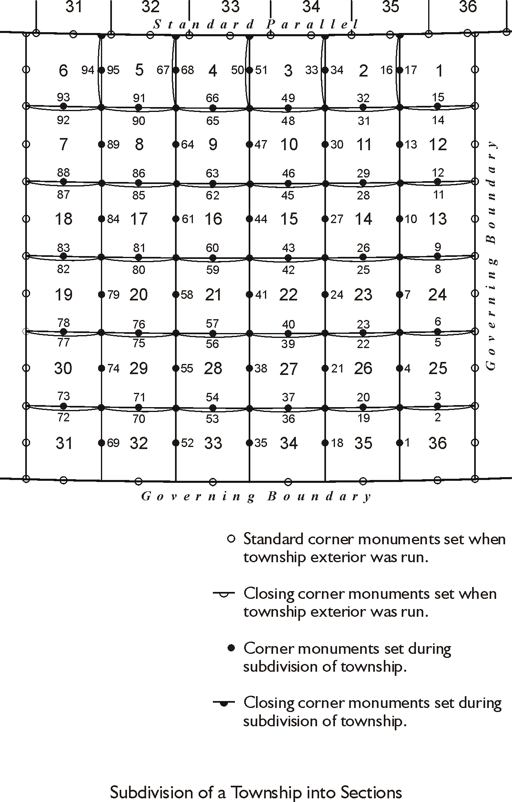

Figure 1.4
Even though the procedure for the present method of subdividing a township into sections was fairly well established by 1855, here is a description of the procedure from the Manual of Instructions of 1930.

The subdivisional survey will be commenced at the corner of sections 35 and 36, on the south boundary of the township, and the line between sections 35 and 36 will be run parallel to the east boundary of the township . . . establishing the corner of sections 25, 26, 35 and 36. From the last named corner, a random line will be run eastward . . . parallel to the south boundary of section 36 to its intersection with the east boundary of the township, placing 40 chains from the beginning a post for temporary quarter-section corner. . . If the random line intersects said township boundary to the north or south of said corner, the falling will be calculated and the true line . . . established. . . . The meridional section line will be continued on the same plan, likewise the latitudinal section lines. After having established the west and north boundaries of section 12, the line between sections 1 and 2 will be projected northward on a random line parallel to the east boundary of the township . . . to its intersection with the north boundary of the township. . . If . . . said random line intersects the north boundary of the township to the east or west of the corner of sections 1 and 2 the falling will be carefully measured and from the data this obtained the true course returned course will be calculated.
(GLO 1930: 181)

In other words, when a township was subdivided the eastern range of sections was first in line. The work began at the southwest corner of section 36 and the line was run parallel with the eastern boundary of the township. A corner monument halfway, at 40 chains, was called a quarter corner, and a corner monument set at 80 chains from the beginning was the section corner. Quarter corners are so named because connecting these monuments with straight cardinal lines across a section divides it into quarters,
Next the boundary between sections 36 and 25, a latitudinal line, was run on a random line, headed for the objective corner at the northeast corner of section 36. Once the falling was discovered, the line was corrected and run back, with the final quarter corner monument set halfway. This procedure was repeated all the way up to the meridional line between sections 1 and 2. At this point there were two possibilities.

If the northern line of the township was not a standard parallel, the north-south line was run on a random line toward the objective corner that had been set when the north line of the township had been laid out. A temporary quarter corner was set at 40 chains from the south, with the excess and deficiency of the measurements thrown into the last half-mile. Once the falling was found to the objective corner the true line returned southward and the temporary quarter corner replaced with a permanent monument, still 40 chains north of the section corner to the south.

On the other hand, if the northern line of the township was a standard parallel the north-south line was still parallel with the east township boundary. However, in this case there was not an objective corner. Please recall that in this circumstance the monuments that had been set when the north line of the township, the standard parallel, was laid out were only applicable to the townships north of the standard parallel, because of convergence of meridians. Nevertheless during the subdivision of the township into sections, a quarter corner was set at 40 chains from the south, with the excess and deficiency of the measurements thrown into the last half-mile. A closing corner was set at the intersection of the meridional section line with the standard parallel and the distance between the closing corner and the previously set standard corners on each side of it were recorded.

Using this plan a township could be fully subdivided. A deviation from the procedure occurred when the last meridional line was run starting between sections 31 and 32. The random and true line method was used to establish the latitudinal lines to both the east and west.

The final result of the work was a township that contained 36 sections. Working with sections today it is clear that most are nearly a mile square. But those along the northern and western boundaries of the township are not so regular, nor were they intended to be. The design of the system itself pushes the distortion from convergence and the accumulated measuring errors into the last half mile of the tier of sections along the north and the range of sections along the west. It is there that the excesses and deficiencies are absorbed, but only after as many regular sections as possible have been carved out of the township.

Creating as many regular sections as possible has been an objective of the PLSS from the beginning, but the rectangular system has had to be flexible. The surface of the Earth does not easily accommodate such a regular geometry. Applying the plan to lands adjoining rivers and lakes, areas where there may be an incomplete south or east township boundary has called for ingenuity. These fractional townships often made it impossible to follow the general rules laid down in the Manuals of Instructions. Joining the townships and sections from one initial point region with those from another and the irregularity of defective township exteriors also tends to disrupt the design.

The Subdivision of Sections

As mentioned earlier straight lines run from the quarter section corner monuments that stand in the middle of the four section lines divide the section into quarters. This method was stipulated in the Act of February 11, 1801. The intersection of these lines is considered the center of the section, or center quarter corner, and is a corner common to the four-quarter sections. Government surveyors set the quarter section corner monuments when they created the sections inside the township, but generally they did not subdivide the sections. Running the lines not done by the government surveyors, including the subdivision of sections has always been left to the local surveyors. Other Acts of Congress in the early 19th century provided definitions of the half-quarter and quarter-quarter portions of a section, 1820 and 1832 respectively. But actually creating those parts on the ground was again left to local surveyors.

These quarter and half divisions are known as aliquot parts of a section. A division of something is aliquot when the divisor is an integer and there is no remainder. But in practical terms this has meant that an aliquot part of a section in the PLSS is a half or a quarter of the previously larger subdivision. These are its legal subdivisions. The PLSS does not recognize other divisions such as thirds of fifths. For example, quarter sections can be further divided into halves and quarters and they are legal subdivisions as well. The quarter-quarter section, that is a quarter of a quarter section, is the smallest legal subdivision per the Manual of Instruction of 2009. The 2009 Manual is the most current version of that long series. In other words, a normal section contains approximately 640 acres. The typical aliquot parts of such a section are four. Half sections contain approximately 320 acres. Quarter sections contain approximately 160 acres. Half-quarter sections contain approximately 80 acres. Quarter-quarter sections contain approximately 40 acres.

Township Plats

When the notes of the original surveys of the townships in the Public Lands were returned to the GLO, and later the BLM, plats were developed from the work. These plats represent the township included in the survey. They show the direction and length of each line and their relation to the adjoining surveys. They include some indication of the relief, the boundaries, descriptions and area of each subdivision of the sections. As mentioned earlier the government did not and will not convey lands in the public domain to others until the survey has been done and the official plat has been filed and approved. This is true in part because the deed, the patent, that does eventually grant the ownership of the land does so with by direct reference to the township plat. It is an integral part of the transaction and binds the parties to the specific dimensions of the land as shown on the township plat. Therefore, the orientation and size of the parts of the sections on the township plat are significant. Significant too then is the creation of the lines on the township plat by protraction.

Protraction in this context refers to drawing lines on the township plat that were not actually run or monumented on the ground during the official subdivision of the land. For example, the lines that divide the sections into quarters, the quarter lines, are shown on the township plat as dashed lines. They are protracted, because even though the quarter corner monuments were set, the official government surveyors never ran the quarter lines themselves. Rules were drafted to guide the local surveyors that would actually run those lines eventually. Rules that stipulated that they must be straight from quarter corner to quarter corner, and their intersection is the center of the section, but the government was not responsible for running the lines themselves. They drew them on the plat. The same may be said of the lines that divided the quarter sections into quarters, the quarter-quarter sections. They are also protracted lines and were not run on the ground by the GLO or BLM, except under special instructions.

Therefore, it follows that for all practical purposes the aliquot parts of a section, that means virtually all the lines and the areas shown inside a section on an official township plat, were created by protraction. They were drawn on the plat, not run on the ground. And that includes the boundaries of another legal subdivision of a section that is not aliquot at all. It is known as a fractional lot.

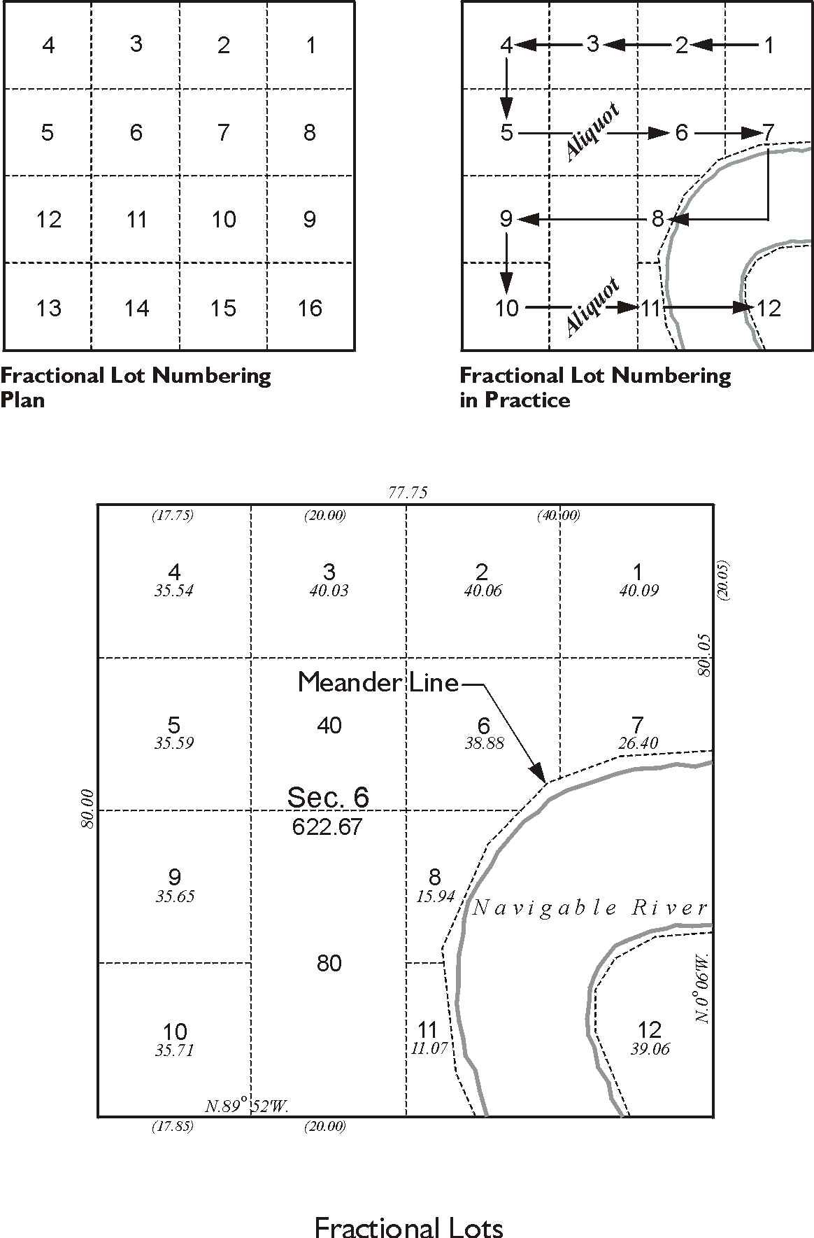
Fractional lots

Figure 1.5

Lotting occurs in fractional sections. GLO Commissioner George Graham wrote one of the earliest definitions of the term to George Davis in 1826,

It is here proper to premise that the technical meaning of ‘fractional section’ is a tract of land not bounded by sectional lines on all sides in consequence of the intervention of a navigable stream or some other boundary recognized by law
and containing a less quantity than six hundred & forty acre.
(White 1983:83)

It still applies to the sections the Commissioner mentioned, and it also includes the sections on the north and west of a normal township. Please recall that the excess and deficiency of the measurements made during the subdivision of a quadrangle into townships and the subdivision of a township into sections is absorbed in the last half mile along the northern and western boundaries. And that means that, by design, the last half of those sections is something more or less than 40 chains, 2640 feet. One of the principles of the PLSS is always to create as many regular aliquot parts as possible. In practice this means that half of that last half-mile of a section on the northern and western boundaries of a township can be held to 20 chains. Doing that creates the last regular aliquot part before hitting the north or west boundary of the township. But the remainder of that distance is then to become a side of a parcel that cannot be described as an aliquot part. It cannot be an aliquot part because it is not, nor can it be, a half or a quarter of the previously larger subdivision. Therefore, it is known as a fractional lot.

All along the north and the west boundary of a normal township one will find one row, or more, of these fractional lots. The sections bordering the north and west boundaries of the township, except section 6, are normally subdivided into two regular quarter-sections, two regular half-quarter sections, and four fractional lots. In section 6, the subdivision will show one regular quarter-section, two regular half-quarter sections, one regular quarter-quarter section, and seven fractional lots. This is the result of the plan of subdivision.

But that is by no means the only place that fractional lots are found. Anywhere a section has an irregular boundary or as Commissioner Graham wrote, any section that does not have complete boundaries on all sides. A section invaded by a body of water for example. In such a case a meander line segregates the water and the section or sections around it are fractional.

A meander line is a line run along the mean high water mark of a permanent natural body of water. The meander line generally follows the curves, twists and turns of the shore. It is run to determine the area of the land in a fractional section, after the area covered by the water is excluded. Since its inception the PLSS has been concerned with transferring land from the public domain to others and therefore the area of usable property contained in the aliquot parts of sections has been a matter of keen interest. However, a navigable river is not a part of the public domain. It must forever remain a common public highway and is excluded from the system. Under current instructions a body of water is meandered if it is a navigable river, is a stream more than 3 chains wide or a lake that is larger than 50 acres. It is important to note that the meander line around the water is not actually a property boundary that is a line defined by the water itself; nevertheless, corners are set on meander lines. When a standard line, township line, section line or aliquot line intersects a meander line a meander corner is set to perpetuate the intersections. Where that happens fractional lots spring up. They are protracted against meander lines.

The same thing happens when a more recent PLSS survey collides with a former official government survey. For example, it is inevitable that PLSS surveys originating at one initial point will grow outward and eventually meet the PLSS surveys that originate from another initial point. When that occurs the lines and areas of the two systems will certainly not match. Fractional lots are protracted where they join. When the PLSS survey encounters boundaries around property that existed before the rectangular system got there, fractional lots are protracted again. This is the case when lines are closed on a reservation, national park, mining claim, previous land grants or other bona fide private claim. In each of these instances the guiding principle is that fractional sections should be subdivided in a way that produces as many aliquot parts as possible.

Fractional lots are numbered. The system of their numbering follows the same model as
that used to number sections. It is a zigzag pattern that begins at the most northeasterly lot, which is Lot 1. Then continuing within the same section, the next lot to the west is Lot 2. It is important to note that the next lot is not necessarily immediately adjacent to Lot 1. The general plan is that Lot 1 through Lot 4 are numbered east to west sequentially as shown in Figure 1.1. The numbering scheme then drops down to the next tier of lots south from Lot 4 to Lot 1. Then the plan would be to sequentially number lots from west to east, Lot 5 through Lot 8, drop south to the next tier and number the lots east to west, Lot 9 through Lot 12. Finally, the southernmost tier would be numbered west to east Lot 13 through Lot 16. However, there are not necessarily fractional lots in each tier and aliquot parts are not numbered. Therefore, in a typical section 6 the lots on the northern tier are numbered east to west 1 through 4, and Lot 5 is south of Lot 4 according to plan. But from Lot 5 east there are usually aliquot parts, no lots. Lot 6 then is numbered south of Lot 5 because it is simply the next fractional lot encountered by the zigzag numbering system. In other words the scheme can be imagined to proceed east from Lot 5 seeking lots to number, but none are there. It then drops south to the next tier, still none. It then proceeds east to west, and finally along the western boundary encounters a fractional lot that then becomes Lot 6. The same thing happens between Lot 6 and Lot 7.

The particular Lot 6 in Figure 1.5 is crossed by a navigable river. The northernmost tier of lots is numbered 1 through 4 from east to west. Then the second tier of lots is numbered west to east starting with Lot 5, which is directly south of Lot 4. East of Lot 5 is an aliquot part, a quarter-quarter. East of that part is the fractional Lot 6. It cannot be an aliquot part because a corner of it is inside the meander line that follows the northern bank of the river. East of Lot 6 is Lot 7 and it is also partially in the river. The east boundary of Lot 7 is the section line so the numbering of the fractional lots drops south the next tier and proceeds east to west again. South of Lot 7 the area is in the river, but directly west of the river is Lot 8. West of Lot 8 is an aliquot part followed by Lot 9 on the western boundary of the section. The numbering scheme drops south to the next tier and Lot 10. It then proceeds from west to east, jumps across the aliquot part, and then Lot 11 is numbered. The last lot numbered is Lot 12 in the southeast corner of the section. It is interesting to note that Lot 12 includes a small area that could be in the tier of lots to its north. However, one of the rules of the creation of fractional lots specifies that very small lots will not be protracted, but such an area will instead be included into adjoining lots, as is illustrated here.

Naming Aliquot Parts and Corners
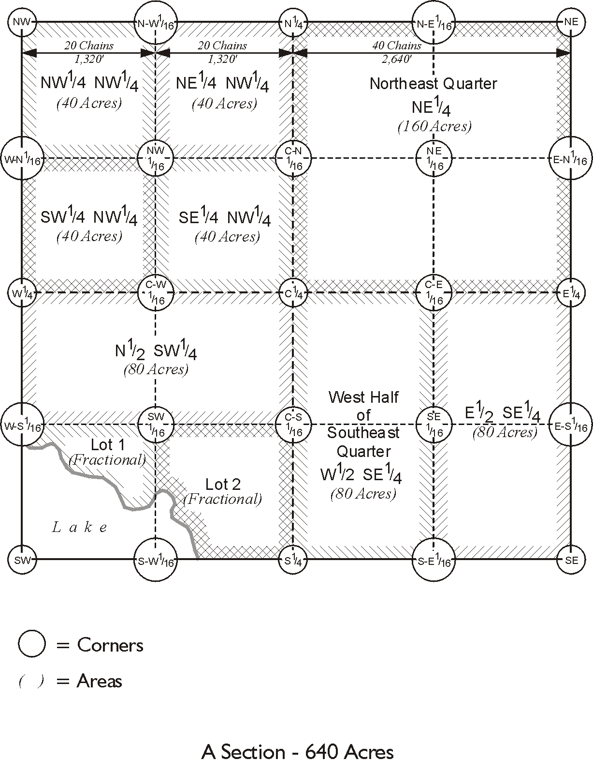

Figure 1.6

As was just mentioned aliquot parts of a section are not numbered. They are named.
Some aspects of their names are intuitive. For example, 160-acre portion of a section north and east of its center can simply be called the northeast quarter. It can also be abbreviated as NE¼. Describing any of the other quarters of a section can be done similarly, such as NW¼, SW¼ and SE¼. Describing quarter-quarters of a section is done with a combination of abbreviations. For example, the 40-acre portion of the NW¼ that is in the most northwesterly corner of the section is known as NW¼NW¼. This description can be read, the northwest quarter of the northwest quarter. The other quarter-quarters in the NW¼ could be described with the same system as: NE¼NW¼, SE¼NW¼, SW¼NW¼. There are a couple of important keys to such an abbreviation system. First, the smaller tract is always first, meaning it is on the left. The larger tract is on the right. Second, there is no comma between the two elements. A comma would mean, and, in this context. In other words NE¼, NW¼ would mean the northeast quarter and the northwest quarter when the intention of NE¼NW¼ is to indicate the northeast quarter of the northwest quarter. The general structure of the system is that the term on the left is a portion of the term on the right. The same ideas can be used to describe the east half of the southeast quarter. It could be described as E½SE¼. Fractional lots can be described using their numbers; Lot 1, Lot 2.

The abbreviated descriptions of Lots and aliquot parts do not fully define them however. Writing a complete and correct description requires the addition of the number of the section, the township, the range and the principal meridian. For example, the S½SE¼
Section 36, Township 3 South, Range 68 West of the 6th Principal Meridian is complete, concise and unambiguous. It can only refer to one parcel of land.

The naming of section corners in PLSS is also straightforward. The northeast, northwest, southeast and southwest corners of a section are simply abbreviated; NE, NW, SE and SW respectively. The quarter corners too are simply stated. The corners at the midpoints on the section lines are the north quarter corner, east quarter corner, south quarter corner and west quarter corner which are abbreviated; N¼, E¼, S¼ and W¼ respectively. The center quarter, which is at the intersection of the quarter section lines, is abbreviated; C¼.

It is important to mention that another common name for a quarter-quarter of a section is a sixteenth. Therefore, corners of quarter-quarters are often called sixteenth corners, such as the corners in the middle of quarter sections where the quarter-quarter lines intersect.
For example, as shown in Figure 1.6 the corner in the centers of the NE¼ of the section common to the four quarter-quarters is called the NE1/16. The other 1/16th corners in the centers of the quarter sections are also named for the quarter in which they are set. They are called NW1/16, SE1/16 and SW1/16. The abbreviations for the sixteenth corners on the quarter lines of the section refer first to the fact the lines on which they fall are the centerlines of the section. For example, the corner on the N-S centerline between the NE¼ and the NW¼ is called; C-N1/16. The other center quarters are abbreviated in the same pattern; C-E1/16, C-S1/16 and C-W1/16. Finally the 1/16th corners on the sections lines themselves follow a similar scheme. Their abbreviations refer to the section line on which they stand first, and then whether they are east or west from the quarter corner on the same section line. Therefore, on the north line of the section there are the N-E1/16 and N-W1/16 corners. On the east section line there are two 1/16th corners; E-N1/16 and E-S1/16. The abbreviations applied to the 1/16th corners on the south section line and the west section line are created with similar logic.

SYSTEM PRINCIPLES
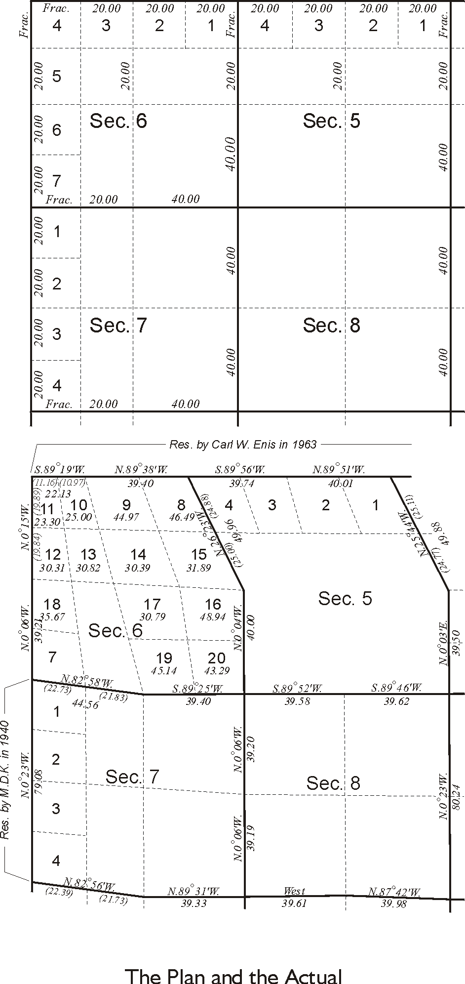

Figure 1.7
This upper portion of Figure 1.7 shows the normal subdivision of sections 5, 6, 7 and 8 per the design of PLSS and the lower portion shows a portion of a township in Wyoming, T18N R89W of the 6th Principal Meridian as it actually stands. Portions of the west boundary, north boundary, south boundary and the subdivisional lines were the subject of a dependent resurvey by a Supervisory Cadastral Surveyor in 1963 under special instructions that restored some lost corners to their true original locations. The work was concerned with protecting the property rights that had arisen from the original survey as well. For example, the fractional lots are shown as given on the original plat of the township, which was approved in 1884. In other words, the surveyor in 1963 did everything he could to reconstruct the positions of the lines and corners, as they had existed after the original survey of 1884. And this is consistent with the mandate for local surveyors throughout the states that were constructed from the public domain. When working in the PLSS their objective is always to preserve or reestablish the original locations of the lines and corners if at all possible.

However, by comparing the two parts of Figure 1.7 one can see that there is often a difference between the pure design of the PLSS and the actual section lines and corners as the original surveyor laid them out on the ground. Nevertheless it is certain that the monuments set and lines run on the ground by that original surveyor are conclusive. The corner monuments originally set and the section lines originally run are inviolable. Here are some of the fundamental rules, which control in the PLSS system and underline the point:

First: That the boundaries of the public lands, when approved and accepted are unchangeable.

Second: that the original township, section and quarter-section corners must stand as the true corners which they were intended to represent . . .

Third: That the quarter-quarter-section corners not established in the original survey shall be placed on the line connecting the section and quarter-section corners, and midway between them, except on the last half mile of section lines closing on the north and west boundaries of the township, or on the lines between fractional or irregular sections.

Fourth: That the center lines of a section are to be straight, running from the quarter-section corner on one boundary to the corresponding corner on the opposite boundary.

Fifth: That in a fractional section where no opposite corresponding quarter-section corner has been or can be established, the center of such section must be run from the proper quarter-section corner as nearly in a cardinal direction to the meander line, reservation or other boundary of such fractional section, as due parallelism will permit.

Sixth: That lost or obliterated corners of the approved surveys must be restored to their original locations whenever this is possible
(BLM 1979: 6)

It is interesting to note the practical effect of these rules. Section lines and quarter-section lines are correct as they were originally run even though typical regular section lines are not one mile long, and quarter section lines are not usually a half-mile long. It is usual that the quarter corners of a section are not actually midway between section corners, nor are they in line with section corners. Nevertheless these monuments are the corners they are intended to represent, exactly. Despite the fact that section lines most often do not have a cardinal bearing and the legal center of the section is not the geometric center of the section, the lines as originally surveyed are right. Even though it may be that none of the angles at the section corners are 90° and the opposite sides of the section are not parallel with each other, the lines as originally surveyed are conclusive. Few sections actually contain 640 acres; in fact, none of its other legal subdivisions usually contain their theoretical acreages. And the actual dimensions of a section measured today seldom match the original record dimensions. But despite all these deviations from the plan the section is absolutely correct as it was originally laid out on the ground. This overarching principle was codified long ago, by the Act of February 11, 1801. Corners and lines established during the original government survey are unchangeable.

That is not to say that there are no limits to how far a section, township or quadrangle may depart from the ideal in the PLSS. The general rectangular limits are:

(1) For alinement, the section’s boundaries must not exceed 21’ from cardinal in any part, nor will the opposite (regular) boundaries of a section vary more than 10'30".

- For measurement, the distance between regular corners is to be normal according to the plan of survey, with certain allowable adjustments not to exceed 25 links in 40 chains.
Township exteriors, or portions of exteriors, are considered defective when they do not qualify within the above limits. It is also necessary, in order to subdivide a township regularly, to set a third limit, as follows:

- For position, the corresponding section corners upon the opposite boundaries of the township are to be so located that they may be connected by true lines which will not deviate more than 21’ from cardinal.
(BLM 2009: 48-49)

However, it should be noted that these rules apply to work done under the current Manual of Surveying Instructions 2009. If the surveying were done under other older instructions, and most of the public domain was subdivided long ago, then the work is not necessarily bound by these limits. Along that line it is important to remember that the rules that governed the original establishment of the corners and lines in the PLSS have not always been exactly as they are today. For example, there was no accommodation of the convergence of meridians and sections were numbered sequentially from south to north in the original seven ranges of sections laid out in 1785 in Ohio. Nevertheless, no attempt would be made to alter those sections to harmonize with rules in place today. For example, prior to 1855 the distance between standard parallels was often 30 miles or more. In some cases they were as much as 60 miles apart. When working with townships and sections that were originally established in that era it is important to recognize that they are correct, even though the current instructions place the distance between standard parallels at 24 miles. There are many differences between current guidelines and those of the past.

Here is an example of the evolution of section and quarter section corners. It is just one instance of official PLSS surveying that was done contrary to the current plan, but was nevertheless absolutely correct at the time. In the Act of May 18, 1796 there was an economy measure. Only every other township was actually subdivided into sections. And in those townships that were subdivided, only every other section line was run on the ground, see Figure 1.8. In other words, in half of the townships the section lines were run every two miles and corners were marked on those lines every mile.

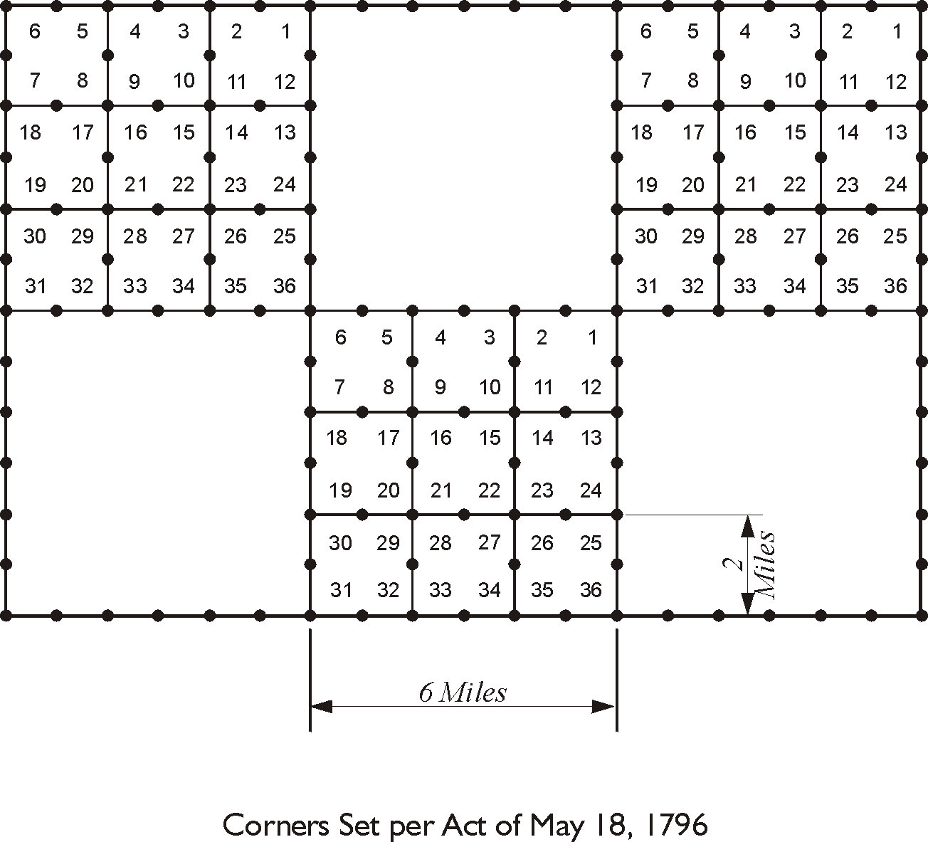

Figure 1.8

The Act of May 10, 1800 was passed to amend the Act of May 18, 1796. It had proven impractical to expect the purchasers of sections to set the many corner monuments that the government surveyors had not established. They were stubbing them in by the easiest methods and that was producing large errors. Therefore, in 1800 Congress mandated that section lines would henceforth be run every mile, not every two miles. Corner monuments would be set each mile on the north-south lines and every half-mile on the east-west lines. Thereby the system evolved from setting no quarter corners, to setting only those on latitudinal lines. Also, the excesses and deficiencies of the measurements would be placed in the last half-mile on the north and west boundary of the township, see Figure 1.9. It took another five years, under the Act of February 11, 1805, for the quarter corners on the meridional section lines to be called for.
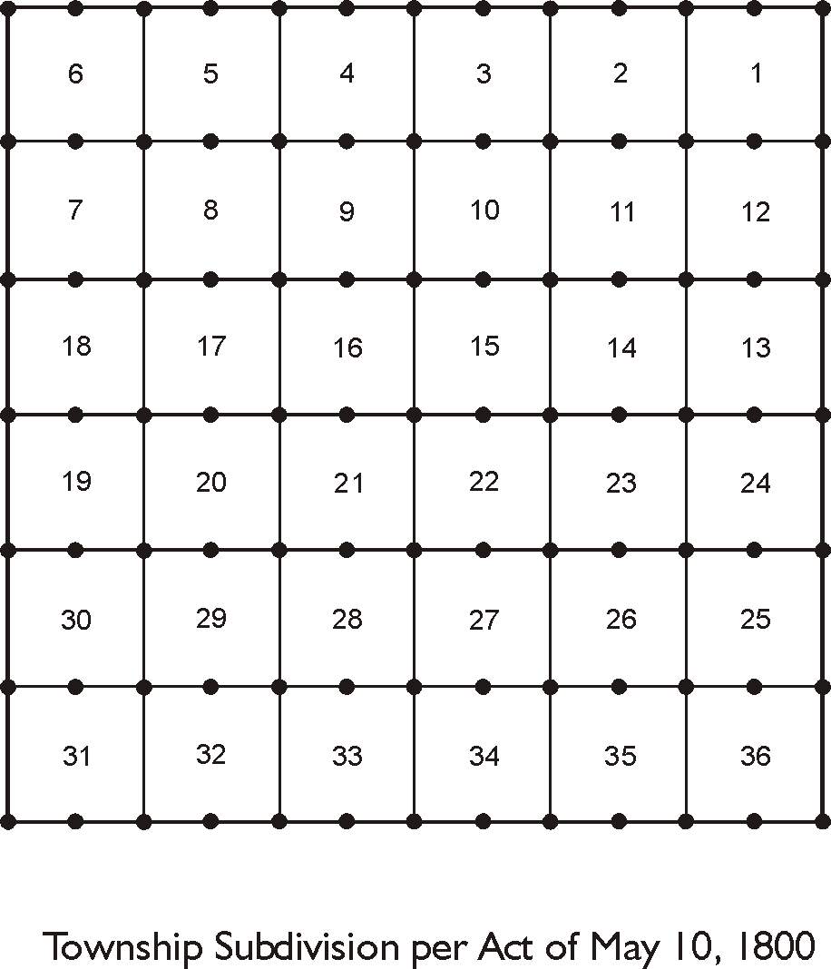

Figure 1.9

It follows that when working with sections that were established before 1805 it might be valuable to recall that all the quarter corners were not set in the original survey. This is just one of many discrepancies from the current instructions that guide the PLSS today.
Another example, the Act of June 1, 1796 mandated the establishment of townships that were, and still are 5 miles on a side instead of 6 miles. Congress had segregated a portion of land known as the U.S. Military Reserve to satisfy the military warrants it had issued to pay Revolutionary War soldiers. These warrants were in multiples of 100 acres and 6-mile townships contain 23,040 acres, not evenly divisible by 100. The 5-mile townships contained 16,000 acres and were much more convenient to the purpose. And that is not the only region in which special instructions stipulated deviations from the normal plan.

There are two eminent books that are reliable guides in this regard. The Manual of Surveying Instructions 2009 and A History of the Rectangular Survey System are both published by the United States Government Printing Office. The former book was compiled under the auspices of the Bureau of Land Management, Department of the Interior and is a clear, concise manual that sets out the guidelines for the current Public Land Survey System plan. The latter book was written by C.A. White and is also published by the U.S. Government Printing Office. It is a valuable resource that explains the rules and regulations that governed the PLSS from the beginning to today. It also includes reproductions of many of the former manuals and instructions issued by Surveyors General in the past. Together these books provide practical and valuable insights to both the past and the present PLSS.

Finally, the Public Land Surveying System was the most extensive surveying project ever undertaken. It has been extraordinarily successful. It has evolved. The rules governing its execution have been practical. Still, there are large portions of mountains, wilderness areas and deserts that have not been surveyed in the PLSS. Unfortunately, unofficial township and section lines are sometimes drawn over and across these areas to provide the continuation of the system where it has never actually been applied by government survey. As has been described here the general PLSS plan does not necessarily correspond exactly with the actual corners and lines on the ground, but it is best to recall that it is always those actual corners and lines as originally surveyed on the ground are correct and conclusive. Where no such corners and lines were ever run the PLSS system is not in place at all.

