PDH Course P119

CONSTRUCTION LAYOUT
A FOUNDATION FOR SUCCESS

PART 2 of 2

Jonathan Terry, P.L.S.

2005

PDH Center

2410 Dakota Lakes Drive
Herndon, VA 20171-2995

Phone: 703-478-6833
Fax: 703-481-9535
www.PDHcenter.com

Course Outline
Whether you're a professional engineer, land surveyor, construction layout contractor, entry-level employee working in a construction layout crew, party chief, construction manager, superintendent or architect, you'll benefit by a fuller understanding of this unique, essential component of any significant construction project.
By walking the reader through a typical, mid-sized project, covering bidding, contract negotiation, paperwork, interpersonal relationships, procedures, documentation, billing, site reconnaissance, geometric computations, and applying specific layout methods, the reader will not just be told about things but will see and experience the broad spectrum of construction layout and related disciplines through the eyes of its author. This approach makes remembering what's presented so much easier.
Tips (maybe even trade secrets) are freely shared - important lessons and experience learned by a surveyor licensed in 7 states, who's been an employee of developers, construction managers, architects, engineers and surveyors since 1963 and possesses a wealth of knowledge gained through founding and operating a successful construction layout business.
Neither fear nor swelling pride fosters success in this unique business. And, both attitudes are more common to providers of layout services than a quiet confidence born of real understanding. This course seeks to establish the latter.
Construction layout is a specialized, demanding function. It deserves study and the sincere respect it seldom gets. Its demands are uniquely complex and its rewards generous. This course is not merely the presentation of technique and processes (though these are included); it's an equipping, enabling source of knowledge and understanding.
This is Part 2 of 2 on Construction Layout – A Foundation for Success. The author strongly recommends that you take both parts of this course to have a complete understanding of the topic.
This course includes a multiple-choice quiz at the end, which is designed to enhance the understanding of the course materials.
Learning Objective
At the conclusion of this course, licensed engineers and surveyors, their technical and field personnel and contractors performing construction layout will have gained a better appreciation for the unique demands of construction project control and will better manage the business, procedural, technical and relationship aspects of construction layout - and, will hopefully enjoy construction layout as much as I do.
- Learn important "trade secrets" from a person who's successfully founded and operated a business specializing in construction layout and established a construction survey division of a large construction management firm.
- Learn how the professional Team creating new development functions and the place of construction layout on that Team.
- Learn tips, tricks and special pieces of equipment that help you perform your layout more quickly without compromising precision.
- Learn how to confidently ask questions when you really don't understand the plans or know exactly what you should be laying out.
- Learn what plans to believe or not to believe and how to check dimensions when staking a major building.
- Learn how to perform marketing and sales in effective ways without assuming an exaggerated self-importance or high pressure tactics.
- Learn how to level the playing field in a competitive bidding situation.
- Learn effective proposal writing concepts for construction layout.
- Learn how to structure your proposal or bid to limit layout items that might never be requested.
- Learn how to handle the correction of errors you discover in the plans and how to stake those items correctly without assuming liability for the correction.
- Learn the advantages and disadvantages of both small firms and large firms in relation to seeking clients for construction layout contracts and how to promote your strengths when seeking contracts.
- Learn the "full-service" layout requirements for a mid-sized, commercial project and how to structure these in your proposal.
- Learn how your billing relates to your proposal and what documents should accompany your monthly statements to your clients.
- Learn how to easily keep track of set-fee, proposal item billing based on percentage of completion.
- Learn tricks for transferring column lines or offsets to column lines to upper floors on multi-story buildings.
- Learn how to set control for major buildings, so that you can repeat precise layout, even after your building or column offset stakes are destroyed.
- Learn staking requirements for traditional utility construction methods and for pipe construction guided by a laser.
- Learn how to limit liability through your proposal, your contract, your correspondence, forms and private records.
- Learn the importance of receiving full sets of plans early and of attending the pre-construction meeting.
- Learn what digital files you should obtain and why you need both paper and digital plan sets - and why you need to get these early.
- Learn how the construction management firm's employees differ in experience and roles and how to handle your relationships with the persons filling each role.
- Learn why asking questions is critical to your success and know what questions to ask of whom and when.
- Learn why you and your crews must be familiar with your contract/proposal and carry a copy to the site.
- Learn why a project Field Folder must be created, what goes in it, and why it's taken to the site with each visit.
- Learn safety tips and principles unique to an active construction site.
- Learn how to make money "in the rain" (or at least maximize down-time due to weather).
- Learn what the Geometric Plan was historically, what it is today and when to believe or not to believe in the integrity of a digital drawing file.
- Learn tips for selecting the personnel who will perform construction layout and managing crews sent to perform layout.
- Learn tips for adjusting equipment on the fly - or on the job site.
- Learn suggested staking techniques and relative precision typically required for the many different features you're laying out.
- Learn standard ways to mark stakes that get the job done, avoid confusion and protect you from the potential for huge back-charges (Mark a stake improperly and you've bought the farm!).
- Learn proven techniques for preserving your primary control (traverse control points) that are needed throughout the entire project's duration.
- Learn why flagging on stakes should be color-coded.
- Learn how color-coded file folders and certain standard forms give you the upper hand when clients misremember what was said or what actually took place.
- Learn rules of thumb that are useful when performing layout.
- Learn why Conversation Logs are essential records and how they can save you from client disputes and claims against you.
- Learn why Work Orders are necessary, how to use them for work authorization and for getting paid in a timely manner.
- Learn what paper field book documentation is appropriate and what notes belong in a data collector file.
- Learn how a standard rubber stamp impression at the start of each day's notes in the paper field book will train your crew to think like business people.
- Learn how to expedite layout by copying sketches directly to field book pages.
- Learn how and when to write CYA memos, e-mails and letters.
- Learn suggested disclaimers to include in your proposals and grade sheets to minimize disputes and back-charges.
- Learn typical staking and grade sheet preparation for single family residences.
- Learn typical staking and grade sheet preparation for residential driveways.
- Learn typical pattern of layout for curbing and parking lots and what sketches are necessary to avoid confusion over your stakes and to uniquely identify each stake on your grade sheet.

Intended Audience
This course is designed for engineers, land surveyors, architects, contractors, or anyone contracting, providing, reviewing or specifying construction layout services.
Benefit to Attendees
This course teaches both technical and practical skills, contract and business considerations, staking and grade sheets, client relations, functioning in and with the design/build team, and relates countless tips and trade secrets learned only through solid, real-world experience.
Course Author
The author of this course is a Licensed Land Surveyor who's obtained professional registration in seven states and served as assistant construction superintendent, teacher, writer, civil technician, site planner, land surveying department head for mapping firms, civil/consulting firms and developers, created and managed the construction layout division of a large construction management firm, founded and operated a successful construction layout business and separate land surveying business and worked as the employee of civil, surveying, and architectural firms, developers and state government. His career began in 1963.
Such a diverse background is rare and provides a breadth of understanding beyond that normally experienced in any single profession. Construction layout is viewed from many perspectives not commonly experienced by the land surveyor.

Construction layout is like a unique and fascinating jewel having many facets, each unique and worthy of careful study. As an object of study, construction layout must be placed in its proper setting - that is, in its relevance and relationship to the design/build process and the professional team that gets thing built. Understanding construction layout from this overview yields success. This is our goal.
This course provides an overview and perspective of critical value to land surveyors, but it's purposefully aimed at any person working in the disciplines listed below. It's not just for surveyors, but most surveyors should obtain a deeper and broader understanding of this challenging and rewarding discipline. The course will increase knowledge and broaden horizons of understanding.

Table of Content

Part 2

Introduction to Part 2

The writing style – holistic and personal

Fieldwork for a Typical Mid-sized, Commercial Project

The Field Crew – two or three people?

Hiring that third crew member (or any entry-level employee)

The Newbie Employment Exam

The Newbie’s Indoctrination Ceremony

The Newbie’s Final Hurdle

Field Equipment – and some money-making tips

Chalk Line & Clear Spray Lacquer

Cloth Measuring Tape or Steel-clad Tape

Stick-on Targets and Prisms

Cordless Power Tools

Double Right-Angle Prism

Survey Belts with Pouches

Stake Bag

Radios

Sledgehammer

Orange Traffic Cones – as Backsights

Tripod Stabilizer

Dist-A-Line™

Tow Chain

Adjustment of Equipment

Checking of Equipment

Typical Requirements of Construction Layout

Build on a foundational understanding.

Getting the right start…

Preliminary Reconnaissance, Control Traverse & Traverse Adjustment (or not)

Geometric Plan Preparation

You, the cause of being behind schedule.

Stake Clearing Limits

Stake Rough Grade

Stake for Blasting

Stake Building

STAKING DOUBLE OFFSETS TO FOUR PRIMARY COLUMNS (VARIATION ON A CONTROL RECTANGLE)

Stake Site Utilities

Protect your control

Label your control points in the field

Be sure your crew THINKS in the field.

Color-coded flagging

Labeling of Stakes

Rules of Thumb

Angles

Steel Tape Corrections

Balancing Foresights and Backsights for Level Runs

Record Keeping

Covering Your A___.

Digital World – Shortcut to Disaster

Record Keeping – Data Collection

Paper Fieldbooks –

Bound v. Loose-leaf

Field Note Reductions

Double Copying – Triple Caution

The Mail Rack

An Undivided Mind is an Efficient Mind

Each and Every Day – Rubber Stamp

Client / Site – Who are you working for – on what project, and what you are doing that day?

Mission – What are you doing there?

Crew – Who did the work?

Date

Weather

Equipment: Instrument and Data Collector

Collector’s filename

Field Notes – Essential Minimums

Inst. Point, B.S., H.I. (even on resets after lunch)

The CLOUDS of Confusion

Last Shot a “ckbs” ALWAYS

Pages numbered at BOTTOM of pages, at corners

At End of Each and Every Assignment

CYA Memos

Most Recent Plan Memo

Staking per Plans Dated

Follow-up to direction given in field

Any requests that might be confused at to whether they are inside or outside the scope of your contract services

Any site activities that might lead to confusion

Equipment tracks along side of stakes

Grade Sheets (Cut Sheets)

Notes

Work Orders

You absolutely gotta have ‘em!

Where to Obtain? What format?

Triplicate Forms should include spaces for:

Aluminum Thing

The TEAM

The Satisfaction of a Job Well Done

CONSTRUCTION LAYOUT
A FOUNDATION FOR SUCCESS
(Part 2 of 2)
Jonathan Terry, P.L.S.

Introduction to Part 2
Welcome to Part 2. In Part 1, you learned “Foundational Principles for Success.” If you’re skipping Part 1 thinking it will be too basic, please reconsider. This course assumes you’re familiar with the principles and information conveyed in Part 1, and that we’ll continue building practical application on the foundational principles presented in earlier material.
In this section we take off the fancy clothes we wore to impress those clients we won over through the procedures taught in Part 1. We’ve successfully completed our marketing effort, negotiated a contract, and it’s time to put on our boots, get out there in the mud and dust and show our clients we really can give them what they need and want.
It can’t be overstated: The construction world is different than the culture where design professionals live and breathe, turning out their inspirations. Becoming comfortable and familiar with the unique dynamics and sub-culture of the construction realm is prerequisite to a design professional’s or surveyor’s success through providing construction layout services.
Many who hire out construction layout experience frustration over unresponsiveness and lack of really understanding the needs. Because this is so common, being truly attuned to your client’s needs gives you an edge over your competition. The advantage is huge!
Part 1 set in place a firm foundation. Part 2 constructs on this a habitable, above-ground structure where the visible life takes place. This living space is adorned with considerable detail. It’s the place where tools and techniques are essential to craft, where the craft is appropriate to function and function supports the lifestyle. You need the tools to perform the craft; the skill and knowledge to do the craft well; the good sense and sensitivity to make the crafted form appropriate to the function; and function is dictated by purpose. “Purpose” is the element that design professionals and surveyors often fail to perceive.
The best tools in the hands of the most skilled craftsman can turn out useless and functionless items. The finest equipment being used by the most educated, intelligent, technically proficient professional often provide precise and accurate layout that is NOT what the client wants. In the end, everything is about what the client wants and needs. Part 1 offered instruction in how to achieve that fundamental insight. This section teaches how to utilize tools and skills to meet that goal. Also, it relates ways to protect yourself from paying for the faults of others. It advises how to protect yourself from the simple lapses of memory that can cost you big bucks or even those occasional, less noble individuals who might want something for nothing – at your expense.

The writing style – holistic and personal
If you’re continuing from Part 1, you’ve already become familiar with the writing style of this course material.
Have you noticed that technical course material is often written in a rather dry way? Let me say up front that the writing style of this course is intentionally holistic and personal. The subject matter is presented as it directly relates to other disciplines, to business and ethical considerations, and to how it interfaces with other members of the professional team. The material is often supported or illustrated through actual experiences – both successes and embarrassing failures. Learning evolves rather than progresses, expands rather than stacking fact upon fact. Word-pictures unite specific technical knowledge with whole processes so that raw information is more readily retained, homogenized with other relevant facts and some practical applications.
Dictionary.com defines holistic as “emphasizing the importance of the whole and the interdependence of its parts… concerned with wholes rather than analysis or separation into parts.” The word comes from holism, “The theory that… reality is made up of organic or unified wholes that are greater than the simple sum of their parts.”
Why choose a holistic approach in creating this particular course? Because success at construction layout requires focusing on the big picture and employing intelligent, integrated, informed, sensitive approaches to layout tasks. Expert measurement skills alone are simply not adequate, though these skills are essential.
To please your clients, make money, and stay clear of those dreaded back-charges that haunt the construction layout profession, expertise in measurement must marry an informed perspective. That necessary union, in a nutshell, dictates the content of this course and frames its essential purpose.
At the end of this course, you should feel like you’ve gained not only knowledge, but more importantly, experience. The former is important; the latter is essential.

Fieldwork for a Typical Mid-sized, Commercial Project
The mid-size, commercial project is chosen as our typical layout job because it’s size and type illustrate the most common phases and requirements of development in any tightly regulated urban area or densely populated suburban region.
The same processes and procedures apply to a diverse range of construction layout projects. The mid-sized, commercial project includes most if not all of the disciplines required for large-scale development, and smaller projects usually require at least some of the same layout. Single-family, residential subdivisions and row-style apartment and condominium projects typically require essentially the same types of layout, too.
Don’t think I’m losing the train of thought as we digress from the work itself for a moment to consider the doing of the work.
Most firms have adopted the two-person field crew as their standard. In a little while, when we outline the typical fieldwork for a typical mid-sized, commercial project, allow yourself to imagine performing it with a three -person crew instead of a two-person crew.

The Field Crew – two or three people?
In order to perform construction layout, you need a field crew. Pretty basic, yes?
Let me start by promoting an idea you need to seriously consider. Since the advent of the total station, and even before to some degree, the trend has been toward the two-person crew. This trend I’ve never subscribed to, though for reasons of practicality or lack of available personnel, I‘ve functioned with a two-person crew when necessary. But, I don’t believe it’s the best approach.
The party chief is a good organizer of the work to be accomplished and the person or people doing it, right? (Why is the party chief the ‘chief’ if not?) With a party chief who is a good organizer, there is seldom a time when two assistants are too many. A capable party chief expedites most work if provided with a third person in the survey crew.
It used to be that the “rodman,” as he or she was called long ago, was the dummy on the crew – the entry-level person most lacking in experience. Since the advent of data collection and automated line work, this “rodperson” position normally falls to the party chief, the most experienced member of the crew or, properly, to the person most capable of knowing what points must be located and what feature codes (or descriptions) will properly construct the automated figures (line work) as the collection file is processed.
Of course, the rod is now a prism pole, and data collection’s capacity to record line work and actually perform mapping simultaneously with the age-old practice or point location has demanded that a skilled, experienced person “run the rod.”
Back to the point: Like making money? Then consider returning to the three-person crew, the old-time standard survey party from the transit and tape days. How can the third member of a crew increase productivity and profitability as well as provide a competitive edge? I’m so glad you asked.
First, don’t forget the obvious: your vehicle has a spare tire, even though occurrences of flat tires are rare. And, that spare tire has no practical use except that one time when you have a flat. The rest of the time is just takes up room. But, you still carry it with you wherever you go. Far more often than your vehicle having a flat tire, your staff members go flat: sick days, doctor and dentist appointments, vacation days, day-care emergencies, etc. Periodically, a member of your survey crew finds other employment or turns out to be unsatisfactory or unreliable and must be let go.
How often do you ask yourself, who is going to work with my party chief today, since Jim called in sick? Or, Jim can probably fill in for the party chief, but who knows enough to work with him today?
IF your standard resource is a three-person crew, you just keep on ticking with two people left – and, not just two people, two people who are used to working together.
Have you tried to train a new-hire lately in the two-person crew? Have you made an enemy of your party chief by expecting normal production when the party chief’s experienced person has been replaced with a newbie? Productivity goes out the window with the inexperienced new hire, and it’s compromised seriously when even an experienced new hire is brought into the two-person crew.
And, what does your client observe during such transitions? Your crew’s performance looks more like a baby-sitting operation than a well-trimmed, professional service. This lasts days or weeks with a really sharp new hire. Meanwhile, you’re unproductive, unprofitable, and unresponsive, plus you just plain look inept to your client.
Your party chief is an organizer. (Again, should that person really be a party chief if not?) If your crew is a reasonably good-performing, two-person team, then there is almost always efficiency in adding the third person to that team. A newbie can flag stakes, pound stakes, label stakes, move the truck, set up safety signs and cones, go and ask the superintendent to drop over to talk with the party chief when he gets the chance, load the truck with supplies in the morning, sweep it out, wash it so your company image looks sharper, charge the instrument and radio batteries, keep the truck’s inventory current, list needed supplies, etc. This list assumes the new person is essentially ignorant of what you actually do for a living and why.
Even with the entry-level employee, it doesn’t stay this way for long. Soon this person is not only performing these mundane yet essential tasks, he or she is turning up the angles or pushing buttons on the data collector, and before you know it, you have a person who actually functions in the repetitive or less critical roles, taking his or her place in the crew as a true team member.
When it comes time to expand to another crew, someone has evolved to at least a junior party chief level of expertise, an employee you know and who knows the way your work. Your expansion is facilitated by the training that’s taken place in the three-person crew.
A trained, coordinated three-person crew can really clean up on contract (set-fee) functions, since most of your competition is less productive than you are. Your hourly fees are structured to cover this third person’s costs, overhead and profit margin, so there’s no loss there.
So, what do you loose by having a third person? I know what you’ll say, so consider this. When that person is hired, simply say, “You know, there may be times when we just don’t have survey work for you because of gaps in assignments or bad weather. In those cases, I may ask you to paint the office, rake leaves or do odd jobs I’d have to pay someone to do anyway if you didn’t do them. Is that something that you’d mind being assigned when we don’t have the money in a budget for a third person or we just don’t have billable work you can do?”
At this point, you read this person’s response very carefully to be sure your point is made and that person is not struggling with the concept. You only hire the applicant with a willing heart to serve, no matter what the task. Believe me, you will always find a task that needs doing. You can line them up ahead of time, as the inspiration hits you, in your “Jobs for Junior” list. You may even assign some chores from your wife’s “Honey-Do” list. She’ll love you for hiring this third crew member!
A great danger I see coming is the one-person crew. A robotic instrument is a great thing, within limits. It is not a person and doesn’t take the place of a person. On the active construction site, it is not only seeking its target, it is one. It can’t get up and run away as a truck backs toward it. It can’t think.
One invaluable security against thoughtless and costly errors is the thought (and word) interaction between experienced crew members as the work progresses. Many, many times, one person sees something the other doesn’t. It’s the “can’t see the forest for the trees” syndrome. Our work is detailed, and we sometimes loose the big picture and stake precisely wrong. The other crew member(s) often sense this and speak about it or question why something is being done, and you have just been saved half the cost of a robotic instrument.
Yes, employees are a constant pain in the administration. Instruments don’t complain, call in sick, not get along, ask for a raise, bathe too infrequently or the endless host of problems encountered with employees. I know this as well as you do. But, a robotic instrument doesn’t THINK. Construction layout is all about thinking. Think about it.

Hiring that third crew member (or any entry-level employee)
This conveniently leads to the topic of hiring a new employee for the survey crew. If you’ve been around a while and done this repeatedly, you know the problems encountered. Generally, you’ll add to the crew at the bottom, adding an inexperienced or relatively inexperienced new-hire. Typically, and often disastrously, little effort is put into interviewing and hiring an entry-level employee. This is a mistake. You’re hiring a team member; this is building the team. It’s best to view hiring an entry-level employee as team building, so the act of hiring is given its proper priority.

The Newbie Employment Exam
Since the subject of hiring an inexperienced person has been raised, this is a good time to relate how I go about this task.
When I hire a person who’s green (Where does that expression originate, anyway?), I have a four-part exam.
PART 1 – The first is something every employer should observe – trust gut instincts and check the references.
PART 2 – The second is simple. I ask very early in the interview if the person can read and write while riding in a moving vehicle without getting sick. I explain that being able to do so is important to the success of my business, because often there is paper work to do or materials to be studied on the way to and from job sites. I make clear to the person that this is a condition of employment, and if they wish to terminate the interview now it will not be a problem. If I sense any uncertainty at all, I tell them that the best test is to arrange a ride with someone – a ride away from a congested area, where the vehicle they’re in is more-or-less in constant motion, a ride long enough to allow the candidate to read a chapter in a novel and write something (anything) for 10 minutes without looking away from the paper. Finally, I advise that it’s best to have an empty wastebasket and a few paper towels along, just in case it doesn’t go as well as hoped.
I don’t actually perform this experiment with the person myself for two reasons. First, it would protract the interview time considerably. Second, the smell of vomit elicits a responsive chord in me, and one wastebasket would probably not be enough.
PART 3 – I take the person outside and have the candidate drive a dozen hub stakes into the ground using full, from-behind-the-back, over-the-head swings with a 10 pound sledge. (I don’t want my employees tappy-tap-tapping a hub into hard clay with a three pound hammer; I don’t know about you, but I can’t afford it. It takes too long. Besides, it’s hard on their wrist joints.)
OK, back to the test. This driving-stakes part is such a great test; my heart rejoices at just the thought of it! What’s so good about it? Well, for one thing, this is what the person is going to do for a living. They might as well face it now, for the sake of all involved. Would you hire a surgeon who fainted at the sight of blood? What’s so different about this? It’s downright practical. I’m looking to see if the person can drive a stake and wants to drive stake after stake after stake... Personally, I still get a kick out of driving stakes. It’s fun! Call me simple.
True story: One summer I hired a star, high school baseball player. Believe it or not, that person couldn’t drive a stake. This young stud, who could hit baseballs over the fence, didn’t get any better at driving stakes during his term of employment. He just couldn’t do it. Go figure.
Also, some women have applied for work who professed a ready willingness to drive stakes at the sit-down portion of the interview, but whose minds changed radically while actually doing the pounding. Needless to say, some of their male counterparts also wilted as they confronted reality.
I’ve learned that a person who can actually hit the stake occasionally and who misses less often by the time the 12th stake is set is a good candidate, provided they face me with a smile on their face after stake #12. Hey, what can I say, some people really like driving stakes. The other thing I learned is to use a sledge with a fiberglass handle and a rubber pad designed to prevent breakage that’s placed over the handle down by the head.
PART 4 – The last and a very critical phase of my employment exam is asking the person to hold a prism pole steady and plumb.
Yes, it does take practice and often some instruction to bring a person to the point where he or she can consistently and steadily hold the pole plumb per the pole’s level bubble.
I’ve found hunters to be particularly challenged during this test. Hunters are used to bracing their weapon in some convoluted system of rigid triangles fashioned from their body parts: upper arms and elbows are held rigidly against the body, and the weapon itself becomes one leg of the triangle. This promotes a steady aim with a rifle, but that technique defeats holding the prism pole steady.
While holding a prism pole, the body rocks back and forth, as it does unnoticed all the time I suppose, even when aiming a rifle. The problem is this: if the body is rigidly linked to the hands holding the prism pole (say by a triangle made of elbows pressed firmly to the person’s side, the pole rocks and sways along with the body. I’ve found that a flexible, finger tip positioning of the rod works best for me and for most people. As the body sways and rocks, the finger tips respond to correct movement of the level bubble and keep it centered in the circular vial.
So if a person comes to my interview wearing a hunting jacket, I cut them some slack and offer instruction – usually after the crack marksman has utterly failed using the body-part/triangle approach and is properly humbled and ready to try a more flexible approach.
Again, incorporating this phase of the test evolved through a bad experience. I hired another summer-help guy who just couldn’t hold the prism pole plumb and steady. He simply couldn’t do it – and, he couldn’t learn it. I honestly didn’t know when I hired him that some people just can’t make the neurological connections necessary to relate the movement of a level bubble to their body parts.
This person was a nice kid, and I didn’t want to let him go. Only a couple of weeks of his summer employment remained before he would take an overseas trip with his parents for most of August. So, I gave him odd jobs to do. I assigned him to wash my new survey van, one I’d equipped as a traveling office with a $4,000 custom conversion of my own design. The van was shiny white, and I liked to keep it looking good. This meant frequent washing to get the mud and dirt off. This same assistant washed the van for me one afternoon. It took him about three hours, but he was a very particular individual, so I assumed he was probably detailing the van. I didn’t go outside to check on him.
Finally, he came in glowing and asked me to go look at the van with him. It didn’t look right. At first I wasn’t sure why. Then I noticed it was flat white, not shiny white. The whole thing was like that. “Gee, Kevin,” I asked (not his real name), “the paint looks quite different. What did you clean it with?” I instinctively ran my fingers over its surface hoping to feel some dried wax.
He replied proudly, “Oh it was really dirty! I walked home and got some of my mom’s SOS pads. That really took the dirt off.”
It sure had! For the rest of than van’s life, it was flat-white.
A particular visitation of grace was on me that afternoon. I simple patted him on the back and said, “Ah yes. You certainly did make a difference in the way it looks.”
Well, back to the point. The last thing you want when staking column centerlines and offsets is a person who can’t hold the pole perfectly still and plumb, or darn close to it.
If an unsteady person is otherwise an excellent employee, and can hold the pole within 0.02’ with consistency, then certainly a bipod can be used for the occasional, super-critical layout. But the person who can’t relate the movement of the bubble to which way the pole must move to be plumb is just not material for a construction layout career.
CONCLUSION – Honestly, this is really how I interview the inexperienced, entry-level applicant seeking employment on a construction layout crew . I try to tell them up-front, before setting a time for their interview, exactly what to expect in the interview. And, I let them know that they’re under absolutely no obligation to go through with the interview if any part of it is not to their liking or if they’re uncomfortable about it.
When that “test” portion of the interview process yields favorable results, and I sense the interviewee will actually consider employment (after such a weird experience), I try to convey a sense of what life in my employ will be like through my indoctrination speech.

The Newbie’s Indoctrination Ceremony
The person who passes the four-part interview is ready for my indoctrination speech. And this part is really fun.
Essentially, I inform them that they will get dirty. They will work in the noise, the mud and the dust. They’ll probably want to shower every night because the work will make them both sweaty and dirty, and the other people they’ll be working with don’t like bad smells.
You think I’m kidding? More than once I’ve had to ask an employee if they have running water at home and strongly suggest they use it. (Hey, not too many preppies apply for this poison-ivy league work.) I tell them that productivity is impacted negatively when co-workers have to hold their noses.
Of course, the candidate by this point has caught on to my sense of humor, which some call ‘dry humor.’ In my case the condition has advanced to the point I’ve labeled it ‘parched dementia.’ (I think the first time I classified my condition this way was speaking to my doctor during a colonoscopy, but that’s another story.)
Anyway, I tell the person seeking employment that my ideal candidate is part bull and part ballerina. This usually gets them listening.
I explain that they need to be brutes, inflicting blunt-force trauma over and over to the stakes they’re driving into the ground. Once the stake has been driven into the ground, while they’re out of breath from the exertion of the effort, they must stand and hold a delicate surveying instrument (the prism pole) perfectly plumb by the tippy-tips of their fingers, balancing motionless, panting and sweating, just like a ballerina at the end of her exhausting performance.
They need to be both strong and gentle, brutish and delicate – each of these opposite natures applied at the right moment to various tasks.
It’s great isn’t it – this bull and ballerina analogy? Of course, some candidates need to be told what a ballerina is or they miss the glorious wisdom I’m imparting.
I tell them that my profits are made in the accumulated seconds shaved from every task – that construction layout is a hurry-up-and-wait activity. There are periods when there is nothing to do, when senior members of the crew are occupied with some computation or other need. I tell them this is not a time, even when bored, to strike up conversations with the person or persons involved in some task that requires intense concentration. So, inevitably, there will be periods of inactivity and boredom.
Then, suddenly, the computation or other preparation for staking is complete, and it’s time to do some staking. At this point the lazy-bug that bit them while waiting for the instrument to be set up or the party chief to make a calculation or review plans, has to be crushed under the sheer force of their will so that they hurry up and get the task done as quickly and efficiently as possible. Time spent walking from one point to another is often down-time for the other member(s) of the layout crew, so that should be done briskly. This can feel unnatural after several minutes of having nothing to do. Just about the time doing the work quickly feels normal, another period of time comes when they have to wait for the other member(s) of the crew to accomplish some task. On and on it goes. Hurry up and wait, then hurry up again.
It’s stand and do nothing; then walk and work with a sense of urgency; then wait; then pound stakes with vigor, advance to the next point and wait for the instrument person to turn an angle… Hurry up and wait, hurry up and wait, hurry up and wait.
The profits are made in those times when there is something to do, provided it gets done efficiently and correctly. It’s the nature of the work that even though there are longer periods of continual work than waiting-around time, the hurry-up-and-work aspect, especially for the less experienced members of the crew, is here to stay. A person who gets sluggish or lazy in those wait-times, and therefore can’t get up and running when the time to work arrives, is not the ideal candidate.
I remind them that what makes participation in sports most enjoyable is the team spirit that accompanies a job well done, where every member contributes just the right effort and skill at just the right time. And, this is the joy in being a crew member performing construction layout (or surveying). It’s enjoyable to work as a team, to know your part, to anticipate needs, to fill gaps productively without being told to do so and to seek ways to contribute to the team effort. It’s not a heavy burden; it’s fun.
I tell them that the construction site is dynamic. There are real, 3D things being done there – fun things, unlike so many employment situations where papers and computer screens form the vista for eight hours each day of the week. People working on construction sites are typically unpretentious, hard workers. On the construction site, you meet some of the most talented builders of our nation. Your team (the crew) is part of a much larger team, and the more you learn as you work, the better you become at serving that team and playing your position well.
Now, when someone actually seeks employment with me after this, there’s an even chance they’ll work out. And, as you employers know, an even chance is as good as it gets.
As supervisors and business owners who have done time in the field know, hiring the entry level employee is not a cake walk. Many don’t work out. Few stay on long enough for you to recover costs of training. The typical survey crew of today is too often the two-person crew. Place an entry level employee with the best party chief in the world, and work will slow to a creep. It takes weeks to get the crew back to reasonable productivity after losing a productive member of the crew. Never underestimate the costs of losing a trained, functioning employee. And, don’t be unsympathetic with the party chief who gets frustrated at how little gets done with a new hire on the crew – even if you, yourself are frustrated with the crew’s level of production.
Many studies have been made to assess the true costs of losing an executive or supervisory employee. Yet, I’m not aware of any such study made to establish the costs of losing the low-guy in the construction layout crew. Of this I am sure, it is very, very costly. Anything that increases the odds of hiring and keeping the right person is golden. This is why I take such pains hiring those who many employers unfortunately view as “expendable employees.”

The Newbie’s Final Hurdle
If I intend to place the newbie primarily with a certain party chief, it makes sense to ask the party chief to interview the person before I make an offer of employment. If I have two party chiefs with whom the new-hire may work often, then I’ll try to have both chief’s present for a time with the candidate.
The party chief is told what I expect before the meeting takes place. I expect the party chief to have a list of questions designed to draw out the candidate and get that person talking. I ask the chief to have three questions that stem from his experience of difficult situations that hopefully can be avoided by the right choice of assistant. I ask that the chief establish dialogue on a personal level during this interview; find some interest in common with the interviewee, whether it be hunting, sports, cars, hiking, cooking, photography or whatever. I tell the party chief to ask the new hire about favorite hobbies or pastimes. Finally, I tell the party chief to ask point blank if the candidate feels there will be any trouble taking instruction and direction from him while working in a subordinate position. I tell the party chief that I need to hear the words, “taking instruction” and “subordinate position” used in that question.
Interviewing this way accomplishes three important objectives:
First, I get to observe the party chief and the candidate as they interact together. This approach tests the chemistry between the candidate and the party chief while allowing me to observe their interactions largely undistracted and unobserved. Of course, everyone is on his or her best behavior at this meeting, but telltale signs generally give me some indication of their chemistry. I look for signs they may explode if mixed together. Is there any sign of a tendency toward foolishness between them? (Some people simply are bad for each other – thus for my business.) Is the candidate being respectful or trying to establish himself as an equal right off the bat. This portion of the hiring process is never rushed. I want to save time, money and aggravation in the long run, and hiring rightly is a key to achieving that goal.
Second, it gives both the party chief (who is in truth a supervisor) and the new hire (who will have to get along with that supervisor) a chance to see what they each think of the other, based on first impressions. And, their impressions are at least as important as mine.
Third, it establishes the party chief’s authority. It’s sad when two people who are each good at what they do, can’t do it together because they don’t get along or when the new person starts testing the chief’s authority or competing for position and favor with the boss. Some new hires don’t realize how difficult the party chief’s job is or how much experience it takes to become a good one. They may think that the party chief is not a person under authority and therefore is someone to contend with or compete with or even to overthrow.
The new hire knows from this experience that the party chief is under my authority and therefore has authority. And, the party chief feels included, important, and to some degree in control of his or her destiny while employed by me.
I make it clear to the candidate during this portion of the interview process that the party chief will be the new hire’s boss, and that the new hire’s success will depend on allowing the party chief to run the crew without strife or distraction. I say emphatically that I don’t want the party chief distracted from the huge responsibilities of the position by bickering with anyone about what should be done or how it should be done, by incessant chattering when the party chief needs to be concentrating, or by other distractions from any team member. I explain that terrible financial consequences come with errors, and that I have confidence in the party chief, provided he or she is not distracted by trying to silence or direct a subordinate.
I did say, she. Hiring a male subordinate to work under a female party chief – or the reverse – may require an extra bit of tack, scrutiny and ongoing oversight. The world of political correctness tries to deny this, but we all know the “chemistry” aspect can, in some cases, be complicated by gender differences between two people who work in a close situation, day after day. Enough said on this point.
I’ve seen so many instances where supervisors, department heads or owners interview and hire a new team member without consulting the person that new-hire will be responsible to day after day. In most cases, the first time the party chief sees the person is on the first day of the new-hire’s employment. This speaks volumes to both the party chief and the new hire. And, what it speaks ain’t good! This simply should not happen.
Anyway, after the introductions and get-acquainted-time, I privately and separately ask the candidate and the party chief, if they think they’d be comfortable working all day, every day with the other person. Their responses will hopefully reveal their gut reactions to each other. Generally, these initial impressions are an indication of how things will go.
I tell the party chief that I will not hire someone that the chief has problems with or a bad feeling about – that I’ll trust the party chief’s gut and honor it. Together, the party chief and I make the decision of whether or not to make an employment offer to this candidate.
A fringe benefit of this approach is that it can’t help but impress the candidate of how important the position is. Yes, it is an entry-level position, but entry-level and unimportant are NOT synonymous terms. Team building is critical to the safety, success and profits of construction layout. In our stressed-out society, way to little attention is given to it.

Field Equipment – and some money-making tips
Equipment considerations for construction layout go beyond those of the land surveying profession, so even surveyors are advised to read this section. Surveyors know what equipment is needed for routine land surveying work. Any well-equipped survey vehicle has almost all you need for construction layout, but not everything.
Remember, in this section we’re discussing typical construction layout fieldwork using the illustration of a mid-sized, commercial project. The demands of construction layout require that thought be given to the people or team performing the work (covered above) and to the equipment that team uses to accomplish their tasks (discussed below), and we’ll talk about performing the tasks themselves very soon.
The following table is a suggested, bare-bones list of equipment that any construction layout vehicle should have. Prices for the items listed vary by choice of brand, model and one’s ability to dicker. Whatever the equipment, knowing what you’re doing is the only safeguard.
It may be worth noting that the bulk of this course applies regardless of the equipment employed to perform the layout. The expense of adding GPS equipment is not covered in the table below, and it’s beyond the scope of this writing to discuss the conveniences and risks of using GPS for your layout needs. One principle applies across the boards in performing all construction layout, regardless of the equipment employed is this:
The less thought that’s required to perform construction layout, the more thought that’s needed to make certain that it’s been done correctly.
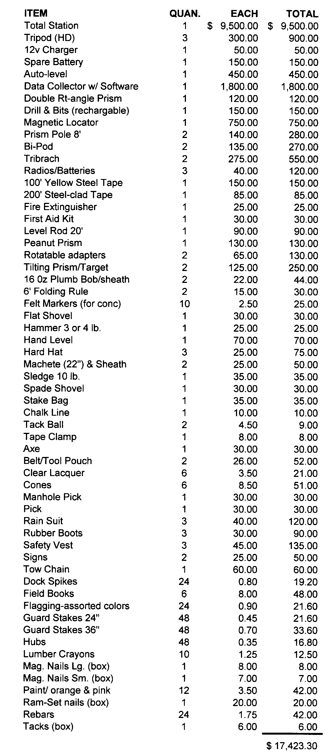
Cheap, huh? Just load $15,000 or $20,000 of gear in the family SUV and you’re off to the construction site, ready to do some damage (to the SUV)!
A few additional items that often aren’t found in survey vehicles are standard equipment for construction surveying. The list above is intended to approximate the cost of basic field equipment. You’ll spend more on some items and less on others, of course.
Below are some tips and notes on equipment that you don’t want to be without.

Chalk Line & Clear Spray Lacquer
You’ll be a hero to your client on occasions when these are needed, and nothing else works like it. Many of your surveyor-competitors are unaware of this “trade secret,” and your client is likely to notice and appreciate your foresight. See more about their use under the section, Marking Projections on Upper Floors (of a building).

Fiberglass Measuring Tape or Steel-clad Tape
All survey vehicles should carry these but often don’t. A 200 or 300 foot long, decent-quality-(but not super-precise), cloth measuring tape on a reel has many uses. Did I say cloth? My age is showing. They used to be cloth tapes. Now they’re made of fiberglass, and some are even coated steel tapes are very affordable. I suggest marking this inexpensive measuring tape at 25 foot intervals, so these intervals can be seen at a glance as the tape feeds off the reel and you can spot these interval markings when the tape is stretched out along the ground. Be sure to mark the back of the tape as well as the front side at these intervals. This can make rough staking (staking in situations where the exact horizontal distance is not critical) very, very fast.
If the measuring tape is marked at these intervals with orange-glo paint, brightly colored nail polish or other inventive marking method, it can be stretched out and stakes slammed in at approximate multiples of 25 feet without taking “EDM” instrument readings for distance and barking the tedious calls to “come to me 2 feet” or “go away 1.3 feet.” Only line needs to be given by the instrument person who’s stepping on the zero-end of the tape in situations where the exact distance from the instrument is not critical. If the instrument person is the one feeding out the tape, those marks make it unnecessary to repeatedly stop the tape to read its graduations until the even 25 foot points are located.
Consider the time saved if you are setting offset stakes along a run of curbing for a straight section of roadway. The offset stakes for a straight run of curbing need to be set in a straight line, and this is fairly critical. But the distance between stakes set along the line of curbing (depending on the situation) often is not super-critical.
In such cases, the tape stretched out on the ground will render distances along its length easily within a foot over its length, provided the grade is not too steep or uneven.
Here’s an example: if the straight section of curb you’re staking is designed at a 6% grade and your stake is placed one-half foot off of the correct distance, the elevation difference between theoretical grade at the true distance and the grade at the position of your offset stake (being one half foot off for distance) is 0.03 foot in elevation. In most situations, an elevation difference of this magnitude is acceptable. Can anyone see if the curb is off 3/100 foot in elevation in a 25 foot run? Will water still flow if it’s off 3/100 foot, and your grade is 6.1% instead of the design grade of 6.0%?
Using this method, assuming a clear line of sight, a hub stake can be set without using a prism pole or plumb bob simply by holding the stake along the edge of the measuring tape for distance and determining the critical line (“Move it left,” or “Move it right.”) from the instrument. I can hear some reader in the distance saying, “Yeah, but what about…”
And sure, this won’t always be appropriate. Just consider the principle and understand that I’ve made a lot of money with this approach – when it was appropriate.
For the sake of easy math, let’s assume your layout crew bills out at $120 per hour. That’s $2 per minute. Assume you’ve accurately bid some layout function at this rate, thinking you’d stake the curbing on several long runs of straight curb using the prism pole to establish the distance for your stakes. Instead, you used the method I’ve described and saved two readings on a prism per stake for 20 stakes where using this approach was feasible. Let’s say that each stake was set 30 seconds faster by this method. You saved 10 minutes using this shortcut. You earned $20 that day over your bid amount through using this approach. Suppose you see a $20 bill sitting on the ground as you return your equipment to the truck at the end of the day, would you pick it up or scoff at it as trivial and drive off leaving it behind?
$20 dollar bills like these are laying around all over the site just waiting for you to pick them up. And, they add up. I have consistently made $2,000 to $4,000 more per contract (bid) job than I would have made billing that work at my standard hourly rates on those same projects. I made this extra money by applying the tips, techniques, and principles related to ethics, client-relationships and business management that I’m relating in this course. Most of those contracts ranged from $8,000 to $14,000 each, so we’re looking at 20% or more profit above my hourly rates that themselves have a reasonable profit built in.
Another thought before leaving the use-a-tape-instead-of-a-prism message: For more critical work, if you have a three-person crew, you can use a steel or a fiberglass tape to get the person holding the prism close enough to the point you’re are about to stake to avoid the time it takes to get multiple readings on the prism before setting the stake. Your third person feeds out the tape to the specified distance, and the prism-holding person uses that for distance and the instrument person’s direction for line. If the prism pole is positioned for its first reading my this method, that first reading on the prism will be within a couple of tenths of a foot of the desired point. Usually, a hub can be set after a single measurement off the prism, since an experienced person can easily visualize one or two tenths of a foot.
Let me state again in a new context that the extra profits to be made in construction layout are in the accumulated seconds saved through ingenuity, appropriate shortcuts suited to the level of accuracy actually needed for the specific layout and by crews moving quickly as a team to accomplish the layout.

Stick-on Targets and Prisms
Stick-on targets placed discretely on buildings or other vertical surfaces as backsight checks or references, save lots of time in subsequent set-ups on known control points. Redundancy is critical, as some mischievous soul might move the targets when you aren’t looking. Some targets are self-sticking, red and white targets for horizontal sighting, but stick-on prisms are also available, and they’re useful for lots of ingenious purposes, among them to help verify your occupied point by distance as well as angle. Considering these when repeated set-ups over time are required on the same control point.
In former times, I used to epoxy a white bicycle reflector onto my Gammon Reel for setting points within a couple of tenths of a foot at close to moderate distances. Range was, of course, limited. Now, stick-on prisms are worth considering for lots of ingenious uses.

Cordless Power Tools
A cordless drill-driver, hammer-drill and/or circular saw is excellent for making drill holes or “x” marks in sidewalks, slabs, ledges or large rocks to serve as control points. Such points tend to be permanent, stable and free from disturbance more than stakes or pins.
On many projects, I’ve set control points in a concrete sidewalk across the street from the project under construction. I used an inexpensive, cordless drill to set drill holes in the sidewalk for these points, and almost without exception, they lasted throughout the entire time of construction.
I always tried to generously set such control points, setting more than would be set for boundary surveying and using points on line, avoiding any occasion of having the same distance between points on line.

Double Right-Angle Prism
The double, right-angle prism is the poor man’s instrument for turning approximate 90 degree angles without setting up an instrument.
Anyone who’s performed topo surveys has experience situations when the line-of-sight between the instrument and some point being located is blocked by some other object. Typically, for work not requiring high precision, the point that can’t be seen directly will be recorded by a right-angle offset. The shot is first taken to a point that can be seen, and then a right-angle offset distance is measured to the true location. Data collectors allow this input and compute the true angle and distance from the instrument to the point that can’t be seen from the instrument.
When the rodperson uses just his or her unaided eye to approximate the 90 degree angle to the point being located, the accuracy of results varies greatly. Being more than a few feet from the feature being located can result in significant errors. It’s amazing how inaccurate these shots often become. Using a right-angle prism significantly improves the accuracy of these locations.
Right-angle prisms are also good for placing yourself on line (or nearly so) between two points, one being on the left and the other on the right of where you’re standing. More than one staff member has insisted he could place himself directly on line between two points while standing mid-way between them. No matter how much I’ve declared it to be impossible, many people have insisted they possess this ability. A demonstration using the double right angle prism was more convincing than my words. After that, they used this device.
Recently working alone and setting control points on a site, I couldn’t tell for sure if two points I was setting were intervisible. Limited equipment was available me, and even if I had tripods and range poles I wouldn’t have used them to determine if the two points I was setting could be seen from one another. That would have been too time-consuming.
Lamp posts and sign posts were scattered between the two points, and a slight hill rose between them. I could tell that the hill wasn’t high enough to block a line of sight between an instrument set at one point and a prism pole on the other, but the hill was high enough that I couldn’t see the paint mark I’d left at one point while standing over the second point I was setting.
To the rescue came my double right-angle prism. With it, I was able to position myself approximately on line between the two points while standing near the crest of the small hill. My double right-angle prism placed me on line between the two points and confirmed there were no lamp posts or sign posts on that line-of-sight.
Double right-angle prisms can also make taking of cross sections or staking approximate grids faster and easier than with other methods. If high precision is not required, the double right-angle prism can make the work fly.

Survey Belts with Pouches
Survey belts and stake bags. I always provided my crews with well-equipped survey belts-with-pouches and insisted they be worn whenever my personnel worked on sites. Crews sometimes complained that the belts are somewhat uncomfortable and cumbersome. Too bad. My crews wore them. No discussion permitted! One employee did genuinely have a back problem, and the belt caused him some distress. About the time I was going to let him off the hook, he rigged work suspenders to the belt and pouches, allowing him to wear the belt more loosely. This solved his problem. Some people really can’t wear them, but most just resist because they are uncomfortable. To this I say, “So are seat belts, my friend; buckle up!”
Trips back to the truck for needed items are almost eliminated by well-equipped belts and pouches, and the time taken for trips back to the truck is disruptive to the work flow and time-consuming. At the minimum these belts with pouches carry hard-tipped felt markers, suitable for marking repeatedly on concrete surfaces, lumber crayon, plumb bob with gammon reel, pencil, scales, tack-ball, two pockets (minimum) for nails, flagging, etc., another pocket for field book and one for a heavy-duty, six-foot folding rule. The well-stocked, seven-pocket surveyor’s pouch is a winner, and generally will suffice for most projects with the addition of a tack ball.
One crew person I knew insisted on using a 5-gallon bucket for stakes, hammer, nails, field book and everything else. This really doesn’t work well, since small nails have to be dug for at the bottom of the bucket, and longer stakes tend to fall out of the bucket or tip it over. If a bucket must be used for some reason, at least get one of the accessories now available for your bucket, the many-pocketed, canvas “overall” that fits over the bucket to hold a variety of tools in various sized pockets.

Stake Bag
I’ve used all kinds of stake bags and found that a stake bag similar to a rectangular piece of canvas with handles on the ends was the best for my use. It lays out flat on the ground. Stakes are placed in the center along with the sledge hammer, and then it is lifted by the two handles to “cuddle” the contents. It carried guard stakes of any size, plus the 10 pound sledge (my weapon of choice). My bag had pockets on the side in which I carried hubs. This type of bag carries iron pins or pipes equally well. For surveyors setting just traverse control, almost any carrier will work. But if you have to set 50, 100 or more stakes per day on a construction site, get, make or buy a stake bag or carrier that’s right for you. Between your belt with pouches and what can be carried in one hand in your stake bag, you want to carry everything needed, thus leaving the other hand free for a prism pole, GPS unit, radio or whatever.

Radios
I must make a pitch for “disposable radios.” The expensive, “professional” radios costing hundreds of dollars are fine if you have the money to repair them when they fail or break or are dropped into a sanitary manhole or stream, and you’re faithful to replace their rechargeable batteries when your crews can no longer get a full day’s service out of them. If you’ve not made an iron-clad commitment regarding maintenance and replacement of these expensive radios, just get the commonly available walkie-talkie type radios. Some have voice activated capability, headsets and privacy channel options, and they’ll work well under almost all typical circumstances. When they break, just throw them away, open your locked supply closet and pass out another.
Your crews MUST have communication. It’s frustrating and inefficient to not be able to hear what one member of the crew is saying to another. Morale is important! This one, easy-to-solve problem faced by many crews is a silent (no pun intended) thief, causing time to be wasted and crews to struggle – and this always, ALWAYS costs you.

Sledgehammer
Pick a sledgehammer that suits your strength and skills. (Allow your crews to do the same.) I discourage the use of a 3 or 4 pound hammer for driving stakes, as the effort expended and time taken for the number of swings needed to set a stake offsets any advantage of carrying reduced weight. The 10-pound sledge in the hands of a skillful person has enough force to pound hubs through light frost and most hard-packed soils. Once this weapon rises from behind my back and swings over my head, gaining in velocity, the sheer weight of the head does most of the work of hitting a stake, without extra effort from me at the moment of impact. Non-slip tape (like the kind sold for tennis racket handles) affixed to the sledge handle near the tool’s head, provides a grip for one-hand pounding of guard stakes. This has worked well for me. I was more efficient and less tired at the end of a day using the 10-pound sledge than working with a lighter, 8-pound sledge or a 3-pound hammer.
This, of course, is strictly a matter of personal choice, but if you’re going to pound stakes day in and day out, all day long, pick a tool that is your friend, not one that just happens to be lying around.

Orange Traffic Cones – as Backsights
A couple of orange cones of differing heights can be useful as a backsight when you’ll be occupying one instrument station for a long session. It is important to check the backsight frequently. Two cones set after the backsight is established by conventional methods can do the trick, without leaving an expensive tripod and prism over the point. Simply set the short cone a few feet in front of the taller one, each positioned such that a survey tack stuck in the cones’ plastic surface is visible on each cone, and each is exactly on line with the true backsight.
If someone moves one or both of the cones, you’ll notice immediately that the tacks line up when the backsight is checked. It can be very frustrating to check a backsight after two or three hours and find that somehow (do we ever know why?) we’ve lost our zero-set on the point. If a vandal moves even one cone or a car hits them, you know immediately because the tacks don’t line up. And, if a wayward vehicle does run over your traffic cone, you’ll rejoice in the fact that you’re not picking the pieces of a tripod, tribrach and prism off the ground, as you would be if you’d left them on the backsight. If you’ve ever had a tripod, tribrach and prism stolen or severely damaged while your back was turned, you’ll appreciate the two-cone approach.
In other circumstances a recorded angle to a point on a building corner, sign, or distant radio tower can suffice as a backsight check without the need to have someone return to the point for the backsight check. And don’t forget the stick-on targets noted earlier.
In the woods, of course, a substantial branch of a tree or tree trunk marked with a nail or survey tack may provide the same service. Even a guard stake with a tack set firmly on the line of the backsight can allow the tripod with prism to advance to the foresight. This can expedite your work when a two-person crew is turning multiple angles to establish a control traverse, provided your data collector and software support the angle-only, second backsight.

Tripod Stabilizer
The smoothly finished concrete floor of a building can be too slippery for your tripod feet to securely set on, as the feet may slide on the finish and send your instrument or prism crashing down. Simple devices can be bought or made, usually consisting of three pads (that the tripod feet sit on) connected by equal-length chains to a circular ring (through which your occupied point remains visible). Some units have solid, steel or aluminum bars instead of chains. Whatever the design, the devices are compact and keep tripod legs from spreading on smooth or slippery surfaces. These are also useful when setting tripods on icy sites or frozen bodies of water. Tripod feet can usually be pressed into the surface of the ice to make them secure, they tend to settle rather quickly. The high pounds-per-square-inch exerted on the ice by the pointed tripod feet melt it, and you’ll soon find yourself releveling and resighting in order to continue your work.

Dist-A-Line™
A Dist-A-Line™ is a device consisting of a small prism set in a machined, Gammon Reel holding device. It provides accurate distance measurement when shot with a total station. It’s a rather expensive device, but well worth the investment in my opinion, particularly when the vertical component of your measurement is not needed or is not critical. If vertical is required, what I’ve done is this: Have the instrument person shoot the little prism with the instrument’s scope locked in position (to keep the vertical angle). Then the instrument person sights and reads a six-foot rule held vertically on the point and records the “rod” height from that reading.
The real beauty of this device is that it needs no adjustment. Gravity takes the place of a level vial. Without adjustment, it remains plumb and as steady as the user’s hand and experience allows. And, the device is quite durable.
Recently through an Internet search, I found the creator and manufacturer of the item at http://www.kmproductsofnc.com/spec_items.htm.
Explaining why I’d have to wait to get one the last time I ordered several years back, the vendor said the device is hand-made in limited quantities once enough orders have accumulated. In my experience, not all suppliers have carried this device. The last time I needed one, I purchase through Lo Ink Specialties (www.loink.com). Recently, similar products have appeared on the market, though I’ve never personally used those.

Tow Chain
Did you notice that item in the list? If you use a two-wheel vehicle on construction developments of significant size, you’re going to either do a lot of walking or take your vehicle into muddy conditions whose significance you occasionally misjudge. On active sites, I’ve always managed to get some equipment operator to pull me out of whatever my truck is stuck in – but, I had to provide the tow chain.
Also, on some sites, I’d stop on clean ground near the entrance of the site and put tire chains (not listed above) on the vehicle. To my taste, this got me around on muddy sites better than four-wheel drive vehicles. They did take a little while to place on the tires, but that is what assistants are for, right?
Some reader is saying, “What the heck are tire chains?” I had to special-order them when I lived in northern Virginia. To view several varieties, go to http://tirechain.com/TRUCK-SUV-CHAINS.HTM.

Adjustment of Equipment
Is it unfair to state that most users of surveying equipment will NOT have periodic servicing performed? Well, that’s been my observation. The difficulty in being without the equipment while it’s being serviced can’t be overstated, and I understand it well. But, if equipment is only sent for servicing after it refuses to work, performs erratically or reports obviously bad data, it can go out of adjustment without being noticed, and your work can suffer. It’s no fun finding yourself on a site with some particularly critical layout assignment and being unable to get your instrument to double an angle acceptably or repeat a distance measurement consistently.
It pays to know how to perform the routine adjustments on your total stations, as well as levels and auto-levels. As noted earlier, this is an excellent rainy-day activity for your employees. They really need to know how to do this, and to do it whenever needed. They will pick up on the need as soon as it presents itself.

Checking of Equipment

Auto-level
In my experience, self-leveling levels go out of adjustment more often than most survey crews realize. A good, sharp bump (such as when setting up on crushed stone when a tripod leg slides off one stone and stops suddenly on the one beneath it) is all it takes to cause maladjustment of the cross hairs on some levels.
A simple two-peg test takes only a few minutes to accomplish, and most levels can be adjusted on-the-fly when necessary. I always tested my level after such a “bump” and frequently in the normal course of business. Some users seem to think an annual tune up is all that is required for an auto-level, and many more never give adjustment of the level a thought – even after numerous “bad” vertical closures – assuming operator-error is to blame for the recurring two or three hundredth errors of closure that begin to appear regularly.

The two-peg test and adjustment
This test is so easy to perform, I just don’t know why more people don’t routinely test their levels. It is even easier if you set up a test range at or near your office. In surveying books, one can find very complex ways of computing your error and making adjustments. The following method works for me.
- Set up two stable points about 200 feet from each other that have a difference in elevation of a couple of feet or so.
- Set your level between the two points about as close to one of them as your minimum focusing distance.
- Read the rod you’re closest to, recording your reading to the thousandth. Estimating it is easy at this close range.
- Rotate the instrument and read the distant rod and record that reading, estimating as well as you can to the thousandth.
- Subtract the two readings to determine the difference between them.
- Move the instrument very close to the other point and repeat Steps 3, 4 and 5.
- Add the two differences and divide by 2 to get the average differences observed. This is very, very nearly the true difference in elevation of the two points.
- Leaving your instrument where it is, adjust you cross-hairs so that the difference between the close-rod reading at the second setup and the far one equals the averaged differences.
Example: You set your instrument 5 feet from your first point about on line between the two points, and your first close reading is 6.005. You turn and sight the distant rod at 8.335. Now, you move 5 feet from the second point, again about on line with the first, and you read the near rod (on the second point) at 4.992. You turn the scope around and read the distant rod (on the first point) at 3.322. The differences in readings are respectively 2.330 and 1.670, the average of these two = 2.000 which is almost exactly your true difference, give or take a or so. (One thousandth of a foot is close enough for my trifocals!) You adjust your cross hairs to read this difference. For a final check, go to the first setup and check to verify you still get 2.000 as a difference.
A variation on this is to set your instrument exactly half-way between the two points where you should get the true difference in elevation between the two points, then go set up close to one of them and adjust the cross-hairs there. Finally, set up close to the other point and check your results there, to confirm you’ve done your math and the adjustment correctly.
Either formula-free approach will achieve excellent results for everyday leveling needs.

Prism Pole
More than one wise surveyor has embraced the saying, “A prism pole is a precision instrument.” I wish I could quote the original source of this wisdom. I also wish more folks realized its importance and absolute truth. A properly adjusted prism pole, held steadily and plumb is a precision instrument. They go out of level frequently if dropped or subjected to a sharp motion.
Once I was discussing the use of a prism pole with a supervisor of crews for another company. He indicated he couldn’t rely on prism poles, as they were always going out of adjustment. Within a few days, I passed one of his crews on the street. The person holding the prism pole was waiting for instructions from his crew chief, and appeared very bored. While he waited, he repeatedly tapped his prism pole point on the concrete sidewalk, apparently to the beat of some tune he had in his head. Any one of the repeated one or two inch drops he gave the prism poles was enough to render the tool useless for precision work without readjusting the level. No wonder that supervisor couldn’t rely on the prism poles.
Not so long ago, I was astonished to watch a person setting a point with the aid of a prism pole, simply let go of it when the instrument person said, “Good. Set it.”
The pole fell over and bounced on the ground as the user reached into his stake bag and pulled out a stake. The site was planted in grass that was about 6 inches tall, but who knew what rocks were in that grass? If breaking the glass of the prism was not a concern, what about bending or breaking the frame holding the prism. And, in my experience a prism pole falling to the ground is often enough to throw a prism poles level vial out of adjustment.
After seeing this, I better understood why this person’s plastic prism-holders were chipped with several pieces broken off. Need I say that a precision instrument should not be dropped on the ground or rapped on concrete to the beat of a tune some cool dude has thumping in the brain?
Finally, how often have you seen someone jam the pole’s point into the ground to make it stand upright while the stake is set, thus avoiding the need bend over and pick it up off the ground after the stake is set? Sometimes when spearing it into the earth, it hits a rock just beneath the surface. Its downward thrust stops suddenly, violently. Other times, it does “stick” only to stand upright for a few seconds before slamming to the ground.
These examples illustrate abuse of precision equipment and should not be practiced or tolerated.

Total Station
Today, almost all surveyors and many larger contracting firms use total stations for all or some of their layout. It’s important not only that they measure correctly, but that they measure consistently.
In most boundary surveying work, a hundredth or two of measurement error is not particularly noticed, even when doubling distances off fixed sights. (It may never be noticed if prism poles are used instead of tripods, tribrachs and prisms.) For most horizontal measurement on the construction site, a hundredth or two is not going to matter very much and may go unnoticed.
But, not so long ago, I was asked to visit a site to help the crew chief discover the cause of his inability to check his primary building control for a proposed structure measuring about 120 feet wide by 350 feet long.
Fortunately, the four primary-offset control points he was attempting to set were intervisible. Even so, after measuring and setting using 90 degree angles, he simply could not get the diagonal distance across the rectangle to check. I suspected total station distance measurement error as the cause, since this crew chief was a stickler for precision. He used the Dist-A-Line™ mentioned earlier, and he was steady as a rock with it – no prism pole problems here! (Incidentally, I may suspect total station error or malfunction early in my analysis of a problem, but I’m disciplined to conclude it only after all human and other-equipment errors have been systematically eliminated. Almost always in my experience, the total station has NOT been at fault.)
When I arrived on the site, the party chief explained the steps he’d taken. Finding no fault with his process or logic, I essentially repeated the steps he’d taken to set the control rectangle. To eliminate the Dist-A-Line™ as a suspect, we compared distance readings using the Dist-A-Line™ and a freshly adjusted prism pole steadied with a bi-pod. They agreed. Then, we rotated the prism pole 180 degrees and read the distance again as a double check of the pole’s level adjustment. Exactly the same reading again.
By now, I was obsessing too. Many of us surveyor/engineer-types are born with an obsessive-compulsive disorder when it comes to precision. But, something was clearly wrong, and I wasn’t about to be defeated by the fact that nothing made sense.
Next we got out the steel tape and measured with temperature correction applied between points set at the shorter ends of the rectangle and checked less that .01 foot with the prism readings. We checked the total station’s optical plumb by carefully leveling and rotating through 360 degrees while looking through it. Right on.
We set the total station on all four corners points and got mixed results. We again adjusted the points set, only to get further bad checks of diagonal distances and repeat measurements between the same two points.
Once more, we adjusted the four control-rectangle points. Checking the diagonal, it again missed by1/4 inch to 3/8 inch (two to three hundredths). We set the instrument on the backsight and the prism on the former instrument point, measured the other way and checked exactly with theoretical or expected distance (that is, measuring between the same two points we got different readings).
After a couple of hours of this madness, my business sense got the better of me, and I said, “OK, close enough. But, let’s keep an eye on this and see if we continue to see inconsistent distance readings on measurements.”
Did this small amount of error really matter? Probably not in the real world, and most crew chiefs wouldn’t have reported it in the first place. Truth was, this particular crew chief was always obsessive over precision. He consistently turned in absurdly good horizontal and vertical closures on large tract surveys where his obsession cost very little and his consistent results saved return trips to find bad closure errors. But, making money in construction layout was indeed difficult with this person at the helm. He couldn’t let go of his quest for precision when rough staking for construction layout purposes. Absolutely everything he staked had to be perfect. That takes time, and is a profit killer when such exactness is not required. But, that’s another story. In this case, precision was important, as he was staking primary building control that we hoped would last throughout our involvement with the building construction.
The tale here is that the total station appeared to be giving slightly inconsistent distance readings. The errors, if they indeed existed, were random in nature and occurred unpredictably. It seemed like the proverbial car with air conditioning that won’t work except when at the repair shop. We could not make the error repeat.
Before a few weeks had passed, we were called to lay out a three-section athletic center at an upscale, private school. The three sections were connected together, but were not parallel with one another. It was a tricky layout, and column line offsets were requested for the three, interconnected buildings.
This time, I went with the same crew and same total station at the start. Again, we were coming up two to three hundredths off when trying to check layout of the three separate control rectangles that had to fit together with very little tolerance for error. We finally got it to check everywhere within two hundredths and called it a day. It was absolutely the best we could do, but now I felt certain the instrument was to blame. I had never been unable to do better than this before. Sadly, the total station was fairly new.
Did this matter in the real world. How could it, really? I’ve seen tighter tolerances in architect’s specifications, but c’mon guys; does it really matter. The people who actually build the structures say no.
But the next day, we received a call from a young assistant project manager who worked for the construction management firm overseeing and coordinating the construction. He was working with a more respected brand of total station costing considerably more than ours (the kind I wished we had) and checking behind us.
I went to the site, and he explained that the points we staked were two hundredths to three hundredths off in some places. I had to confess that he was no doubt correct. I explained to him the trouble we were having with our total station and that we had only just confirmed our suspicions on his project. I suggested we go to the gray-haired superintendent who was his boss and see if the discrepancy really mattered.
The seasoned superintendent said, “Don’t worry about it.” The sharp young assistant seemed baffled. I was considerably relieved. A subsequent call to our instrument supplier elicited a confession that a few users of the same make and model instrument had reported this same problem, and it was uncertain if it really could be eliminated.
A hard decision was made to replace the not-very-old instrument with a new model. This was an expensive solution, but the only sure one. If we’d only been doing land surveying work with this instrument, I’m not sure the problem would have been discovered. But, since we were routinely performing layout of expensive and complex buildings (with our clients looking over our shoulders), it seemed the only wise thing to do was replace the otherwise good total station.
What is the point of this story? Well, we’re talking about checking equipment, specifically the total station. It is important to have a baseline near your office that is stable and secure, where you can check near, medium and far distances on a regular basis. We probably would have turned up this problem sooner, if we used such a base line and made periodic, scheduled checks.
You might even be able to set up a base line on the ground level of a shopping mall or under the overhang of a strip mall. This way you can check without much difficulty even on a rainy or snowy day. Also, a calibrated steel tape can be used (with temperature correction, of course) to set the points by measuring on the floor or walkway surface, thus eliminating sag problems from inadequate tension on the tape when measuring. To be honest, I’ve done this with out-of-the-box steel tapes for decades and never found that I needed a specially calibrated tape for this purpose. But, suit yourself.
Precision has its limits, and I’ve done very precise work when proper care of equipment and procedures was observed.
Just so the point is not lost in the telling of the illustration, it is this: Don’t wait until the instrument betrays you to discover even intermittent problems. Check it on a schedule, even if that schedule is the first inclement-weather day of the month. It was embarrassing to have a green-behind-the-ears, recently graduated construction assistant tell us professional surveyors that we couldn’t measure accurately. And, he was absolutely correct – regardless of whether or not the small amount of error mattered in the real world.

Adjustments in General
My observation is that most surveying instruments are designed to permit routine adjustments by their users, and documentation in their manuals instruct on how these are adjustments are performed. Yet, most times, the equipment is sent to a repair facility once they fail to meet tolerances for direct and inverted angle measurements. Why is this?
Apparently the art of simple adjustments to the cross hairs has been lost, at great inconvenience and cost to their owners. In my experience, some dealers will even instruct you over the phone on how to remedy common problems like tangent screws bottoming out and the instrument therefore losing its ability to lock upper or lower motions. We need to recover these skills that once were routinely employed by any self-respecting instrument person.

Take it for repair when necessary – Don’t “limp along.”
Finally, when equipment really needs service, don’t delay. I know of a surveying firm whose total station logged a few readings per data collector file with incorrect distances. When larger raw files were processed, one or more points fell well outside their expected positions. Fortunately, these errors in distance were very large. Generally they were discovered when the files were processed, though not always. The errant points often fell outside the view on the computer screen, so some were discovered some time after the files were processed. Small errors might have gone undetected forever, but these were at least large errors, and all were hopefully discovered eventually.
For a while after the problem appeared, most of the bad shots were simply dropped from the job.. Other times, the bad shot might be on a point that the survey manager decided could be “fudged in.” Sometimes though, the bad shots were critical to the project, say a building corner or fence corner, and the crew had to return to the site and locate the missing point.
Multiple instruments and data collectors were in use by this firm. For a while, we weren’t sure if the problem was caused by a certain combination of data collector and instrument. (This is another example of why throughout this course I advocate THOROUGH record keeping.) Analyzing the raw files from several projects, we were able to isolate the problem to a particular total station.
A decade or so earlier I’d encountered a similar problem using another make of total station. Digging deeply into my memory bank (the dust bin of my mind), I recalled that the problem back then was an unexplained add-on of 300 or 400 meters to the occasional shot’s true distance, making the recorded distance to the shot considerably longer than the true distance to the point.
Once this old memory of mine surfaced, some experimentation determined this to be the case once again; a 300 meter add-on to true distance to a point was the problem. It was not too difficult to diagnose, as a row of equally spaced bollards had been located by shots taken on each individual bollard. One of them plotted in an absurdly distant place, and the gap in evenly spaced bollards was readily apparent. When 300 meters was subtracted from the distance logged in the data collector, the bollard fell right where it should have, taking its rightful place along the row of bollards. The horizontal and vertical angles were fine. Once corrected for distance and reprocessed, the data collector’s file placed that bollard in line with the others, equally spaced with a correct elevation. It should be noted that we were not collecting data in meters, but in U.S. feet at the time. Nevertheless, the distances on these bad shots all appeared to be 300 meters too long.
A few shots taken in a controlled experiment confirmed both the amount of the error and what was causing the error. When shooting a prism at some distance from the instrument, most total stations will allow the shot to be taken with the instrument’s crosshairs sighting the edge (or even slightly beyond the edge) of the prism’s glass. When taking distance readings with this particular total station purposely sighting the edge of the prism or just off it to the left or the right (no data collector connected at the time), we discovered this same 300 meter add-on of distance occurred frequently. The instrument was only about six months old when we isolated the error and its cause. It still had a year and a half left under its two-year warranty.
Having confirmed exactly what was causing the errors in collected data what do you think happened? The firm immediately sent it in for service, right? Nope!
As any field personnel reading this course know, when making non-critical observations (for example, topo shots taken in a grassy field a couple hundred feet from the gun), it’s expedient to turn the gun to the approximate location of the prism for the shot. Exactly centering horizontal and vertical crosshairs on the precise center of the prism is simply not necessary. What difference does it make if the shot is 0.1 foot from its true horizontal position elevation? Or, when shooting a building corner at some distance from the gun, rather than take the shot using a horizontal offset routine, it is faster and less prone to error to align the crosshair on the building corner right next to the prism. Provided the point is not too close to the instrument, most total stations will read the distance correctly by “sneaking into the prism,” and the angle is taken simultaneously from the crosshairs positioned at the building corner. This method is safer than using an offset function of the data collection software, because there is no risk of entering a wrong right-or-left or physically keying in the wrong distance to the offset position. Sure, most collectors allow taking one shot for distance and a second for angle. But, this is means two shots to get one point, which is more time consuming and means pushing more buttons on the data collector creating additional opportunities for error.
The commonly used shortcut (shooting the edge of the prism when longer distances between the gun and the prism allow) saves considerable, accumulated time and provides a safer way to log shots like building corners, fence corners and the like. But, this method had to be abandoned during the time this total station was in need of repair.
Finally, the week before the instrument’s two-year warranty expired, the firm sent the instrument to the dealer. The dealer narrowed the gun’s angle of acceptance when reading a prism, and the problem was corrected – a year and a half after its cause was diagnosed!
In the office, for a year and a half, these bad shots had to be isolated and manually corrected by calculating both the correct horizontal distance (300 meters less than the recorded distance) and the vertical correction (a function of vertical angle and corrected distance) for every point where this occurred on every project. This took time and introduced opportunity for errors in the hand-made calculations of all those bad points.
In the field, too, time was lost. Once the problem was attributed to shots taken near the edge of the prism rather than at its center, the instrument person had to be careful to center the prism on every shot, whether or not the point being located required such precision. The person holding the prism had to take extra care not to let the prism pole drift to the side while the shot was being taken. This extra care taken in the field for thousands upon thousands or non-critical locations reduced occurrences of this equipment error to about two or three shots per thousand.
This took time. For every single shot, the instrument operator needed to precisely center both the horizontal and vertical cross hairs on the center of the prism. For non-critical shots, a properly functioning instrument allows the gun to be turned toward the prism until it begins taking the reading. The person holding the rod had to keep close watch in the level bubble instead of glancing ahead to plan the location of the next shot. The instrument person needed to look at the distance before accepting the shot to see if it was reasonable or if it was three football fields too long. Lots and lots of time was wasted, while the occasional bad shot still crept in unnoticed.
Because the crew using that instrument was often collecting topo in fairly developed areas, lots of shots were taken each day. This meant that almost every day at least one such error slipped their notice and had to be hand-calculated and corrected – or, the data collector file had to be hand-edited and reimported.
The net results of not taking the instrument for repair until about a year and a half after the problem was discovered was all of the following:
- Opportunity for errors due to hand-made corrections increased.
- Increased costs of processing data increased due to manual calculations and modification of point databases by hand or reprocessing of collector files.
- Constant extra care was needed to achieve the otherwise unnecessary precision that alone avoided most occurrences of the error. Over a year an a half, this added days of extra effort on the part of field crews, distracted them from what they were locating with the need to concentrate on how they were locating it, and increased fatigue while adding frustration to the crew.
- Indirect costs of poor morale caused by frustration of both field and office personnel may be the greatest cost of all.
Be good to yourself and your staff. One of the most unnoticed, substantial costs of doing business today is the significant, indirect expense of poor employee morale.
The probable reason for delaying repair of the instrument in the above, true story was avoiding the expense of renting an instrument while the one on warranty was in the shop for repairs or adjustment. Perhaps the manager thought a slow time would come when the instrument wouldn’t be missed. Yet, this one instrument problem frustrated numerous personnel and slowed both field and office processes for a year and a half before it was easily and quickly resolved.
My advice: Never, never be penny-wise and pound-foolish. If some piece of equipment doesn’t work like it should, bite the bullet and git the dern thang fixed!

Adjusting the Firm to the Times
The preceding tale took place in a large, multi-discipline firm. Before leaving this topic, I must say that we are in a difficult period when it comes to management of large firms. The reason is that the owners of large firms have in most cases been successful and grown their companies precisely because they stopped doing the work themselves a couple of decades ago and delegated production to others so they could devote their time to business promotion. They promoted and circulated and wrote proposals and eventually delegated some or most of that to managers of departments. Accountants and even comptrollers who have never surveyed a day in their life make ultimate decisions and impose Catch-22 constraints on office managers and department heads.
In short, many business owners don’t really know how things are done in our time, and the folks who keep the books and count beans for the owners don’t have the remotest idea how things are done either. Many older owners and partners honestly believe it can still be accomplished the way it was in the days when employees were given a pencil, calculator and Leroy lettering set. Just throw any computer and software package at them, and expect results! Staff is told, “Just make it happen. I don’t care how you do it!” There is no awareness of the time it takes to develop CADD standards, of the time it takes to get up and running in a new CADD package or even an upgrade.
Yet these folks who count the beans and those who spend the beans are decision makers and authors of policy.
Example: In the mid-1990’s I heard a branch manager for a several-hundred-employee-firm ask his surveyor, “How long is it going to take for you to get up to speed in AutoCAD?” The branch manager’s tone betrayed some evident displeasure with that surveyor’s perceived rate of progress at learning the program.
The surveyor answered, “Well, I don’t have a computer to work on.”
The office manager replied hotly, “Well, you have a key! You can come in on evenings or weekends and use a computer when somebody else isn’t.”
I feel very sorry for all the ‘guys and gals in the trenches’ who are required to perform in today’s ruthless, competitive market with yesteryear’s programs, equipment and computers. And, sadly, it’s a pretty common tale, a very common tale.
And, I also feel sorry for owners who don’t have a clue how profitable their firms really could be if they would simply listen to the experts – those who actually produce on a daily basis, often with one hand tied behind their backs.
Many owners of large firms don’t mean to be this way. They don’t know they’re shooting themselves in the foot. The reason small firms don’t generally suffer these ills is that the owner is still actually producing the work product, understands what it takes to get the job done, knows how to do it, and can balance the bean-counting analysis with the increase in his end-of-year profits that result from making wise expenditures.
Enough said.

Typical Requirements of Construction Layout

Build on a foundational understanding.
Up to now, we’ve said little about the step-by-step procedures involved in the actual acts of laying out the typical construction site. Now we come to the part many have been waiting for – some actual how-to instructions and step-by-step methods.
I could not present the remainder of this course divorced from what’s been presented up to this point. Achieving maximum success at construction layout requires a foundational knowledge of your clients’ needs and of business considerations peculiar to the specific layout being performed at any given time.
Surveyors have always prided themselves as being “experts in measurement.” If that’s the only claim to fame a surveyor has, then he or she will have difficulty competing for construction layout contracts. Today’s measuring devices and equipment allow almost anyone to become an expert in measurement in a fraction of the time it used to take to acquire consistent, accurate, “expert measuring skills.”
Today’s technology presents a serious problem for anyone who does not understand the differences between measuring for land surveying and measuring for construction layout needs. Twenty years ago, surveyors were called in to perform construction layout because of their skill in computing coordinates (that is, their mastery of coordinate geometry computations) and their expertise at measuring precisely. This required special knowledge of math, geometry and trigonometry plus acquired, disciplined, physical skills. Measuring with a steel tape demanded that adequate tension be used in measuring; temperature and sag corrections had to be computed and applied correctly to observed measurements; physical strength was needed to pull the tape hard enough in contorted body positions. Even the skill required to hold a suspended plumb bob steady while making measurements took time to learn. This, like any difficult physical discipline, took lots of patient practice. And, some people never really got good at it.
Creating a geometric plan from which to lay out the construction of a site required considerable computational ability twenty years ago. Now, even that has been made immensely simpler due to the graphic solutions of the CADD world.
Today, it is not rare to encounter a recent graduate of a two-year construction management program checking or supplementing the work of surveyors on a construction site. (Remember the true story related earlier in this course under the “Total Station” section.)
Many older surveyors who perform construction layout services haven’t noticed this evolution. They rest on their laurels, boasting expertise in measurement as their claim to fame. But, they haven’t noticed that their laurels have become brown and brittle.
Sadly, many surveyors assume they are experts in construction layout simply because they are experts in measurement. To be truly effective, construction layout requires more than basic measurement skills – more than advanced measurement skills. To stand out as a provider or construction layout services demands an understanding of the matters presented in this course. And, don’t think that the party chief sent to perform construction layout doesn’t need to know these things, too.
By diligently applying the material presented in this course (whether you’re an owner, manager, office or field person), you can stand out among the competitors and serve your firm’s clients in a way that makes them happy and keeps them coming back.

Getting the right start…
The key to getting started ‘on the right foot’ when performing construction layout is taking care with the initial fieldwork and making necessary office preparations at the very beginning of a project – BEFORE any actual layout is performed.

…in the field
Your control traverse (network) should be plentiful, located to last throughout construction wherever possible and be as precise and accurate as you can possibly make it.

…in the office
Getting the current plans at the start of the project is critical, as is performing necessary checks and computations before attempting any critical layout.

Preliminary Reconnaissance, Control Traverse, Traverse Adjustment (or not) – Your First Visit to the Site
This section necessarily requires many if/then’s. Bear with them and try to follow the variables. It will be worth your effort. Study even the headings that don’t appear to apply to your situation.

Assuming you are a surveyor, but not the record surveyor
On a typical project for which you are not the record surveyor (the surveyor who performed the boundary survey for the parcel being developed), your initial visit to the site is to recover evidence of property lines and corners or whatever the design drawings (usually site development plans) dimensionally tie the locations of the new construction to. Usually the proposed improvements are dimensioned from property lines or phase lines of the project.
Typically, you’ll run a closed traverse around the site to “prove” the positions of such evidence and best-fit your traverse to any supplied coordinates of pre-existing control you recover on the site. This data may be provided to you by the design engineer or record surveyor, as noted earlier.

What if You’re an Engineer or Layout Contractor, But You Aren’t a Licensed Surveyor?
As stated earlier in this course, if you are in the business of providing construction layout, but you are not a licensed surveyor, the ‘Assumptions’ portion of your proposal should state that at least three property corners and two vertical benchmarks exist on the site prior to the start of your work. If, on your first visit to the site you do not find confirming evidence of at least three corners of the site to be developed, you may be off to an awkward start – and a SLOW start.
SLOW is your enemy at this juncture. Your client won’t tolerate delays at the start of a project.
This is the sticky part of offering construction layout services if you aren’t a licensed surveyor. Also, if you’re not a surveyor, be careful to know your state’s definition of “a surveyor” and of “surveying,” so that you don’t expose yourself to the public scorn and penalties for overstepping your bounds by performing the services of a regulated profession.
The bottom line is this: You MUST recover and locate property corners as a starting point for your horizontal control and computations. Sometimes you can get by without established, on-site, vertical benchmarks by checking the tops of several existing utility manholes or catch basins that are shown on the site development plan and best-fitting for your elevations to those features, provided you confirm essential agreement between the labeled elevations of those structures.
Some surveyors will give you their coordinate values of property corners AND their traverse points. With this information, assuming you find and verify coordinates of three points of their traverse, you can compute exactly where that surveyor’s property corners are (whether or not they exist in the field). Always check any such data very, very carefully to be certain it all agrees with itself and with whatever mapping that the surveyor produced. Then write CYA memos to both the surveyor and your client stating what you’ve found and how it relates to unrecoverable property corners. Sometimes the surveyor’s control traverse and the property corners get positionally disassociated from each other in the CADD drawing. This shouldn’t happen, but it does. Just believe me on this. I’ve seen it happen several times. This is why you MUST draft carefully worded CYA memos, closing with something like, “Please advise if there is any reason or condition that makes the approach I’ve taken insufficient to establish coordinates of the missing evidence of property corners.”
If you’ve been to the site and set a traverse, and you later hire a surveyor to set corners, (or your client or the developer does), ask that surveyor to locate two of your traverse points while there on the site setting corners, and get the surveyor’s coordinates of the corners and your two traverse points. With this information, you can simply rotate and translate so that your traverse and the record surveyor’s corners are based on the same coordinates and north rotation. This helps place the liability for the orientation of your staking of new construction squarely on the shoulders of the surveyor. As an unlicensed person, this is where you MUST keep it – on the surveyor’s shoulder.
If you are not a surveyor, familiarize yourself with the statutes governing and defining “surveying” and also study the Board rules and regulations governing surveying so that you don’t violate any in the course of your work. As an unlicensed person, you may have as much expertise in measurements as some surveyors, but you can’t certify to it. You may know where the property corner belongs (especially if the surveyor gave you the coordinates of the point), but you can’t monument it. And, you certainly can’t weigh the value of conflicting deed elements or make judgments about where a boundary is located. If you are capable at laying out a site for construction, you are probably capable of locating what is built at the end of construction. But, you can’t sign and seal an As-built Survey.
The above guidelines are presented as a starting point for your own research. Laws and regulations vary widely from one geographical area to another and political subdivision to another. Avoid learning the hard way that you’ve inadvertently crossed that line into professionally regulated activities.
For the unlicensed person performing construction layout activities for hire, the delicate “dance” of getting the corners staked by a licensed surveyor may be the trickiest part of contract negotiation with your clients. Sometimes, you may even have to subcontract that service to the record surveyor and absorb the expense. Keep in mind that you’ll also need to hire a licensed surveyor for anything in your contract that requires a surveyor’s certification. And, offering such services as an unlicensed surveyor may be illegal in your state. Typically, at a minimum these services include setting of property corners, performing wall-checks (or foundation as-builts), final as-built surveys, and anything that requires accuracy certifications.
A word of caution and advice: If you are not licensed, be very careful in your proposal not to word anything in a way that can be construed as you holding yourself out to be a licensed surveyor. Save yourself trouble later, and hire a lawyer to help you phrase your standard, proposal boilerplate. You MAY be able, for example, to say, “will provide an As-built Survey bearing the seal of a licensed surveyor” and not “will perform an As-built Survey.” This example may or may not be legally correct. In some states, this simply won’t fly. I note it here simply to give you an idea of the types of questions you need to discuss with a lawyer. If, unlicensed as a surveyor, you can find a legally sound way to provide full-services under your umbrella contract, (that is, the services of a licensed surveyor you subcontract), then you can compete head-to-head with your licensed-surveyor competitors. Your client’s contract as well as your proposal language (and of course the law) can impact the feasibility of this approach. Your client’s contract with you may not permit assigning any of the services of your contract. Ask your lawyer about all these things.
Please be clear in your understanding of this one point: I am NOT advocating any approach or offering any legal advice. Except this: If you are not a licensed surveyor, get sound legal guidance on how to handle your situation in your geographical area. While I have obtained licenses as a surveyor in seven states, I have practiced construction layout, and that very successfully, in a state in which I was NOT licensed as a surveyor. I did this legally without dishonesty or resorting to unethical means. I sought sound legal advice and stuck with that counsel.
Get legal advice from an attorney familiar with professional regulation and Board hearings! If you ever are called before the Board that regulates professionals in your state, remember that in many states, the Board acts as both investigator and prosecutor and has the authority under their Administrative Rules to levy large fines and order you to cease conducting business – if they feel you’re practicing without a license. Those words “investigator AND prosecutor” do not sound awfully friendly, do they? My advice is, don’t conduct business in such a way that you’re called before the board; and, if you should be, don’t attend a hearing without an advocate, a lawyer. I’ve never been called before a Board, and I hope never to be.
Not all surveyors appreciate competition from non-licensed people who get construction layout contracts they wanted for themselves. Know the law and stay within it. If you are unlicensed, make friends of your local surveyors whenever possible and walk softly around those who put you on notice that they don’t like what you’re doing. If you give them cause, they may report you to the Board.

Set primary off-site control where possible. When running your control, be precise!
OK. Whether you’re licensed or not, your core construction layout needs require that you perform the same preliminary activities before you can provide layout.
Let’s start with your first, post-award visit to the site. You are here to set your control points for all future layout. This should always include a closed traverse, so that you can verify the accuracy of your work. Set primary off-site control points in places where you expect them to remain undisturbed throughout the course of the new construction and on-site control points where you think they will last throughout construction. Often I try to place such control well outside the clearing limits and often across the street from the project or on adjacent property where that’s legal (or if necessary permissions have been obtained). When feasible, I like to set drill holes in a sidewalk or some distinct, stable points not likely to be disturbed or covered by vehicles or snow banks in colder climates.
Off-site control should usually be a part of your on-site, closed traverse used to locate the existing evidence of property corners. Wherever possible, set on-site control where it will survive the new construction.
One key to profitability in construction layout is knowing how much precision is required for different types of layout and not fussing to obtain a high degree of precision (or accuracy) when its unnecessary to do so. This is a real challenge for an anal-retentive personality, a nature often present in surveyors.
And, the key to learning how much precision or accuracy is required is to ASK. Who should you ask?
Ask lots of questions of the people actually constructing what you are staking. These people know what most surveyors and many engineers never really know. Ask different people on different sites who perform similar sorts of construction, “How accurate do I really need to stake this?”
Want to know how accurate your work has to be when staking sanitary sewers? Ask three or four different contractors constructing sanitary sewers on different sites. Ask how precise both horizontal and vertical (elevation) references (your stakes) have to be. Ask whether they generally prefer two offset stakes on line with the proposed manhole, say for example a 10’ and a 20’ offset stake, or do they like a 10’ offset stake set at 90 degrees to the line back and another 10’ offset stake set at 90 degrees to the line ahead. Ask everything you can think of. Take notes. Compile and compare the answers you’ve received. Do all their answers agree? If so, you’ve probably learned in general what level of precision to put into staking typical sanitary sewer construction and where in relation to the manholes most contractors like your stakes to be set.
And don’t forget to ask what they can think of that might be exceptions to whatever guidelines they’ve given. For example, a storm catch basin that has a flat top and is designed to be constructed in the middle of a parking lot driveway could probably be constructed a half foot off, to one side or the other of the dead-center of the drive. But, a basin fit into the curb line, having a pre-cast concrete top with its own curb section might cause a problem in the curb alignment if set a half foot off. Don’t use this as a fact, unless you confirm it for your specific application. I’m just illustrating what you are trying to determine when you ask the experts – the ones who use your stakes to construct everything on site.
OK. Back to the control network you’re establishing. BE PRECISE! Never wonder how precise the control network for a project should be. Do your very best work. Just believe me on this one if you have any doubt. When running your control loop, always, always be as precise as your equipment allows. Be certain all your equipment is adjusted prior to running the traverse – the optical or laser plumb of your instrument, the tribrachs, the prism poles, the cross hairs of the instrument, everything you use! Set the correct PPM setting in the instrument for the weather conditions of the day. Turn multiple angles sighting with direct and inverted scope.
I always run the initial control traverse with foresights and backsights set on tripods, with tribrachs that I know to be sighting accurately through the optical plumb. I measure and record heights of instrument and prisms in decimal feet plus feet-and-inches or meters for verification.
And here’s a tip. Make sightings on prisms with care, wagging the head so the eye moves side to side behind the instrument’s eyepiece to check critical focus. If the cross-hair appears to move on the target as the head wags side to side, the scope is not properly in focus, even if the naked eye can’t notice that the focus is not quite correct. Sighting errors due to parallax are common if the instrument is not focused exactly. This is typically overlooked and is often a source of error. When precision matters, always check for parallax in this way.

Run Your Traverse PRECISELY!
Why such concern for the precision and accuracy of the traverse? Consider the following illustration of how things go in the real world of construction layout.
Suppose you’ve been awarded a contract to perform construction layout for a facility on a site that measures about 600 feet by 1500 feet. The new building will be cross shaped with one leg of the cross measuring 400 feet and the other 500 feet. To keep your primary control traverse outside the limits of new construction, you run around the outside of the site, on opposite sides of the road wherever possible.
This hypothetical example is illustrated in Figure 6, below. Refer to it so the written explanation makes sense.
In this example, for the sake of illustration, suppose the following:
- Traverse length 4,300 , more or less
- The site is nearly level throughout – less than ten feet difference in elevation distributed evenly over its entire length, rolling gently from one end to the other.
- Distance from #4 to #6 = 660 feet, more or less. These are drill holes set in a sidewalk on the opposite side of the street from the site, and #5 is a point on line between #4 and #6. Distance #6 to #7 is another 245 feet.
- Your raw error of closure for your closed traverse is 1:10000.
Well, you usually do better but, hey, 1:10,000 is good enough, right?
You adjust the traverse as usual, knowing the 0.43 ft. error of closure will be distributed over the 14 legs of the traverse. No big deal, you think.
After the site is cleared and rough graded, your client asks you to stake the building. Your client wants two control rectangles for the building, one for each major group of columns. These two sections of the building are at right angles to one another.
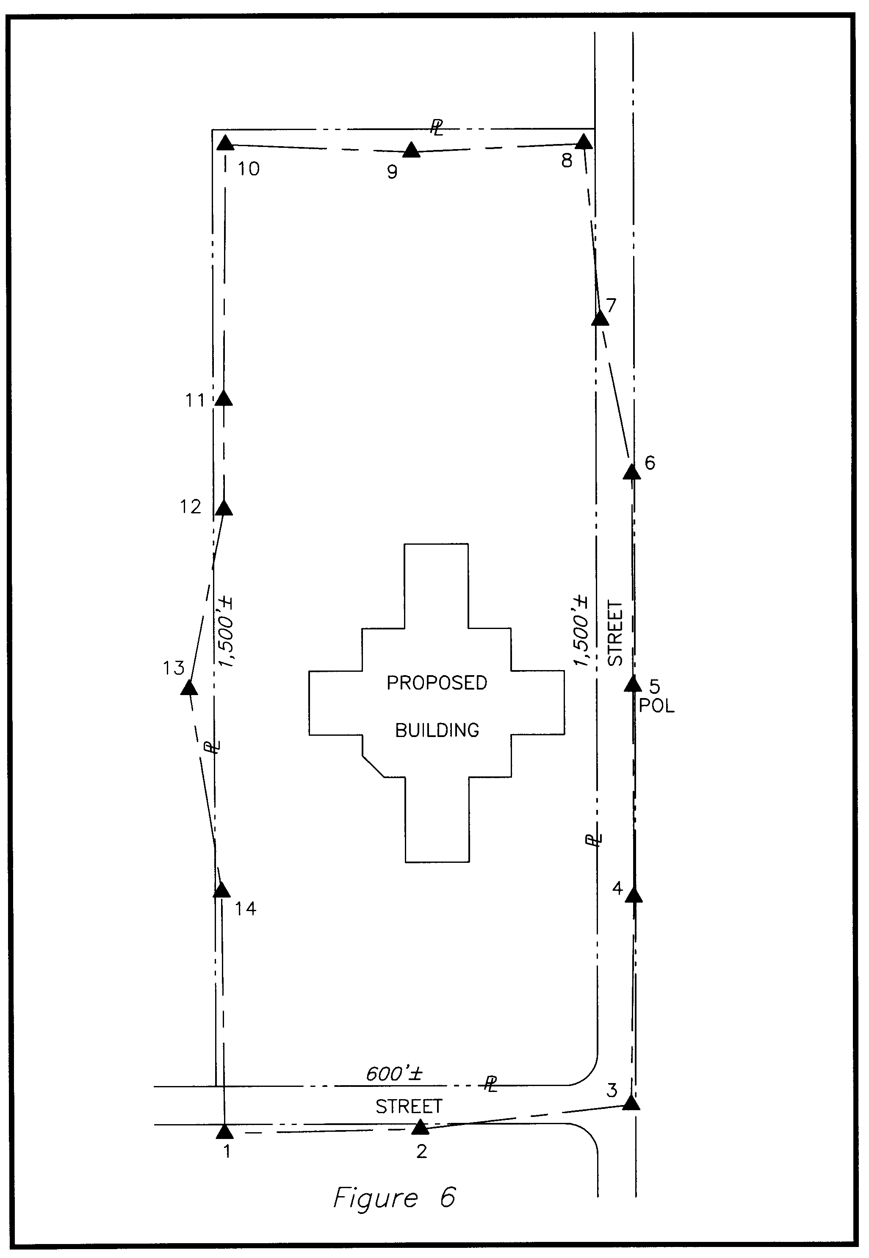
After the site is cleared and rough graded, your client asks you to stake the building. Your client wants two control rectangles for the building, one for each major group of columns. These two sections of the building are at right angles to one another.
At this point, you feel very proud of yourself because you set your traverse anticipating this exact circumstance. You took the trouble to set your traverse points where they’d facilitate this layout. You even set #5 as a point-on-line between #4 and #6, so that you’d have three traverse points that would last throughout the course of the job. You located them along the sidewalk across the street. Not only that, you placed #5 and #13 so that they could be useful to layout one leg of the building’s control if needed. You planned to shoot across the site between #5 and #13 as you ran your traverse, but the site was lightly wooded at the time. You didn’t realize until you occupied #13 that there was a tree on line blocking your view of #5. You decided to skip tying across the traverse.
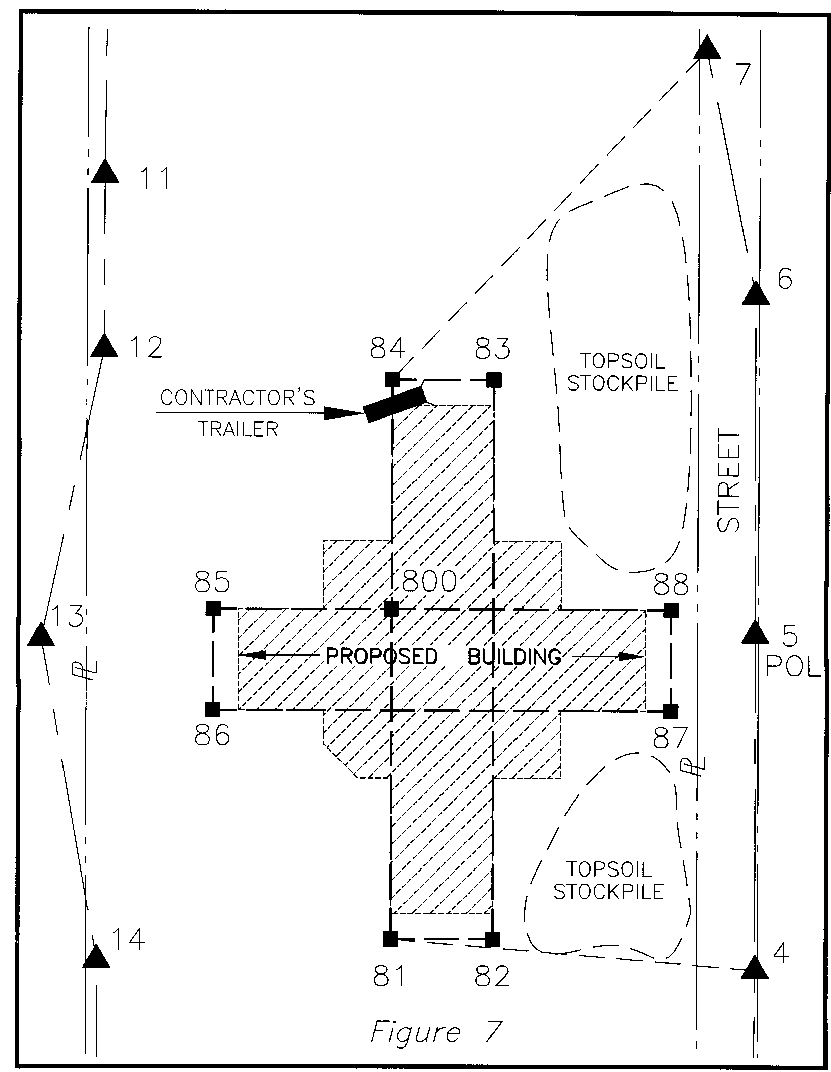
So, for the building layout, you arrive on the site ready to fly through the assignment because of your forethought and planning in setting up your control traverse. But, when you arrive, you notice that something new has been added: topsoil stockpiles – two of them. You’re faced with the situation illustrated in Figure 7, a blown-up section of Figure 6.
You had a plan for staking the building, but you’ll work around this unforeseen development of finding stockpiles of topsoil in your way. You set your instrument on #4 and backsight #5 and then turn an angle to set #82. But, you hit smack into the side of the stockpile. Same with #81. Still, with a little help from a backhoe operator you chatted-up on some other project, the edge of the stockpile is soon cut away, and you radially stake #81 from #4.
Next you set on #81 and backsight #4. From this setup, you intend to stake #84, but when you turn the angle, you hit the trailer part of a tractor-trailer that the plumbing contractor parked on the site. No one is there to move it. No problem. You stake #800 and #82. You check the angle 800-81-82 and confirm that it’s 90 degrees, dead-on. Distance 81-82 is perfect, also. Now you’re cranking!
You advance the instrument to #800, backsight #81, turn 90 degrees and set #85, then 270 degrees and set #88. While on #800, you radially stake #86, #87 and #83. You know you can check and adjust these slightly later if needed.
You next set the instrument on #88 and backsight #85. You check the diagonal angle 85-88-86 and distance 88-86 and find everything is tight. Next, you turn to #87 and get a real good check on 270 degrees. Distance to #87 is good, too. Your radial staking is doing great.
You turn the angle to set #83 and again see dirt; the other stockpile is smack in the way. A little nervous now you turn the angle to set #84 and find that, sure enough, Murphy’s Law got you; all you see in your scope is the dead trailer. What a rotten break.
While you’re here on #88, you decide to check into POL #5, just to be sure everything is on track. Your distance checks within a hundredth of a foot or so, but your angle is off by over a minute. Now you’re beginning to sweat. But still, everything you’ve staked for the building and been able to check is tight so far. You’re not sure what’s going on with #5 failing to check, but you decide to keep moving and see what happens.
Since you staked #83 radially and have been unable to check it, you consider your options. You could see #83 from #82, but you’d be checking a radial stakeout with a radial stakeout. Trying to set #84 has challenged your manhood. (If you’re a woman reading this, you’ve seen how obsessed men can get when things go wrong. If you’d been there, you probably would just stop, think and analyze and come up with a better idea than our hypothetical man. But, for the sake of what I’m trying to illustrate, just bear with this example.)
On impulse, you set the instrument on traverse point #7, backsight #6 and turn the angle to check #83, one of the points that you radially staked from #800. If this checks well, you feel you can be reasonably confident in setting on it (#83), backsighting #82, turning 90 degrees and staking #84, even though you can’t see much of anything with that darn trailer on line. You’re mumbling aloud now, “Why did the plumber have to park it there?” You set the angle to #83 in the gun, look through the scope and again see only dirt. The stockpile is on line. You say a bad word.
You’re having more bad thoughts about that plumber, but you steady yourself as you dial up the angle to set #84.
“Take that, Murphy!” you shout. You can see past the stockpile to stake #84; your line of sight is just grazing the stockpile. As your assistant goes to set #84, you have him stomp the edge of the stockpile, and you now see through nice and clear. You’re feeling better, now. You set #84, from #7, realizing that the moment of truth is coming.
You advance the instrument to #84, backsight #7 and turn the computed angle to check #83. If this checks, you’re as certain as you can be (since that trailer’s in the way) that everything is OK. You’d hoped for clear lines of sight, but what can you do? You look through the scope to compare this theoretical position for #83 with what you staked from #800.
Your assistant is holds the prism pole on the staked position of #83 and steadily looks at the level vial. But, he hears nothing from you for some time and glances up. He sees that you’re walking in circles behind the instrument, shaking your head and muttering. Your fists are clenched.
This is because you missed hitting the #83 hub entirely. You’re off its left edge, over 8 hundredths of a foot from the tack you set from #800. This you know is about one inch, and that’s nowhere near tight enough. Something is wrong. What to do now? Check another point. Check #85.
You turn to check between #84 and #85, and now you really loose your cool. That plumber’s trailer is blocking that line of sight, too. Your assistant stands very still, waiting for the moment to pass, as you look to the heavens and let out a primal scream. “How can you be so far off?”
You had a decent closure on your traverse, and everything up to this point checked so well… except the angle to POL #5, you recall.
And, this is the clue you are looking for. Think about it.

Traverse Adjustment. Time to rethink it?
The distance from the traverse point you started the building layout from (#4) and the one you last occupied (#7) is over 900 feet. If 1:10,000 (your traverse’s closure) is applied along that distance you have a possible difference between the distances you measured when you ran the traverse and the adjusted traverse of 0.09 ft. Did the adjusted traverse differ from the sum of the observed distances from #4 to #7 by 0.09? By half that? Even half a tenth is way too much to let float for steel column layout.
The worst of this is that even many surveyors wouldn’t suspect of their traverse adjustment as the culprit. But, if the traverse adjustment contributed even half a tenth to the “error” and your work is perhaps another two or three hundredths off, then your instrument could conceivably report an error of seven hundredths of a foot in this hypothetical. And, this is really too much. If you don’t realize that your traverse adjustment has mathematically ruined your ability to repeat measurements and get the same result as before, you don’t know where the error is or what caused it. In such a case, there’s nothing to do but to find it and fix it – or try some other layout approach. This is a dilemma – a situation in which there are two choices, and they both stink.

To adjust your traverse or not to? That is the question.
If you are a surveyor, you’re likely to adjust your traverse out of habit. The point to remember from this example is, you may want to check your traverse closure but not allow the computer to adjust it. Or you could decide to manually constrain the adjustment in areas where you know you need to repeat your original observed relationships of angle and distance.
In this example, you know you will want to use at least #4, #5 and #6 for the building layout. Your traverse closure is not all that good, and you probably don’t want those points to have any relationship other than what you observed on them when you ran the traverse. In other words, you don’t want them mathematically adjusted to distribute the error. Why? Because being able to repeat your actual field-measured distances between those points is the only way you can lay out one end of the building from #4 and the other end of the building from #6 or #7 and still have the overall length of the building check.
In our day, pushing a button to balance a traverse works for most boundary surveying, but not always for construction layout.
In the above example, many of us when hunting for the source of our error would have neglected the traverse adjustment as a prime suspect, especially when we’re ranting and raving about the plumber’s trailer instead of keeping a cool, analytical, thoughtful, practical head on our shoulders.
You may recall that several paragraphs back, I urged, BE PRECISE. Your traverse CAN’T be too tight. Consider the same situation if you had a 1:40,000 closure instead of the 1:10,000 closure. The maximum likely adjustment between #4 and #7 is more like two hundredths in that case. Why not constrain those points to observed values (for the sake of the building layout) and let the rest of the traverse that will be used for less critical layout be the place where closure adjustments are made?
I’m not recommending any single approach except to say that, from my own experience, the control on a site NEVER gets better as the project progresses. It only gets worse. I learned to put effort into establishing the primary control, looking for 1:30,000 to 1:40,000 as a norm. In the end, on a large project, it saved me more to fuss at this initial stage than it cost to wrestle with problems later. And, I learned to constrain some points to their observed relationships in areas that would later be used for critical layout. Usually, the only layout on a site that can’t tolerate being a tenth or two off horizontally is the building layout. And, you’ve got to do some real sloppy traverse work to result in alignment or distance problems of two tenths of a foot between any two items to be constructed on the site, even after you constrain some traverse points near the proposed building.
I’ve taken some time with this example for a couple of reasons. First, to illustrate what can and usually does go wrong on the site. Stuff gets in the way. Second, to encourage you to reconsider the button-push adjustment method we all use today. Third, to emphasize the critical aspects at the start of a construction layout project. This is the point at which certain things MUST come together, or you delay the project. Coordination is very, very important at this point.
You can’t always sit back and wait to be awarded the contract before doing some preliminary work on the site – even on speculation. The timing at the start of a project is always tight. Your client’s construction management personnel almost never realize that they can’t call you on Monday to start staking for construction the next morning.
You have to set your primary control, locate it PRECISELY, and adjust it (with human analysis, forethought and care).
Only then are you ready to relate your control traverse and all the evidence your found to the design drawings and coordinate data you’ve accumulated.
With this field and proposed data in hand, you’ve ready to create the Geometric Plan.

Geometric Plan Preparation
The geometric plan has been introduced and discussed in earlier sections of this course. In this section we’re speaking about typical layout requirements, and it’s worth expanding briefly in this context. I also encourage the earnest course-taker to review the material on the Geometric Plan earlier in this course, and then come back to this place and continue studying.
The Geometric Plan is your prerequisite to actually staking in the field. Once your preparation of the Geometric Plan has been completed and you’ve verified the data you’ve received from Engineers and other professionals on the design team, you’re ready to actually stake something.
Again, and I can’t emphasize this enough to save YOU from avoidable stress, this is the CRUNCH time for most layout projects. You may be awarded the contract one day and asked to stake clearing limits the next. This is generally difficult to impossible. It’s important to get across to your client that initial lead-time is required between being awarded the contract and the first call for layout to allow you to prepare your essential base-work for the project.
But, unless your client is the best-of-the-best, you may have to scramble to satisfy the client at the start of construction. Be flexible. If you are viewed as the person who single-handedly got the project off to a start BEHIND SCHEDULE (two VERY bad words), you’ve got an uphill battle to win this client’s praises in the future. And, we all know about first impressions, don’t we?

You, the cause of being behind schedule.
This is an aside, but something critical to your understanding. The contractors who need your layout completed in order to begin their work will blame you for them not showing on the site. They’ll say, “We were all ready to work on this project, but the construction layout was lacking, so we went to another project that was ready. Now we’re stuck here for the rest of the week. We can’t just pick up and leave this half completed.”
They will say this even though they wouldn’t have made it to the project that you’re staking if your stakes had been there. In addition, they’ll use your tardiness as an excuse to pull off the job and go to another, thus satisfying some other raging customer of theirs who’s been put off through various excuses.
In short, you’ll be blamed for delays whenever you don’t stake within your client’s requested time frame. How often, I’ve been told that a certain contractor is waiting on my layout to service the site. I go and do the staking, yet that contractor doesn’t show up on that site for days afterward. But, this is not my business. My business, and yours, is to stake when asked. This shuts the mouths of those needing an excuse, and that’s good business for you and me.
Remember that construction is a critical path management challenge for the construction manager. The nature of it is: this thing must happen before that thing can take place. Your layout must happen before much of the site and initial building construction can commence. Your role, though a small part of the construction budget, is a vital one. This is why you are so conveniently poised to be blamed for delays in the schedule.
The best defense is to just do what you’re asked when you’re asked, whenever humanly possible. The inconvenience you suffer is a cost of doing business – construction layout business. Get used to it.

Stake Clearing Limits
OK. From this point, we assume you are either a licensed surveyor or that you have obtained what you need from one in order to tie your control to property corners or other documented control set by a licensed surveyor; you’ve computed and found agreement between field evidence and plan data, made appropriate adjustments, and you are ready to stake!
Your first call for staking is often to mark clearing limits. Be sure you know how critical this layout needs to be. The more populated and developed the region, the more accuracy you’ll need to bring to this task. Check your plans VERY carefully for any ‘hard’ dimensions associated with clearing limits and any specific ‘trees to be saved.’
If there are specific trees to be saved, discuss with your client how to mark this. Should you stake the drip line of the trees to be saved? If you simply flag the tree trunks, will the contractor fence around them, or will the excavator know enough to stay off their roots? (As you may know, compacting the soil over the roots of trees with heavy equipment can kill them.)
Make sure you get a signed work order that reflects your client’s express directions. Remember, when that tree is gone, your flagging and stakes will be gone along with any visible evidence that you marked it for preservation as directed. Document your instructions on the work order and drop a short note or e-mail to your client’s office or project manager stating what you’ve staked and how you’ve staked it.
General Principle: After e-mailing any important communication, print and file your e-mail. Print it AFTER you’ve sent it so that it bears the date and time sent. In that e-mail, you state that you have marked for preservation x-number of trees as directed by so-and-so [trunks only or at drip line] as noted on Work Order #____ dated ________.
Failure to document this could cost you the price of setting large, mature trees to replace the goners, and maybe even fines. Don’t buy any trees!
If you are a modern surveyor, you like to radially stake from coordinates uploaded to the data collector. When I started surveying, there was no such thing as a portable calculator. Just stop and think about this if you’re considerably younger than I am. There may have been one electronic distance measuring device in the entire state at the time I started surveying. (I heard rumors such a device existed, but I’d never seen one in 1963 and frankly doubted its existence.) One thing I was absolutely certain of back then: As long as I had a steady hand, I’d always have a job. I was a draftsman, and a good one. I was certain that nobody could EVER make a machine that could draft a map! Of this I was very confident.
I love the way we do things now. I was the first surveyor I knew who closed traverses in the field before returning to the office. I wrote my own programs that could carry 44 points when popular computing devices weighing 40 times that of mine couldn’t carry a point’s coordinates from one operation to the next.
By the mid-1980’s, I worked out of a van conversion of my own design and computed in the field at a wall-to-wall drafting table inside the van, communicating by mobile phone (that cost $1,400!) to my office, and I carried a pager. Sometimes, I computed in the van while my crew worked on site. I listened to their communications through a radio in the van and could thereby pick up on any confusion or need for direction they might have while I worked on computations. This facilitated training and allowing a junior party chief to try his wings at leading the crew as I listened to their verbal communications.
I love technology and have always pioneered in it if given the chance. And, I’ve made a lot of money by NOT waiting for the prices to come down.
BUT… I’m old enough to remember creative ways to get things done. It usually is possible for you to stake clearing limits before your Geometric Plan is ready. If the boundaries are well marked with fences or walls and the limits can be related to these or to specific trees or other physical objects on the plan, and you are both clever AND careful, then you may be able to do your magic without having any coordinates already computed and uploaded to a data collector. I’ve done it many times with an engineers scale and cloth tape.
Remember, that gray-haired superintendent on the site has done it knowing nothing about coordinates, so you may not be able to sell the idea that you need a week to compute and verify everything before staking clearing limits. But, staking clearing limits and MAYBE even staking for rough grade by scaling off the plans is generally my limit for staking on a site before my Geometric Plan is complete. Use good business and good risk-management judgment if you’re pressed by your client to stake clearing limits before you think you are confident and ready. Better to do it right and late than to do it wrong and early. Best to do it early and right.
The good news is that staking the clearing limits will generally keep your client off your back for a while.
A site that’s already cleared by demolition activities by the time you get the news that the job is yours can really stretch you at the start of your contract.

Stake Rough Grade
Rough Grade stakes guide the earthmoving that gets the site from whatever elevations it was at prior to construction to its approximate final grade. Staking this can be accomplished conveniently using a data collector uploaded with 3D point data based on design grades at the points being staked.
Good data collectors allow you to radial-stake your point and then record a shot you take on the point you’ve just staked. They can report cut or fill – without tedious hunting through menus and having to re-enter your set-up data to stake another point. If you do a lot of construction layout, be sure to verify this capability exists in your data collector prior to purchase.
By including the Z value (elevation) of proposed points while you’re calculating in the office, you can expedite the layout. Uploaded N-E-Z coordinates of points to be staked can make your staking process a one-stop effort. Of course, in some cases GPS can be used, too.
You may be asked to mark your cuts and fills to some grade that is below the final proposed grades shown on the plans. For example, in a parking lot, the final grade shown on the site plans is to the top of pavement. But, to achieve that grade, the area to be paved needs to be cut lower than final grade to allow for crushed stone and a base course of paving to be placed below the top course of asphalt. When staking rough grade for the concrete slab of a building, the finish floor elevation is not the grade the contractor is likely to want referenced on your stakes because the earth beneath the slab must be at a certain distance below the eventual top of slab elevation to allow for its base and the thickness of the concrete.
Take care in marking stakes!
Be certain to document what grade your stakes reference (sub-grade, finish grade) and what point on the stake to use as the reference for those cuts and fills (top of stake, ground at stake or mark on side of stake). For lack of knowing how important this is, I almost paid costs of excavating and carrying 25,000 cubic yards of fill off the site, for trucking it back to the same site it had been removed from, and for the costs of regrading and compacting that fill. (Sounds like the Army doesn’t it? Dig a hole and fill it in.)
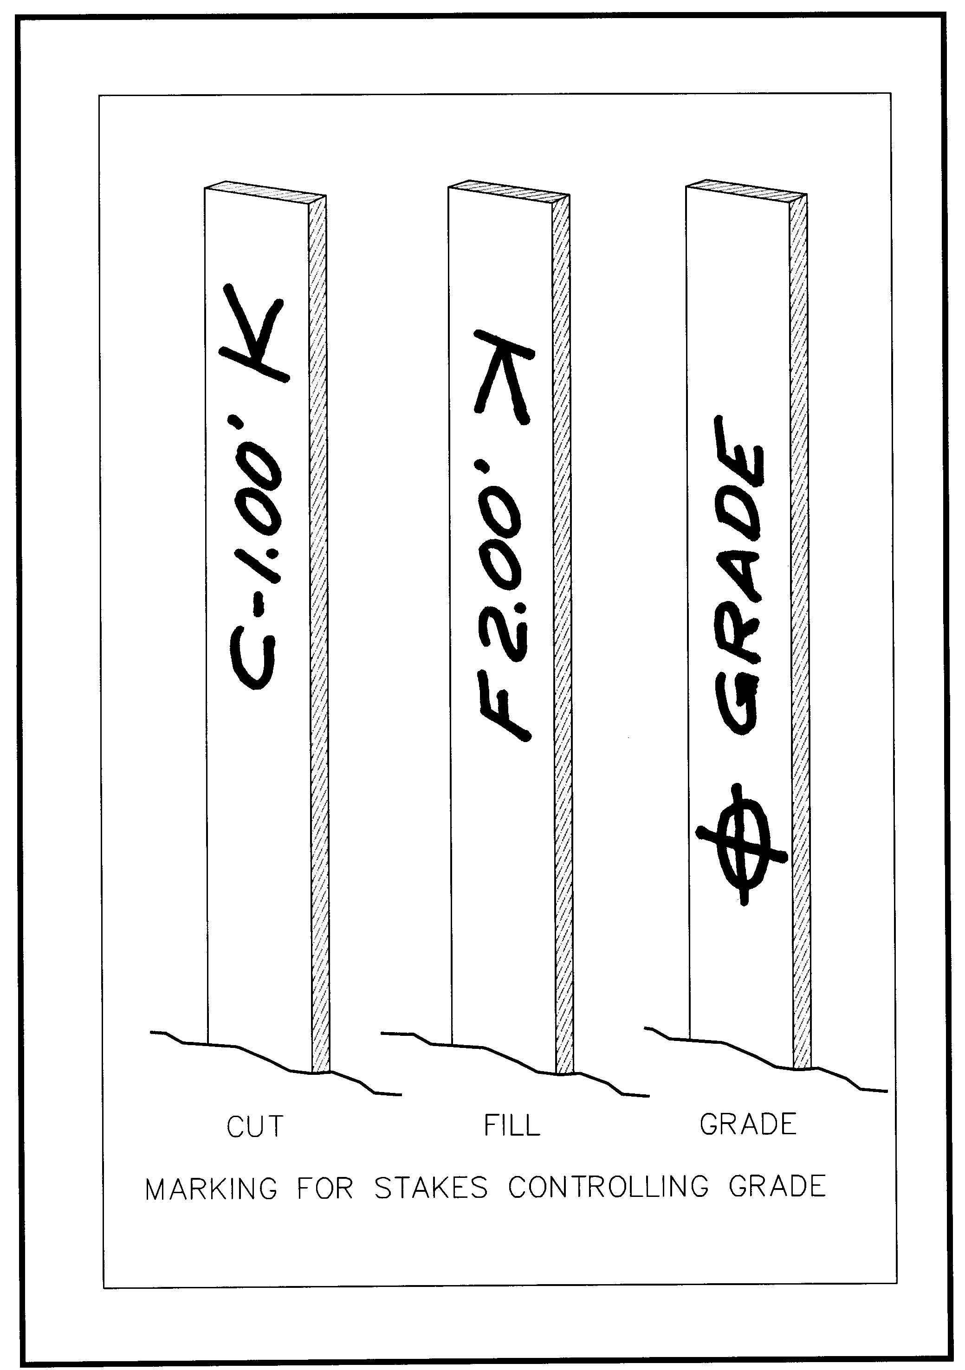
This is how the 25,000 cubic yard mix-up happened: When starting out in construction layout, I staked rough grade and noted the cuts and fills on guard stakes. The cut and fill notations that I marked on the side of the tall stakes were referenced from the TOP of the tall stakes. But, I didn’t note anywhere that the top of the stake was the point referenced. This worked fine for several projects, until…
An equipment operator on a 10-acre site thought my cuts and fills were referenced from the ground at the BOTTOM of the stake. I used 24” tall stakes for the layout, so the whole site was cut to almost two feet below design grade due to that lack of communication – and I almost had to pick up the tab for that error. Have you done the math on this one? I’d still be paying for it, or maybe hiding in Brazil.
Ever since that near miss with the grim reaper, when tall stakes alone are requested to control grades, I mark those stakes in the fashion illustrated below:
This method eliminates confusion over what point on the stake the excavator should use to measure cuts and fills. This should avoid any possible confusion when marking stakes for rough grade, right?
Figure 8
No, not really. This alone does not remedy the potential for confusion over whether you’ve referenced you cuts and fills to final pavement grade or to subgrade; to top of building slab or grade on which construction materials (crushed stone, etc.) will be placed. This is a critical distinction and you may pay for any confusion you create – or even for any confusion you fail to eliminate.
In your contract, you may wish to include a phrase to the effect that you will not be responsible for communicating directly with other subcontractors regarding your layout because you are not regularly on the site; and that your client will be responsible for relaying all information you provide to your client’s individual sub-contractors.
Be CERTAIN to advise your client in writing of any pertinent information that can’t be written on the stakes. For example, write: “At the direction of Mel Harper, foreman for Lightwell Excavation, all rough grade stakes reference two inches below finish grade for unpaved areas of the proposed site and six inches under drives, parking and the building’s proposed finish floor elevation. This direction was given by Mel in person to Pete Flannery, my party chief, at 10 o’clock in the morning, last Wednesday, the 14th of September as recorded on our conversation log.”
Thus, I repeat a principle that applies to ALL your staking, though the near-miss just related occurred while I was staking for rough grade: Take care in marking stakes! YOU may know where on the stakes the cuts apply and what grade you are actually referencing, but be sure the people performing the construction know what you’re thinking.
At this point, in view of the 25,000 yards of material I almost bought (plus all associated costs), consider this: Rough grade staking, while not immune to liability concerns, does not demand ultra-precision in most cases. If a stake for rough grading the open areas of the site is a foot left or right of an exact position, how much is the rough grade impacted by that? If a stake here or there is a couple of tenths off for elevation, can the site be rough graded to any closer tolerance than that anyway? One might reasonably generalize that staking for rough grade is not super-critical layout in most cases.
This is what probably tripped me up and almost cost me more than I could afford to pay. True, the rough grade staking did not demand extreme precision. But, COMMUNICATION about that (or ANY other) staking ALWAYS requires redundancy, precision and written documentation.
Be sure you are out of the firing line when some contractor misinterprets your intentions. Generally, if you have faithfully informed your client, then your client is responsible to pass that information along. But, tell those using your layout anything they need to know if you have the opportunity, and try to leave nothing to anyone’s imagination.

Stake Building Pad for Grade
Often you will be asked to provide grade for the building, particularly if it is a large building to be constructed on a slab, like a strip shopping center for example. The above advice bears repeating: be certain to ask your client what grade is to be referenced, top of slab or some specific depth below that. Also, use a different color-scheme for your flagging on stakes referencing building grades. This will help the equipment operators visualize this area of the site more readily. Compaction may be an issue under the building and paved areas but not in the future open or landscaped areas. You can set yourself apart from your competition by being sensitive to this and making a picture for the users of your stakes through creatively flagging different features your rough grade in distinctive colors.

Stake Roadway Rough Grade
If staking for a road, most contractors will prefer stakes placed at offsets from the centerline, so that the equipment operator can grade the road without grading around stakes set down the center of the road. But, don’t assume this. Ask. In many large-scale developments, the area of future roads will be cleared and cut to grade prior to constructing other, proposed improvements. This facilitates access to different portions of the site for the workers and their machinery. The contractor grading the road may prefer the centerline of the proposed road staked at this early point. It’s best to give the users of your stakes what they want and not what you think they want. When centerline of road stakes are requested, these be used for clearing and rough grading, and offset stakes may be required later for paving and curbing. As in all things, know your contractual obligations and get paid for work beyond what your contract commits you to perform at set fees.
If you’re staking the overall site and the road at the same time, be certain to use distinctive flagging on stakes used for the road, and mark all stakes clearly in large, neat characters, so the operator can see what the grade should be without getting off his machine.

Stake for Blasting
Here’s a true story about precision, accuracy and profit:
Once, when my business was slow, I subcontracted for a firm that employed me before I opened my own business. My mission was to stake water line for blasting. The project limits covered a vast area. I was given design drawings (site plans), a map depicting the general location of control points along with a listing of their coordinates, and coordinates of the proposed water line points to be staked.
For some reason, the future roadways had been cleared quite some time before my arrival on the site. It appeared that the project must have sat idle for years. Finding the original control points was more challenging than expected. My reconnaissance at the site recovered only a couple of control points near the start of the staking, but nothing near the end point of my assignment, about a mile away. In the project folder I’d been given, I found a plan showing an earlier phase’s control points with their coordinates noted. As I reached the end of my staking for blasting, I tied into a point on that other site (also surveyed by the same firm) by quickly traversing a couple thousand feet to reach those points.
When I reported back to the person who ran my former employer’s six or eight field crews, he asked how I’d made out.
“Oh fine,” I said. “The control near the end of the water line staking has been totally destroyed, but I found points in Phase 1 and made a quick traverse over to them. I checked in missing by less than half a foot off.”
“Oh gosh,” the man said as his eyebrows narrowed into a worried look, “I hope that’s close enough. That’s only a 6” water line, you know.” He face bore a look of deep concern.
“George,” I said (not his real name of course), “where they’ve already blasted on Phase 2, the earth mounded up about six feet high with something that looks like huge chunks of granite the size of your drafting table. That blasting is creating a very wide swath under the ground. Besides, they can’t lay that 6” line using a 6” bucket on the excavator. The trench will be at least two feet wide. There can’t be a problem with the staking when I check in half a mile beyond the end of the run within half a foot. And, George, all our stakes were placed on the waterline’s path, not offset; they are marked, ‘FOR BLASTING,’ and they’ll be destroyed by the blasting operation. Your crews will be back there staking the waterline for construction. This staking was only for blasting. There’s absolutely no way it isn’t good enough.”
That chief of parties was the best I’d ever seen at overseeing over a half dozen crews. But, he didn’t know the variables of construction layout very well.
Point of this story: If you want to make money, know what accuracy is required for whatever you’re staking and adjust your methods accordingly – unless, of course, you love pointless precision more than money. In that case, indulge yourself, if you can afford it.

Speaking of Required Precision…
At another firm, working as an employee, I was always sent out by the firm’s owner on significant construction layout assignments. This was because his regular party chief was terrified of construction layout. He’d been with my boss’s firm a long time, but the firm didn’t do a lot of construction layout, and this party chief was unnerved by it. So, I was a party chief over the regular party chief on complex construction layout projects or any layout prone to high-liability.
On one such mission, we were staking clearing limits for a single family residence in the middle of a 40-acre, wooded site. Now, this was not precision work, and I really can’t be sure why I was needed to supplement the party chief’s talents on that day. But, my boss said go, and getting out of the office is always refreshing.
Whatever, I was running the instrument and remember saying over the radio to this fastidious party chief known for his penchant for precision, “OK, go back 8 tenths and stake it.”
I turned the angle off that point and was setting the angle for the next clearing limit stake when over the radio came his voice saying, “Check me here, Jon.”
Now, this guy was seasoned and would have no trouble estimating the 8 tenths of a foot I’d told him to go back to set the stake. And, if he staked it within two feet in that particular setting, it would have been almost too precise anyway. But, this poor soul lived for precision. He couldn’t let go of his quest for it, even if it made the work take three times as long. He was a precision junkie. I knew that if I’d not been out there running the crew in his place, he would have made the work take considerably longer.
“Two feet off is too close,” I replied, “Just nail it.” He got mad at me because I refused to reset the first angle and check him a second time.
So, if you want to make money doing construction layout, match the accuracy to the need. Often your competition is a lot like this guy I was working with that day. They will take too long on stuff that doesn’t matter, blow their budget and then try to save the project by skimping on what really does deserve precision. This is your lucky break, because you can compete with these people, underbid them, and make money, too.
Also, the seasoned construction personnel on the site, including the employees of the firm that hired you (or your boss), will be refreshed to see someone with the ability to let go of precision when its wasteful, and it’s slowing down the project.

Stake Building
Often the building construction on a commercial, industrial or institutional site will take place consecutively with the site construction. Offset stakes must be set close enough to the future building to not be destroyed by site construction yet far enough away to survive building excavation and construction. Be guided by the site superintendent or the building sub-contractor on placement of stakes.

Stake Control Rectangle
If staking a control rectangle, normally the four longest walls or outermost column lines will be offset. This approach is generally used for single family residences and “row-house” types of multi-family buildings. A control rectangle may be requested for commercial buildings that are essentially rectangular in shape, especially if the building contractor has layout capabilities sufficient to take your basic layout and develop remaining control from there.

Stake Column Lines
For very large custom homes and larger structures, clients frequently request staking of offsets from proposed columns. The column layout of buildings is generally some rectangular array with or without some additional columns set between the basic array.
A very simple example of a column array and essential staking of offsets on column lines is depicted below in Figure 9:
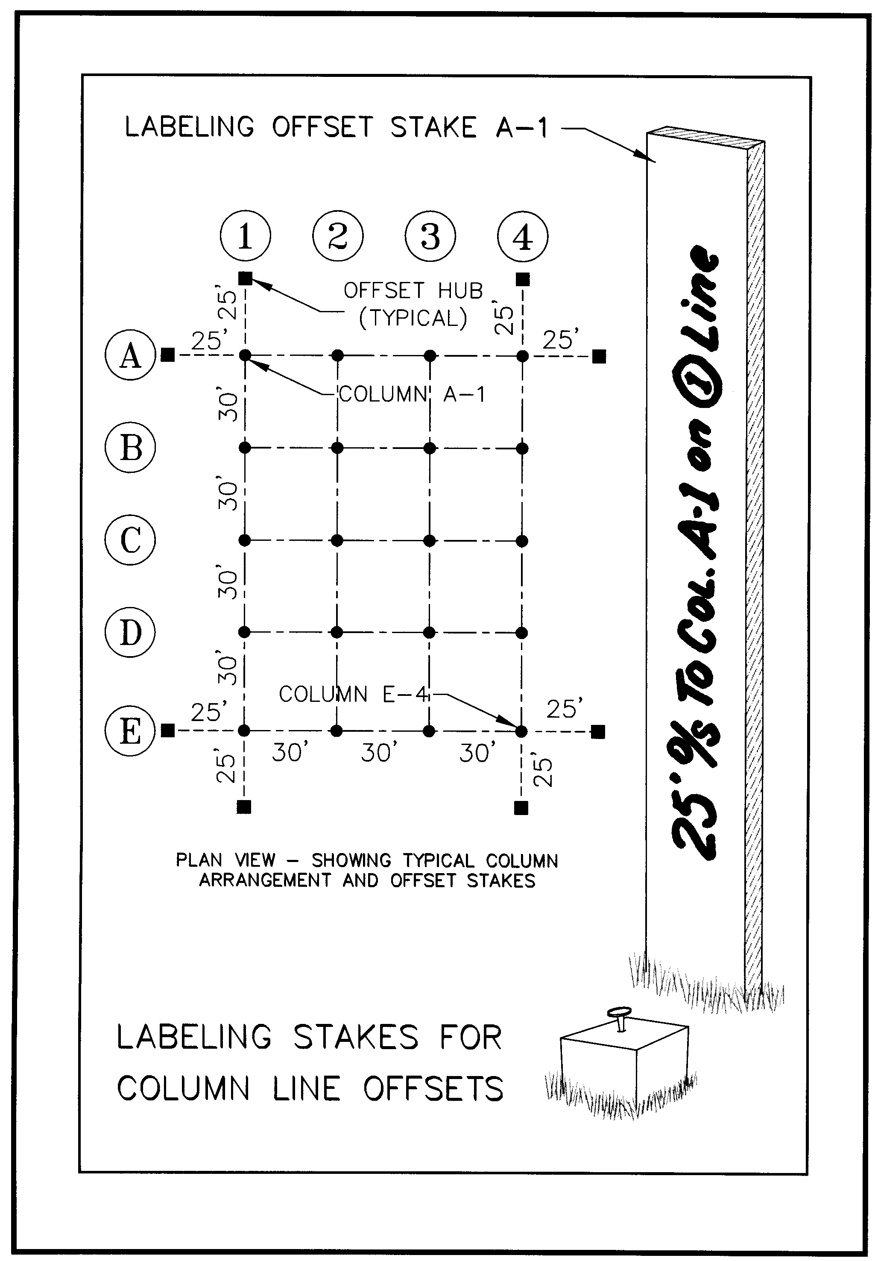
Figure 9
Columns are individually identified by the grid, for example, Column A-1 or Column D-3. Often, intermediate columns are located in between the major grid of columns to meet some specific structural need. If the column is located midway between the D and E lines and the 2 and 3 lines, the column might be designated as column D.5-2.5.
When staking column offsets, it is important to note not only the column being offset but also what column line the offset stake is placed on. Note that the sample stake labeling of Figure 9 depicts not only the offset to the named column (A-1), but the column line the stake is set on, column line 1.
Similarly then, the stake labeling for the other offset to Column A-1 in Figure 9 should read:
25’ ^{O}/_{S} To Col. A-1 on A line

The principle, one which is best applied to ALL construction layout is, LEAVE NOTHING TO THE IMAGINATION. Be specific. The person using the stakes is not as familiar with the intent of the staking as the person setting the stakes. Whenever possible, make a sketch to depict what has been staked. This often benefits the persons using the stakes to place construction and can avoid mistakes. It can protect you from frivolous claims. Never allow anyone using your stakes to claim your labeling and/or sketches were confusing. I always strive to ask myself, “If I hadn’t prepared or set this layout, and all I knew about the stake in the ground is what I can learn from the stake labeling and the sketch, would I conclude the right information, or would I have unanswered questions?”
I once read a book on beekeeping. Early into the book I came across an unfamiliar term, “brood.” I kept reading, expecting the word would soon be defined, or I’d learn it’s meaning from the context in which it was used. At the end of the book, I still didn’t know the meaning of brood as it applies to bees. In fact, I was brooding over it. The author’s failing may be ours in construction layout: The author’s familiarity with his material made him insensitive to the lack of familiarity in the users of his product. When workers and equipment stand idle as supervisors walk around scratching their heads over your stake labeling and sketches, unable to figure out what exactly you’ve staked or what you mean by the labels or sketches, your popularity is diminishing rapidly.
Finally, when staking columns or column layout, keep in mind that some architectural specifications call for columns to be constructed within plus or minus 1/8th of an inch over the length of a 600 ft. long building. Good luck! This tells me that the spec-writer hasn’t done much surveying or constructing. It also tells me that I’d better set my stakes so that no one can find more than a hundredth of a foot (1/8th inch ) variance between stakes, and that I’d better get the overall length to check as close to the 1/8th inch as I can. And, this can be done – with good people and good equipment that’s finely adjusted.
I never skimp on column line layout and advise that you don’t either. Too many surveyors (known for their obsession with precision) blow their budget setting their rough-grade stakes to the nearest hundredth (for no good reason or practical purpose) or setting hubs-with-tacks plus tall stakes when tall stakes alone would suffice, and then rush through the building layout because they’ve blown their budget. Bad idea! Really bad idea. ALWAYS fuss with column staking.
How do we make our column layout precise and accurate? Prism poles must be carefully adjusted prior to building layout (as should your equipment), and a person skilled at holding the prism pole must be doing that job. A bi-pod attached to the prism pole may help a less steady person achieve the desired results, though it will slow things down a bit. One assistant superintendent I ran into actually SET column stakes using a tripod, tribrach and prism with target. He’d move it and move it until the instrument person told him he was over the point. Then, he’d have the instrument person run over and look through the optical plummet on the tribrach to guide him as he set his point. He’d then pick up the tripod, and repeat this to set the next point. To me, this smacks of overkill. And, even this degree of effort leaves room for errors due to the tripod level or the optical plummet —cross-hairs being out of adjustment. Good people with good equipment can perform accurate layout a lot faster with other methods.

STAKING DOUBLE OFFSETS TO FOUR PRIMARY COLUMNS (VARIATION ON A CONTROL RECTANGLE)
How would I suggest staking column lines if my client asks me to double-offset stake the four outer columns (Columns A-1, A-4, E-1 and E-4)?
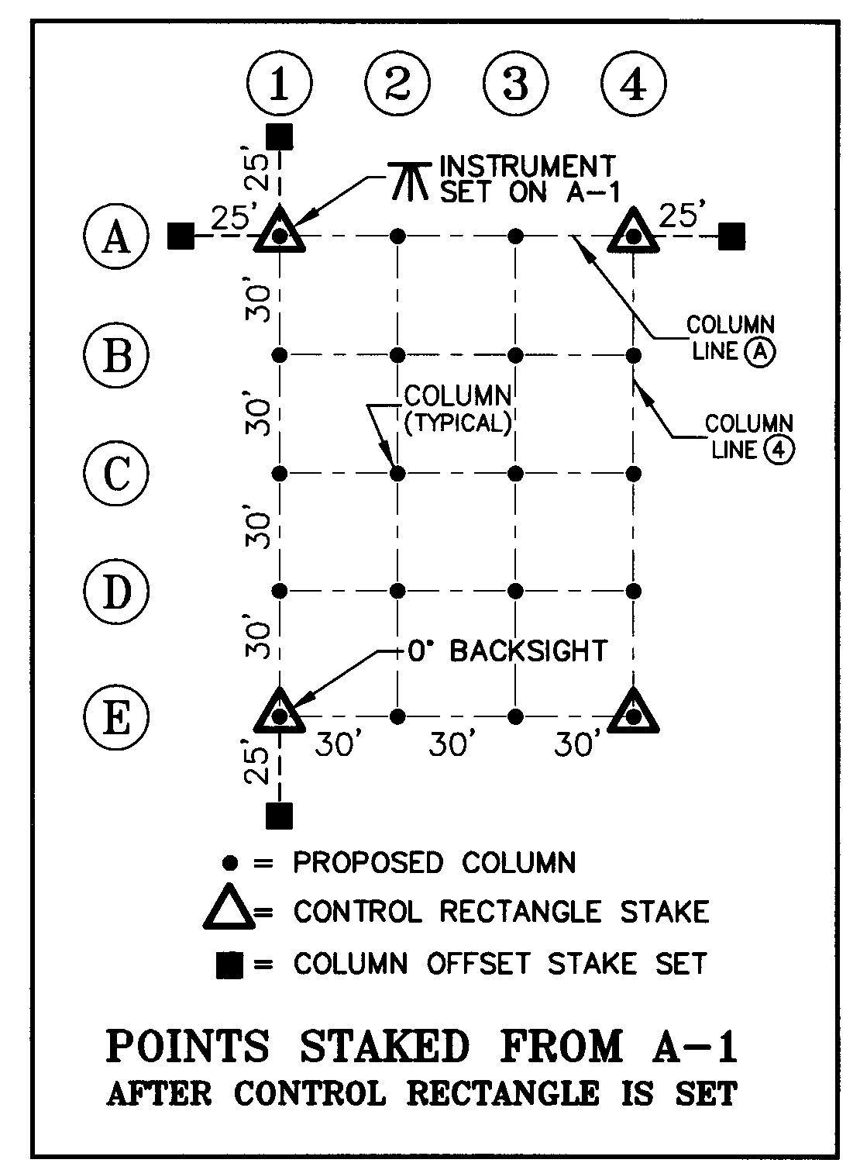
Let’s assume our building has the column layout seen in illustration. First, stake a rectangle at the outermost, major-column’s, gridline intersections. Simply put, stake the centerline of columns A-1, A-4, E-1 and E-4.
You may decide to radial-stake all four corner-columns, but do save time in the long run by doing this as precisely as possible, initially making a mark on the tops of hubs rather than tacks. You’ll set tacks during your final adjustment.
Once these four points are staked, the rectangle formed by those four stakes MUST be checked for square by checking the angle and distance across the diagonal (the hypotenuse), the 90-degree angles at the corners and the distances of the four legs. How you do this is largely a matter of personal preference. Make any adjustments necessary to get your rectangle precise and accurate before proceeding.
If you took care with your radial staking, these final adjustments should be very small and will be made rather quickly. Most readers will know how to do this checking, but just in case you need refreshing, it’s the Pythagorean Theorem to the rescue – gotta love that guy! Pythagoras says that the sums of the squares of the two short legs of a right triangle equal the square of its hypotenuse. The United States Naval Academy website offers a nice little animated graphic at http://www.nadn.navy.mil/MathDept/mdm/pyth.html to prove the theory. For a teaching aimed at 6th to 8th graders, visit http://www.arcytech.org/java/pythagoras/index.html. If you’re not convinced, see 43 proofs for the theory at http://www.cut-the-knot.org/pythagoras/index.shtml.
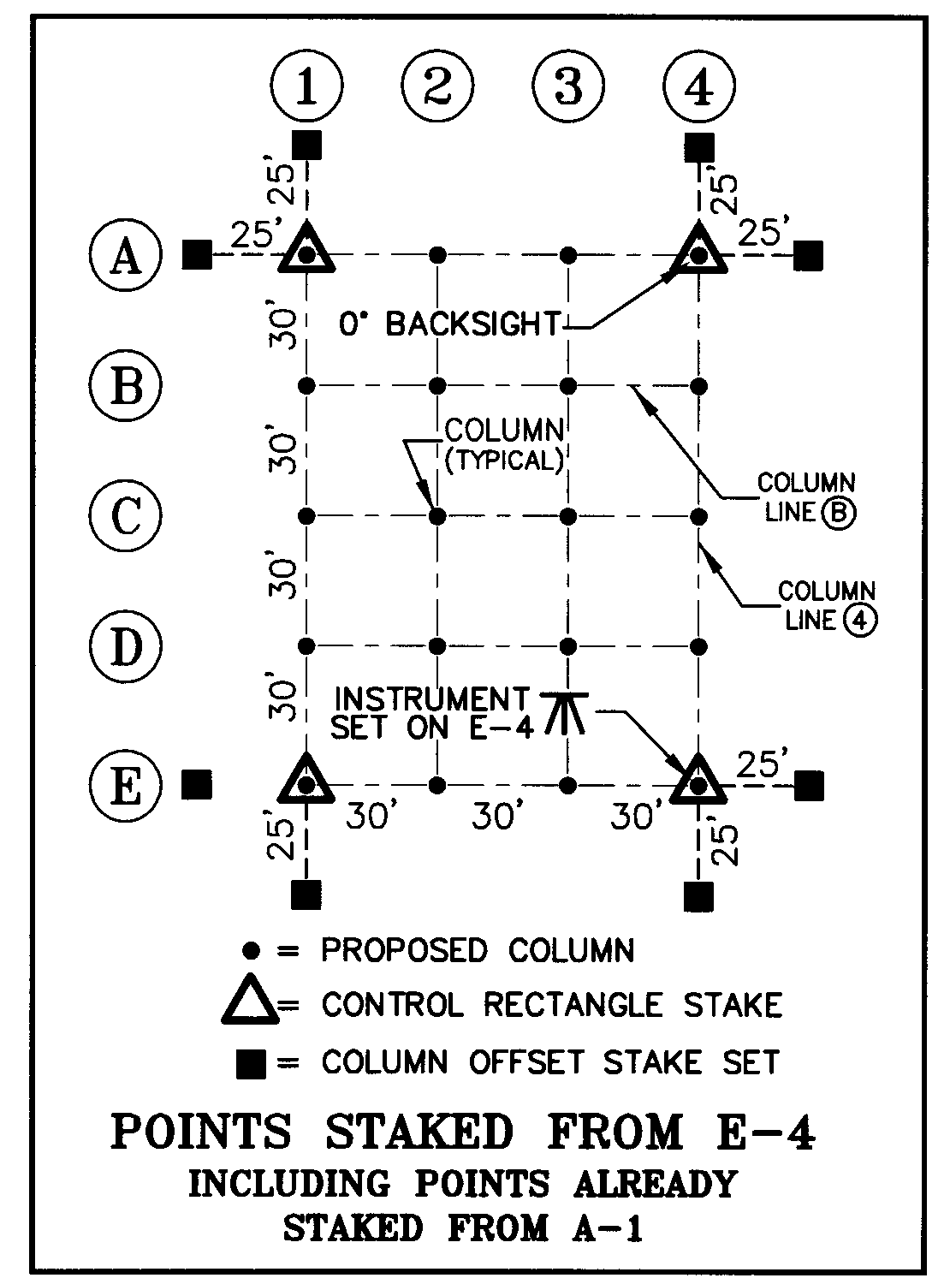
Next, occupy a corner of the rectangle, say at Column A-1, backsight your stake already set as a corner of your rectangle at Column E-1 and set E-1’s offset stake at the proper distance beyond E-1 on Line 1. Then flop the scope or turn 180 degrees and set the offset stake for Column A-1 on Line 1.
Then, turn 270 degrees and set one of the 25 ft. offset stakes for Column A-4. Of course, this line should check well on your rectangle’s corner stake already set at Column A-4.Next, flop the scope or set 90 degrees and stake the remaining offset stake to Column A-1. When this is completed, check the backsight on Column E-1 to be sure the zero-set was not lost.
The instrument is now set over the control rectangle stake set at Column E-4, and zero is set backsighting A-4. The same procedure as noted immediately above completes the remaining offset staking, and all four primary columns are now offset staked. From these 8 offset stakes, the contractor can set remaining offset stakes with a steel tape and transit. Some contractors will take it from here.

Staking Column Offsets – All Major Column Lines
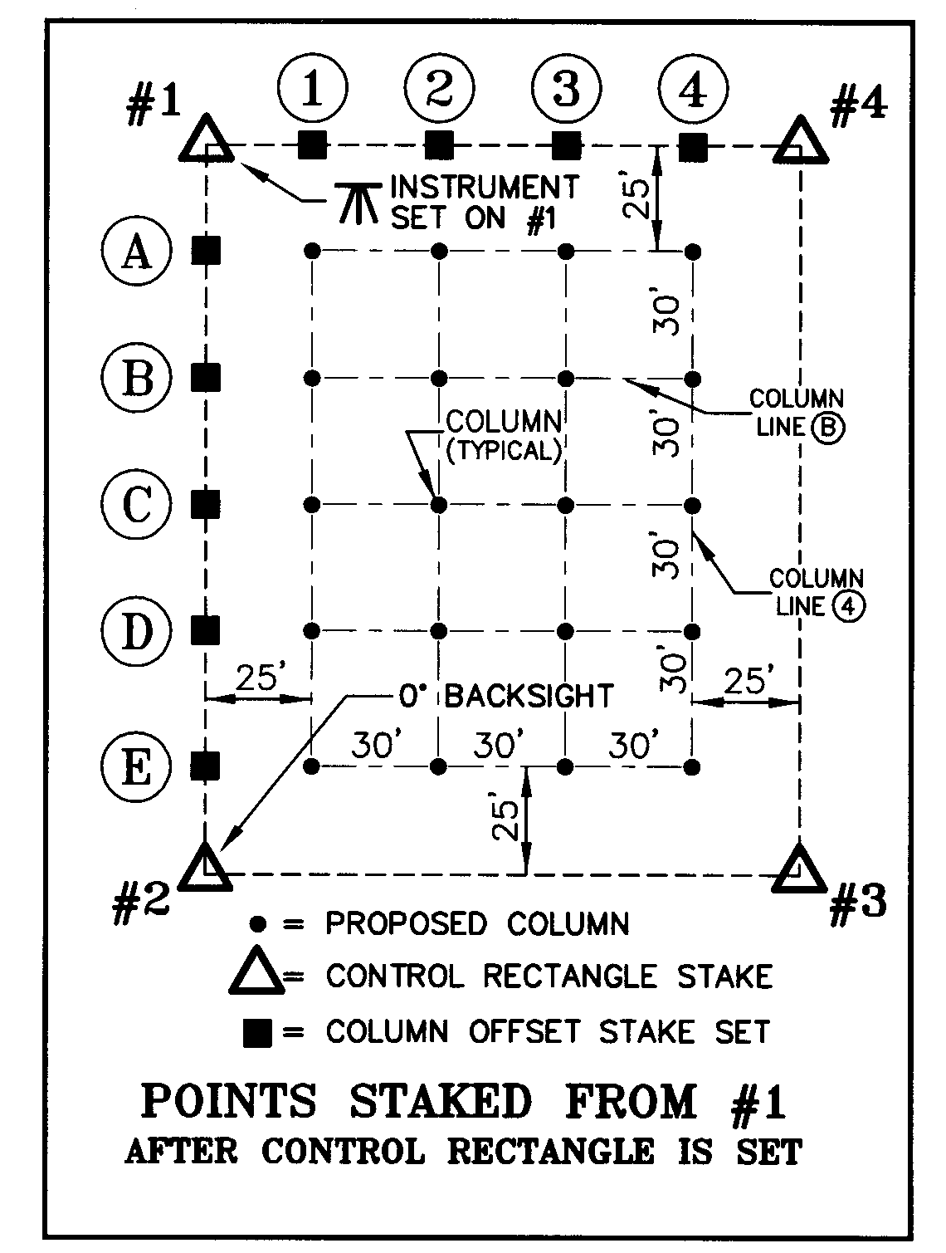
When asked to stake offsets to all the major column lines, the control rectangle is set at the four intersecting offset lines, and no actual column locations need normally be staked.
The control rectangle must first be staked and checked for ‘square’ and dimensional integrity as discussed above.
Next, #1 as shown in the illustration below is occupied with #2 backsighted. Offset stakes are set along the line to the backsight. Then, 270 degrees is turned, and that line, of course should be looking at #4. Offset stakes are set along the line between #1 and #4.
The backsight on #2 is checked to be certain the zero-angle is still good.

The instrument is next set on #3, with zero set sighting #4.
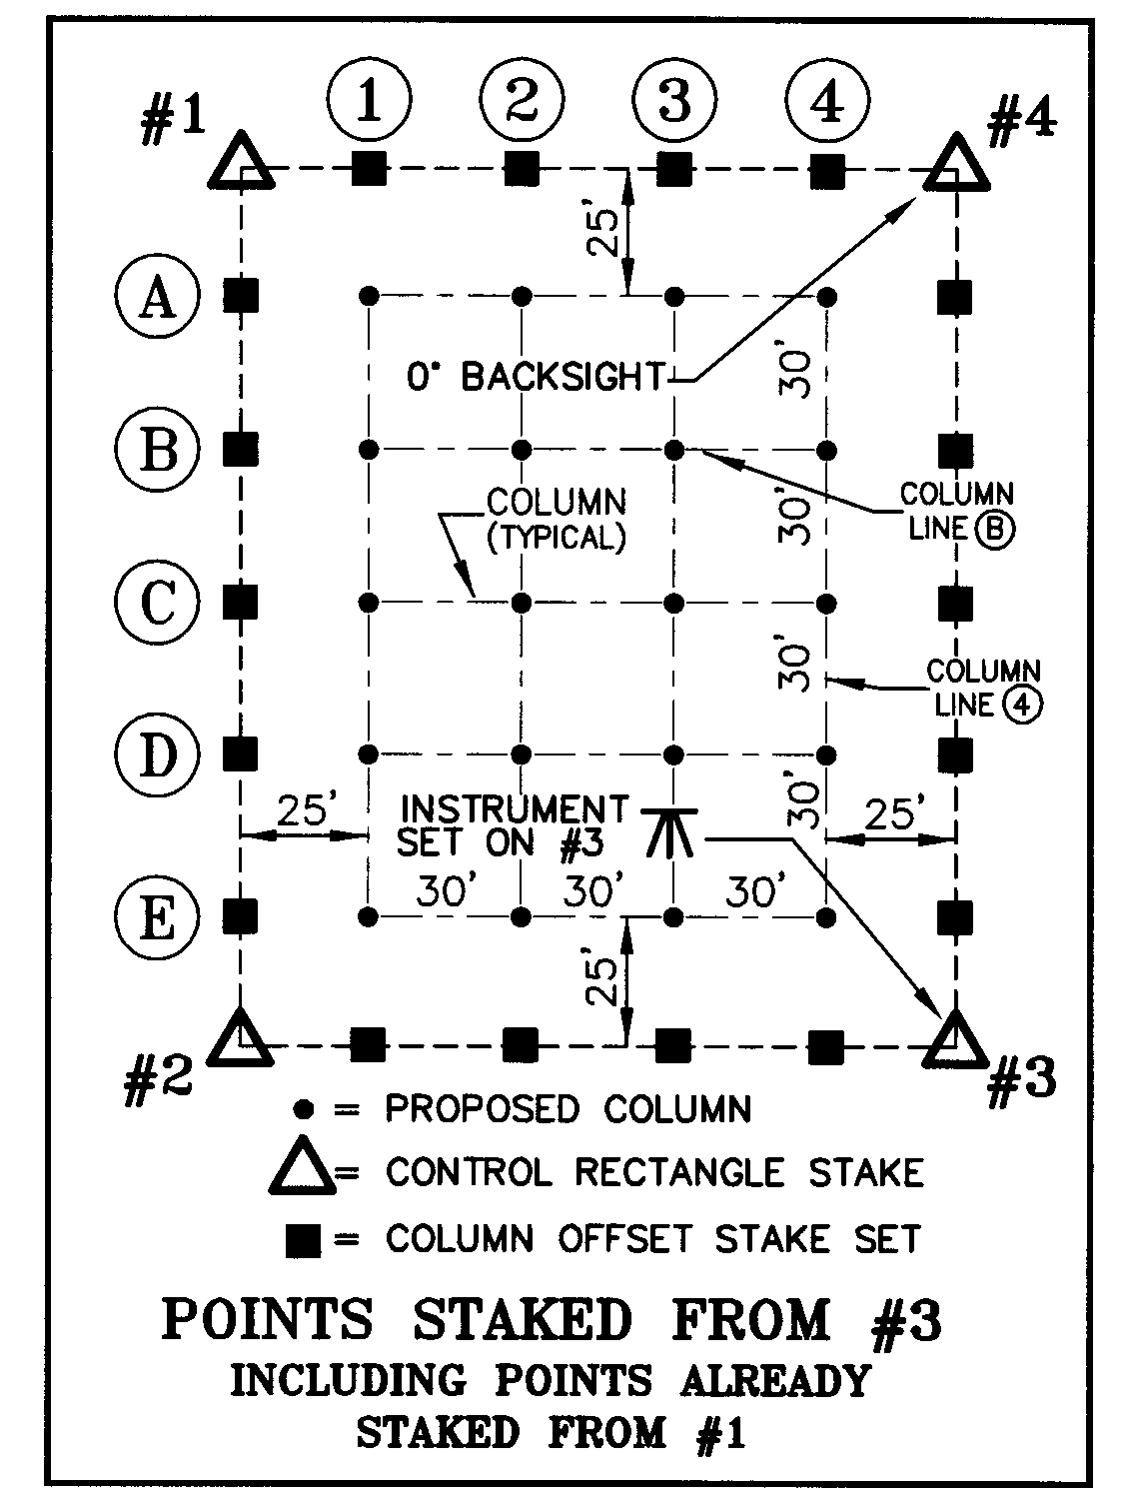
Offset stakes are set along the line between #3 and #4. Then 270 degrees is set in the instrument and this angle should be sighting on #2.
The offset stakes between #3 and #2 are set and the backsight checked to be sure it is still 0º, thus completing the staking of all the offsets.
Using this method may seem a bit old fashioned. One may argue, “Why not just stake it radially?”
With the best of equipment and personnel, that would probably yield results good enough, but the key word here is probably.
When your client sets up an instrument and sights along a line of offsets, it is important that they line perfectly. If they don’t, you’ll probably be receiving a call. And this is very hard to accomplish by radially staking. Also consider that you are talking about turning 22 angles in this example. Then you’re telling the person with the prism to move back or come forward so much; then you’re probably fine tuning line to set the hub and another shot is needed to set the tack; and for column layout, you’d better check that tack and adjust it if it’s off a full hundredth.
But, by setting the rectangle, getting it TIGHT and turning only multiples of 90º angles, your layout proceeds quickly. Often you are on level ground for this layout, and you can use a quality steel tape for the layout and accomplish it rather quickly. This is really the best way and by far the safest way to perform column offset layout.
A reminder: Stakes must be labeled carefully as discussed above.

Checking the Layout
No matter which method is used, I always check the layout before leaving the site.
Usually, I set the instrument in some random location where I can do a two- or three-point resection sighting my control points and see all the building points I’ve set.
I want the angle I record between two of the control points to be as close to 90 degrees as feasible, but in no case less than 45 degrees. The data collector will establish the coordinates of my position, which I sketch and note in a paper field book along with the essential data related to the staking of the control rectangle and the checking of it that I’ve already recorded.
To digress for a moment, some people record in their paper field books the point occupied, the point backsighted and every angle and distance they turn to set their stakes. This is pretty good evidence, particularly if logged in a bound field book rather than a loose-leaf style field book for obvious reasons. But, some party chiefs record the angles and distances before staking, often while sitting in the truck, and then do their layout from the collector, never taking their field book out of their pocket. This speeds things along, especially with a one-person-and-robotic-instrument approach or a two-person crew staking in a conventional manner. The problem here is that it is fabricated evidence. The angle and distance to the staked point should actually be shot on the as-staked point and logged to the paper field book. This is what really was staked, not the theoretical stuff from the collector.
Whether or not you keep a paper record is a personal choice. In this specific example, I download my collector files of this final check and make these a permanent part of the project files. Both raw files and coordinate files generated in the collector should be kept.
Meanwhile, back on the random point… From the random point, I locate and record in the data collector every building stake I set. Usually, I number the point numbers of the points I’m collecting some increment higher than the calculated point numbers for the points I just staked. For example, if the points I set were #501-519, I might number the check shots #1501-1519.
Then, while still on the site, I inverse between the theoretical, computed locations of the points set and actual shots taken on the stakes themselves. This inversing is somewhat easier if the points are incremented as noted above.
I am hoping for little more than 0.01 ft. between the inverses. In some cases, they may all be off 0.02 ft. or 0.03 ft. in generally the same direction (same bearing or azimuth). This would indicate some difference between the control points I staked from and the ones used to establish the random point presently occupied.
This points out, as is noted elsewhere in this course, the importance of getting your initial control stable and located as precisely as you possibly can. Also, traverse adjustment can make this not check as well as you’d wish. The concept of NOT adjusting your traverse (for the sake of repeatability) is also discussed fully elsewhere in this course.
This random point must be located so that I can see the stakes I’ve set, or a second point from which I can see the remaining stakes I’ve set must be established in the same manner and documented in the paper field book. It is best to do the resection from the same two or three points though, and to have the random set-ups as close to one another as possible. If a second point is needed, overlap the check shots some to aid in your analysis of your data if the check shots on points shot from two random points don’t yield the same coordinates from each setup.
The staking methods noted above leave little room for error, and this is precisely the point. This approach guards against the potential to set an offset point a foot off along the line you are sighting. Things like this can happen, and the results for you can be disastrously expensive. This check will catch any significant errors in time for you to correct them.
You never know what you will be blamed for, so it pays to document that your building is both staked accurately, AND that it is located in the right place on the site. The random-point setup is proof positive of both. But, don’t use the same two control points you staked from to perform your check at the end. If you do this, you loose the proof-positive that you’ve staked the building in the right place.
You never want to go to court to prove the unlikelihood of having made an error. It is far cheaper and better for client relations to simply, humbly and POSITIVELY demonstrate why your layout could not possibly be wrong.

Setting Extended Building Control
At the time of staking column control, I also set extended, permanent building control at some convenient distances. In the above examples, this control is set either side of the building on at least two perpendicular column lines, two points staked on each column line.
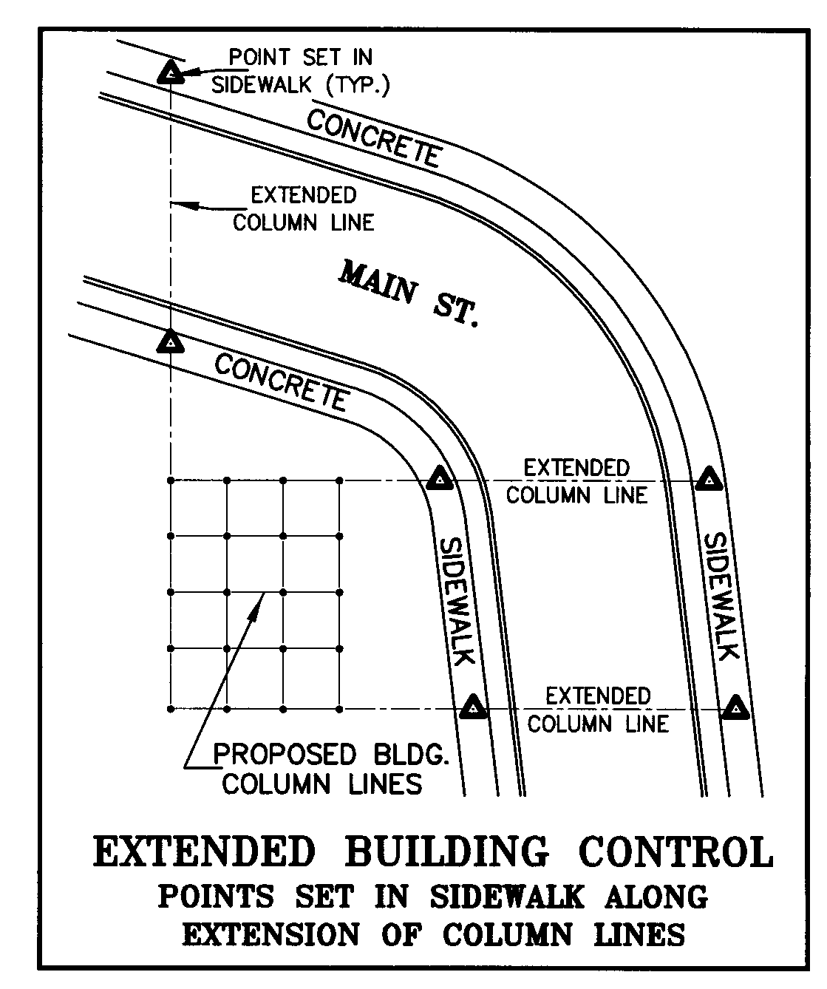
I set these well outside of construction limits or at some point that appears safe from disturbance until the proposed building is actually coming out of the ground. I usually coordinate this with the site superintendent. If at all possible, I always try to set two very distant points on each outer, major column line in case all my points set near the building get destroyed.
If you should lose building control and primary control located near the building, it can be very difficult to re-establish building offsets (column offsets in this case) close enough to their original positions to meet specifications. This can be extremely frustrating and time consuming, and your client may feel you lacked foresight if the process becomes terribly costly in restaking fees for your re-establishment of control. Your client may feel you should have foreseen this possibility and made provision for it. Legally, this is probably not true unless some contract provision states otherwise or you included it in your proposal. But, it pays in client relationships to set some points from which you can conveniently re-establish your original position of the control you staked.
Also, if through some mishap the building stakes are misinterpreted, or through the contractor’s own error the building is constructed on the wrong location on the site, you have additional evidence of your original staking. This could possibly happen if most stakes are knocked out and the contractor tries to re-establish it, for example, if a column line offset stake is assumed to be an actual column location.
I’ve serviced sites where the contractors pull my tall stakes to use somewhere else on the site, and the hubs I’ve placed are unlabeled as a result.
Admittedly, the responsibility to protect your initial control and to correctly interpret it rests with your client provided you’ve coordinated its placement with your client, set stakes with uniquely colored flagging, and labeled your stakes conspicuously, thoroughly, consistently and correctly. Still, considerable experience has taught me that if I can establish building control points well beyond the building in a half-hour or so, I’ll be very, very wise to do so. For the sake of efficiency, this should be done while staking the building control rectangle. At that time, you’re already set up on the rectangle and sighting along column lines. It won’t take much longer to set a couple of points at specific distances along those lines you’re sighting to set your close-in, building offset stakes.
Frequently, the client requests anchor bolt checks. Most times, the offset stakes set near the building are gone or disturbed by this point in time. That distant control is absolutely golden at this moment.
I can’t stress how worthwhile the time spent extending building control is in most cases.

Set Vertical Controls
Whether for a single-family residence, a strip mall or multi-story building, it is important that the vertical position (the elevation) of the structure be controlled and accurately placed. Take time setting bench marks of whatever kind and in whatever locations the client requests, and provide considerable redundancy in determining the elevation of the benchmarks you provide. Maintain the utmost care in calculating and documenting your processes and calculations.
Sometimes you’ll be asked to set a point at a specific elevation, for example to set a rebar in the ground near the center of the building with the top driven to the finish floor grade. Do not label the stake or pin “Finish Floor Grade” or any such thing. Label the point with its elevation. The design team has raised and lowered the finish floor elevations of buildings without my knowledge on numerous occasions, and I don’t want to buy any buildings I don’t already own by stating what the finish floor elevation should be. The plans may say one thing, but sometimes, that has been changed without my knowledge. If I label the state stating that it’s set at floor or slab elevation, the entire building may be constructed at the WRONG elevation. But, if I label that stake with its elevation, then someone else must decide if that is the current intent of the designers.
Also, when asked to provide a bench mark, I always provide TWO bench marks, not one. This way, the contractor has little or no excuse for accepting my elevation without checking between the two benchmarks for agreement. Sometimes, bench marks are disturbed without necessarily looking as if they have. For this reason, I always set two and instruct the person requesting the bench mark of the presence of TWO bench marks. I advise (in writing if possible) that neither bench mark should be relied upon without checking into the other to confirm that neither has been disturbed or mislabeled. If this advisement has been verbal, I note this in a conversation log and file it and also make a note in the field book right along with my notes related to setting those bench marks.
Generally, it’s not advisable to use a total station to set bench marks, and almost never to use GPS, unless you really know what you are doing. If you’re a GPS button-pusher, use a level and a rod! It’s much safer.

Brick Points – Sometimes called, Wall Points
Frequently, concrete footings are marked with nails set in the footing at outside corners of the walls to be constructed on those footings. This guides placement of the first course of concrete blocks or forms. The number of points required varies, but often marking every outside wall corner is requested.
Be certain to document on your work order which side of the wall your points represent. I’ve never been asked to locate inside corners, but I make it a point to note on the work order, CYA Memo or e-mail that I’ve set points at the outside corners.
The field conditions vary. Sometimes, the footings are under water or even ice. Often they are covered with dirt or mud. Sometimes, rebar sticks out of the footings requiring extra care in walking along them. Slippery footings and rebar sticking up make for dangerous working conditions.
It is very difficult to predict the time involved in providing this layout, or even if it will be requested, so I normally do not include it in my bids unless specifically asked to. Instead, I perform this task as an “extra” if this layout is requested. Including it also places me at a disadvantage in the apples and oranges game discussed at length earlier in this course.
If a client requests a firm number for this layout in my proposal, I always state that the fee assumes clean, dry footings at the time of layout and that the control I’ve staked for the building remains undisturbed.
These are reasons I give if asked why I did not include wall corners marked in footings in my proposal: (1) Some contractors will provide their own wall points from the primary building control without my assistance, (2) the number of corners marked varies widely from project to project, (3) about half the time, the building control I’ve staked is disturbed requiring restaking, and (4) footings are often covered with mud, dirt, water or even ice, and hourly fees then apply in addition to the fee noted in the proposal.
This work must be fairly precise, and it can be hard to get a nail into the concrete footing without it slipping off an unseen stone lying just below the troweled surface of the concrete. When this occurs, it busts up the surface of the footing rather unpleasantly, and some fussing is required to set the points accurately.
I’ve found that the short, ½ inch or ¾ inch nails typically used in gunpowder-powered nail guns work well for this purpose. I don’t use a gun to shoot them into the footing, but rather set the nail on the desired point with the little orange “washer” that comes on them pulled to the bottom of the nail. The little nail will “stand” there on its orange washer, and I give it a smart rap with a carpenter’s hammer (not a 3 or 4 pound hammer). This usually sets the nail, and a second sharp hit will work if needed. I drive the nail to the point it squishes the orange washer, leaving the head of the nail up 1/8th inch or so. Then, I spray the footing with paint to indicate the corner and the side the blocks or poured wall will go on.
Below is a photo of longer versions of these nails.
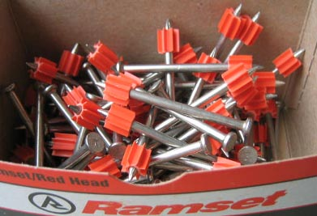

Marking Projections on Upper Floors
Sometimes, the client asks that some reference line or construction line be projected to upper floors and marked on those floors. A request might be made, for example, to mark a line on the second and third floors of a building at two feet outside of the outermost column lines. This is another situation where your distant building control that I recommended earlier comes in handy. Normally, the primary building control is too close to the building to see through the scope to the upper floors. And, often the control set for the columns has been destroyed. Lines of sight through the building are more often than not blocked by this point in time as well.
If you were able to set and preserve solid control that is distant from the building, you’ve just saved yourself the tearing out of your hair and also saved your client a good sum of money. (Consider blowing your own horn a little with your client over this.)
A word of caution at this point. You will no doubt have to offset your extended building control in order to see by the columns you’re being asked to reference as you mark the upper floors. Be certain to check into the column lines on the upper floors before you commit to paint-on-concrete marks on those upper floors. Your client may not want a theoretical offset from the column lines (based on your original control) but the actual offset from the as-built locations of the columns. Theoretical (or calculated) location of the columns and as-built locations may not be exactly the same, and you need to be certain which you are being asked to reference and to note it in your conversation log and on your work order.
One tool you must have for this assignment – and it’s seldom found in most survey trucks – is a good quality chalk line. Two are even better, one with orange chalk inside and the other with blue chalk. If one color is already in use on the floors you want to mark, use the other color to avoid confusing your work with another’s. Also note the color chalk you use in your conversation log and your work order. On the work order write something like, “Marked with blue chalk-line second and third floors, two feet outside of calculated (or field-located) position of column lines A and E.”
No one will criticize you for noting the “blue” on that work order. But, if someone mistakenly references the orange chalk-line placed by some other contractor, that adjective could save you from a back-charge.
Another important supply not found in most survey trucks is a couple of spray cans of clear lacquer. After you are sure of your marked chalk lines, gently spray just a DUSTING of the clear lacquer over the chalked line. It will last a long time and not be erased by wind and rain. If you are in a pinch and have only your traditional orange or red spray paint, it will work if you have a delicate hand. DUST the chalk line with the paint, being careful not to discharge enough paint to obscure the chalked line. This will work fine if you have a light hand at spraying.

Never use a chalk-line for marking a consistent vertical slope!
Most surveyors and engineers are not experts in the use of a chalk line. A word of caution: if you are ever asked to use a chalk line to mark VERTICAL control, such as the approach slab to a bridge, don’t do it. (Or be darn sure you know your limits and the limits of a chalk-line.)
A surveyor I know was employed by a bridge contractor. He once bowed to pressure to provide the vertical control for a bridge approach slab with a chalk line, and he did it. The firm’s level was providing erratic results, and the boss barked the order to just do it with a chalk line.
The line was suspended in the air and snapped to mark a grade along the side of a stake set mid-way between the beginning and the end of the approach slab. That surveyor pulled very, very tightly on the line in an attempt to insure against sag in the middle of the line. Sighting by eye along the line didn’t reveal any sag either.
Well, it didn’t work. The mark he made looked good, but it wasn’t. Even pulling so hard he thought the line might snap, sag was still present in the line and the chalked reference line made on the vertical reference point mid-way between the ends of the chalk line was lower than it should have been due to the sag in the line. But, it was not visible to the eye.
Driving over that finished approach slab at sixty-five miles per hour made your stomach drop as your car hit the bottom of the sag and then rise as your car crested the end of the approach slab and rode onto the bridge deck. The contractor had to demolish and replace the entire approach slab. This necessitated lane closings and state police rolling-road-blocks to slow the traffic ahead of the reconstruction. And it meant night-work on this busy, interstate highway – overtime pay, night delivery of concrete, extra pay for inspectors, etc. All this to save the trouble of breaking out an instrument (or of having one that worked!) Some head had to roll, and that surveyor was fired for the mishap, even though he was following orders. If that surveyor had been a sub-contractor to the bridge builder, he would have been back-charged for the costs. Be very careful never to be pressured to do something you aren’t confident and at peace in doing.
String lines sag. Never forget that. They are for marking on horizontal surfaces, and this, too has its limits. If you equip yourself with a chalk line, get some practice snapping it and check your results over distances with an instrument.
Remember, there’s a degree of skill involved in snapping a precise line even on a flat, horizontal surface. The line you snap is influenced by wind, by anything on the surface along the snapped line, by how tight the line is pulled just before being snapped and by whether or not you are directly above the true line between the two end points or off to the side when you let go to make the snapped line. Practice with your chalk line prior to using the tool professionally. It’s kind of fun, actually.

Special, unexpected requests for layout from plans you’ve not seen before.
As a professional layout person, you may be asked to perform layout you’ve never anticipated, from plans you’ve not reviewed. Be cooperative, but be very, very careful. It is critical to your financial well-being that you receive and document specific instructions for what you do in these cases, and that you’re confident you understand both the plans and your assignment.
Be humble! If you’ve never dealt with whatever plans you’re asked to interpret, calculate and stake from, don’t be afraid to ask your client if you’ve understood the plans and verbal instructions. In a sense, try to get the person who assigned the work to check your understanding of the work or even review the calculations you’ve made. Most often, you will not be looked down upon for this level of caution and coordination.
If you say something like, “Look, I’m an expert in measurements but not in constructing what I’m about to lay out for you. Would you mind looking this over to be sure it’s what you want?”
Then explain your steps involved in calculating the layout. Do this slowly and seek nods or verbal confirmations that you’re seeing things rightly. Of course, make whatever notes you can on your work order to specify what you are laying out, from what plans, dated what date, and at whose direction. In your conversation log, note the steps you went through to obtain client-verification of your work. And, label your marks or stakes specifically and clearly.

3-4-5 and Patterns
Finally, when it comes to staking structures or parts of structures, don’t forget the carpenter’s mantra: “3-4-5.” These three dimensions form a right triangle, as do multiples of them. (Long lives Pythagoras!) Times may come when you will find it easier to mark column bolts on a bridge pier or some other thing using a right angle off a centerline you’ve marked along the surface. With care and practice, you can form your right angles using the 3-4-5 approach, and set points more accurately and quickly than you can by fussing with a radial stakeout method or the offset function of the instrument.
3
5
90º
The 3-4-5 rule
4
Sometimes, it is easier to take an hour and make a template or pattern used to mark your points. This is especially useful in certain building and bridge applications.
As an example to illustrate the use of a template, suppose you have to mark anchor bolt locations along a slab and many of the anchor bolt patterns are identical.
All sorts of convoluted approaches can be hatched to fulfill such an assignment. The more complex and difficult the approach, the more likely that errors will result.
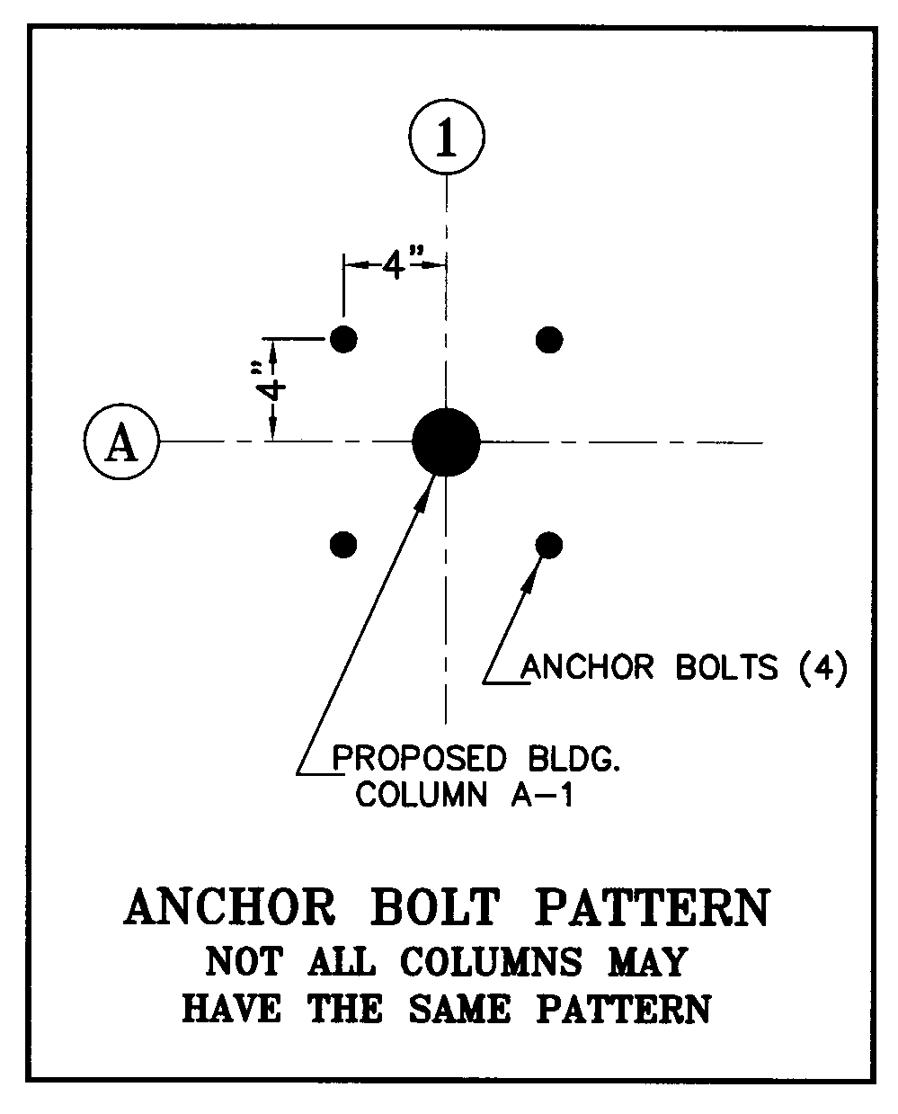
Wouldn’t it be nice if you could sight along a column line and simply set a template at the proper distance, rotate it until it lines up with the column line you’re sighting and trace the locations from a pattern?
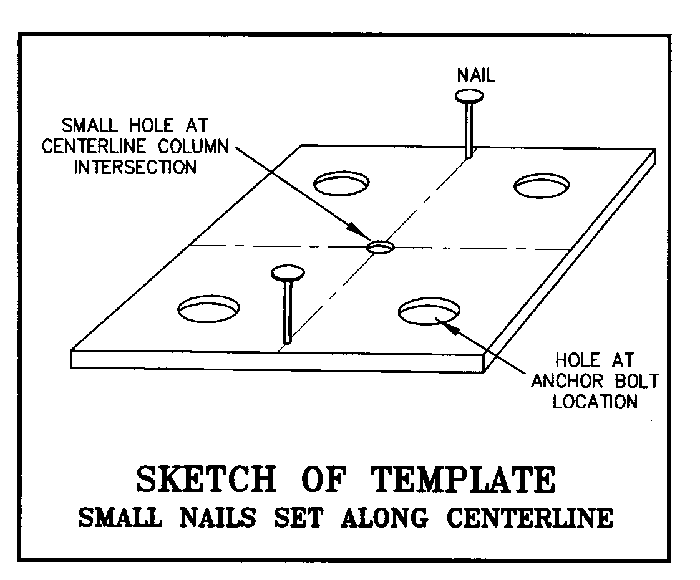
Using an anchor bolt template like the one illustrated at right, the first step is to set the instrument so that its line of sight is along a column line. Then, locate the centerline of column intersection by measuring the correct distance with a prism pole, mini- prism, steel tape or Dist-a-Line™. Once the intersection of column lines is marked on the slab, place the template over that point. The person at the template simply rotates the pattern around the marked, centerline intersection point (while sighting through the center hole) until the two nails line up along the instrument person’s line of sight. Then the four anchor bolt locations are marked at the four holes.
If you elect to make and use a pattern or template, don’t neglect to verify which columns (or whatever you are laying out) do or do not have the same dimensions. Not all columns for a given building, for example, may have identical anchor bolt dimensions or even the same number of anchor bolts. Be careful to check the plans to know for certain which columns your template fits and which it doesn’t.
Carpenters have an expression: Measure twice and cut once. This wisdom cannot be overvalued. We need to check the plans and re-check them to be certain we are applying the correct detail for the thing we are laying out.
We surveyors and engineers can make things unnecessarily hard at times. Watch and learn from the people who work construction every day of their lives. It’s amazing what can be learned from them. If they seem to question how I’m approaching some layout task, I always ask, “How would you do this?” In many cases, I now do it the way they would do it, not the way I used to do it.

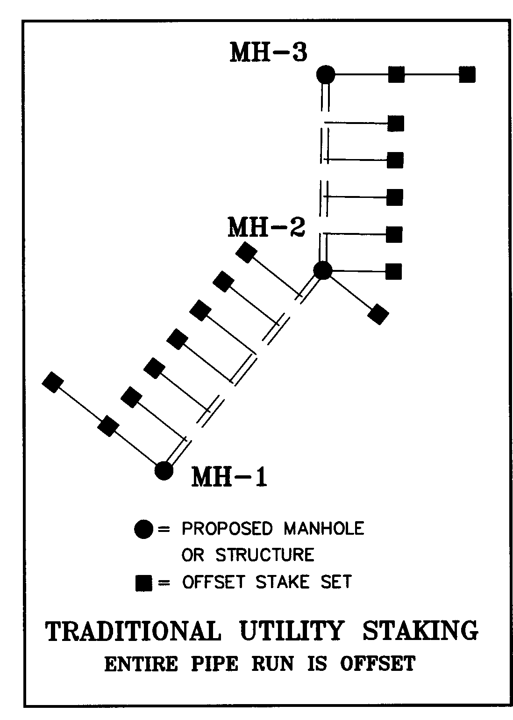
Stake Site Utilities

Sanitary Sewers
Traditionally, stakes set for construction of sanitary sewer lines were comprised of a line of stakes set at offsets to centerline of pipe stations along the run of the line, with double offset stakes set at manholes or chambers.
The double offsets might be in line with each other so that the workers constructing the line could “line between them,” or, if the manhole was at an angle point in the run, the offsets might be at right angles to both the line-back and line-ahead pipe runs. The workers would then “swing tie” the offsets or use an instrument to determine the center of the manhole.
Always place offset stakes for the structures the on the side or sides the client or pipe crew says to stake on. Often they don’t care, but sometimes they know on which side of the trench they‘ll place excavated material.
For pipe contractors using lasers to guide the line and slope of the pipes, really only the manhole locations need to be staked. As a precaution, I always stake at least one or two pipe offset stakes ahead of the manholes and instruct the contractor in writing to use it as a check. This provides some measure of protection for me if there is an error in my cut noted to the manhole invert. If my manhole cuts are labeled in error, and the contractor fails to check the pipe grade from my stakes set 25 to 50 feet ahead of the manhole, I at least have an argument against paying to reinstall an entire run of pipe.
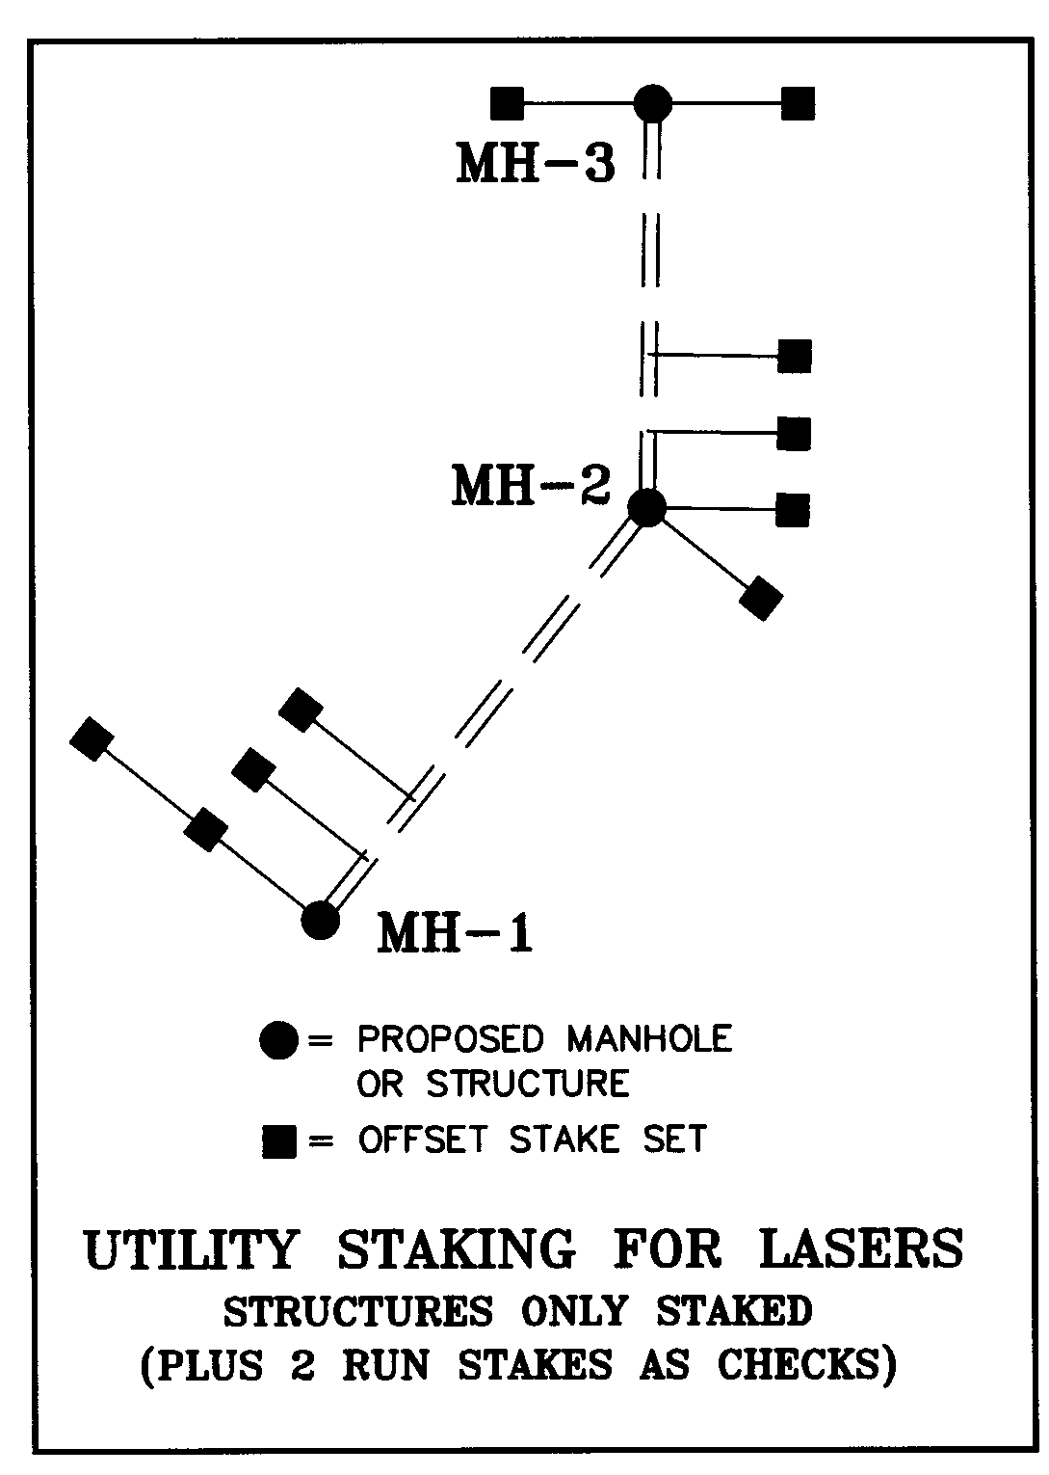
When placing these check stakes, bear in mind that gravity utilities are normally constructed from the low end up. This way, the pipes aren’t constantly being filled with storm water flowing through as they construct the lines.
It’s important to check with the site superintendent or utility contractor to know exactly how intensive the staking must be as well as on which side of the utility run to set my offset stakes.

Storm Sewers
Typical storm sewer pipe and manhole staking is similar to sanitary sewer layout. But, often there are more variables to consider. Almost all storm sewer systems include structures along the curbing of parking lots, drives or roadways. This makes staking accuracy critical. Tops of drainage structures constructed along curbing must be rotated to align with the run of curbing. Often, different size pipes require the installation of different sized structures.
Staking storm structures can be tricky. An illustration from my experience will best illustrate the danger in not knowing your local standard details and when they apply or don’t apply.
This story takes place when I was operating a business specializing in construction layout in Northern Virginia, just outside of Washington, DC.
On a particular project, a young graduate engineer serving as project manager for the construction management firm overseeing construction of a large commercial development decided to “split the bids,” awarding me some of the construction layout for the site and a Maryland firm the rest of the layout. The project site was located in Virginia, but the Maryland firm was only about a 45 minute drive from the site.
This young, inexperienced project manager reviewing the bids for construction layout noticed that a firm competing with me had lower fees than I did for certain line items, so he picked and chose the lower numbers for various line items from my bid and from that of my out-of-state competitor.
He awarded the curb layout to me. (Virginia typically used a monolithic, concrete curb-and-gutter approach.) The storm sewer layout was awarded to the Maryland firm, and the rest of the layout was divided between our two firms.
To the best of my memory, my competitor was furnished coordinates for the geometry of the parking lots by the design engineer, as was I, so we both had the same geometry to work with regarding where on the site the parking lots with their curb-and-gutter and storm structures actually belonged. My competitor was, of course called to stake the storm sewer structures along the curbing before I asked called to stake the curb-and-gutter.
Since the Maryland firm and I both shared the same geometry for the proposed location of the parking lot curbing, the curb-type storm sewer structures staked by them should, in theory, be constructed in the right relationship to the curbing that I would stake after the storm structures were in place.
I received the call saying that the storm sewer was installed and that I should stake the curb-and-gutter as soon as possible. While staking the parking lots, I found that storm structures were not fitting properly with the curbing I was staking. I checked my computations against the coordinates furnished to both me and the Maryland firm by the design engineer. The catch basins appeared to be staked a half-foot or so off from where they should have been. I reported the conflict to the site superintendent, who called an urgent meeting with both me and the Maryland contractor present.
At the meeting, I asked my competitor’s three representatives (who arrived on the site dressed in suits) how exactly they had computed the catch basin locations. One of them pulled out an inch-and-a-half thick Virginia DOT manual and placed it on the desk. He opened it to a page showing a standard detail of the basins being staked. He also had a sheet of graph paper on which he’d extrapolated the salient dimensions and began to proudly present the logic and perfection of his tedious calculations made from the admittedly not-so-easy-to-figure-out standard detail.
As soon as my competitors broke out the Virginia Standards, the superintendent and I exchanged knowing glances. Because I discerned an air of superiority in the Maryland team, I allowed him to take about five minutes to explain and defend his elaborate computation of how from the face of curb line the actual center of the basin should be located. The superintendent also allowed the presentation to run its course.
When he finished his “gotcha” presentation, he leaned back in his chair with a go-ahead-and-try-to-prove-me-wrong smirk on his face.
I paused for a few seconds, then said sympathetically, “So this is the first job you’ve staked in Northern Virginia, is it?”
The Maryland team exchanged quick sideways glances as I sat silently with raised eyebrows, looking from one to another and waiting for an answer to my question. I wondered who would speak first.
Their faces slowly transitioned from over-confidence to something approaching dead-pan. Still, I said nothing and waited. The superintendent was absolutely motionless. He knew where I was headed.
Finally one of them replied with considerably less bravado than expressed in their computation demonstration, “Yes, actually this is our first venture into the Northern Virginia market, but we’ve carefully checked and re-checked our computations and confirmed that we staked the structures precisely per the Virginia standard details.”
“Yes,” I said, “I can also confirm what you’ve said. My locations of the structures built from your layout confirm everything you’ve said.”
At this, they began to ease back into their superior posture. I had mercy on them at this point and spoke before they could get themselves all puffed up again, “But we don’t use that standard in Northern Virginia. Here, for all the smaller size pipes, we use a standard, 4-foot diameter barrel the center of which is always set 2 feet off the face of curb for curb-line inlets. Nobody in this area constructs by that standard detail, and for larger structures, I always need details supplied by the pre-caster who’s supplying the specific structures. Then, I stake from those dimensions.”
A look of incredulity passed between those who moments earlier were so confident. One of them asked, “What do you mean, you don’t build to Virginia standard details in Northern Virginia?”
As they realized all or most of the storm structures they staked were already constructed in the wrong place throughout the entire site, their cockiness-turned-incredulity quickly transitioned to something close to panic.
With my competitor properly humbled, a cooperative air was not hard to achieve in that construction trailer. I turned to the superintendent, who I knew well, for I had set up a construction layout division of his boss’s company just a couple of years earlier and recently bought it out to start my own business. (The Maryland firm’s men were of course not aware of this relationship, or of the fact that I’d cautioned the young project engineer who split the bid against the wisdom of that approach.)
Anyway, I turned to the superintendent, who’d remained silent – I think enjoying the interaction that had taken place – and said, “Well Pete, let’s put our heads together and see how much of the storm drainage we can leave in place. Where can we warp the curb layout or shift the parking lot to match the catch basins without causing trouble?”
We began reviewing the plans to see which basins and runs of pipe we could save and which storm structures and pipes absolutely had to be removed and replaced. Together, we were able to save most of the storm drainage constructed per my competitor’s wrong locations. In a few places, structures and pipes had to be moved, but by working together, my competitor was spared most of the back charges that they might have suffered.
Have I said before in this course, “Ask lots of questions?”
Standards vary by region and sometimes, as in this case, the most detailed, official standards are not even followed in daily practice. Never be too proud to ask how to do your own job. Just ask someone who knows. Contractors know what most surveyors and lots of engineers don’t really know, and that’s how it’s actually put together. We surveyors don’t admit this to ourselves, but the contractors have figured it out through long experience, and they already know our closely guarded secret. Don’t ever be too proud to ask questions.
Remember the above, true story. If only that Maryland firm had asked if the state standards applied, they would have been told not to use them. Ask!
Also, keep in mind that larger storm and sanitary pipes require larger-than-standard structures to accommodate the pipe sized. Obviously, a 48” pipe can’t fit into a 4’ diameter manhole or catch basin base. Be sure to ask what conditions determine the size of structures to be installed and become familiar with the kind of structures used in your region, especially storm structures constructed along curbing. Very little tolerance for error (or ignorance) exists with these structures, as the Maryland firm learned on their first Northern Virginia project.

Water Lines
As the above story illustrates, it’s best to ASK how the contractor wants things laid out. When staking water lines, this carefulness and diligence is particularly true regarding fire hydrants.
In some areas, the hydrants must be installed a certain distance behind the face of curbs and a certain elevation at the bottom flange above the top of curb. Be sure you know just how critical such layout is and what governs both the horizontal and vertical position of hydrants. Some jurisdictions are quite lax and others very strict.

Roadways, Drives and Parking Areas
In my experience, offset stakes along gently curved sections of curbing for roads, drives and parking are typically set at 25 foot intervals and at 50 foot intervals along straight sections, plus high points and low points and sometimes drop curbing for driveway openings or wheel chair access.
For roadways or major driveways, the design plans provide stationing, usually expressed as 1+00, 2+00, 3+00, etc., referring to distances 100, 200 and 300 feet, respectively, from a point of beginning at 0+00. Thus, on gently curved sections, you may be asked to stake every 50 foot station or every 25 foot station. In addition to regularly spaced stakes, you will normally stake high and low points and beginnings and endings of curves in the roadway. Normally, a profile is provided in the design plans, and these will show the high points and low points. The plan view of the road will show the stations of the beginning and end points of curve, but you will usually have to get or compute the elevations of these points from data on the profile sheets.
In driveway areas and parking lots, spot grades or contours are normally shown, and you‘ll have to interpolate between them to find proposed grades at your stakes’ positions.
Parking lot corners are normally offset two ways. Small islands with “noses” having a radius of about five to eight feet or less usually get just one stake at the radius point (center) of the arc. Assuming you’re using cut sheets to report the relationship of your stakes to the proposed construction, you must always provide a labeled sketch to indicate where multiple cuts and fills that are referenced off the same stake apply. For example, a single radius point stake may provide control for three points along the nose of the future curb, the PC, the end of the nose and the PT. I recommend always supplying a sketch with your spreadsheet-style cut sheet. The best approach I’ve found is to use circled letters both on the sketch and in the tabulated area of the cut sheet, indicating exactly where the grade for each circled letter applies along the curb.
In the illustration, points A, B and C all are likely to have different proposed grades, yet the three points on the proposed curb are referenced off one stake. Your cut sheet will require three lines for this. The stake identification and stake elevation will be the same for all three stakes, but proposed grade is likely to differ, as will the cuts or fills at those three points along the future curb.
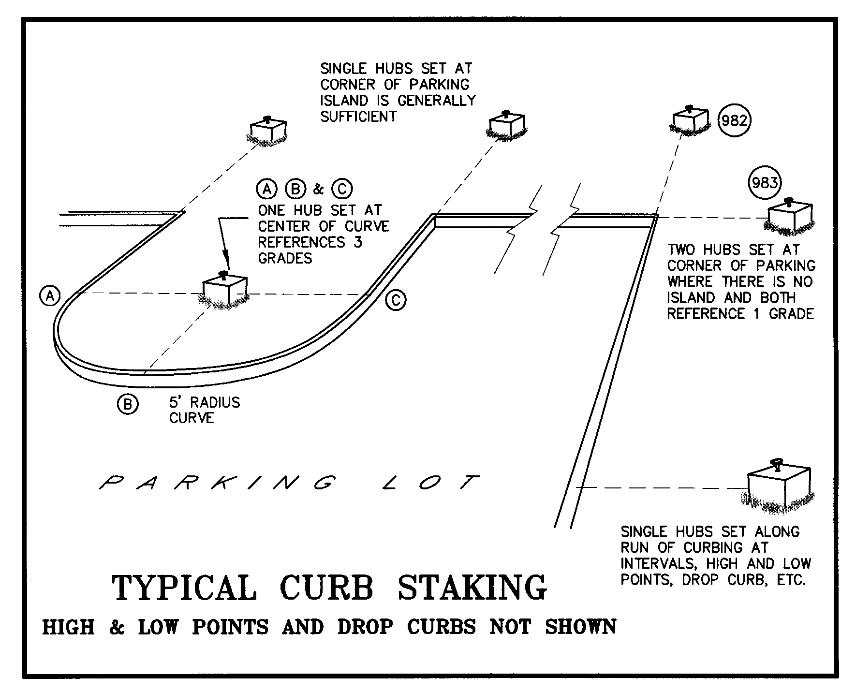
Where multiple stakes represent a single point on the future curb, for example when a parking lot corner is offset two ways (#982 and 983 in the illustration), I always label those stakes with circled letters or numbers and make a clear sketch in my fieldbook linked to the shot taken on that stake for elevation, so that there is little chance of reversing them on my cut sheet or on a sketch I provide. This is important, because one of the two corner stakes may be destroyed prior to construction, and if you’ve reversed their cuts on the cut sheet, it will probably be constructed at the wrong elevation.
Find out what is typically referenced, top of curb or gutter grade. Often the contractor building the curbing will want cuts and fills referenced to the top of curb grades, but the site plans will most often show grades along the pavement or bottom of curb. Be sure to be clear headed when listing the proposed grade. It’s easy to forget the add-on from gutter grade to the top of curb.
The portion of a sketch accompanying a grade sheet for the illustration above might look like this:
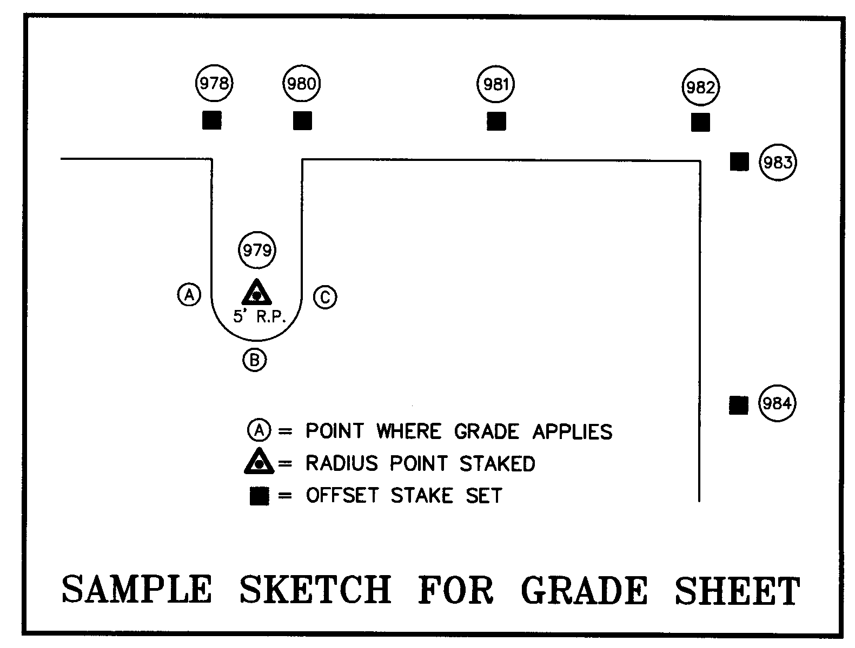

Misc. Calls for Layout
Sometimes you’ll receive calls for other miscellaneous layout, that is, layout beyond the scope of your contract. I normally do not place possible staking in a bid, because of the apples-and-oranges factor discussed under bidding in this course. In short, I don’t include it because it makes my bid higher than my competitors.
These miscellaneous requests are handled as “extras,” and one must be very careful to document an authorization to proceed through a signed work order or other form of written approval that acknowledges the services are in addition to your set-fee, contractual obligations. It’s all too easy for your client to assume that ANY layout they desire is part of your contract. This is why your contract must specify exactly what you’ve agreed to stake. Always document in your Conversation Logs any verbal authorization for work that exceeds the scope of your proposal or your contract with your client.
As in all issues pertaining to construction layout, when a request for extra services is made, never be afraid to ask the persons requesting the layout how and where they’d like it staked. Always find out if they need a vertical reference. Ask if they need horizontal offsets or just a stake for the point itself. They almost always know the best distance and side to place offsets and whether they need offset at all. Remember, you’ll impress them more with your questions than you will by providing control that’s hard for them to use or that’s too far or too close to their work or gets destroyed by adjacent construction before they use it. Ask what plan you should stake it from, making certain you have the latest information.
Then, make a work order and note any important instructions you receive, being certain to note the date of the plans you are staking from.
Miscellaneous calls for layout may include:
- Site Lighting
- Transformer Pads
- Containment Facilities
- Auxiliary Structures
- Equipment Sheds
- Playgrounds
- Off-site Utilities
- Garages and Carports
- Elevator Shafts
- Trash Areas or Dumpster Pads
- Menu Boards
- Bus Shelters
- Swimming Pools and Fountains
- Decorative Walls, Walks, Stairways and Patios
- Athletic Fields, Backstops, Tennis Courts
- Ticket Booths
- Sign Locations
- Walls
- Fences
- Anchor Bolt Surveys/Checks

Like working for free?
Again, you MUST get written authorization THAT INDICATES THE WORK IS BEING PERFORMED AS AN “EXTRA!” If there is any confusion in the verbal communication or written documentation of this work order, you may not get paid. Never forget that although construction layout is your business, and even though your contract is specific as to your limits of services, your client views your services as routine and rather a small part of the overall project budget. Your client’s attention to the details and specifics of your contract is likely to be lacking. It’s up to you to point out that the services being requested are not a part of your contract and to specifically ask if an extra fee is being authorized for this work. Then, GET IT IN WRITING. Use the words, “authorized extra” in your brief description on the work order, and get it signed before you start the work.
This is good business, and your construction client is good at business and understands the need for pre-approval of extras. Don’t be shy about doing business in a business-like way.
It is very, very common for your client to think of services you can perform “while you’re here.” This is why it’s so important that you and your crews are familiar with your contract and know exactly what is and is not in it.
Many, many requests vanish when the person asking for it realizes you need to be paid for it. It is also good business to occasionally provide an extra service without charging, if it won’t take too long and you have the time. Occasionally, you can make a friend of a site superintendent by providing some service that’s easy for you to do but hard for him to do on his own. But, he can’t authorize an extra charge for it because of the red-tape he’d face with his superiors. You’ll make a friend if you do it for free. Be smart, but not rigid. Train your crew chiefs to know the difference and to call you when in doubt.

Protect your control
We’re back on the subject of control points – the initial control traverse and any additional control set during construction. This is very important material, so please don’t skip over it. Every surveyor/engineer thinks he or she knows all that needs to be known about control traverses and networks. But, really, the stuff below is important. If you don’t learn something by reading it that you didn’t know before – or you’re not reminded of something you’ve forgotten – I’ll be surprised.
The safety of your personnel and equipment is not the only consideration on the site. Your control points have significant value to both you and to your client and must be protected.
Whenever possible, carefully coordinate the placement of primary control points (points that will hopefully last throughout the layout processes) with the site superintendent. Including the superintendent in the decision process helps that person feel connected to the importance of the control. The superintendent’s knowledge of what will happen where on the site is invaluable. In the course of my discussions with the superintendent, I state that each control point is flagged in certain, unique colors and represents about $300 in re-stake fees if disturbed.
I always mention to the superintendent that I have no problem with the point being destroyed if it’s cheaper to destroy it than to work around it. Sometimes, the area occupied by a control point is better used for storage of materials or some other need. If the superintendent knows that using the area occupied by the control point for some other purpose will cost about $200-$300, then he can freely decide whether it’s better to use that area or save the control point.
You may ask, why such pains about protecting control points? With the modern two-point and three-point resection features of instruments and data collection packages, can’t new control be set on the fly?
There are two things construction layout providers learn:
- You can never restake a point in exactly the same location it was in when you first staked it, and
- Precision diminishes as new traverses are run from one point in a previously adjusted control network to another.
The more educated reader may contend with these two principles, raising arguments about least squares adjustment, the increasing statistical probability obtained through redundant observations (resulting in smaller error ellipses), and other lofty notions. Yes, theoretically and statistically one may dispute almost any practical wisdom.
But, what’s important to remember in the 3D world of construction layout is this: Any point you restake to control the position of a building corner or the centerline of a column MUST be in the EXACT same place as the original stake that got disturbed or destroyed.
Of course, this is humanly impossible to achieve. Thus, a restaked control point (or any newly created control point) that you occupy to restake some other critically precise point won’t get the restaked point in the same place as your original stake. Experience will convince you this is true if I can’t.
How about a typical example – one that will have you tearing your hair out? You receive a call to restake some primary building control you set a week or two earlier. You find that a control point you occupied to stake some column offsets has been disturbed or destroyed. All you need to do is restake that control point, and then restake the missing building control, right? Simple enough – until you try to do it. Then, theory be damned; the new column offsets you’ve just restaked aren’t checking as well as you’d like with the surviving, original column offsets.
In this example, assume that virtually no human errors or equipment errors exist. You arrive on the site and restake the control point that got destroyed. From this restaked point, you restake the original column offsets. Your restaked control point used for this purpose was originally part of a closure-adjusted loop run between two points on your original, closure-adjusted traverse that looped the entire site. What could possibly be wrong?
The fact is, any number of things can cause you trouble when you try to restake control points. The surface of a construction site is normally unstable. Heavy equipment is vibrating the earth on and near the site, and often some settling occurs. Surviving control points that are used to restake a missing control point may look undisturbed, but in truth, they’ve moved. The adjustment of the traverses may have “moved” the coordinates of the points from their true positions in relation to one another. Your equipment may be in either better or worse adjustment than when the control was originally set.
Construction layout is a great teacher. It has taught me that facts exalt themselves against theory, truth and experience. Any classroom theory is worthless if it doesn’t achieve consistent results in the mud and dust of the construction site. The key word here is CONSISTENT.
Principle: Put extreme care into establishing your primary off-site and on-site horizontal and vertical control. Be as precise as you possibly can. When it comes to precision, accuracy and repeatable consistency, from the moment your initial control network or traverse gets established, it’s all down-hill from that point forward. Repeatable consistency falls apart with time and with every re-setting of control and with additional loops and legs of new traverses adjusted to older ones. Some surveyors simply can’t grasp this fact, and living in denial creates mutually exclusive realities that defy any consistent explanation.
So, what is the solution?
Set your primary control as precisely as you possibly can, and make it as plentiful as you can at the beginning of each project. And, make every reasonable effort to preserve these points throughout all critical phases of construction.
Principle: Be redundant. Normally, a surveyor is accustomed to setting as FEW traverse points at as great a distance from one another as possible. This is great for boundary surveys and for good, mathematical traverse closures, but it’s absolutely NOT a winning strategy in construction layout applications. Instead, set as many primary control points as you reasonably can. As usual, keep a good distance between them (to increase angular precision), but set points on line at frequent but random intervals between your primary traverse points. Set them very, very accurately; you may later need them to use as primary control or to reestablish lost control.
And don’t let your computer adjust these P.O.L.’s off-line, even a little. Their coordinates MUST fall on a line between the end points. Hand-adjust P.O.L.’s if necessary, proportioning the distance between them, to maintain their computed positions perfectly on line between primary control points.
Turn angles from control points to distant, permanent reference points like building corners across the street or recognizable points like the dotted “i” on some distant store-front sign. This redundancy may pay off later as little by little, your primary control gets disturbed by the construction activities.
Some may argue, “Hey, I’ll get paid to restake any control that the contractors destroy. Why take such pains setting original control? Setting original control has a set fee in my bid, but I’ll get paid hourly fees to restake anything they knock out?”
Well, take that attitude if you want to, but you’re expected to know how life goes on the construction site. There are limits to how much patience your client will have with your inexperience if you initially set too little control to properly service the site. You should always have off-site control, set in areas not impacted by your client’s site development, and this must be adequate to establish new on-site control points in a minimum of time.
When on-site control has been destroyed, it really shouldn’t take you more than an hour or two to occupy some original, off-site control, verify it with two other original control points, set a new point on the site, and check that new point against one or two existing, on-site control points, making any adjustment you deem prudent and get on with the task you’ve been called to perform.
Never say to the client, “All my control has been destroyed.”
Your client will understand by such a statement that you don’t know your business and either skimped or didn’t take appropriate precautions in setting and densifying your initial control.
As soon as you discover some of your on-site control has been destroyed, immediately inform the superintendent or whoever is paying you. Do it right away! Your client may be able to recover your fees for re-establishing control from the contractor who destroyed it.
For example, if loss of a primary control point is reported immediately upon discovery, it may be obvious from tracks left at the destroyed control point that a certain piece of equipment ran over the point or came too close to it. The superintendent probably knows whose equipment that is. If the point was adequately marked (with a staking scheme as described in this course), your client has the option to seek costs of restaking from the firm that destroyed it – or at least to warn the firm that any future repeats of such carelessness will cost that firm.

Label your control points in the field
Whenever feasible, label your control. Obviously, one-foot high orange numerals painted on a concrete sidewalk across the street from your job may bring criticism. But, one-inch high felt pen numerals probably won’t. Have your crews ever set up on point #44, backsighted #45 and reversed these point numbers in the paper or electronic field book? It happens all the time, especially when the control points are not physically labeled in the field.

Be sure your crew THINKS in the field.
While on the topic of control points, a word of caution: Always provide your crews with the data necessary to check distances between control points. Instruct them to check their observed distance between any existing control point the instrument is set over and the backsight on a known control point. Obviously, close agreement between inversed distances and observed distances must be verified. This agreement provides comfort that the crew truly knows what point they are occupying and what point they’re backsighting.
Notice I said, “comfort,” not proof. What if the crew thinks they are occupying point #44 and backsighting #45, when in truth they are actually on point #45, backsighting #44? The check of backsight distance will not declare this common error.
Next, the crew must check the angle between their backsight and another known point. This will verify that the point numbers for the instrument and backsight are not reversed. This also verifies that you’re using YOUR drill hole or x-cut and not that of another surveyor.
Surveyors know that a backsight distance check plus a check to another known point are essential to confirm that they are actually occupying and backsighting the points they intend to use. Therefore, always check a second, known point for both angle and distance agreement. This alone provides the extra confidence that the ever-lurking potential for liability requires.
Sending a crew out to perform ANY survey work from a pre-established control network without giving them the data necessary to verify their set-up and backsight points is tempting fate.
This happened recently to a surveyor friend. Another survey firm had set an x-cut that my friend’s crew mistook for their own. My friend’s crew did not check the backsight distance or turn an angle to another known point to verify the instrument’s position, and proceeded to locate points from there. The results were costly.
This is a very common tale when management’s attitude is, “I don’t want my crews to do too much thinking in the field.”

Color-coded flagging

The “Orange” Firm -or- It’s hard to scratch your head while wearing a hardhat.
Color-code your layout. Every major category of future construction getting staked should have its own color to distinguish it from other features staked. Consider this story:
Once there was a small firm whose expertise was in land surveying. This firm ordered flagging by the gross, all orange-glo in color, the only color flagging this firm used. This was a little confusing when retracing their property surveys, because traverse points and property corners and points marked during their initial recon on a project were all flagged in orange.
Their party chief flagged remnants of wire fence and other evidence of boundaries in orange during his initial visit to a property. Next, his traverse points were marked with orange flagging. When he came back to set corners, these were flagged with orange. If the project required vertical control, the bench marks were flagged in orange. When they staked a house for construction, they’d stake offsets with orange flagging. Most of their work was in rural areas and caused only occasional, minor aggravation to the firm’s clients.
For example, once a house offset stake was set about ten feet from a stake marking an angle point in the property’s side line. As always, both stakes had orange flagging. The contractor had to go to the stakes and read their labels to know which stake was which. Later in the day, he instructed the man digging the foundation to use “that stake over there,” pointing to the stake marking the angle point in the property line instead of the only remaining offset stake for the house at that end of the proposed house. The lot was quite large, so the location of the house didn’t seem critical to the operator, who dug the hole for the foundation ten feet toward the rear of the lot from the intended position. Because of mistaking the property line stake for the house offset stake, the house was built encroaching within a wetland setback. If only the house offset stakes and the property line stakes has been flagged in different colors, this costly mistake would have been avoided. Flagging is cheap!
Another time, this little firm received a layout contract for a major, commercial center. And, you guessed it, control points, boundary points, clearing limits, rough grade, column lines, elevator, sanitary, storm, water, elect/tel/cable, curbing, site lighting, retention basin – all were staked in orange. Equipment operators repeatedly got off their equipment to read the stakes, walking between them and scratching their heads as they tried to get the picture of which stakes applied to their immediate work and which were irrelevant to the task at hand.
Show more consideration for your clients than the orange-firm does. Use different flagging colors for each different feature staked. And, be consistent! Your regular clients and your own crews will appreciate the clarity brought by standardized color-schemes, and any error in your staking might declare itself prior to construction because of its proximity to another staked feature that’s recognizable by the color of its flagging. With consistency, your color-coding becomes familiar to your crews and the end-users of your stakes. And, this is what you want. The site plans are 2-D representations of what the finished site will look like. Your color-coded stakes are the first on-site view of what that is. This is not only kind and helpful; it could save you a bundle if you stake something wrong, but your error is discovered early because of the picture made by the different colored stake flagging. A wrongly staked feature is far more likely to “look wrong” if the picture made by the flagging is clear in the field. Unique colors for each category of staking help tremendously in making a picture of the future construction in the minds of people using your stakes.
Determine your firm’s color-coding standard and insist your crews stick to it. Once they learn it through repeated use, they will apply it by habit and appreciate it themselves (eventually if not immediately). Certainly your clients will!
And lastly, imagine this: You have a repeat client, a commercial developer, who is used to your color-coding scheme and knows what each color represents. Then, some competitor underbids you, and your client hires that firm for their next project. Guess who’s been hired in your place. It’s the ‘Orange-Firm!’ What do you imagine your client will think of the confusion the Orange Firm creates? That firm has just become your sales force, and they don’t even know it.
Little things mean a lot sometimes.

Suggested Color-coding Scheme for Flagging
Below is my personal color-coding scheme. Any consistent scheme is better than none. Being anal-retentive, I’ve put considerable thought into this scheme. It may benefit you to read through it to learn the reasons for my choices.

Orange & Blue – Primary Control Points (one strand of each color)
Orange-glo and blue (separate strands of each) make a stand-out color scheme for primary control. Primary control is comprised of the following:
- Traverse points that you hope will last throughout the job
- Primary control-rectangle points for buildings
- Distant building offsets (discussed earlier)
- Other semi-permanent points used for construction
- Property corner markers and monumentation
- Street right-of-way monuments or reference points
- Permanent reference points (NGS, County, City, etc.)
- Bench Marks
I always flag the most important control with this color scheme and triple or quadruple guard these critical points with similarly flagged guard stakes that claim a territory around each control point, often an area sufficiently large to set up and operate an instrument.
This is my territory on the site, and destruction of these will almost always result in hourly fees for restaking. Because of the importance and critical nature of these stakes, I coordinate their placement with the superintendent and advise of the expense associated with their destruction. If the superintendent is involved in choosing the placement of on-site control, you have an advocate to watch over your control when you’re not there. Upon returning to one site following such a discussion with the superintendent of a ‘better’ construction management firm, I discovered that as extra security, he’d placed orange plastic snow-fence material on steel posts driven into the ground around all my on-site control points. These did last throughout the entire project on a very tight sight.
I tell the client, “Orange-and-Blue is EXPENSIVE. Every orange and blue point disturbed is worth about $200-$300. If disturbing it is cheaper than working around it, then by all means destroy it. Otherwise, if you can, keep people away from it.”
After handling my control staking in this way, I’ve actually witnessed a superintendent telling an equipment operator, “If you disturb that point, it will cost you $300.”

White – Clearing Limits
I like white for clearing limits because it’s not used for any other staking. It’s good because it shows against the usual green shade of whatever is to be cleared, namely grass, brush and trees. Plain colors are cheaper per foot than vibrant colored flagging, and staking clearing limits on a site consumes lots and lots of flagging.
Usually, I run flagging from tree to tree or bush to bush, more or less continuously stringing the white flagging along the clearing limits where vegetation is continuous. In doing this, I make the pieces of flagging a maximum of around 25 feet long so that the equipment doesn’t rip off a whole line of flagging before the operator knows what is to be cleared. But, the appearance of the flagging is continuous in heavy vegetation.
In grassy areas or not-too-tall brush, stakes set along the line are needed at appropriate intervals. I generally don’t run flagging from stake to stake, because such an approach tends to pull the stakes over as the clearing takes place .
When staking the clearing limits, confusion can exist. Does flagging on a tree trunk mean clear this tree or clear leaving this tree? Normally, I stake a limit based on a line drawn on the plans to denote limits of clearing. This line in a digital file is easily reduced to points with coordinate values set at appropriate points along that line.
These points are then staked in the field. I leave decisions about specific trees or shrubs to remain to the client or excavator unless a specific tree or easily identifiable group of trees is to be saved. In the case of specific trees to be saved, I may flag the drip edge as well as the trunk, so that the equipment operator stays away from the roots. Often trees are killed by root damage. In my limited, inexpert knowledge, the critical root area is approximately at the drip edge of the foliage, and soil disturbance close to the trunk may kill the tree. Not all equipment operators realize that a tree to be saved needs some undisturbed ground space to exist. If a little extra expense in flagging saves a tree, it’s worth marking such limits. Flagging is cheap, and a mature, healthy tree is of great value in what it ministers to the inner man and the “feel” of the sites we develop.

Blue and White Stripe – Rough Grade
Once the site is cleared, you’re often asked to stake the site and building for rough grade. It is important to ask and document in writing what grade you are instructed to reference on your stakes. You may be asked to use a particular depth below finish grade for parking and another depth for seeded areas, and another for the building itself. Normally, I add a second color of flagging to the blue and white striped flagging to help the excavator know what area is being graded.
For example, to the blue and white stripe I might add a strip of red for parking and drives and perhaps green for the building pad, if there is one.
This takes time, but the contractor will love you for this extra bit of care and concern for the team. (I can almost guarantee that your competition will not be so kind.)

Pink – Building Control
Pink-glo flagging is very visible on a construction site. The building layout is something you really don’t want to restake, because getting something in the same place twice is somewhere between difficult and impossible. Pink helps to avoid this simply because it’s visible and exists nowhere else on site.
A second color should be added for special features within the building, such as elevator shafts, etc., so as not to confuse these stakes with other building stakes. For example, you might double-flag an elevator shaft with pink-glo and green-glo flagging, so that it’s distinguished as something unique from stakes set for columns or other features. There is so much activity with people and equipment, and the layout is so critical, that flagging for buildings should be chosen for its visibility.
Stakes should be marked clearly in a manner similar to that illustrated elsewhere in this course, and a sketch or plan showing what you’ve staked should be created and provided to your client.

Yellow or Yellow with Black Stripe– Sanitary
Sanitary sewer is usually deeper in the ground and usually gets built early in the site work process. Yellow is distinct, but not highly visible on a site void of vegetation. I use yellow at this point primarily because little else has been staked on the site. In areas of traffic, I may spray the stake itself with orange or pink paint to make it more visible.

Orange-Glo and Black Stripe – Storm
Often stakes for both sanitary and storm sewers are present at the same time on the site. This orange-black combination is very distinct and visually separates the storm drainage from any sanitary stakes that may be nearby. Getting the two mixed up can be a problem, and the contractors appreciate recognizing one from the other at a glance.

Blue – Water
Requests for staking water lines usually follow storm and sanitary. Water lines are pressurized and can generally be installed at a fairly consistent and comparatively shallow depth below the proposed grade. For this reason, they are often constructed after storm and sanitary utilities are in place. The color blue and water seem made for each other.

Red – Pavement/Curbing/Walks/Patios
Red (not red-glo) is cheap, yet distinct. You may use a lot of it staking pavement and curbing. It does the job and is both visible and inexpensive. I often added a second piece of flagging in some other color to distinguish stakes at radius points. Even if your competition uses distinctly colored flagging, they are not likely to distinguish between curbing offset stakes and radius points by adding a second color of flagging. This small, extra effort may endear you to your client and to the subcontractor constructing the improvements.
That little extra touch may cause your work to be praised in brief conversations between contractors, or between contractors and your client. Nothing is more valuable than a good report.

Yellow plus Green-glo (one strand of each color) – Miscellaneous Features, with purpose of stakes clearly labeled.
Envision the complete site staked with the distinguished colors as suggested above. Go ahead and conjure up an image. Any will do. Now, imagine the same site staked out by the orange-only firm. While not all features of a site are ever likely to be staked at once, many stakes referencing different features typically coexist at the same time. With a distinctly colored flagging scheme, all a superintendent of contractor needs to do is glance at a site to determine if new staking has been performed. Imagine an excavation contractor walking a site trying to determine if water lines have been staked when every stake on the site is flagged in orange. Now imagine this same supervisor trying to determine if equipment should be mobilized or not. This person familiar with your work and color-coding, need only look for blue flagging flying on the site in the general location of the water lines. No blue? Not staked yet. Blue flagging there? It’s staked.
Can you imagine the advertising your blue flagging has done if this person has just come to your site after roving throughout the maze of the orange-only surveyor’s work?
If asked to stake electric, telephone or other features like a transformer pad or dumpster pad or menu board, I use combined colors that are distinct from any other stakes on the site. The particular color chosen is not as important as the distinctiveness of the staking. But, I must be certain it is not a color or combined color scheme I use for standard staking.

Summary – Color-coded Stakes
In this world, people think too little about what it’s like to be the other guy. Following this or your own system of color-coding stakes will make the other guy’s work easier. Most of your competition won’t take special care with this. Many firms will stake like the “Orange Firm” mentioned above. Others will look around the site and maybe pick a color they don’t see there already. Only a few firms truly have a color scheme and stick to it.
Be one of those few. Beyond this, why not make pocket sized, laminated tables of your color schemes and distribute it to your crews, your client and the subcontractors, particularly the excavator and utility contractors. If you don’t have a laminator, maybe you should get one. They’re relatively inexpensive and are useful for your list of feature codes, data collector menu structure and for lots of just plain fun or promotional uses.

Labeling of Stakes

Hubs/Hubs with Tacks
A “hub” is typically a tapered stake six to twelve inches long having a top about one or one and a half inches square. I know of a firm that calls ALL their control points “hubs,” even though the physical objects actually used for control points were rarely hubs but rather, 12” spikes, mag-nails, cross-cuts in rock or concrete, drill holes or rebars with plastic caps. A hub is a particular type of wooden stake. A control point can be any of a number of physical marks or objects, including a hub.
Many times, when staking for construction layout, a hub or a hub with a felt pen mark or tack in the top is set in the ground, along with a taller stake along side to call attention to the presence of the hub.
Hubs disappear from view on cleared sites because they blend in color with dirt. Why not make a rainy day activity the painting of the tops of your bundles of hubs with a bright pink or orange color? Hubs normally arrive bundled, and this facilitates spraying them.
Sometimes, when setting a hub and tack, you may wish to fold a piece of flagging to form a square or a square with a tail and put your tack through it in the hub.
In high traffic areas, you can spray the exposed portion of the sides with paint to make the hub more visible. In grass, you can spray a circle around the hub. Paint applied to grass can last quite a while, so use discretion.

Guard Stakes, Witness Stakes and Lath – Tall Stakes
A “guard stake” or “witness stake” is usually a tall stake (usually 18” to 48” in length) with a flat surface wide enough to write on with a felt pen, placed along side of a hub and labeled to identify the hub and its relevance to future construction. “Lath” is sometimes used, lath being a thin strip of wood similar to that attached horizontally to vertical wall studs under plaster in older homes. For simplicity, I’ll call these “tall stakes” in this discussion.
In my own business, I used oak stakes about ¾” by 1 ½” and 24” to 36” long, the length depending on both the type of soil the stake would be set in and the amount of labeling I expected to place on the stake. These stakes were planed (not just rough cut), stored indoors at the mill before I bought them and indoors at my office (Oak will turn black if it sits wet and also stinks.), and provided a smooth surface for labeling. They had a wide, flat top that made pounding them into the ground easy. They were sturdy, close-grained pieces of wood that almost never split or broke when being set.
One firm in my area used pine stakes made by one of their employees. They were made in a barn near the employee’s home. I purchased these on occasion but found them to be rough, making writing with a felt pen difficult. And, they had knots that often caused them to break when being set in hard soil. When these broke, the sharp, splitting stake was a danger to the shins of the one installing the stakes, and the path the sledge hammer took as a stake broke under its blow was unpredictable. Once the sledge hammer deflecting off a breaking stake injured an employee’s knee. Cheap stakes can be expensive.
Another firm used rough-cut, 48” long lath, without even a point on one end. These ¼” thick slices of pine were flimsy, springy and unwieldy to set. Placing one in hard soil required making a hole with a hub or frost pin prior to setting the lath. The edges were so rough, they were very hard to write on.
It never ceases to amaze me the truth in the expression, “penny-wise and pound-foolish.” My advice: buy a good grade of stake and save some money by spending a little more for something that saves time and is safe to work with. Don’t get thrift and intelligence confused. The former must remain under the dominion of the latter.

When to Use Hubs, Hubs with Tacks, and Tall Stakes
In some cases, particularly for layout of construction requiring less precise horizontal location, no hub stake need be provided, a tall stake being sufficient for the purpose.
If you want to profit from your contract services (that is, from your fixed-fee layout services), it’s good to know when providing just a labeled guard stake is sufficient, rather than setting both a guard stake and a hub,. Likewise, when the horizontal, positional tolerance of the item being laid out does not require the accuracy implied by the presence of a tack in a hub, it is best to not place a tack in the hub.
Does this seem like splitting hairs? While employed as an assistant superintendent, I remember watching a surveyor set a hub to mark blasting for utilities. This struck me as an absurd waste of time and money, because a tall stake alone is generally more than sufficient for the purpose. But, that surveyor wasn’t through. Next another shot was taken to set a tack in the hub. Finally, the surveyor called for a third measurement to confirm the set position of the tack. I kid you not! After that, of course, a guard stake was placed and labeled. This penchant for precision took time. That layout activity was being charged to my employer on an hourly basis. For that blasting work, just a tall stake set within a half foot of the theoretical position would have been more than adequate, maybe even overkill. The fee for the surveyor’s service was considerably higher than it should have been.
You’ve heard the expression, “The devil is in the details.” This is true in the construction layout business. Knowing when to major or minor on details is a key to financial success.
Many surveyors and engineers, because of their lack of construction experience, simply and honestly don’t know how precise the layout needs to be for a particular construction item. My advice is, never be afraid to ask the superintendent or the person requesting the layout, “How precise does this need to be, both for horizontal position and vertical cut or fill labels?” I’m convinced that most people love to help and instruct others. They like the experience of doing it. Seldom, if ever, have I had anyone refuse to tell me the answer to this question. And, to my knowledge, no one ever thought less of me for asking. If anything, they appreciated being asked. Remember, any seasoned construction person has watched surveyors split hairs on things requiring little precision and yet fail to provide sufficient precision for things that do matter.
In general we may conclude that a tall stake is generally sufficient for any blasting activities, and column line staking almost always requires all the precision one may bring to it. In between these tasks are layout items requiring varied levels of precision. Some require more precision in the horizontal component than the vertical, or visa versa. Know where to place the extra effort and when not to spend energy and time on precision if it just plain doesn’t matter for that layout.

Marking Guard or Witness Stakes
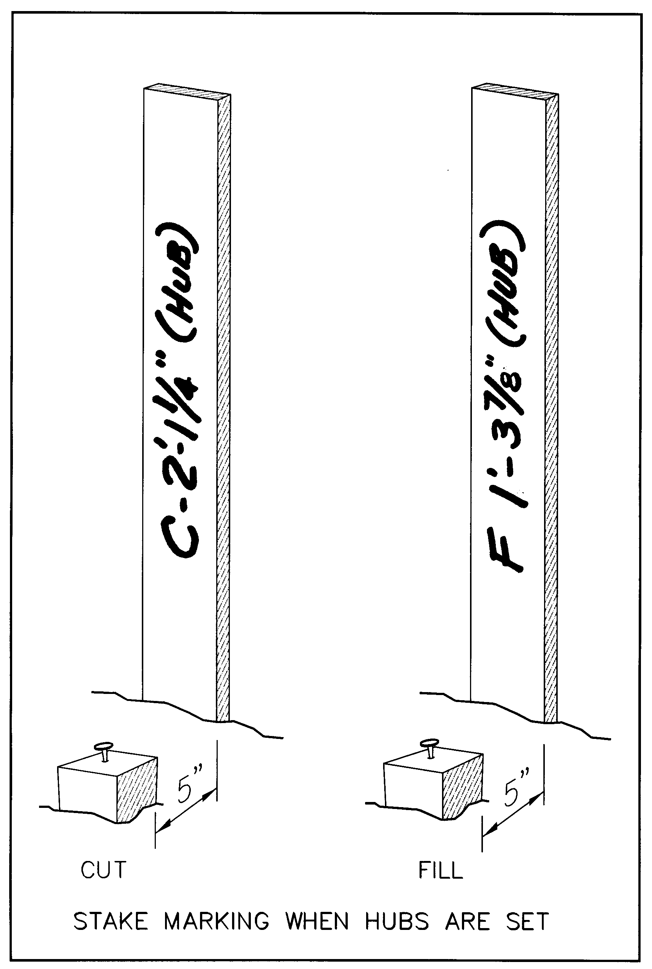
Remember, the person using your stake as they work may be on a piece of equipment or walking some distance from your stakes. Make your writing as large as reasonable and as legible as you can. Sloppy writing on a stake is annoying to the person trying to decipher its meaning. Never allow a 9 look like a 4 or a 3 to become confused with a 5. No one should stand scratching the head because your 7 has such a short top that it looks like a 1. Be consistent in the format of your labeling and in the positioning of the various labels on the stake.
When you label a tall stake with a cut or fill referenced off a hub stake, note “HUB” along with the cut or fill or grade notation, so that there is no possibility of confusion over what the cut or fill should be measured from. The illustration at right shows stakes clearly marked with reference to the hub.
Also, note that the illustration shows the clear space between the tall stake and the hub as 5”. In my experience, if 5 inches or more is left between the tall stake and the hub, seldom, if ever, will driving the tall stake into the ground cause movement of the hub. For the critical horizontal reference from a tack set in a hub to be accurate, the hub must not move when the tall stake is set in the ground. Probably the safest thing to do (not always the most convenient thing) is to set the hub, then set the tall stake, and set the tack in the hub last.
If the primary use of the stake is to control grade, place the cut or fill labeling on the side most likely to serve the person using the stakes. For example, if the offset stake is for a sanitary sewer, place the cut labeling on the side facing the future trench. If the offset stake is to a house or building corner, try to mark both the offset distance and the cut or fill on the side facing the excavation. On the back, you can add the point number or some specific detail regarding the point being offset. Once the person using your stakes has identified the relationship of your stake to the “hole,” that stake will be referenced again and again from within the hole, not from behind the stake. So, give that person the ability to stay in the hole and read the ‘cut.’
Be certain the person ordering the layout or using the stakes knows what point is being referenced. Remember the true story related earlier in this course where a large site was rough graded about two feet too low, with all that material carried off site because the contractor thought tall stakes with cuts marked on them referenced cuts from the ground level at the base of the stakes. The surveyor’s intended reference was from the top of the tall stakes. This was a near disaster, and I’ll never forget it.
Little things mean a lot. (Have I said that before?) I always tie my flagging to tall stakes by wrapping the flagging three times around the stake an inch or so below its top and tying the knot on a corner of the stake. This activity can be done prior to staking, because the flagging will not slip up and off the stake while pounding, if the flagging is good quality and is wrapped and tied tightly. I find it faster to pre-tie by holding the stake between my thighs than to tie-when-staked. (I once tried to teach this method to a very skinny employee. With his knees together, the stake simply couldn’t be held tightly.) I turn the stake when setting it, so the flagging (tied on a rear corner of the stake) is less apt to obscure the writing on the stake. Without wind, the flagging hangs toward the side of the stake away from the most-useful labeling. You may have seen equipment operators leap happily from their equipment when the coffee and food truck drives on the site. Don’t let this confuse you. Equipment operators don’t like having to get off their equipment to read your stake.
Figure 8, found earlier in this course, illustrates a suggested method for labeling grade stakes. Note the redundancy of the “C” or “F” with the V-shaped symbols that point to the reference line, and how those symbols are distinct from the “Grade” symbol. Of course, any labeling scheme will suffice if it clearly meets the following, essential requirements:
1) The point referenced by the stake – the unique name or identification of the point the stake references (N.E. Cor. House, Column 1-A, Sta. 3+50 Water Line for Blasting, Face of Curb at CB-17, a point per labeling on a sketch you provide, or whatever the plans call the point)
2) The horizontal position of the stake in reference to the point being constructed (10’ offset left, 25’ offset to Col. A-1 on A-line, Stake “A” on grade sheet sketch, Bottom of Retention Basin, etc.)
3) The vertical relationship to the point referenced (cut or fill to the future point or grade, …to Top of Curb, Rim of M.H., Basement Floor at Elev. 104.50, Top of Top Step, Pavement Grade, etc.)
These THREE components MUST be present and presented clearly – not subject to misinterpretation. Your familiarity with what you are doing becomes your greatest enemy in this regard. Always ask, “How many ways can a person unfamiliar with what I’m staking interpret the information I’m providing?”
If the answer is anything but ONE, you’re at risk of paying for the resulting confusion and what gets constructed under its influence. Not all construction workers are brilliant people. Many are, don’t get me wrong. But some are not. You need to think like the less intelligent folks and make your labeling so simple that the least literate or least intelligent laborer will get it right.

Rules of Thumb
Your work will go faster and be as precise as is needed if you memorize rules of thumb to help you interpret data or circumstances easily.

Angles
A rule of thumb I use very, very often is this:
One hundredth per 100 feet for 20 seconds.
If you turn an angle to check something you’ve set 100 feet from the instrument and find the angle is off by 20 seconds of arc (0º-00’-20”), the point is about 0.01 foot left or right of its intended position. At 200’, it’s doubled (0.02’ or about ¼”). I love this rule of thumb.
What if you stake some point 50 feet away and discover when checking it that it’s a whole minute off for angle. One minute is, of course 60 seconds or 3 times the 20 second rule per 100 feet. So, in 100 feet, being a minute off for angle shifts the point 0.03 foot left or right. But at the distance you are checking (50’), the error is half that, or 1 and ½ hundredths of a foot. Is that close enough for what you are staking? If so, move on. If not, fix it.

Steel Tape Corrections
If you are skilled in the use and care of a high quality, steel measuring tape (or willing to become so), you will find many ways to save time and even increase accuracy using one. But, the steel tape expands and contracts with temperature changes, and corrections must be made for precise work. How much?
Another rule of thumb: one hundredth per 15 degrees Fahrenheit. If your steel tape is standardized at the usual 68 degrees, and it’s actually 15 degrees hotter (not the air temperature, the tape’s temperature), then the steel tape is 0.01’ longer per 100 feet than it reads.
In my experience, many construction layout people have scratched their head over differences in redundant measurements observed using the same steel tape because of wrongly thinking that temperature correction is insignificant.
Yet, it’s not uncommon for a cold morning to turn into a hot, sunny afternoon. If the difference between morning and afternoon air temperatures is 30 degrees, the temperature difference between the black-top road the tape is lying on first thing in the morning and later in the day, after the sun has soaked into the black pavement for hours, could be twice that, or 60 degrees. In this example, applying the rule of thumb, one hundred feet measured to set a point in the morning will measure 0.04’ short later that afternoon. A half inch different? Yup.
The steel tape is a wonderful tool in the hands of someone who knows how to use it, knows how hard to pull to eliminate errors due to sag (very, very hard on longer distances – harder than you’d care to pull usually), and how to care for the tape so it doesn’t look like the edge of a lasagna noodle as it comes off the reel.
The purpose of this course is not to instruct in its use, but IF you use one, be aware of its strengths and limitations, and keep this rule of thumb memorized.
For my first years of construction, prior to the total station, I used the 200’ steel tape as my standard measuring tool – for control networks and for layout. It never failed me. It had no battery to go dead. But, in our time, not many people know how to use it for precise work, and this is a loss to the surveying profession and construction layout trade alike.
A thirty-something surveyor recently said to me, “Well, I’m not checking into some very old control points recovered. But, that was probably set back in the days when crews dragged a steel tape around.”
I used those steel tapes for over twenty years before my first total station. And I got better closures on control traverses than many less skilled crews get today with total stations and prism poles. There is nothing wrong with using a steel tape – providing you know how to use it. It is becoming a lost art, I’m sad to say.

Balancing Foresights and Backsights for Level Runs
Not a rule of thumb, really, but a RULE.
IF – the crosshair in a level is out of adjustment (too high or too low in the center of the scope as you sight the level rod), and if it is consistent (meaning that the self-leveling mechanism of an auto-level is functioning properly),
THEN – if you balance the backsight and foresight distances between the level and the rod sightings, you will get the true difference between the elevations of the backsights and foresights.
Therefore, it is always a good idea to make your backsight and foresight distances to rod readings approximately equal when doing level runs.

Record Keeping

Covering Your A___.
CYA, CYA, CYA!!! I used to say, “I spend 70% of my time performing construction layout services and 30% of my time Covering My A-a-a-a-ctivities.”
Construction is a blame-game! Beware. Do your work right and according to the plans or to written instructions, or at least to some form of written authorization or documentation. Try to think of what could go wrong, or how your labeling could be misinterpreted, or of who might unfairly blame you for inaccuracies in your work that did not actually exist. Then, CYA.
This theme is oft repeated throughout this course. Construction layout is like police work – lots of paperwork; lots of documentation, lots of reports, and occasionally a little work of the kind you imagined when you decided to do this for a living. You get the picture. Don’t think for a minute that all this CYA’ing isn’t an integral part of your job, your success, and your prosperity. When you get back to the office and you’re exhausted, write that e-mail, memo or letter instead of going home.

Digital World – Shortcut to Disaster
In the digital times we live in, there is a tendency toward the elimination of paper and documentation. We don’t need the paper field book set up with all the angles we expect to turn and the stakeout distances written down. Our coordinates are uploaded, and we need merely tell the collector what point we’re occupying, what point we’re backsighting and what point we intend to set. The person with the prism pole heads in that direction and we push a button. The collector tells us how far to go or come to set the point. Some even tell us if our angle is wrong or how much left or right to go. We set the point and press on to set the next point, right?
Maybe not. If it is a critical point, subject to significant back-charges if we set it wrong, writing down the angle turned as read on the instrument (not the collector) and the distance (from a reading taken on the SET point) provides two benefits. First your work can be checked in the office. Second, you’ve made a record from which you can mount a defense against claims that you staked it wrong. How much more convincing it is to point to a record in a field book than to say, “Hey man, we used modern equipment!” Of course, if your angles and distances written down as checks exactly match their calculated, theoretical counterparts, we all know you’re lying.
Another and often better approach is to shoot the point you’ve staked and record it in the data collector with an unused point number. The collector can be downloaded, and the office computer can quickly inverse between the theoretical point and the very one you staked and then located. This set point remains in your digital data base, and can provide substantial proof of your work, even when the stake you set is long gone. Not too many will choose to argue with such proof, though it could be faked. Your field book should, of course note the point number used to locate the point set and adequately describe the identity of the feature staked to relate it to the new point number. Keep your data collector’s coded files. From these, you can demonstrate that your raw files are unaltered by making the conversion from the coded file and comparing that to your raw file or other output.
As noted elsewhere in this course, digital plans are subject to corruption. Methods exist to reduce chances of this happening (such as locking layers and making frequent, permanent back-up files of work-to-date) but these methods are beyond the scope of this course to cover. But, do keep in mind that an inexperienced or inept CADD operator has the potential to do great damage unawares to the digital product. Be very careful who you let at the drawings that are as critical to your work as cogo points used to be in the dark ages of twenty years ago or less.

Record Keeping – Data Collection
It amazes me that many of today’s crews do not make notes in their data collection file using their collector’s keypad. Often, looking at the files, it’s impossible to tell what project, what function, what crew, which positions in the crew, environmental conditions, or much else about the job or exactly who did what and why.
We need to get back to basics, folks. A fieldbook contains a record of certain essential things, whether electronic or paper, that have been standard operating procedure for surveyors or other professionals doing construction layout since the Flintstones. Basic surveying books from antiquity speak of these things, and people once observed their sage advice. What has happened?
Get back to basics, and keep good digital records when using data collection!

Paper Fieldbooks –

Bound v. Loose-leaf
Debate will always abound regarding this, but one fact is certain: It’s infinitely harder to fake data, particularly past data, or to create the impression you performed some task you didn’t or in a way you didn’t, if you log your activities each and every day in a bound field book. Its bound pages can’t be torn out or new pages inserted between others without leaving traces of those actions. For this reason, bound books are generally adequate evidence that you’ve made a habit of consistent, sequential record keeping. Loose-leaf field books offer many advantages, but this is their weakness. If you are ever in court, you’ll appreciate the benefit of using bound field books.

Loose-leaf Fieldbooks:

Advantages of Loose Leaf Field Books

Copier Sketch or hand-drafting easier
If you elect to use loose-leaf fieldbooks, don’t overlook the advantage of sometimes copying an image directly to the fieldbook paper.
Here’s one way: Suppose you have a reduced sketch or plot of a column layout with point numbers for a building you are going to stake, and that it will fit on a loose-leaf sheet. Wouldn’t it be helpful to have that sketch right in the fieldbook?
You can place the sketch in your copier and make a copy on a regular sheet of paper. Next, place the fieldbook page over top of the image on the just-copied sheet of paper, with cellophane tape holding the leading edge of the loose-leaf sheet to the copy paper, letting just a little of the tape cover the leading edge of the loose-leaf sheet (most of the tape being on the full sheet of regular sized paper).
Without moving the sketch you are copying, pass the paper with the loose-leaf sheet taped to it through the single-sheet feeder of the copier and voila! You have the plot right there on the loose leaf sheet for insertion into the field book.
I’ve done this often, and it’s wonderful not to be wrestling with large plans when staking for construction. It becomes a part of your documentation, too – all in one place.

Not lose all or damage all
A second advantage of loose-leaf sheets is you don’t lose a whole book if you or your crew misplaces the day’s work or leaves it on the roof of the truck when driving off the site. You lose only what was in the binder. Having lots of pages in the binders I’ve used makes turning the pages difficult, so a few pages is all I usually carried while performing the work in the field. The benefit? Less to lose that way.

Lighter to carry
With all the stuff I carry on my belt, I appreciate the lighter field book.

Disadvantages of Loose Leaf Field Books

Not as good legally
Any old-time surveyor and many young ones will tell you that the bound-book style of fieldbook is superior to loose-leaf fieldbooks when introduced as evidence in a court of law.

Individual pages are easier to misplace, misfile or lose.
A record in the wrong job folder is as good as lost. It’s easier to misplace or misfile individual pages than a whole book. Individual pages disappear in a project folder and easily fall out of folders when they are being handled. They fall on the floor of the survey vehicle unnoticed. They blow out the window as you’re driving.

Copying slightly more difficult
I find copying loose-leaf pages more challenging than copying from a bound book. Somehow, the flip-flop of pages to make facing pages copy on one sheet and get returned to the binder in the right order is sometimes confusing. Then again, I’m copier challenged.

May lose count when numbering pages resulting in skipped numbers or duplicate page numbers
It’s always been a no-no to erase in a fieldbook. If someone gets confused when numbering fieldbook pages in a loose-leaf binder (or pages that have just blown off your desk), it may be hard to get straight which page goes where. If you cross out or erase page numbers, your work looks messy and disorganized. You may take a few loose-leaf pages with you to a project and forget that pages 20 through 30 are in the office, so you start numbering pages with numbers that are already used. Or maybe you don’t number them at all, because you aren’t sure what the starting page number should be. This is a hassle.

The raised rings of loose-leaf binders make note taking harder.
Sometimes notes are neater in bound books because the raised rings on loose-leaf binders makes writing difficult by interfering with the free movement of your hand. The rings also make using templates difficult.

Do as I say, not as I do.
In spite of these truths, I’ve used loose-leaf field books for construction layout. This is a personal choice. To date, I’ve not suffered for this choice, a decision made contrary to the text books, my own advice and common sense.

Bound Fieldbooks:

Advantages

Legally Superior, as stated above
Did I mention that bound books make better legal evidence? A bound field book with dated pages and entries made without erasures has always been the surveyor’s friend in court. Instead of erasing in a fieldbook, conventional wisdom says that errors or bad entries should be crossed out with a single line – a line bold enough that the entry can’t be mistaken for good data, but lightly enough so the voided data can still be read.
Of course, entries can be altered in a bound field book at any time by a determined and clever person. But, it is hard not to leave trails. Adherence to the age-old rule, “Never erase in a field book,” with the use of bound field books is the safest rule for creating sound evidence. Just remember: evidence is evidence, whether for you or against you.

Can’t open in the wind and scatter pages
Sometimes a dropped, loose-leaf field book opens its rings and sends your pages flying on the winds. The sight of you chasing them across the construction site will amuse the other contractors on the site, and there’s something to be said for lightening their day. But, pages that are lost in the chase or destroyed by landing in the mud or being run over by equipment may contain data you can’t afford to lose.

Disadvantages

Not convenient to copy to
You can’t photo copy directly to pages of a bound field book like you can to loose leaf pages (in the manner noted above). Still, it’s possible to tape a photocopied image directly to the bound page. This may be easier than photo copying directly to a loose leaf fieldbook page. (The idea of taping a copy directly to the bound page should not be dismissed lightly. It’s sometimes a tremendous convenience and time-saver, and yet is almost never done.)

Sketching more difficult
It’s harder to make sketches at a table due to the thickness of the binding. Single pages are easier to make sketches on when making sketches in the office. (Of course, bound field books are easier to sketch in when working in the field.)

Entire book may be lost or destroyed.
If you leave a bound book on the roof of the truck and drive off, you’ve lost a whole book of data rather than the few pages that would be in a loose-leaf book. For this reason, photo copies of your bound field book should be made current with each day’s completed work. That way you may lose the book, but you never lose more than a day’s notes.

Field Note Reductions
Field books, whether bound or loose-leaf, frequently contain data to be reduced, for example, conventional level runs. The land surveyor typically checks to verify that the sum of backsight readings and the sum of foresight rod readings are equal or near equal for a given run. But, the individual turns along the route of the level run are reduced back in the office.
Many surveyors copy their field book pages and make all reductions, averaging of angles and such only on the copies, and these calculations are typically made in red pencil. For most land surveying applications, this is fine. For construction layout, this may not work.
While performing construction layout, information is often needed immediately and repeatedly. The field book may be the place to make and record these calculations so that the information is always available in one place for the field crew’s use.

Double Copying – Triple Caution
This may seem like a simple administrative task, but… How can you make certain that copies of final reductions and calculations are available to the field crews and also safely backed up in the office?
When a field crew needs to know the elevation of a particular turning point observed a few days earlier, they need that elevation right then – and, it needs to be the final elevation as computed and adjusted in the office. If the firm’s policy is to copy the field book and then make final adjustments on these paper copies, that’s great. Most firms do this.
But, copies of the copies that contain final adjustment need to be in the field folder for the crew’s use. Any revisions made later (say, in the light of additional information or evidence) must also be updated in the field folder’s copies of copies of field book pages.
Of course, at the moment the office person making updates thinks of placing it in the field folder, the field folder is where? Probably in the field. So, the updated pages are set aside on the cluttered desk of the overworked office person and are soon covered over with the mound of paper generated by that person’s next assignment. The revised pages that should be in the field folder get buried or misfiled with some other project.

The Mail Rack
I recommend a mail rack to solve this administrative problem. This is a place to put paper work or notes for each crew chief or each active project (or maybe both if different crews service the same project).
This Mail Rack must also have slots for the field crews to leave notes or copies of the previous day’s field notes for the office people. The field person may quickly scribble a note on a piece of paper for the office technician saying, “Downloaded Parsons Way – Pars-9.rw5. Ready for edit & processing.” This note attached with a paper clip to the copies of newly created field book pages for that data collection file let the office person know exactly the status of the field work.
In that crew chief’s mail slot are copies of the reduced level run with final, adjusted elevations to be used for the duration of the project.

An Undivided Mind is an Efficient Mind
This simple system ensures essential back-and-forth correspondence among field and office workers. You and I know the problems that occur because we place a piece of critical correspondence on someone’s cluttered desk and the uncertainty we feel as we walk away. Will that person see it? Will a less important piece of paper cover it before it’s seen and acted on?
These concerns, whether we’re conscious of them or not, are parasite ideas that nibble at our consciousness and consume a part of our faculties that should be present to the next task we tackle.
Or, we wonder if the crew closed out a data collection file the previous day, and if so, what did they name the file. So, we begin searching the project files in the computer, trying to remember what the crews named their raw files or looking at dates of files to find the most recent. Then we open the newest one and see what point numbers were used for that collection, and then we open the drawing file or the cogo file to see if anyone reduced and processed that electronic file.
The larger the firm, the worse it gets!
All this wondering if something has been done and trying to remember to check with so-and-so to be sure the paper you left on his or her desk has been acted upon is taxing, distracting and inefficient.
The Mail Rack is your friend. You know if so-and-so got your note by whether or not it’s still in the rack. You can be certain the crew will receive the latest data on the project because it was placed where the crew looks each morning to get their instructions and updates.
Equally important, you can say good-bye to parasite ideas that bring you tension, stress and uncertainty. Your mind is free to attack the next project with undivided concentration (except for the phone calls, distractions from co-workers, malfunctioning software, administrative duties, e-mails…).
Isn’t your work difficult enough without having to do the job a Mail Rack would do faithfully for you, day after day after day, project after project, never complaining, never asking for a raise, never creating a disaster for lack of follow-through?

Each and Every Day – Rubber Stamp
Most crews and firms I’ve work with in the last two decades have lost the art of diligent record keeping and thorough communication.
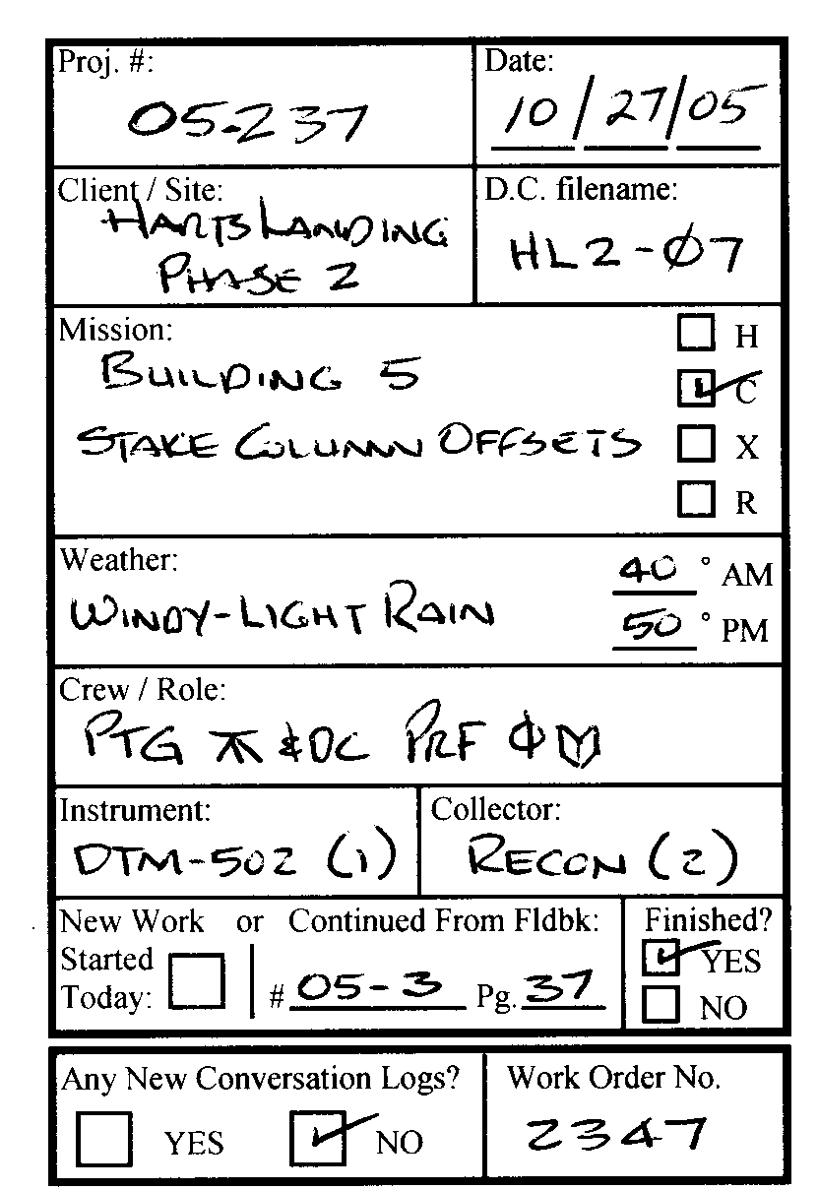
The field book, whether paper or electronic data collection file, must have the following records for each and every day. I require the following notes at a minimum, and have a large rubber stamp that is carefully applied to the field book each day before leaving the office for the site. This is helpful, because the information is placed consistently in the same location on the page of the paper fieldbook every single day, no matter which persons make up the crew that day.
This stamp fits a #1 (standard) stamp pad. Before a crew leaves in the morning, they stamp their beginning page in the fieldbook and fill in the blanks. This format not only encourages keeping a complete record, it also builds a consciousness into the party chief regarding whether the assignment is hourly work, contract work, extra work or restaking (the meaning of the H, C, X, and R boxes). The boxes at the bottom are the “end of day” reminders: The party chief states that the assignment was or was not completed, is reminded to fill out any Conversation Log(s) for conversations or instructions that took place that day, and the Work Order number is placed here, so the actual work can be easily linked to the Authorization.

Client / Site – Who are you working for – on what project, and what you are doing that day?
Every page (or pair of facing pages) MUST note this essential data. This data automatically gets noted on the start-page because of the rubber stamp, but the crew must be required to note it once at the head of every double page so copies don’t get shuffled with some other project. It is not sufficient to just place this on the first page used each day.
On successive pages for the same assignment and project, an abbreviated notation is acceptable like, “Baker Subdiv, Ph. II – Stk. Robbins Dr. for Clearing.” The person who is not the driver returning to the office can add this to each page at the end of the day.

Mission – What are you doing there?
How hard is it to place prominently in a note what the mission for the day is? “Stake water line for blasting” This facilitates office work so much, and it makes finding some particular matter so much faster. The larger the project, the more critical this becomes. Yet, I’ve seen page after page in a field book lacking this basic and essential information.

Crew – Who did the work?
Not only the WHO should be recorded, but the WHO-DID-WHAT must be logged. I want to know who made the notes or operated the data collector, who ran the instrument and who ran the rod or prism pole. When the roles change during the day, I want to know exactly where in the day’s work that change of roles took place.
Often the experienced crew will swap roles after lunch. This should be noted in the data collector and in the paper field book.
Is this necessary? Absolutely. Is this being a Big Brother Control Freak? No, and here’s why. I’ve seen crews who’ve been collecting automated line work in data collectors for years who don’t know how to code and shoot the curves correctly. When I speak to them and show them examples of what went wrong, it’s always the other guy who was running the prism pole for the shots – or – if it’s a problem in the notation in the data collector, it’s the other guy who was running the collector that day.
This doesn’t happen when the collector indicates a specific person was running it after lunch, and that’s when the mistake occurred.
Having this information is not for the purpose of condemning anyone; it’s for the efficiency of correcting bad data in a timely manner. It’s way down the road that any one person is chastised for the problem – only after repeated instruction goes unheeded. And, it seldom comes to that.

Date
EVERY pair of facing pages MUST be dated.

Weather
A simple note like “Intermittent Rain, 40 degrees & windy” may not seem very important, but two years later, that information may bring the particular day to remembrance. This note may be made at the end of the day when the weather for that day can be summarized. A note made at the start of the day can’t possibly summarize the day’s weather.

Equipment: Instrument and Data Collector
What instrument was used? If you own more than one instrument of the same model, enter the serial number or the firm’s instrument number. The filled-in sample of the rubber stamp above indicates the firm’s #1 DTM-502 was used with the #2 Recon data collector
Have more than one collector or instrument? Which was it? This can be critical information when you’re trying to figure out which instrument/collector combination is giving inconsistent performance, intermittently fails to function or gives occasional bad data. These things do happen, and it is a diagnostic nightmare to find out which instrument, collector or operator is at fault. Finding the pattern is so much easier with good records.
And what if you discover an instrument is adding some constant to its distance readings? It’s a simple matter to go back job-by-job with these records and quickly determine which ones may have been impacted and if so, which ones matter for the degree of error.

Collector’s filename
The paper fieldbook that most people keep to accompany electronic data collection, should note the data collector’s file name. No one in the office should ever have to turn page after page in the field book hunting for that information.

Field Notes – Essential Minimums
Some common sense and age-old, standard procedures must be applied if field notes are to be efficiently interpreted and contain adequate information.

Inst. Point, B.S., H.I. (even on resets after lunch)
Most firms, even when using data collectors, will note in paper field books the occupied point identification (point number and physical description of the point set), backsight point number, H.I. and rod heights (that is, the initial rod height and each change in prism height made before what point number). On large projects, the instrument will often be taken down for lunch and reset after lunch. Some crews fail to record the reoccupation and backsight and even exchange roles within the crew without noting that change. This should not be.
The little three-legged transit symbol should appear in the paper field book each and every time a new instrument setup is made. And, incidentally, a new backsight equals a new setup!
I’ve seen paper field books in which there’s an obscure notation about the horizontal angle being zero-set on a new backsight point without moving the instrument. The note was buried among other busy notes and easily overlooked. A critically important note that is graphically lost amidst general notes can bring much confusion.

The CLOUDS of Confusion
I always instruct my crews to draw clouds around notations in the paper fieldbook that indicate errors, deletions or changes that need to be made to the data collection files prior to processing. This causes essential notations jump off the page at the reader. They are hard to miss. Conversely, critical notes buried among other notations in the paper field book are easy to miss, and this can be very, very costly.

Last Shot a “ckbs” ALWAYS
How can you prove that the zero backsight setting was not lost during your layout or recorded observations, if you don’t record a final reading on the backsight before picking up the instrument? Answer: you can’t!
Imagine yourself in court answering the question, “How do you know the zero backsight angle was not lost?”
Can you point to the last line in the data collection file, or do you say, “Well, the guys always check.”
The simple truth is, if it isn’t recorded, it can’t be proven. When problems appear in the data, there is no way of knowing if the backsight was lost at some point during the shots taken at that setup.
In data collection, a unique description (feature code) can be used for this shot, something like “CKBS.” If you don’t like the shot plotting in your drawing for the backsight check, you can easily convert that line in the collector file to a note before processing. But it will always remain in the original downloaded file and can prove the integrity of the angles turned at that setup if the need should arise.

Pages numbered at BOTTOM of pages, at corners
If fieldbook pages are to be copied with facing pages on a single sheet of copy paper in landscape orientation (8 1/2” high and 11” wide) and bound at the top, place page numbers at the bottom of the pages paper field book pages, not at the top. This makes finding a particular page number easy, without having to lift entire sheet after sheet of copies to peek at a page number stuck up there under the binding edge. If loose-leaf fieldbook pages are used, use the same number for facing pages, so that the two facing pages have the same number, labeling each.
Pet peeve: Field book pages should be copied so that a blank area on the finished copy coincides with the binding edge on the copied pages. Believe it or not, some folks just don’t get this, and stuff you need to read gets stuck out of sight under the binder.

At End of Each and Every Assignment

“End of Day” note
At the end of the day, place a bold “END OF DAY” note at the end of that day’s work in the paper field book. Also, an “END OF DAY” note should be placed in the electronic data collector if the file is to be added to on another day, and the standard notations should be placed in the electronic file at the start of each new day. A sharp crew person will do this during the drive to the site, so time is not taken on the job site to log these entries.

Index in front pages of paper fieldbooks
Leave plenty of blank pages at the front of the paper field book and use them as index pages. Entries should be neatly and consistently entered in columns, appearing as they would in a spreadsheet. I know some crews who feel that during long drives to distant work sites, one person drives to the site while the other sleeps, and those roles reverse on the way home. Neither person thinks it necessary to take a couple of minutes to index the day’s work in the front of the fieldbook. Unbelievable!

CYA Memos
Much has been said in this course regarding your CYA function – an integral part of the construction layout business. In fact, if you analyze this course material, you’ll find this topic lurking beneath the surface just about everywhere. As said earlier, construction is a blame-game. Play to win.
Certain standard memos are sent to my clients as a matter or course.

Most Recent Plan Memo
As noted earlier, I periodically send memos with a catch phase in bold type saying,
“Remember – It doesn’t get built according to the most recent plan!
(It gets built according to Jonathan’s plan.)”
Then I briefly note that I am working from plans dated such-and-such and will continue to use these plans unless notified of revisions.
This sort of memo is always sent when I am awarded the contract, since time has passed between when I obtained or reviewed a bid set and the time a contract was awarded.
In many cases a new plan has evolved, and I don’t want to waste time computing from an old plan. This is one of the first orders of business upon being advised of the award. Obtain current plans.

Staking per Plans Dated
With each new feature to be staked (utilities, building, etc.) I consider whether or not to send another memo advising that I am staking based on plans dated _____. I don’t want to be a pest to my client, but some clients need to receive such a memo in order to protect both them and myself.

Follow-up to direction given in field
If given direction to stake contrary to plans, I will ALWAYS get signed authorization from the client on my Work Order to do this or anything contrary to plans. Sometimes, depending on the significance of the change from design, I will follow-up with a memo to my client’s project manager or the designer.
Do be careful not to offend the person who gave you this direction in the process or C’ing-Y-A. It may be a good idea to let that person know you will follow with a memo to their office and the designer just to CYA. The site people know this is a regular part of your self-preservation, and they’ll normally not take offense at your carefulness in this regard.

Any requests that might be confused at to whether they are inside or outside the scope of your contract services
Normally, on a typical site, the superintendent is both capable and empowered by his employer to authorize you to do work as an extra, that is, to perform work beyond the scope of set-fee services listed in your contract.
If you have any doubt about this or have gotten burned by this client, then a memo to your client’s project manager may be necessary.
My experience is that the superintendent will almost never take offense at my memo to his superiors if I advise the superintendent of my need to do so prior to sending the communication. I’ll say something like, “Well, you know, I’ll have to shoot off a CYA memo to your office, because this isn’t in my contract, and I don’t want them to argue about paying me later. I’m sure you understand.”
And they do.

Any site activities that might lead to confusion
Have you observed that activities of others on the site might compromise the integrity and usefulness of your stakes? Have vandals removed, or worse yet moved your stakes? Have you seen other subcontractors moving your stakes or robbing them for other purposes, especially before they’ve served their intended purpose?
You may wish to document such observations to your client in writing. It is possible that someone may use the relocated stake without knowing that it’s out of position. You need to be out of the firing line when this happens.

Equipment tracks along side of stakes
Have you observed equipment tracks along the side of your stakes set to mark some critical element of the construction, column offsets for example? Verbally notify the superintendent and the contractor who will use your stakes, if that contractor is available or easily reached by phone. Put this in writing and copy both your client’s field and office supervisors. Make a Conversation Log to document whom you’ve told about the condition and when.
Is this really your responsibility? Of course not – until something goes wrong because the stake was disturbed. If you know about it, let others know.

Grade Sheets (Cut Sheets)
The sample Grade Sheet on the following page illustrates essential information typically found on grade sheets. This Grade Sheet (sometimes called “Cut Sheet”) accompanies layout of a driveway and house on a single, upscale subdivision lot. Note this is Sheet 1 of 3. It’s advisable to always include sketches to make your Grade Sheet understandable. Don’t make the contractor walk the site, analyzing your stake placement and it's labeling just to try and form an understanding of your approach. Make clear sketches. Sheets 2 of 3 and 3 of 3 illustrate this and are shown and discussed in more detail on pages that follow.
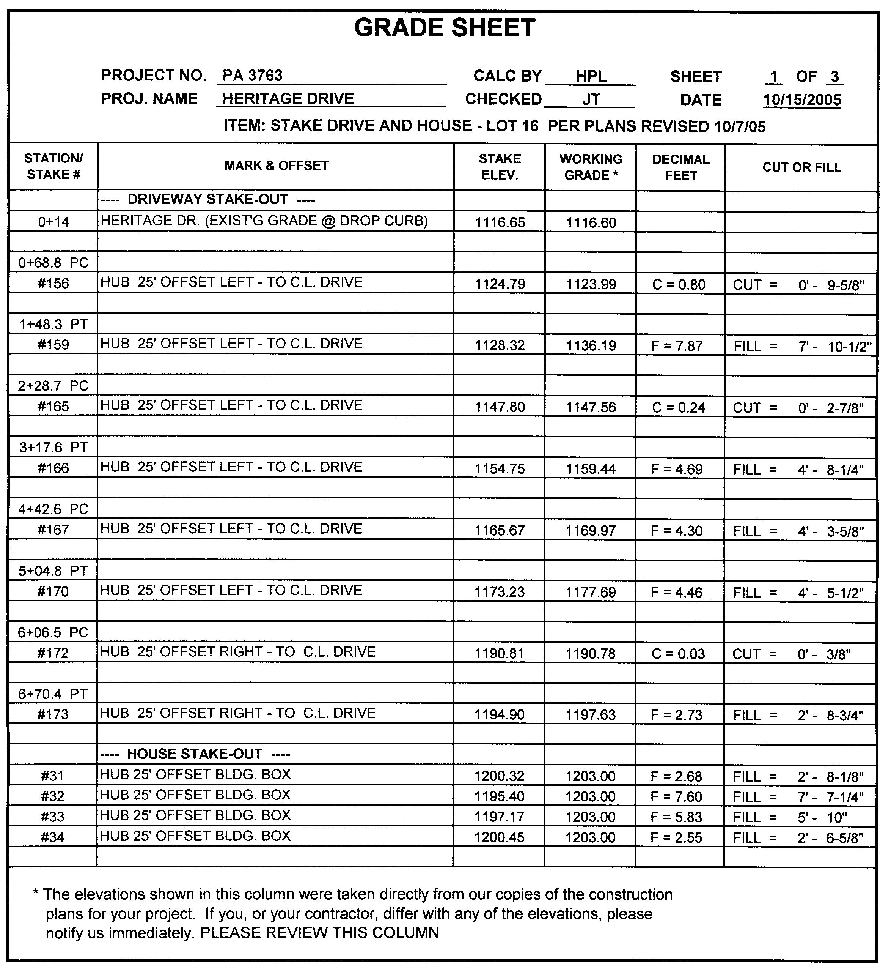
First, let’s look at the first sheet in the set. Grade Sheets are set up in various ways, but the essential information usually includes the following:
Heading Data:
- Project data.
- Date of preparation
- Other miscellaneous data you may wish to include (your firm’s logo, who prepared and checked the data, etc.)
- Under “Item:” (or similar heading) the grade sheet must always state what future construction was staked, in this case a driveway and control rectangle for a house. It’s important to note very specifically what was staked and where on the site it’s located. For example, on a commercial site, it might be “Storm Sewer, North and East of Building.” In the case of this Grade Sheet, the construction is taking place in a residential subdivision, and the location is clear from the project name and lot number.
- Also, prominently on your grade sheet, be certain to state the date of plans upon which you based your layout. This could help to save you the cost of demolition and reconstruction in the event you have not been provided with current plans. On this grade sheet format, that information is included with the description of the layout provided in the hopes of drawing the contractor’s eye to that information.
Cut and Fill Data:
- In this sample case, the subdivision’s roadway has already been constructed and paved. The contractor knows to match the driveway to the existing drop-curb (the driveway opening in the curb) at the edge of road. This is the first station given, 0+14.
- In the first column under Station/Stake #, the first driveway point actually staked in the field is at station 0+68.8 (68.8 feet from the centerline of the road). At this station a curve in the driveway begins (noted “PC” for point of curvature).
- Next under Mark & Offset, the grade sheet tells the contractor the control point is a hub placed at a 25’ offset left of the centerline of the proposed driveway, looking up-station. The contractor will find a guard stake placed next to a hub, and on the guard stake a point number (#156) is labeled.
- The top of hub stake elevation at this point is 1124.79.
- The working grade (the proposed grade at the centerline of the driveway is 1123.99.
- The grade at the final centerline of constructed driveway must be 0.80 lower than the top of hub elevation (thus, Cut = 0.80).
- An equivalent Cut is given in feet, inches and fractions of an inch, because this contractor works in feet and inches, not decimal feet.
It’s important to always state the physical type of reference mark you’ve placed in the field to guide future construction. In this case hubs were used. Hubs are tapered stakes normally about 6” to 12” in length, with a 1½” by 1½” to 2” by 2” square top. For precise layout a surveying tack or nail is set in the top of the hub to mark precisely the reference point on the stake. Because hubs are driven flush with the existing ground surface or close to it, guard stakes are normally placed along side the hub and serve both to “guard” the stake and to provide identification and other information about the hub.
Guard stakes, sometimes called witness stakes, vary in dimensions, as noted elsewhere. Whatever their size, they are normally flagged (hopefully using a color-coded flagging scheme), and each guard stake’s labeling tells the contractor information about the hub it guards. When you provide a grade sheet, all a guard stake’s labeling must accomplish is to distinguish it from any other stake on the site. A stake number is adequate, though you may often add the station plus the offset distance and direction (left or right) and the point referenced (in this case, the centerline of drive). In some cases, you will be asked to mark the cut or fill on the stake, which makes creation of a grade sheet redundant and generally unnecessary. But, there are added liability risks in not providing a grade sheet, as discussed elsewhere in this course.
In some geographical regions, contractors want cuts and fills expressed in feet, inches and fractions of inches. If you provide this, be most careful in making conversions and be sure to check them carefully. I use my spreadsheet’s LOOKUP function to make the conversions, but it’s dangerous to always trust the results of a spreadsheet’s formula or lookup table. Three sources of error are:
- Any fault in the formula or table,
- Any corruption a user may inadvertently cause, or
- An unknown occurrence of input data that causes your formula or table to return wrong answers. This is usually a rare circumstance unforeseen at the time you built the formulas and lookup tables in your spreadsheet. A typo in a lookup table could also return an occasional or rare error.
Any of these may cost you dearly. I always review the spreadsheet’s conversions to be sure they look right.
Finally, note any disclaimers or warnings you feel are prudent to include.

Notes
You may wish to include standard notes like the one at the bottom of the sample Grade Sheet. Additional notes, disclaimers or warnings that may be appropriate for some applications are given below:

Check two stakes
“Contractor is advised to check elevations of two stakes at critical points prior to construction to verify accuracy of data provided.”

Based on Plans Dated.
“Computations based on plans dated ________. Do not construct per this sheet if newer plans exist.” (In the sample, the plan date is included at the top of the sheet, but this caution’s importance is one that can’t be overstated.)
As noted elsewhere in this course, frequent problems exist because you, the surveyor, engineer or layout contractor, are generally out of sight and out of mind. When plan revisions are distributed, you’ll often be left out of the loop.
Always, always include the date of plans used for your computations somewhere in the material you deliver to guide construction. On the sample Grade Sheet this is noted in the heading of Sheet 1 of 1.

Abbreviations
You may want to create a standard table of abbreviations, such as L=left, R=right, C=cut, F=fill, O/S=offset, CL=centerline, EP=edge of pavement, BLD=building, FNDN=foundation, or any abbreviations you think require explanation.

Offsets to
Some grade sheet forms specify in their heading what the offsets are to. For example, a blank line at the top of the sheet labeled, OFFSETS TO: __________________. A Grade Sheet can be set up any way that works for you and your clients.

Sketch(s) Attached
The sample Grade Sheet does not specifically note that sketches are attached. The fact that it is sheet 1 of 3 implies that additional pages follow, but it would probably be better if a prominent note were included saying something like, “SEE 2 SKETCHES ATTACHED”.
For the above Grade Sheet, two sketches are provided (one for the driveway stakes and one for the house), and these are shown next:
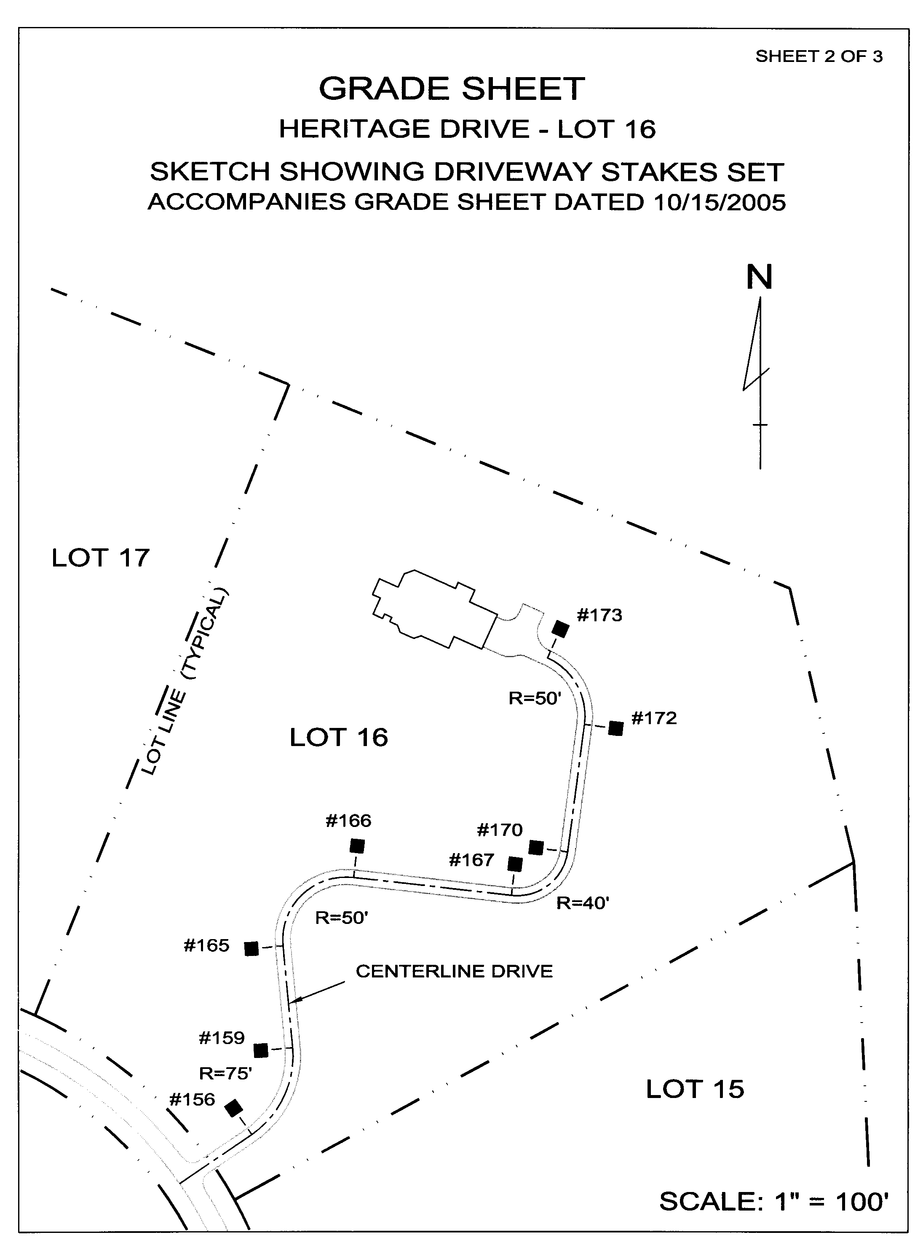

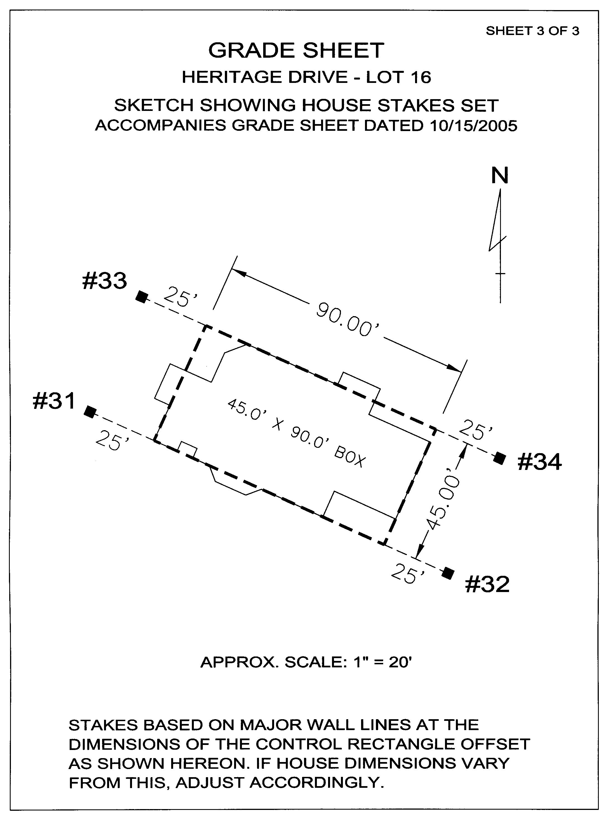
It’s best to indicate clearly when a sketch or multiple sketches are attached, since sketches may detach from the grade sheet and the contractor not realize they are needed to clarify notations on the Grade Sheet form.
Imagine trying to perform even the simplest construction from a Grade Sheet alone. Impossible? Of course not. But, the contractor must relate the grade sheet data to physical control (stakes) set in the field, and those stakes to the completed construction. Typically, the contractor walks around, finding the stakes and marking cuts and fills to guide equipment operators. His work is much less prone to errors caused by misinterpretation of your data when you create a picture in the contractor’s mind with sketches.
Remember, you are intimately acquainted with the plans and with your grade sheet data. The contractor has never seen your grade sheet before and is aided in grasping your intent when you provide a simplified sketch, even a hand-drawn, not to scale sketch, that illustrates the relationship between the grade sheet data and stakes set in the field.
For example, it’s likely you’ve created the stationing on the sample grade sheet above for the residential driveway solely for convenience in performing your computations. That data often appears nowhere on the design plans for residential driveways unless the reviewing authority requires a profile for the proposed driveway.
On the sample Grade Sheet above, the contractor will find #156 written on one of the guard stakes. But, the stations noted on the Grade Sheet are something you created for your convenience in computing the driveway centerline, and they will be meaningless (or nearly so) to many contractors or equipment operators who walk around the wooded site trying to find and make sense of your stakes – UNLESS you provide a sketch.
The simple sketch on Sheet 2 of 2 clarifies where the stakes lie in relationship to the driveway. If you notice the stationing in the sample grade sheet, you’ll see that there is considerable distance between stakes. This is because the lot is large, the proposed driveway is not close to any property line, and the contractor requested merely a rough guide to align and grade the driveway. The stationing reveals that the driveway is longer than two football fields, as it winds up a hill to the proposed house. Only eight stakes are provided on this wooded site. This is all the contractor wanted.
Can you imagine how helpful the driveway sketch is as the contractor hikes almost 100 feet in elevation through the woods to find your stakes and figure out what they mean? How difficult this would be without a sketch!
With an adequate sketch, misinterpretation and errors are minimized. Also, you’ll be appreciated for making your work product easily understood. This is good business promotion.

Sheet __ of __
Sheet numbers are important for the same reason as stated above. I always attach my sketches and label them “Page ___ of ___,” so that a person looking at the first sheet showing data in a spreadsheet format (rows and columns of numbers and letters) realizes additional sheets follow and are required to complete the “Grade Sheet” package. I label these sketches “GRADE SHEET,” so they are more evidently an integral part of the package comprising full data for layout control.

Not responsible for errors that are not reported prior to removal or destruction of evidence showing source of error.
The sample Grade Sheet a few pages back omits an important note:
We will not be responsible for suspected errors unless we are notified immediately upon their discovery and provided opportunity to verify and document the source of any actual error before stakes provided for the layout are disturbed or destroyed.
It’s imperative that you are called to the site the moment a suspected error in your work has been detected. Often, your work will not be the cause of the error or problem, and being called to the site while your stakes are still present and undisturbed allows you to discover the true source of the problem and show others why your staking is correct (hopefully it is!), before they go off and assume you’ve messed up. For some reason, contractors seem to think they can just bill you for costs to remedy whatever they believe to be your fault without any proof. Do your best to change that thinking.
This disclaimer has worked for me, and I strongly advise establishing the policy that you won’t be responsible for errors if you’re not advised in a timely fashion and given opportunity to confirm the source of any error to be your fault. If you’re called to a site because someone thinks you’ve made an error, respond immediately. It can save both your reputation and your money. And, of course, be responsible for what you really do mess up. Your client may well assume that you’ll deny you’re at fault no matter what. Once you’ve owned up quickly to a problem you’ve caused, your credibility when you deny your fault is increased.

Work Orders

You absolutely gotta have ‘em!
Work Orders are mentioned throughout this course, and I urge you not to underestimate how critical their use is to your success.
Remember, you’re not creating extra or unnecessary paperwork with Work Orders. They perform several functions vital to your success and prosperity, such as:
- They create documentation so that you will get paid for work performed outside the scope of your contract.
- They prove you’ve been instructed to do certain things, especially layout that differs from design plans, on the authority of one empowered to make such decisions (You are not!!!).
- They are little mini-contracts to document understandings between you and your client.
- They’re proof that you were on the site performing work on a given day. (This provides an instant, amicable solution to a billing dispute.)
- Work Orders document delays or down-time due to the site not being ready or other causes beyond your control.
- They foster good habits: Daily use of your Work Orders gets your client accustomed to the routine of signing authorizations for your work. It also makes you or your party chief used to approaching the client for a signature. This makes obtaining authorization for extra work or restaking part of a familiar exchange between you and your client. If you only pass a piece of paper to your client for a signature for extra money, the client may be wary. Instead, do it every day. You’ll find that you’re much more at ease “asking for money,” and any natural resistance your client has to signing your Work Orders has been vastly reduced.
- Work Orders eliminate most traumas between your client’s accounts payable staff and you. A Work Order signed by the superintendent provides necessary documentation to your client and authorizes you getting paid. If the accounts payable department has a beef, it’s with their own superintendent, not with you. Result: you get paid! There are some loops it’s better to be left out of.

Where to Obtain? What format?
I have not seen pre-printed or standard forms that I consider suitable for the construction layout function, although some standard “contractor” forms come close. Early in business, you might get by with an initial order of some standard forms, but I suggest you order pre-numbered, triplicate, carbonless Work Order forms, tailored to your specific needs.

Triplicate Forms should include spaces for:

Task
This is a short space for a general comment like, “Stake Water Line for Blasting.”

Description
In this space, you specify the extent of your work assignment, something like, “Station 10+00 to 23+50” or “In parking areas west and north of Building #3.”

Ordered by
Place the name of the person who ordered the work in this box.

Contract/Restake/Hourly/Extra
Have four check boxes with the above words next to them. It is critical that your field crews know how to distinguish the four billing categories of work, as discussed elsewhere in this course. (Again, your rubber stamp used in the field book pages at the start of each day provides training in this awareness.) Be sure you and your crews know what these four categories mean, what they apply to, and where one starts and another begins.
CONTRACT – Briefly, to summarize, you do not specifically need special authorization for set-fee, contract services; your contract has already authorized such services and determined how much compensation you will receive for these services. BUT, I always have the superintendent or contractor sign a work order anyway for two reasons. First, even though you contract authorized the work, it can be important to know when you were asked to do the actual work. If you stake something too early, before the site is prepared, it may need to be restaked, you’re your client may not want to pay for that restaking. If you can prove you were only following the client’s direction, then the fault for staking too soon is not yours. Second, it gets your client in the habit of signing without resistance. This makes getting a work order for extra work signed easier, since the superintendent of other client representative is accustomed to signing work orders each day without a fight.
HOURLY – Again discussed earlier, restaking is always performed on an hourly basis; it’s impossible to predict these fees ahead of the need, and fees for restaking vary widely from site to site, because considerably more destruction of your initial staking happens on one site than on another. Hourly work is authorized in your contract (if you’ve constructed your proposal carefully), yet may not be paid for if not performed under the signature (thus, authorization) of the client’s representative in the field.
Hourly work is essentially Contract work, the scope or intensity of which is impossible to predict ahead of time. It is thus distinguished from set-fee work often called, “Contract” work.
In your proposal, it is good to keep Hourly work to a minimum. If, for example, you’re staking a large corporate headquarters on a site with many acres of land used for paved walking paths, there is no way to tell if these will be located by the contractor or by you, or some joint effort of both. This item can be listed in your proposal as, Stake Walking Paths – Standard Hourly Fees if Requested. Or, as noted earlier, you may wish to just be silent on this item to avoid losing at the Apples and Oranges game.
RESTAKE – Your client may grumble about authorizing restaking, but smile and agree that it’s really too bad the stakes got knocked out. Remember, you never stake twice and get paid just once unless you’re correcting a mistake you made in the first layout. May this happen rarely.
EXTRA – Oh boy! Check this box only when you can’t find any other box that works. It is hard to get Extra Work authorized. Your client may have a hard time getting paid by the owner, and you may have a hard time getting it out of your client. It’s a bad word to the construction manager, so be prepared. Be absolutely certain you know it’s outside of your contract scope and that it’s neither restaking nor hourly. Then, and only then, check the EXTRA box on your work order and talk about the weather while its being signed.
But, sometimes, the construction manager’s own contract with their client causes some activity to be designated an “Extra.” This is a time when your client probably wants you to call your work an Extra, so they can collect your fees from their client.

Per Plans Dated___/___/___; Revised___/___/___
The time to make these entries on a Work Order prior to having it signed is time well spent. You must be certain that the copy you leave with the superintendent or contractor shows this data. THIS IS CRITICAL! By now, you know why I’m saying it yet another time. If you stake from outdated plans, let someone else be responsible!

This Work Order authorizes work differing from the plans.
Train your field staff to make this hand-written note whenever it applies. If they (or you) are directed to stake something different than the plans you’ve been officially given, be absolutely certain someone in authority authorizes that activity in writing – and that they have the authority to do so. Drill into your crews that they have no authority to stake anything contrary to plans, ever, without written authorization from somebody important. If such work is requested, be absolutely certain to note this on the Work Order before you getting it signed, so the copy you leave with the person requesting the deviation has their own instructions in writing and put their signature to it.

White – Always kept. PINK – first to go.
Assuming your first (top) copy is white, your second is yellow and your third is pink, KEEP YOUR WHITE COPY after it’s been signed, and give your 3rd (PINK?) copy to the client’s representative who authorized you to do the work by his or her signature.

Yellow – kept with billing copies
This second copy is presumably more legible than the third copy. Don’t let your field personnel get away with NOT pressing hard enough with a ball-point pen to make a legible third (PINK) copy! Anyway, I send the second (YELLOW?) copy with my monthly billing if the box checked is Restake, Hourly or Extra.
If the work assignment on a Work Order will be billed as a Contract item, I don’t usually send such Work Orders with my billing. The reason is, I want the person authorizing payment to know that the Work Orders I do send require their attention. Contract work is billed on percentage of completion, and whether or not it was authorized is almost never questioned. If it ever is questioned, I have a Work Order for it and will supply a copy to the accounts payable department.
I note on my billing statements Work Order numbers for each item or occurrence of non-contract items billed. I make a clear cross reference between my billing for all Hourly, Extra and Restake fees and my Work Orders’ authorizations for work performed. I want my billing and specific authorizations to arrive at accounts payable together, to avoid delays in me getting paid. When the accounts payable folks have to pass my billing to the project manager, who passes it to the superintendent for confirmation, who forgets to do it, I don’t get paid quickly. And, I spend time chasing payment for work already performed, when I could be generating more income from new instead.

Format of Work Orders
What format is best for your Work Orders? Design your own.
Begin your design based on a standard format similar to work order forms you find at major office supply stores or from an Internet supplier like NEBS. A basic, generic format may be viewed at: http://www.nebs.com/NASApp/nebsEcat/products/product_detail.jsp?pc=6558#
Study standard forms and begin to sketch one that works for you, remembering the points above. It really isn’t that difficult. Then get a local printer or an Internet provider to make them for you. It will be worth the cost.

Aluminum Thing
You just gotta have an aluminum thing. They’re often called portable desks, and one version may be seen on the right side of the web page using the above link. Some models hinge at the top and others on the side. Some are great to use on your lap, and others are not. Some provide better protection against the wind taking away your completed work orders that are stored in the device.
These provide a means to keep your blank and signed work orders together and safe from loss. The surface has a clip to hold the current work order or other paper and makes handing your work order to your client for signature convenient, even when standing out on a site.
The device is also handy for keeping a few blank Conversation Logs at the ready. Again train yourself and your crews to fill these out faithfully whenever direction or important information is transmitted verbally.
I recommend keeping a few sheets of graph paper (or sheets from a computation pad) in there, too, plus an extra stick pen and pencil.
Be sure to keep a copy of your contract in there for ready and easy reference. Contract questions often come up when you are trying to get a work order signed, and you want to have your contract at the ready. If you leave the superintendent’s trailer to go get a contract out of your survey vehicle, you can be sure that superintendent has occupied himself with another person or phone call, and you’ll have a wait on your hands.
File folders cut to make 8 ½ by 11 inch sheets make excellent separators between your Contract, Work Orders, Conversation Logs and graph paper.
Sound like this thing is stuffed to the full? A few blank Work Orders are enough to have in the aluminum portable desk, leaving plenty of room for a few conversation logs and sheets of graph paper. The device itself doubles as a clip board, so any letter size sheets can be clipped onto it. Stores of blank forms should be kept in each survey vehicle and refreshed at the beginning of each week. During the week the aluminum thing can be refilled as needed from this supply.
The aluminum device also comes in a smaller than letter-size, made specifically to hold Work Orders. Because of the multiple-use of the item, I recommend getting a letter size unit, even for use with smaller work order forms.
Finally, I recently saw a plastic version of the aluminum thing. Pick the size and the material it's made of, but do get one. You’ll love it!

The TEAM
Construction Layout is fun! It’s a dynamic, ever changing environment full of challenge and learning. The folks on the construction site are generally competent, hard working and practical. They don’t have time to ponder grand theories, although they are generally open to a better idea, one that makes their work go more easily and more efficiently. I find this refreshing and fun.
One thing that turns any enjoyable work into an unpleasant chore and increases liability exposure is a poor attitude in a member of the team. Construction layout requires sharp thinking and alertness. Everyone has to be thinking about the task at hand and yet maintaining a mental/emotional peacefulness that’s capable of discerning that little voice inside that warns, “Wait a minute here. I’m not sure this is correct.”
A lazy or contentious person is a drag to be around under any circumstance, but it’s particularly dangerous to share construction layout responsibilities with such a person. There can’t be too many eyes and ears on the construction layout crew. The nature of the work requires this, and lives can even depend on it. Things do go wrong on a construction site, and occasionally people do get killed. An alert yet peaceful person is valuable in preventing costly mistakes and may even prevent serious injury or death.
A person who is raging inside or who is hating their work makes a lot of internal noise. Such people are not sensitive to the changes around them; they are not attentive to what other people on the team are thinking and doing; they are making so much mental noise, and they’re so preoccupied with their own issues that they can miss critical signals and thwart the function of intuition.
The team is very, very important and should be chosen wisely. No winning team allows a member to goof off, be foolish or act inappropriately without accountability.
Construction layout is sometimes viewed by surveyors as “less professional” work than traditional land surveying. I’ve done both and can’t agree with that opinion. In fact, my experience says that it is easier to perform conventional land surveying than construction layout. The dynamics and demands of construction layout require a team specifically skilled in this work. Not every land surveying crew can perform construction layout safely, efficiently and profitably.

The Satisfaction of a Job Well Done
And, that’s what this course has been about:
- developing a broad overview of the dynamics and processes of construction layout,
- encouraging participation on the Team – a team is made up of skilled, talented and diverse people. Together, things get done, and that’s fun!
- generating even a little excitement over the opportunity to serve in the building of a nation – That’s what you’re doing, folks; may as well admit it.
- bringing together specialized skill, knowledge of the role it plays, managing the processes and records involved, dealing successfully with those who pay you to do what you do best,
- making sound judgments about what precision is needed and being free to let what is needed be good enough, and
- knowing when to split hairs and get every bit of precision possible, and having the talent and skills to do just that!
I love the construction layout business and activity, the ever changing environment, the down-to-earth people on the site, the opportunity to work in a team of experts in their field and to function as an expert in my own profession. I enjoy learning. When providing construction layout services, learning never ceases.
It’s been fun to record for your benefit some of the things I’ve learned over the past 4 decades. My sincere hope is that you’ve found this course enjoyable and beneficial. Any feedback on this course work will be gratefully received and thoughtfully considered for future refinement of this material.
Thank you for making the time to take this course.

--- END ---

