PDHonline Course P122 (3 PDH)

Professional Liability

Instructor: Samir G. Khoury, Ph.D., P.G.

2005

PDH Online | PDH Center

5272 Meadow Estates Drive
Fairfax, VA 22030-6658
Phone & Fax: 703-988-0088
www.PDHonline.org
www.PDHcenter.com

Professional Liability

Course Content

Introduction

Professional liability refers to the responsibility for alleged unfavorable outcomes arising or resulting from the implementation of work performed by a contractor for a client in accordance with the terms of a contract. The debilitating effects of professional liability claims can best be appreciated by those who have experienced them. The resulting drawn-out court litigation results in psychological trauma for all parties involved and represents an enormous waste of time, a scattering of energies, a drag on productivity, and a drain on profitability.

A business is successful when it generates a profit, which means that its income exceeds its expenses. Unfortunately, however, the simple act of working to realize a profit exposes you to possible charges of professional liability. In other words, profit and liability are regarded as the two sides of the same coin. This course reviews, from a contractor's perspective, promising strategies that will help you minimize your exposure to unwarranted professional claims and maximize your chances of retaining as much of your profit as possible. To accomplish this important goal you should pay special attention to the 4 Cs of business: contract, credibility, competence and communication.

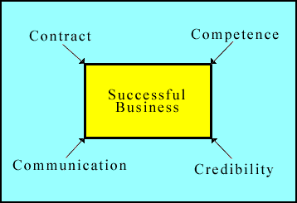
Figure 1: The 4 Cs of success in business

Professional liability claims are not filed at the time the technical scope of a proposal is accepted and incorporated into a contract. However, it is during this early stage that steps can be taken to minimize your exposure or prevent it altogether. It is often here that the seed of a claim is planted, since the scope of work is an integral part of the contract and promises made in it are legally binding.

Establishing and maintaining the confidence of a client should be the prime objective of a successful business. It is an ongoing process that cannot be allowed to lapse during the entire life of the contractual relationship. You should also be aware that your staff can assist you very effectively in establishing and maintaining credibility with your client.

It is the contractor's staff that has the responsibility to implement the scope of work in accordance with the terms of the contract and accepted professional standards. Therefore, the people you work with and the way your company is organized will make a great difference to the success of your business and to your exposure to professional liability claims.

Finally, clear and effective communication is essential to establishing positive agreements with the client, to directing and coordinating the work of the project staff, and to promoting the cooperation of subcontractors and other parties.

To address these issues, the following topics are examined:

- Elements of a contract
- Methods for establishing and maintaining credibility
- Staff competence and performance
- Communication skills

Elements of a Contract

A contract formalizes in writing the verbal agreements reached between the client and contractor, and it spells out the terms and conditions under which a specified scope of work is to be implemented. Therefore, it is particularly important to draw up a contract with great care, especially since the team that negotiates the contract and the staff that initiates the work may change over the lifetime of the project. You should keep in mind that a contract, once executed, is a legally binding document whether implemented by you or others on your behalf. Consequently, any departure from its terms and conditions exposes you and your firm to claims of alleged unfavorable outcomes. Ideally, a properly drawn contract needs to anticipate and prevent as many future misunderstandings as possible between the parties involved. Also, once a claim is filed, a contract provides the basis on which a court of law can rest its decisions and judgements.

The following discussion about the terms and conditions of a contract assumes that the scope of work has already been negotiated and that all parties are clear and in agreement as to its content and deliverables. If problems exist, they should be resolved before the contract is finalized because the scope of work is attached to the contract and becomes a part of its legal and binding sections. In other words, no contract changes or adjustments can overcome or compensate for serious problems with the scope of work. Unclear and/or unrealistic promises and unworkable deliverables should be reviewed, clarified and/or adjusted as needed before the contract is executed.

Following is a list of thirteen common standard terms and conditions that you are likely to encounter in a contract for professional engineering services. Each term is then discussed in more detail.

- Definitions
- Equipment and access to site
- Billing
- Responsibility for services
- Indemnification
- Insurance
- Special Liability
- Consequential damages
- Delays
- Third party interests
- Changes and termination
- Precedence and divisibility
- Concluding statement

Definitions

This is the introductory section of the contract. It defines who the client and contractor are, and it establishes the working relationship between them. It also defines what is meant by the scope of technical services and states that the scope of work is included as an attachment to the contract. Provisions are also made in this section for modifications and/or additions to the scope of work to be treated as an extension to this attachment, provided they are mutually accepted and ratified by the client and contractor.

The word "contract" is also defined in this section to include the terms and conditions contained in the remainder of the document. Usually a statement is inserted in this section to the effect that these terms and conditions supersede any other agreement reached between the parties.

In essence, however, there are two important aspects of this section relative to liability: 1) it incorporates the scope of work as an integral attachment to the contract, and 2) it invalidates and supersedes all other agreements between the parties. Make sure that 1) the scope of work is clear and attainable and 2) there is a statement covering the fact that the contract invalidates and supersedes other agreements.

Equipment and Access to Site

This section should state that the client will provide site access to the contractor so that the contractor can perform the scope of work efficiently. It may also include reference to supporting documentation that the client will provide the contractor to enable him to perform the services effectively. If the contractor intends to use specialized equipment that requires special handling before use, arrangement for appropriate site access and testing of the equipment can be included in this section. The illustration provided below is an example where special arrangements were made to bring in and set up specialized equipment on site.

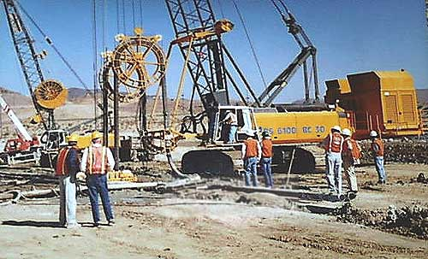
Figure 2: Example of the type of heavy track-mounted equipment that needs special handling to get on site and assemble for use. This equipment was operated to dig and install a cut-off wall in the foundation of a major dam.

Billing

This section spells out the elements of the financial agreement between the client and contractor. It defines whether the contract is to be implemented on a time and cost plus reimbursement of expenses basis or on a fixed cost basis. Payment frequency in relation to the scope of work and other charges for reimbursement are also specified here. In drafting this section, you should keep in mind that the relationship between your revenues and expenses may spell the difference between realizing a profit or incurring a loss.

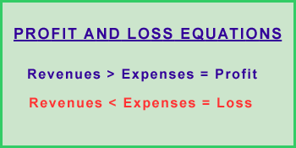
Figure 3: The difference between realizing a profit and incurring a loss depends to a great extent on the structuring of the billing clause.

It is obvious that the wording of this section should be reviewed quite carefully to ensure that you establish an equitable cash flow in return for your services. You should not wait till the end of the contract to get paid. Converting completed work to cash on a regular schedule is particularly important from a professional claims standpoint. It should be realized that on-time payment is closely linked to the financial status of the client.

In a tight cash situation, the client will tend to stretch its account payables by delaying payments to vendors and contractors. In such a case, the vendor or contractor becomes the financier of the client's business. A certain amount of delay may be inevitable and should be treated with tact. Pressing too hard for payment may lose the client. The contractor should be able to absorb a reasonable delay in payment from the client. In such a case, short-term judicial borrowing by the contractor can be used to alleviate the situation until it gets resolved. In other words, you can borrow from time to time to weather a tight cash situation, but you cannot do it forever and expect your business to survive. Also, accepting excessive delays in payment will eventually lead to the filing of claims by the contractor and counterclaims by the client, a situation that should be avoided at all cost. Paying attention to the details of the contract at this stage can help resolve this impasse. Therefore, it is recommended that you set a clear agreement in this clause that ties a regular cash flow to a demonstrable progress of your work.

Responsibility for services

This section establishes the fact that the services will be performed by the contractor and other qualified parties, such as consultants and subcontractors, on behalf of the client. Attention should be paid to include in this section a statement explaining that the services will be performed with the care and skill ordinarily exercised by the members of the engineering profession practicing under similar conditions. It is not recommended, or thought necessary, to offer guarantees or warranties for the services rendered. If such warranties are deemed necessary, they should always be accompanied by a statement specifying the extent and limit of any liability exposure.

The right of the contractor to rely on information provided by the client and the client's advisors and consultants should be addressed here as well. The contractor should be able to expect and accept such information at face value and without independent verification. If such information is not available, the contractor should be able to propose a modification to the scope, schedule and cost of services to check existing information or acquire new and necessary data.

It is prudent to include in this section a statement that limits the total liability of the contractor in performing the referenced services. For example, liability may be confined to the re-performance of any defective services plus limited compensation for time lost. The period of liability exposure should also be specified and kept as brief as reasonably possible

Indemnification

Clients usually request the contractor to indemnify and hold them harmless of claims and liabilities arising from negligence or intentional misconduct during the performance of work. This liability exposure affects not only the contractor, but also the contractor's agents, subcontractors and employees.

To offset this exposure, the contractor should request the inclusion of a similar clause that would indemnify and hold him harmless from the negligence and intentional misconduct of the client. For example, if the contractor relies on information provided by the client and that information turns out to be defective or erroneous, the contractor should be entitled to an equitable relief. More importantly, the inclusion of this mirror image term will tend to discourage the client from filing frivolous claims under this clause.

Damages that may result from preexisting conditions, despite the high standards of professional care and caution exercised by the contractor, should be mentioned specifically under this heading and excluded from consideration. This means that the client will not be entitled to indemnification if the alleged damages are caused from preexisting conditions that are beyond the control of the contractor.

Insurance

The contractor is usually required by the client to secure various types of insurance coverage before starting work on any of the contracted services. The following are examples of such coverage:

- Workers' compensation and employers liability
- Comprehensive general liability, including protective coverage for property damage
- Automobile, public liability and property damage, including rental car coverage

The contractor should keep in mind that providing such insurance coverage is a business cost that should be accounted for in the revenue versus expense equation. Consequently, as a contractor, you should work at minimizing these costs in a way that is consistent with a realistic assessment of your exposure and the size of the project. Under normal circumstances, adhering to the recommended statutory limits of coverage in each case is a safe approach to take.

On large engineering projects, however, you should think about two other issues: 1) securing sufficient insurance to cover your large and diverse work force and 2) implementing preventive measures to reduce your exposure to claims. Because insurance costs may be quite high in such cases, it is cost-effective to focus on prevention. Lower accident rates and lesser claims have the beneficiary effect of lowering the rates that are charged for the insurance coverage.

The following pictures illustrate the extent to which the general contractor of a large water supply and hydroelectric scheme went in educating his work force about the hazards of working on a major construction site.

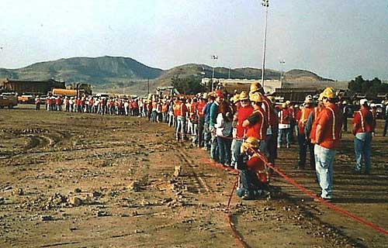
Figure 4: Towards the end of a working day, the contractor required all of his supervisory personnel and construction work force to attend a staged collision between a 60-ton construction loader and a pick-up truck.

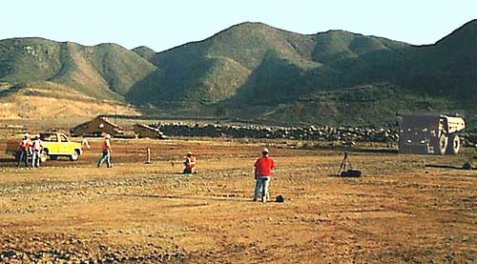
Figure 5: This photo shows the 60-ton construction loader (right) and the yellow pick-up truck (left) at their initial respective position. The message the contractor wanted to deliver was that the driver of the loader is seated so high above the ground that he will not see the pick-up truck. In addition, the loader is so massive and heavy when fully loaded that the driver would not even feel his collision with the pick-up truck.


Figure 6: This photo shows the 60-ton construction loader proceeding on its course without deflection after flattening the pick-up truck (yellow heap, left of center). The contractor wanted to impress his staff and convince them to stay away from the construction loaders in order to avoid the possibility of an accidental encounter. It is evident in this case that the contractor did not spare any expense in delivering his message. His derived benefit came from a sensitized work force to this particular hazard on the work site.

Special Liability

In this section, the contractor may want to shield himself, his agents and representatives from unanticipated types of liability exposure. For example, the contractor may want to specifically mention that the client shall be responsible to defend any claim, action or proceeding that may be brought against the contractor or his agents as a result of alleged improper disposal of hazardous substances on or within the site. The contractor may also want to exempt himself from responsibility arising from the improper characterization of engineering conditions at the site prior to his arrival. In such cases, reimbursement of expenses related to schedule delays and/or court litigation costs plus expenses of attorneys should be considered. Also, if during the performance of his work the contractor is, for any reason, summoned by a court of law to disclose information prepared under the contract, the client should be notified as soon as possible and expected to lead and cover the costs of the ensuing legal proceedings.

Consequential damages

In this section, the contractor may want to specifically exclude from consideration indirect and consequential damages that may be brought against him. Examples of such damages include: loss of profits or revenue, loss of full or partial use of any equipment or facility, cost of capital, loss of goodwill, and claims brought by the client's customers and/or other third parties. This practice will discourage the filing of frivolous claims that are not directly related to the performance of technical services..

Delays

This clause specifies that neither party shall be considered in default of performing its obligations to the extent that the performance of such obligations is prevented or delayed by any cause beyond the reasonable control of the affected party. In such a case, the time of performance for either party shall be extended by a period equal to the time lost. Compensation shall also be equitably adjusted to account for the effects of such delay. For example, the occurrence of a natural disaster in which neither the client nor contractor had a role in would trigger the provision of this clause.

Third party interests

This clause states specifically that the contract is not intended for the benefit or construed as creating rights in favor of any third party. It essentially ensures that the contract is entered into by the client and contractor without the involvement, intervention or participation of a third party that may claim later on to have some interest in any aspect of the agreement.

Changes and termination

This section establishes the right of the client to make changes and/or additions to the contractor's scope of work. Usually, these changes become effective upon execution of a mutually accepted change order to the contract. Any change order agreed upon by the two parties becomes an extension to the original scope of work and is legally binding. Before agreeing, however, the contractor is advised to analyze the ripple effect that such changes have on the total existing contract. If the proposed changes affect the ability of the contractor to deliver on any aspect of the original agreement, some schedule accommodation and compensation adjustment should be negotiated to the satisfaction of both parties.

The second aspect of this clause reserves the right of the client to terminate the contract at any time, including the ability to do so prior to the completion of the contracted services. In such a case, the contractor should reserve his right to receive reasonable notice in writing of the client's intent. The contractor should also specify that he is entitled to be paid for work completed at the time he receives such notice plus reimbursement for reasonable costs incurred in terminating the remainder of the services described in the contract.

Precedence and divisibility

This clause is included to clarify that the provisions of the contract shall fully govern any and all services furnished by the contractor and shall prevail over and render void any inconsistent or conflicting provision of the client's initial order and the contractor's proposal. Also, if any term, condition or provision of the contract is declared by a court of law to be void or unenforceable or limited in its application or effect, such event shall not affect or invalidate any other provision of the contract. You should understand that all other provisions will remain fully enforceable and the parties can negotiate an equitable adjustment in the affected provisions with the purpose of implementing the intent of the contract.

Concluding Statement

This clause contains a final statement that reiterates that the contract in question contains the entire agreement between the parties as to the services to be rendered. All previous or contemporaneous agreements, representations, warranties, promises, and relating conditions are expressly superseded by this contract.

Summary

A contract formalizes in writing the verbal agreements reached between the client and contractor and spells out the terms and conditions under which a specified scope of work is to be implemented. This is a very important step that needs to be accomplished with great care, especially since the team that initiates the work may differ from the team that brings the project to its successful completion. A properly drawn contract also attempts to anticipate and prevent misunderstandings between the parties and, if all else fails, provides a basis on which a court of law can base its decisions and judgements.

You should keep in mind that a contract, once executed, is a legally binding document whether implemented by you or others on your behalf. Consequently, any departure from its terms and conditions exposes you and your firm to claims of alleged unfavorable outcomes. With respect to professional liability, the following nine clauses require special attention:

- Definitions
- Billing
- Responsibility for services
- Indemnification
- Insurance
- Special Liability
- Consequential damages
- Delays
- Changes and termination

Establishing and Maintaining Credibility

The time spent negotiating a contract with the client is precious. This is the point at which the contractor creates a first impression on the client. Therefore, remember that in searching for ways to reach mutually acceptable compromises the contractor should not be tempted to offer products or services that cannot be realistically delivered within the constraints of the agreement being negotiated. Setting realistic expectations at this stage will most certainly pay handsome dividends in the long run. In other words, the contractor should be particularly vigilant not to overextend himself and promise products or services that cannot be realistically delivered. If pressed by the client, however, it is important to clearly differentiate between what is promised and what will be attempted without assurance of success. The mantra of the contractor at this stage should be to "under-promise" and, to the extent possible, "over-deliver" while performing the work. This approach to the delivery of products and/or services will help build and sustain the client's confidence in the contractor's capabilities.

It is important to start a contract on a good footing. To that effect, the implementation of the initial tasks is of particular consequence. This early work should be performed by experienced staff that will pay particular care and attention to detail. Good execution at this stage will communicate a feeling of technical competence to the client. Also, once confidence is established, it will be easier to maintain as work progresses.

Maintaining the confidence of the client is an ongoing process that should not be allowed to lapse during the entire life of the contractual relationship. To that end, you should enlist the assistance of your staff and rely on their collective input to sustain your credibility with the client. You can do so by encouraging the active participation of your staff in developing efficient strategies to address and fulfill the contractual commitments which were made.

The following sections that deal with staff performance and communications skills address the issues that will positively influence the effectiveness and credibility of your company. The payback comes from being able to establish good communication with the client which, in turn, will help you negotiate and reach mutually acceptable agreements on future modifications and/or expansions to the scope of work. Extensions and expansions to the scope of work translate into additional profits for your company and contribute to the success of your business. You should remember that satisfied clients are the best source of future work. They not only spread the word about your capabilities, but they also reuse your services themselves. Finally, a satisfied client is also less likely to hold you liable for minor contractual transgressions that can be simply remedied and resolved informally.

Summary

Establishing and maintaining the confidence of the client is initiated during the early stages of contract negotiation. The mantra of the contractor during this stage should be to "under-promise" and, to the extent possible, "over-deliver" while performing the work. This approach to the delivery of products and services will help build and sustain the client's confidence in the contractor's capabilities.

The good execution of work during the early stages of a contract will communicate a feeling of technical competence to the client. Also, once confidence is established, it will be easier to maintain as work progresses. Maintaining the confidence of the client is an ongoing process that should not be allowed to lapse during the entire life of the contractual relationship. You should remember that satisfied clients are the best source of future work.

Staff Competence and Performance

The way your company is organized and the employees who execute the work will make a great difference to the success of your business. You should keep in mind that your staff represents the company and as such it can either detract or enhance your ability to establish and maintain credibility with your client. The key factors that will positively influence the effectiveness of your staff's performance include: updating their technical competence, adopting new technology selectively and in a timely fashion, implementing progressive techniques of human resources management, and planning and reviewing the work to be performed ahead of its execution.

Technical Competence

Much of what an engineer learns in school is out of date within a few years of his/her graduation. Therefore, if the knowledge of your staff is not continuously updated, these individuals could expose your firm to the most harmful of all professional liability losses, those stemming from incompetence. This is the reason why many firms and professional organizations require their staff and members to acquire credits from qualified continuing education providers in order to maintain their proficiency and/or professional registration. Companies can also profit by holding regular meetings on topical subjects for employees and by making available to them the latest informative books and journals on subjects of immediate interest. Also, setting-up a good and accessible technical library for your staff is a relatively inexpensive investment that can pay significant dividends over the long run. Some studies have reported that engineers spend, on average, twenty percent of their time maintaining their level of competence, ten percent acquiring new knowledge, and ten percent regaining unused or lost knowledge.

Although you may have the best on-the-job training for updating technical knowledge, not all employees will benefit equally from it. Technical competence cannot be improved if an individual does not come to training with a basic level of intelligence, skill and motivation. Therefore, it is important to recruit the right people. Careful recruiting helps assure you of the capability and technical competence of your staff in the first place. Unfortunately, college grades are not always good indicators of who will succeed in the business world. Extensive interviews and reference checks help but are not fool proof ways to select individuals who will prove themselves in the actual work environment.

With these limitations in mind, one way of successful recruitment is to seek references from your best and most productive employees. The end goal is to employ a motivated, capable staff who will lower your exposure to liability claims by performing well for you and the client.

Adopting New Technology

During negotiations, contractors are frequently pressured to incorporate the latest technology in their scope of work. You should recognize, however, that not all new technologies are worth adopting especially in their early stages of development. Before committing to new technology in a contract, have one of your technical professionals evaluate the benefits and costs, as well as the risks, associated with its adoption. This information can help you determine whether this technology will facilitate or burden your work, thus spelling the difference between a profit and a loss. In addition, working with unproven technology may cause you to generate mediocre products that may result in claims and charges of ineptitude.

On the other hand, companies can fail to keep up with the rapid pace of important technical developments. Think about and plan for these changes by continuously reviewing and evaluating new technologies. Talk with experts about the costs, ease of use, problems, and advantages. When you determine that the time is appropriate, plan to introduce the technology to your staff giving them ample opportunity to learn about it and plan for its use. A timely and judicious use of new technology will positively affect your bottom line and make you less vulnerable to charges of technical incompetence, thus shielding you from liability exposure. The basic message is: don't rush and not all technologies are worth adopting - until they are proven to be valuable and cost effective.

Human Resources Management

Fair compensation allows employers to remain competitive in the open market and retain capable employees. How does one determines what constitutes "fair compensation?" Even though it is difficult to compare salary levels between companies because of variations in the fringe benefits, market surveys are a good starting point.

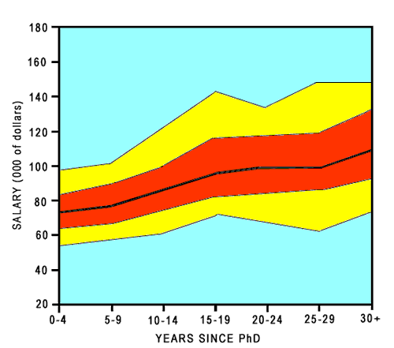
Figure 7: This graph is an example of a market salary survey, in this case a survey of industrial salaries for Physics graduates in 2000, by years since Ph.D. The black center line is the median. The 25th to 75th percentiles are in red. The 10th to 90th percentiles are in yellow.

Be aware that salary comparisons made among employees within a company remain a prime source of dissention and dissatisfaction. Although the organization's level of compensation may be adequate, an employee may become dissatisfied if someone else that he/she considers his/her equal is earning more. The performance of such resentful employees could decline and their behavior might be interpreted by clients, other contractors and members of the public in the most unfavorable light. Therefore, to avoid a climate that invites poor performance and exposure to claims, the records of salaries should be openly discussed by supervisors within a firm to avoid hidden feelings of dissatisfaction.

While salary is key, it is no longer considered by employers as the only motivator. Industry surveys indicate that acceptance by peers, self fulfillment and feelings of accomplishment are viewed as important contributors to employee satisfaction. Frequent recognition and acknowledgement of good performance, matching interests to responsibilities to the extent possible, and creating and developing well-functioning teams will help satisfy this aspect of your staff's needs.

In addition, it is interesting to note that well-motivated workers perform surprisingly well even under the most adverse conditions. Factors that affect performance are usually related to the feeling of esteem and a sense of belonging by the workers, in addition to the basic motivations of survival, security and self-fulfillment. The management structure that tends to foster this type of efficient behavior is one that places emphasis on group, in addition to individual, performance. The ultimate reward should be group, rather than individual, recognition. Thus, the energy expended by each individual to reach his/her self-defined goal is sublimated by the desire to help all of the group achieve its goals and promote the success of each member. In this respect, it is interesting to note one of the important ideas set forth by the "Game Theory" advocates. This idea states that when players are presented with a complex problem, the preferred solution emerges from designing what is best for both the individual player and the group as a whole.

Also, the sense of staff cohesion, particularly in a threatening environment, is an important asset in facing professional claims situations. One way to foster group cohesion relative to a particular project and contract is to engage the staff in reviewing the entire scope of work and discussing the most efficient ways to implement the contracted work. Also, encourage the staff to anticipate problems before they flame into major confrontations and then brainstorm with them on solutions and alternatives. More often than not, compromises which can benefit both the client and contractor will usually be identified during these exchanges.

Planning and Reviewing

Planning how to conduct a project is as important as doing the work itself. Not only productivity and profitability but also the client's satisfaction will depend on proper planning. You should realize that in many cases the client's costs may be many times those of the contractor as a result of delays in the delivery of services. Lack of proper planning that hinders the flow of work could result in claims alleging failure to deliver on time. Project schedules showing the sequence and interrelation between tasks should be prepared with great care and early within the life of a project. In addition, provision should be made to keep such schedules updated as work progresses. This is desirable in order to be able to spot problematic situations in time to either augment the resources needed to implement the work or advise the client of impending delays.

It is also important when setting up an initial project schedule to build in reasonable contingency to accommodate unanticipated conditions. Again, the team entrusted to implement the work should be consulted in identifying potential problem areas and asked to devise ways to overcome problems that are encountered in order to prevent delays. Impending schedule slips should be presented to the client with great care and should be accompanied by a plan to recover lost time. It is also advisable to set up a schedule with multiple review points and deliveries. The purpose of this strategy is to obtain the concurrence and approval of the client and other interested parties, such as regulators, at regular intervals and to keep you in front instead of behind the delivery dates. Another advantage to you, as the contractor, is that once a milestone is reached you do not have to revisit it any longer.

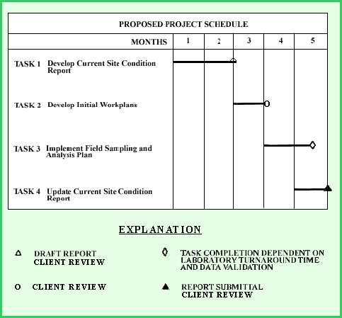
Figure 8: Example of a schedule with multiple interim deliveries and review points. This schedule was approved by the client and used to guide the implementation of the initial phase of project work.

As work progresses, the client may request amendments to the schedule. Any requests for changes must be scrutinized with great care because any shift in schedule may jeopardize other work that has already been scheduled. Any change may also impose on the contractor a requirement to expedite performance, and work done hastily and under pressure can result in costly errors.

Summary

Maintaining technical competence is the best defense against charges of professional ineptitude. Continuing education, effective recruiting, staying abreast of new technology, fair compensation and motivating staff are all steps that can reduce exposure to frivolous claims.

Early planning and careful scheduling coupled with follow-up checks to compare actual performance to plans will help eliminate claim-provoking situations. In addition, clients are generally satisfied with work implemented in accordance with well-defined plans and schedules. Furthermore, satisfied clients spread the word to others about your capabilities, which lead to additional work from new clients or repeat business from existing clients.

Communication Skills

An interesting aspect of most professional liability claims is that they do not generally result from technical incompetence but rather arise from different understandings, or misunderstandings, of contractual clauses by the client and/or contractor. In other words, the claims are the result of a breakdown in human communication. Consequently, a large number of these cases can be prevented if the parties involved take simple measures to avoid common pitfalls. Clear communication between the parties during all stages of their interaction, including clarity in the contractual documents, can prevent a significant number of claims from being filed in the first place. Effective communication is also essential to directing and coordinating the work of the project staff and to promoting the cooperation of subcontractors and other parties.

The most fundamental communication problem arises from not framing what we know clearly in our own mind. The message is then attenuated when it is sent and further modified and changed by the listener when it is received and interpreted by others. Given these limitations, it is surprising that in many cases communication is as good as it appears to be.

Communication begins by formulating thoughts, hopefully as clearly as possible. You may then need to commit your thoughts to a formal or informal written format so that you can transmit the concepts to a recipient or an audience either orally or in a report, memo or email.

Formulating Thoughts

Choosing the ideas that one wishes to convey to others is an important first step even if the exchange is as simple as engaging in casual conversation. Outlining what one wants to say ahead of time is useful, and for simple interchanges it may be sufficient to carry and organize thoughts in your mind. During an oral transfer of information you should also try to see if the other person understood what was said. One way to do this is to question the person or ask him/her to repeat or paraphrase the message. The response will help you determine how well your ideas were communicated.

Use your co-workers, friends and acquaintances as sounding boards to help you elucidate your ideas. This practice will help clarify your thoughts and help you formulate strategies to communicate your message effectively, and it is particularly important if you are dealing with complex and/or controversial issues. In such cases, consider rehearsing your delivery in front of an in-house critical audience before delivering your message publicly. The in-house audience can be asked to challenge your ideas and identify shortcomings allowing you to address problems before facing your client.

Oral Communication

People engage in oral communication in order to exchange ideas. The real power of oral communication lies in the array of contributing factors such as voice inflection, volume, pauses, eye contact and body language that enhance the effectiveness of the exchange. Keep in mind that the effectiveness of the message may be attenuated by external factors such as inattention, lack of interest and external noises that can distract the listener. In order to compensate for possible distractions, the communicator should repeat or paraphrase the content of his message. Also, by rehearsing the delivery, the speaker can learn to recognize and feel comfortable with the various aspects of his message.

Grammatical slips and poorly structured sentences, even when uttered in casual conversations, will affect the polished professional image that you probably want to project at all times. Fortunately, these types of shortcomings can be easily prevented by taking and having your staff receive continuing education courses in technical writing, English composition, grammar and public speaking.

Remember also that careless, off-hand comments by your staff can generate unfavorable impressions from clients, other contractors, members of the public, and may expose you to unwanted professional liability suits. Most importantly, you do not want your client to hear of impending problems or difficulties second hand or from your staff. You should act proactively by engaging your client in informal communication and offering constructive and realistic solutions at the earliest possible opportunity. You may find, as well, that engaging your client in helping you find an optimal solution to a developing problem may end-up benefiting both parties in the long run.

Written Communication

When you put your thoughts down in writing, you want to be sure that they are organized in a logical and clear manner. One way to accomplish this is to use the technique you learned in school which consists of constructing a written outline subdivided by topics. The outline can later be expanded by the use of sections broken down into paragraphs and sentences. Mind-mapping is another alternate organizational technique that is effective because it parallels the way individuals think.

When developing a written document for the client, strive to create a document that is clear and concise. A sentence is the basic unit for expressing thoughts, and a paragraph is composed of a series of sentences that amplify and expand on one logical set of ideas. The arrangement of sentences in a paragraph should provide a cumulative effect that lead to the delivery of the message.

Keep in mind that each section heading should provide a clue about its content. Many readers may only be interested in certain aspects of a document and not its entire content. In other words, a reader should be able to grasp the important ideas from the table of contents and section headings.

If the objective of your written documents is to reach and seal a binding agreement, then be particularly careful about how your sentences are constructed and the words you use. From a professional perspective, select words carefully in order to avoid exposure to frivolous liability suits. For example, avoid using words that imply the granting of comprehensive warranties in contractual documents. It is difficult, and sometimes even impossible, to live up to the abstract level of perfection implied by warranties. Note that professionals are not required to promise more than conformance with generally accepted engineering practice prevailing at the time services are provided. To do more equates to inviting claims. Generally, the use of words that imply absolutes, such as "all, comprehensive, always, never, etc." should be avoided in contracts.

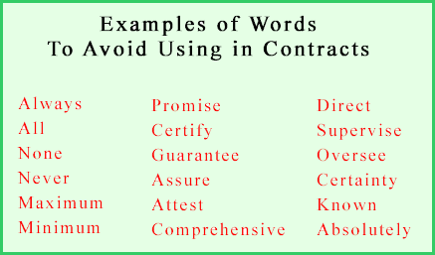
Figure 9: Example of words to avoid using in contractual documents. The words "supervise" and "oversee" may seem odd in this list. They refer to situations in which you take on responsibility for staff other than your own. This will expose you to liability if the work is done poorly or the individuals are harmed.

The use of precise words is important to convey the meaning of a message. When a technical term is the most exact word, use it. However, if most of the audience is not familiar with the term, inserting a brief explanation is in order. If the message contains too many technical terms, consider adding a glossary.

Proposals to perform work are particularly important documents and deserve special attention during preparation. Good proposals generate business and are relied upon by successful firms to grow and expand. Basically a proposal is a sales document that provides a project outline and plan for execution. Keep in mind also that the technical portion of the proposal is often used directly as an attachment to the legally binding contract between a client and contractor. If a proposal, as a sales document and project outline, is poorly written it will result in the loss of a potential client. On the other hand, as a contractual document, a poorly written proposal may promise more than can be delivered, and people may develop different expectations if its central message is poorly framed and imprecise. Such conditions may lead to unnecessary exposure to claims and/or the loss of a client.

Books on Communication Skills

There are a number of books that you can read to improve your art of public speaking, listening, body language, assertion, negotiation skills, conversation and writing. You can find copies of these books at your public library, purchase them from your favorite bookstore or order them on-line. Following are three recommended titles that you may want to review:

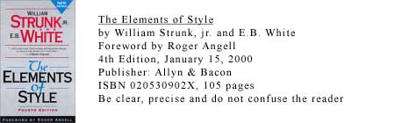

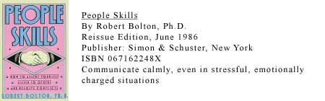

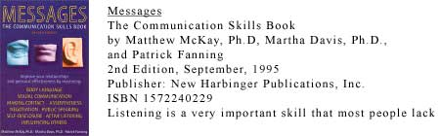

Summary

Success in business is dependent on good communication which is essential for the clear understanding of working agreements between client and contractor. Conveying a clear message depends on:

- Developing well formulated thoughts before attempting to convey a message
- Selecting an appropriate transmittal method, i.e., either written or oral
- Constructing the message with care
- Testing whether the message was heard and understood

As with everything else, an ounce of prevention is worth a pound of cure. Use preventive techniques to defuse potentially difficult situations. Fostering and promoting effective communication will help minimize your exposure to professional liability claims.

Conclusions

Professional liability refers to the responsibility for alleged unfavorable outcomes arising or resulting from the implementation of work performed by a contractor for a client in accordance with the terms of a contract. The simple act of working to realize a profit exposes you to possible charges of professional liability.

Professional liability claims are not filed at the time the technical scope of a proposal is accepted and incorporated into a contract. However, it is during this early stage that steps can be taken to minimize your exposure or prevent it altogether.

Establishing and maintaining the confidence of the client is an ongoing process that should not be allowed to lapse during the entire life of the contractual relationship. To that end, you should enlist the assistance of your staff and rely on their collective input to sustain your credibility with the client.

The contractor's staff has the responsibility to implement the scope of work in accordance with the terms of the contract and accepted professional standards. Therefore, the people you work with and the way your company is organized will make a great difference to the success of your business and to your exposure to professional claims.

Most professional liability claims do not generally result from technical incompetence but rather from different understandings, or misunderstandings, of contractual clauses by the client and/or contractor. In other words, the claims are the result of a breakdown in human communication. Consequently, a large number of these cases can be prevented if the parties involved take simple measures to improve their communication skills and avoid the common pitfalls that lead to the filing of claims.

Although complete eradication of professional liability claims may be a distant goal, the number and sizes of claims can be drastically reduced by:

- Negotiating the terms and conditions of a contract with care
- Establishing and maintaining the client's confidence
- Paying attention to the factors that affect staff performance
- Improving communication skills
- Adhering to accepted standards of professionalism
- Advising clients of professional limitations
- Avoiding expressing warranties in contracts and work products
- Clarifying the extent of responsibility in contracts
- Reaching equitable agreements on limitation of liability
- Following clearly defined guidelines in reporting to clients
- Selecting clients with care and based on previous experience

Most importantly, negotiating and reviewing the terms and conditions of a contract with care is well worth the time and effort involved. The payback is a well developed and balanced document that protects the contractor and client from the damaging effects of lawsuits and litigation.

Finally, success in business depends to a great extent on the quality of your contract, the credibility and confidence you can instill in your client, the competence of your staff and the clarity of your communication.

