Analyzing Employee Performance Problems
PDH Course P129



Table of Contents
Course Overview 3
Management’s Role in Employee Performance 4
What does Management control? 6
Theory X and Theory Y in practice 7
The Performance Problem Flowchart 8
About Outsource Training.biz LLC 13

Course Overview

After this course, you will:

- Know a little about some of the founders of Management Theory
- Understand what management traditionally controls
- Understand the difference between McGregor’s Theory X and Theory Y management styles
- Understand how to determine whether or not employee performance is a problem or just an irritation
- Understand how there is a 90% probability that an employee’s lack of satisfactory performance has its roots in something controlled by management
- Be able to take an objective and systematic approach to analyzing employee work performance problems
- Know how to ask specific questions to determine root causes of performance problems
- Make recommendations for change that create long-lasting solutions for recurring performance problems

Management’s Role in Employee Performance
“What do you think is management’s role in relation to employee performance?”

Your answer to this depends on your academic background, experience as an employee, the kinds of leaders, bosses, or tyrants under which you have worked, and your personal thoughts about any activity called “work.”

The view that the activity called “management” may have some well-defined behaviors associated with it just like engineering, surveying, or architecture does, was revolutionary after the turn of the twentieth century. Soon, however, it became evident that we could not look at management practices in a vacuum because management occurs within an organization.

Whether the “organization” is a work team of one boss and one worker or thousands of each, the study of any management practice must be done within the context of the organization.

A well-known organizational theory thinker, Douglas McGregor, offered the Theory X – Theory Y concept of management. A “Theory X” manager has a negative view of employees assuming they are lazy, untrustworthy, and incapable of assuming any responsibility.

The counterpart, a “Theory Y” manager, looks at employees differently as being trustworthy, responsible for accomplishing their own work objectives, and capable of assuming high levels of motivation.

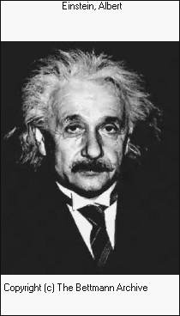
Another belief that a Theory Y manager would have comes from one of the world’s most famous scientists and thinkers, Albert Einstein, who told us, “You cannot do things the way you always have and expect different results.

Can you recall trying to do something the same way over and over and expecting different results?

How does this situation apply to your workplace or your personal life?

“So,” you ask, “what does all of that have to do with analyzing employee performance problems.”

The reason we mention that is we are about to show you why there is a 90% chance that an employee performance problem may have its roots in something controlled by management! Theory X managers would never consider such a possibility.

“Failure to perform to expectations is only because the employee is too lazy or just doesn’t want to”, they would confidently affirm while never considering any other possibility.

If you are a Theory X type of manager, this will be a difficult course for you because it will severely challenge your perceptions of the workplace. However, if you are willing to consider other possibilities, then you will enjoy this (and start enjoying leading your employees, too.)

What does Management control?
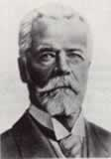
Another famous thinker in the world of Management and Organizational Theory was a French Industrialist, Henri Fayol. He defined the activities controlled by management as PODSCORB (planning, organizing, developing, staffing, coordinating, and budgeting).

We can expand those duties a little farther, from a practical standpoint, and say it includes:
- Training employees (making sure they receive training to do their jobs or stay current with improvements in the equipment)
- Providing resources such as equipment, information, guidance, and direction
- Setting performance standards (and making sure they get trained so they can meet these standards)
- Understanding, at least minimally, what motivates employees

Theory X and Theory Y in practice

Let us look at a situation where an employee did something that ended up as a problem. A Theory X manager would say, “You screwed up! It’s your fault!”

However, a Theory Y manager using Einstein’s quotation would look at the same situation and ask, “What may have led the employee to the wrong performance?” because he knew that outcomes flow from inputs. (This section is based upon Analyzing Performance Problems and Why Employees Don’t Do What They’re Supposed To Do)

Einstein’s quote must also be considered when you are trying to get employees to change their behavior. Burn this next piece into your mental ROM chip:
You cannot begin to coach for a change in behavior without first addressing the CAUSE OF THE BEHAVIOR. Otherwise, the behavior will JUST KEEP REPEATING!!

Remember, you must do something differently if you want a different outcome!

The Performance Problem Flowchart

Before getting into this analysis tool, we must first have a universal understanding of what we mean by “problem behavior” and how we determine whether we should do anything about it.

The easiest, most universally relevant question to ask when trying to determine if we have problem behavior in the work place is, “DOES THAT BEHAVIOR IMPACT THEIR WORK OR SOMEONE ELSE’S?”

If the answer is “yes,” then you must find the cause of it. If the answer is, “No” or “Not sure,” then take some time to think about it some more. If their behavior just irritates you but does not affect their work, it may cause more trouble dealing with it than any gains from changing it.

For example, suppose you are a manager who thinks there should be a lot of teamwork in the department and everyone should be very friendly with each other. You want your employees to eat lunch with each other and do other social things that would create a lot of interaction.
However, your highest-producing employee is a loner and not a participant in the department’s socializing. Should you counsel with them about being more of a “team player” and making an effort to socialize more or leave them alone?

We suggest you ask yourself, “Does their lack of socialization hurt theirs or anyone else’s productivity?” If it does (and you could measure it if necessary so people will not think you are just harassing them), you should use this flowchart to find out why they are not socializing.

However, if you cannot show how productivity is harmed, you would be better off by leaving them alone to be productive even if their behavior goes against your “team work” philosophy. You risk upsetting them so their production drops and they still may not want to socialize!

This flowchart will prove to you that 90% of the reasons for employee performance problems have their roots in systems controlled by management. Work your way through these ten steps and you will see what we mean.
Before you begin
Ask yourself, “Is this issue worth pursuing?”
Question: How do you know if it is worth pursuing?”

(If it interferes with work, it is worth pursuing!

If it is only a nuisance or aggravation, but does not interfere with work, it may be best to leave it alone.)

If so, go to STEP #1. If not, you are done!
Remember, you can stop anytime the problem is “sufficiently solved.”

(This means it is not worth the time, effort, or expense to “fix it better”.)

STEP #1
Ask yourself, “Are my expectations clear?”

If so, go on to the next step.
If not, what should you do?

Question: What do you ask your employee here?

(I want to make sure I did a good job of explaining. Please tell me what you think I expect you to do.)

STEP #2
Ask yourself, “Are their resources adequate?”

Question: What do you ask your employee here?

(Do you have everything you need to do what I expect?)

If so, go on to the next step.
If not, what should you do?

If so, go on to the next step.
If not, what should you do?
STEP #3
Ask yourself, “Do they get fast and frequent feedback on their performance?”
Question: What do you ask your employee here?

(How do you know how you are doing?)

STEP #4
Ask yourself, “Does the desired performance seem punishing?”

(Hint: What do you usually do if they finish early and others have not finished yet?)
Question: What do you ask your employee (or yourself about the situation) here?

(If their “reward” for finishing early is you give them the work the slower people have not finished, you will soon have no one finishing early.
You must praise the ones who finish early, let them know you documented their file that they finished ahead of the others, and ask if they will help the slower ones.

This way they do not feel that the slackers are getting away with anything)

If so, what should you do?
If not, go on to the next step.

STEP #5
Ask yourself, “Is poor performance rewarded somehow?”

(Hint: What do you usually do if they have not finished yet but others have?)
Question:
What do you ask your employee (or yourself about the situation) here?

(This is the opposite of above. If they are behind, let them know you documented their file that they were behind and you asked a faster worker to help pick up their slack.

This way, they realize they are not getting away with anything.)

If so, what should you do? If not, go on to the next step.

If so, go on to the next step.
If not, what should you do?
STEP #6
Ask yourself, “Is there any penalty for not doing it right?”
Question: What do you ask your employee (or yourself about the situation) here?

(“Is there any penalty for not doing it right?” If there were no penalty, why would they stop doing it?)

STEP #7
Ask yourself, “Is their non-performance a genuine skill deficiency?”
Question:
What do you ask your employee (or yourself about the situation) here?

(Can they not do it or can they do it but just do not want to.)

If so, go on to the next step.
If not sure, what should you do?
Question:
Have they ever done this in the past?

(If so, give them practice to refresh their skills)
If not, continue to the next step.

STEP #8
Ask yourself, “Can the task be made easier?”
Question:
What do you ask your employee here?

(Can you think of any easier way you can do this?)

If so, do it. If not, go to the next step.

Question:
What do you ask your employee here?

(“Can you think of any thing keeping you from doing this?”)
STEP #9
Ask yourself, “Are there any other obstacles that keep you from doing what we want?”
If so, what can you do?
If not, go to the next step.

Question: What do you ask your employee here?

(Do you have any plans to change your behavior?)

STEP #10
Ask yourself, “Does the person have the desire to change?”
If not, REPLACE THEM!
If so, go to the next step.

Train them to the desired skill level!

Have you noticed that every step, except #10, is a factor controlled by management?

This means there is a 90% probability that an employee’s performance problem is caused by something controlled by management!

About Outsource Training.biz LLC
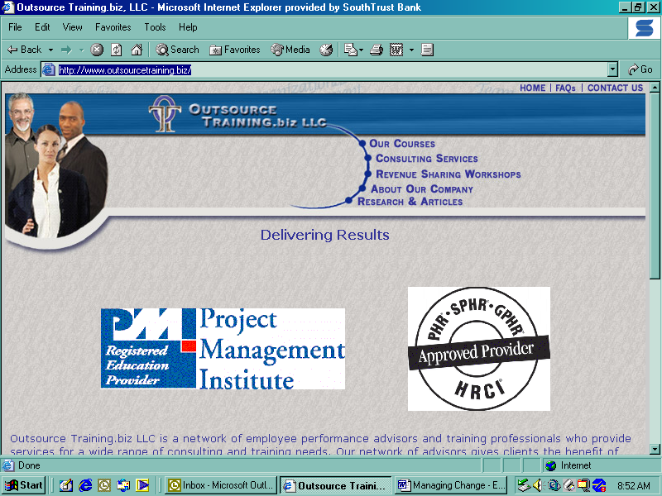
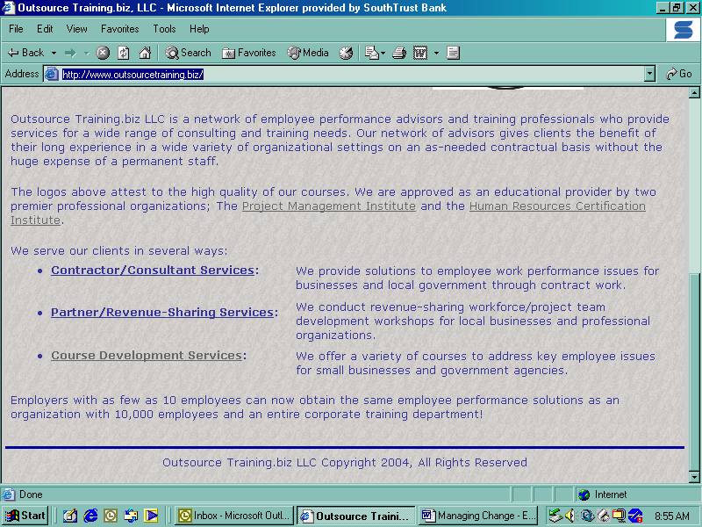
www.outsourcetraining.biz
We provide self-study courses for professional development credit for Project Management, Human Resources, and Engineering professionals.
Contact salesmanager@outsourcetraining.biz
205-706-5228

Analyzing Performance Problems or You Really Oughta Wanna, Mager and Pipe, 3rd Edition, 1997
Why Employees Don’t Do What They’re Supposed To Do and What To Do About It, Fournies, 1988

