How to Develop
(or Save) a

Project
Safety
Project Engineering
Project Team
Human
Resources
Project
Accounting



Table of Contents

Table of Contents 2
Introduction 3
Selecting Your Project Team Members 4
Eight Essentials for a High Performance Project Team 6
Sharing Behavioral Values 7
Developing a Project Code of Conduct 7
Testing the Value of Your Project’s Code of Conduct 10
The Components of Motivation 16
What Would Motivate Your Employees? 18
A Motivation Classic 19
The Hawthorne Studies 19
The Hawthorne Effect 19
The Experiments 19
Variables Affecting Productivity 19
Relay Assembly 20
Feedback Mechanism 20
Mayo's Conclusions 21
Looking Back on the Experiments 22
Modern Management Lessons 23
Applying the Hawthorne Effect 23
Tracking Process Improvements - Gathering Performance Metrics 23
Someone Really Cares About Me? 24
Developing a High Performance Project Team 26
Basic Elements of a Productive Project Team 26
The Project Organizational Element 26
The Project Leadership Element 28
How To Save a Project team 30
A Diagnostic Project Team Survey 31
About Outsource Training.biz LLC 33

Introduction
The title of this course, How to Develop (or Save) a Project Team, may sound like it is trying to cover two completely different concepts at the same time.
“How can you discuss developing and saving a project team in the same course?” is a reasonable question.
If you consider there is a strong possibility that the reason a team needs saving is because it was not developed correctly in the first place, it makes sense to take this approach.
We will look at first how to develop a team from scratch for a new project. Then we will assume you have been called in to rescue an existing one that is sinking.
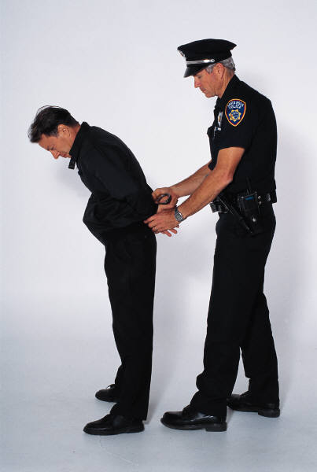
Once you understand the elements necessary to develop a productive project team, your first analysis of the problem can be looking for the extent to which these elements are present. There is a high probability there are not many. If this is the case, introduction of these elements will begin to stabilize the team.
Also, there may be some project team members who prefer chaos and anarchy instead of maintaining social order. These you will have to remove as quickly as possible.
Once they are out and you begin to implement the activities that lead to team development, things will settle down quickly as the remaining team members breathe a sigh of collective relief and focus on work. After all, that is why they are there and humans really do enjoy being productive and effective.

Selecting Your Project Team Members

“You Cannot Do Things the Way You Always Have and Expect Different Results!” will guide us on our team selection.

We suggest you consider a different way of selecting team members in case your existing practices do not always provide what you want in terms of project members.

Consider the way Southwest Airplanes approaches hiring when they say, “Hire for Attitude, Train for Skill!”

Why would this approach be useful for Southwest?
(You can teach people how to be ticket agents or baggage handlers but you cannot teach them to smile and be courteous to people. That is a part of our personality.)

Would that be a useful approach for your project?

What kind of questions would you use in interviews?

(Describe a time when you had to tell a client “no” but still had to maintain good will. Any questions asking for examples of them using the traits you seek.)

What “train for skill” considerations are there for professionals hired into your project?
(Obviously, you will not be teaching people to be engineers: they are already that when they come to your project. But you can “train” them how you want them to apply their customer service talents within the framework of your project team.)
Here is a way to identify the traits (Attitudes – Behaviors) you want on your team. Try this with friends who are project-experienced and put their responses on a flip chart so they can learn as this develops.

Traits of the best team member I ever had… | The impact of those traits on me… | The impact those traits had on my work…
You may get something like, “She always smiled and didn’t gossip, had time to listen to my stories about my kids, asked if I needed help with work when she finished hers.” | It made coming to work pleasant instead of something I dreaded. It also made me think twice about doing the same for her and other team members. | My work productivity was high because I was not wasting energy on complaining, focusing on the job and not project politics.

Once you have identified the traits, what do you do with that information concerning selecting project team members?

(You focus on finding people with those traits by asking applicants, “Tell me about a time when…. [they used the trait you are seeking.])

How likely are you to find 100% of what you are looking for regarding the “traits?”

(It is unlikely that you will find 100% but there is a strong probability you will find more than you think because most people have experienced situations like those that you are describing. The interview with you will probably be the first time anyone has asked them about it.)

If you will not find 100% of what you are looking for, how would having these traits publicly displayed (or readily available for review) around your project be useful?

(You will have made a public statement that these are your expectations. If you reference them periodically, you will gradually raise the awareness of it in your team and you will start to seem them acting that way.)

Eight Essentials for a High Performance Project Team

Project team development, as we use it here, is the process of personal, professional, and organizational development that occurs with the team over the life of the project.
The team members gain confidence in themselves and each other. Reliability, trust, and cooperation are present in everyday work; they are not elusive dreams we hope to find in the next project.
Project management becomes project leadership and the entire workforce becomes a cohesive team. Obviously, this is much more than a one-time pep rally, ropes course in the woods, or a golf outing after which the project members are expected to work and play well together forever.
In order to create and sustain an on-going process so this development of a highly engaged, motivated, and performing project team can occur, we first will have to understand what people require in their work environments so that optimal team development has a chance to happen.
Here are eight basic essentials:
- Sharing Behavioral Values
- Sharing a Common Purpose For Existence
- Having a Process to set Measurable Performance Goals
- Having a Chance to Work Toward Those Goals
- Getting Periodic Feedback On Goal Progress
- Receiving Help and Guidance When Needed
- Rewarding Success with Pay Or Praise
- Receiving Help With Professional And Personal Growth

We will expand some of these (the full expansion is in a separate, 2-day class) and try to convince you they are critical to have yet easy to create with the support of executive project management.

Sharing Behavioral Values

Developing a Project Code of Conduct

The Marines use “Semper Fi (delis)” (‘Always Faithful’) as a promise that they will not let each other down. The Ten Commandments guide Christians on their behavior. Even Colonel Sanders’ “We do chicken right!” was a type of value statement that helped KFC workers and customers share similar expectations of chicken.
A very effective way to do this is on a project is in a meeting with the project principles, project department heads, and some ‘high-potential’ project employees before the project starts bringing aboard the rest of the staff.
Here is how you can present it to your audience.
YOUR QUESTION | DESIRED ANSWERS  (Keep Probing Until You Get  Something Similar To These)
“Do you think a code of conduct has value for an organization?  For example, what value does the code of conduct called The 10 Commandments have for the organization called ‘Christianity’?” | “It defines their expectations of each other. It gives them guidance for action where there are no specific rules and regulations.”  (And if there were such policy and procedure manuals, they would be so thick that no one would read them!)
Question 1

An example would be, “Do unto others as you would have them do unto you.” Many volumes could be written about fairness in dealing with other people in thousands of situations. (Lawyers call them case law.)
Instead, that simple line of “Do unto others…” allows us to fit our definition of fairness to our situation instead of searching through some policy manual.
Please let us clarify something before we go farther. This code of shared values is not intended to replace the compliance regulations required by government agencies; specifications and procedures required by insurance companies; or the policies from the Human Resources or Safety departments on the project. It is intended to identify and publicize the unspoken expectations that we all have of each other on a project.
Unfortunately, even though these are traditionally unspoken, we still expect coworkers to be aware of them and comply with them. Then we get upset when they do not.

YOUR QUESTION | DESIRED ANSWERS
“Do you think our project qualifies as an ‘organization’?” | You should get agreement quickly on this!
Question 2

YOUR QUESTION | DESIRED ANSWERS  (Keep Probing Until You Get Something Similar To These)
“Do you think we could avoid some potential friction among team members if we could identify and publish a Code of Conduct for our project?  If so, what kind of behaviors would we want in our Code?” | See below. Put them on a flipchart page so you can post them in the meeting for reference.
Question 3
You may get many suggestions with this question but they will probably distill down into thoughts like these:

- Be reliable. Get to work on time (or early); meet your promised deadlines (or earlier); and follow through on your promises to team members whether project related or personal.

- Share knowledge if possible and ask for help when needed.

- Smile and be as friendly as you can. We are all in this together.

- Consider your behavior as seen through the eyes of your peers. If they were asked, “What is it like to work with you, what would you want them to say?” Then be sure your actions would make it easy for them to make those comments about you.

- Trust is historic. Team members have to learn they can trust you.

Some limitations you should consider while developing this code is the temptation for some to be ‘preachy’, too lengthy, or too much like specific rules that already exist somewhere else on the project.

Try to discourage this as much as you can because short, concise, and easy-to-remember statements are more likely to be used by the workforce. But, if they insist that is what they want, then give it to them because it is their project and they are agreeing (by arguing their points) they are willing to live by them. (This is all you were after, anyway!)

An additional benefit of having a project Code of Conduct is it helps the leaders at various levels within the project with employee performance issues. If this were the code in use on our current project, a supervisor or manager (we generically call them ‘leaders’) could point to the “Be reliable” and “Trust is Historic” statements and ask (not TELL) the employee what they are teaching teammates about their reliability by being late to work again.
This is a very subtle yet powerful tool for performance management. The smart leader never says, “You broke a project rule by being late!” because the tardy worker may view the project as some vague, Big Brother sort of presence inflicting a myriad of rules on him.
But teammates are not vague: they are very specific people with names and faces. “Letting our teammates down” has a much bigger impact on people than does breaking one of Big Brother’s innumerable rules.
The Code of Conduct concept helps the employees self-manage their behavior without the intervention of their leaders. This tool helps to shift part of the management role as “cop” to the employee who now becomes self-regulated.

Testing the Value of Your Project’s Code of Conduct

We will assume you have been successful in leading the project team in the creation of their Code of Conduct. Here is how you can show them its value.
Ask them to think about the best project they have ever worked on in the past. Or, if some do not have much project experience, ask them to think about the best work team or sports team of which they were a part. It can be full-time, part time, or volunteer. It can be with their current employer or a previous one.
Collect their responses so they can all see them on a chart like this on the board or easel paper. These represent typical responses.

Traits of the best team I was ever a part of… | The impact of those traits on me… | The impact those traits had on my work…
#1 No one was finished until we all were. If someone finished early, we helped someone else. | I kept learning more about the work so I could “show off” by getting finished first. It increased my value to the job and department. | I could do many different jobs so I got a lot of OT. Also, it showed my boss the potential I had and he gave me some more, difficult work (I loved it!)
#2 Everyone pulled his or her own weight. We did not tolerate “slackers.” | I wanted to be at least as good as the person next to me. I did not want my friends to think of me as a slacker. | High production and quality. I had very little rework because that would make me look bad.
#3 There were clear expectations about what the company wanted from us. We knew what we were expected to do. There was very little oversight by the bosses. | It gave me confidence because the boss knew I knew what was expected. I kept my quality and quantity of work high so she would not bother me. | I looked forward to coming to work because it was doing something in which I could take a lot of pride.  It also showed her how little supervision I needed.
#4 When someone figured out how to do something faster or better, they were expected to show at least one other person. That way, we all got smarter. | It made me want to learn more so I could be a teacher, not a “learner.” | It was not long before my job roles expanded because I had shown I could do a lot. My increased value to the company helped me be promoted.

Using that chart as your reference, refer back to the code of conduct your group generated back on page 8 and ask them this question:

YOUR QUESTION | DESIRED ANSWERS
“How many of the items we mentioned in our Code of Conduct (gesture to it) would have been applicable in this composite “best team” setting you have described?” | (There is no set answer here other than the probability that some of the items they listed today were part of the best team they were ever a part of. This is because our desire for cooperation, reliability, and looking out for each other is part of our fundamental nature. We just need to be reminded of it sometimes.)
Question 4

You are working toward a connection between the potentially great memories they can have from this project and their fond memories of great projects in the past. Be sure to tell them this can be just as great a project, too, if they will focus on that code of conduct in everything they do on this project and help new team members learn it, also.

If you can establish a code of conduct that is published, posted prominently throughout the project, and referenced frequently from senior project leadership downward through the ranks, the team will be well on its way to a great project experience.

Naturally, they will have you to thank for it!

What is “Motivation”?

ASK YOURSELF, What incentive do you have to work on this project?

What incentive does each of your project team members have to work on the project?

What incentive does each of your employees have to work for you?

Many surveys have shown that most employees do not stay with (or leave) their employers, they stay with (or leave) their supervisors.

What do you think about that statement?

You cannot do things the way you always have and expect different results!

What do you think about that statement?

What impact would it have on employee motivation?

Read this – why would this be included in a section about motivating project employees?

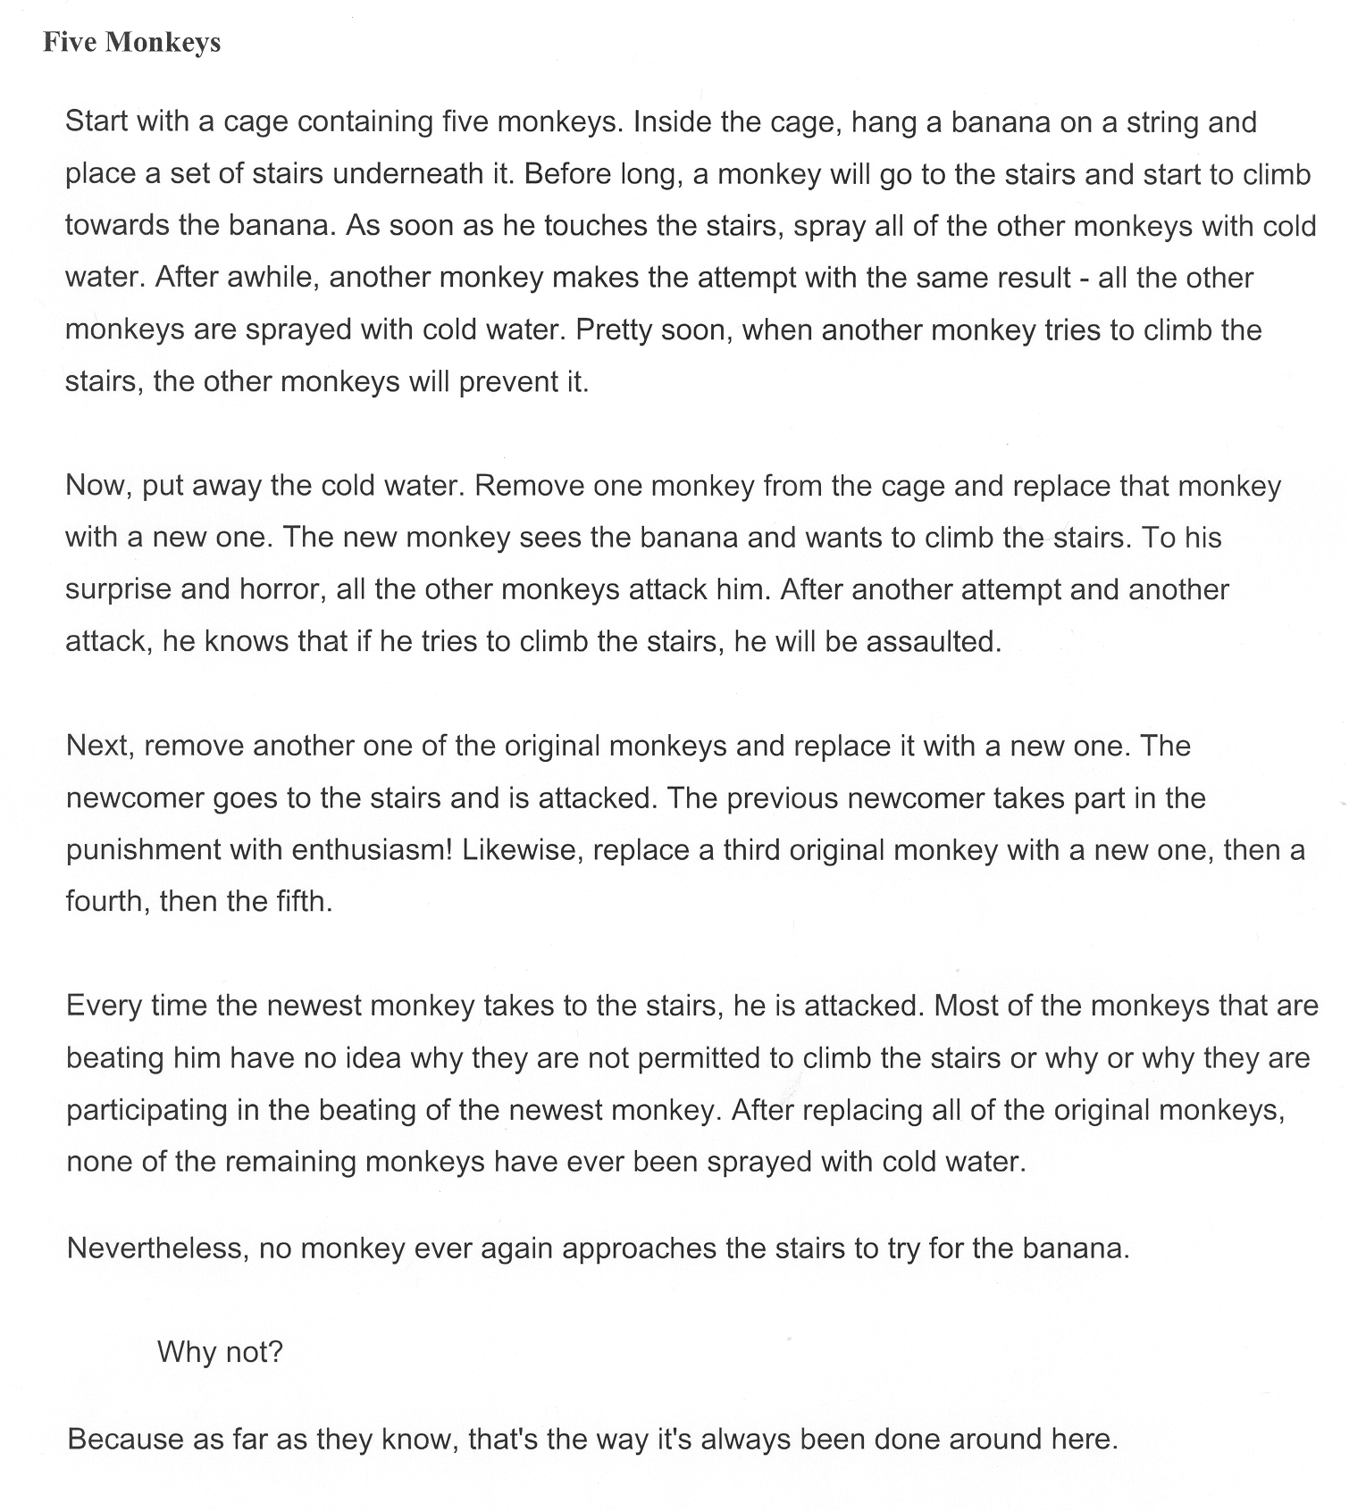

QUESTION: When you were in school, did you know the least you could do to get by and not get in trouble at home? Did you ever discover the most you could do in school?

WHO DETERMINED WHETHER YOU DID THE LEAST OR THE MOST YOU COULD DO?

Who controls the width of this performance gap?
5.0 = “The Most I can do” = COMMITMENT

4.0 = Proportionally between 3.0 & 5.0

3.0 = “The Least I can do to get by” = COMPLIANCE

“What is the difference in contribution between a top-performer and a below average performer at the same pay-grade?” (100%+)
“What is the difference in pay?” (Between 5-10%)*
-1998 American Compensation Association “Attracting and Retaining Critical Talent Conference” From a presentation from the Wilson Group

2.0 = Needs improvement – soon!
1.0 = Worst performance

From a survey asked of 2,000 managers.

THINK ABOUT- Who was the best supervisor you have ever had?

Their name: _________________________

List at least three things he/she did that make you think they are the best you have ever had.

When they did the things you listed above, what were at least three results on you?

When you worked for them, where would you place your work performance on the chart on the previous page: closer to the 3.0 or 5.0 level? Why?

Would results like that be good for some people in your project?

Which things did he/she do that were successful with you could you do for your people to make them feel the same way about you?

THINK ABOUT- WHAT IS STOPPING YOU?

The Components of Motivation

- Tell me what you expect of me in measurable terms (quality, quantity, time) that reduce the risk of my confusion.

- Give me a chance to perform (and learn from my mistakes, too.)

- Let me know how I am doing as I go along…(Remember the report cards you got in school every 6 weeks? You did not have to wait until the end of the year to learn if you had passed or failed the grade.)

- Give me help and guidance when I need it.

- Reward me with pay or praise when I succeed.

Check the columns if present.
Component  of  Motivation | present with the  best boss  I ever had? | present with YOU? (Would your employees agree?)
Tell me what you expect of me in measurable (q,q,t) terms.
Give me a chance to perform.
Let me know how I am doing.
Give me help and guidance
Reward me with pay or praise when I succeed.

Think of two of your current employees: your top performer and your lowest performer.

Fill in this table as honestly as you can about what may be their impression of you.

Use a rating scale from 1= Lowest to 5=Highest

Component  of  Motivation | How would your TOP PERFORMER RATE YOU? | How would your LOWEST PERFORMER RATE YOU?
My supervisor tells me what he/she expects of me in measurable (q,q,t) terms.
My supervisor gives me a chance to perform.
My supervisor lets me know how I am doing.
My supervisor gives me help and guidance
My supervisor rewards me with pay or praise when I succeed.

Suppose you asked your top and lowest performers to rate you on this scale.

What do you think the scores would be?

Do you think the lowest performer would rate you differently than the highest?

What would that difference be?

Is there possibly a connection between how they perform and how you think they would rate you?

Most Valuable Employee
“YOU GET WHAT YOU REWARD!”
(What does this mean to a smart leader?)

What Would Motivate Your Employees?
“WHEN YOUR EMPLOYEES GET WHAT THEY WANT, YOU’LL GET WHAT YOU WANT!”
---Zig Ziglar
Motivational speaker

CONFIDENCE >> COMPETENCE >>PERFORMANCE

Confidence grows when people:
- Know what is expected of them in measurable terms.
- Know what they expect of themselves.
- Know their strengths.
- Know their weaknesses.
- Know where to get help.
- Constantly measure their own performance against their own goals.
- Expect that rewards will follow achievement.

Make three copies of this table below. Then put the names of three of your employees (your best, average, and poorest performers) into it and rank each one from 1-5 (1 = “very little” to 5 = “very much”) based on your perception of them in each category.

Then give each of them a copy of it and ask them to rate themselves on that same 1-5 scale.

Elements of Confidence | Employee #1 | Employee #2 | Employee #3
Knows what is expected of them in measurable terms.
Knows what they expect of themselves.
Knows their strengths.
Knows their weaknesses.
Knows where to get help.
Constantly measures their own performance against their own goals.
Expects that rewards will follow achievement.

A Motivation Classic

The Hawthorne Studies
The Hawthorne Studies (or Hawthorne Experiments) were conducted from 1927 to 1932 at the Western Electric Hawthorne Works in Cicero, Illinois (a suburb of Chicago), where Harvard Business School professor Elton Mayo examined productivity and work conditions. These experiments started by examining the physical and environmental influences of the workplace (e.g. brightness of lights, humidity) and later, moved into the psychological aspects (e.g. breaks, group pressure, working hours, managerial leadership).

The Hawthorne Effect
In essence, the Hawthorne Effect can be summarized as "Individual behaviors may be altered because they know they are being studied." In the Hawthorne experiments, an increase in worker productivity was produced by the psychological stimulus of being singled out, involved, and made to feel important.

Additionally, the act of measurement, itself, affects the results of the measurement. Just as dipping a thermometer into a vial of liquid can affect the temperature of the liquid being measured, the act of collecting data, where none was collected before creates a situation that did not exist before, thereby affecting the results.

The Experiments
The studies grew out of preliminary experiments at the Hawthorne plant from 1924 to 1927 on the effect of light on productivity. Those experiments showed no clear connection between productivity and the amount of illumination but researchers began to wonder what kind of changes would influence output.

Variables Affecting Productivity
Specifically, Mayo wanted to find out what effect fatigue and monotony had on job productivity and how to control them through such variables as rest breaks, work hours, temperature and humidity. In the process, he stumbled upon a principle of human motivation that would help to revolutionize the theory and practice of management.
Mayo selected two women, and had those two select an additional four from the assembly line. He segregated them from the rest of the factory and put them under the eye of a supervisor who was more a friendly observer than a disciplinarian. Mayo made frequent changes in their working conditions, always discussing, and explaining the changes in advance.

Relay Assembly
The group was employed in assembling telephone relays - a relay being a small but intricate mechanism composed of about forty separate parts that had to be assembled by the girls seated at a lone bench and dropped into a chute when completed.

The relays were mechanically counted as they slipped down the chute. The intent was to measure the basic rate of production before making any environmental changes. Then, as changes were introduced, the impact to effectiveness would be measured by increased or decreased production of the relays.

Feedback Mechanism
Throughout the series of experiments, an observer sat with the girls in the workshop noting all that went on, keeping the girls informed about the experiment, asking for advice or information, and listening to their complaints.

The experiment began by introducing various changes, each of which was continued for a test period of four to twelve weeks. The results of these changes are as follows:
- Conditions and results
  - Under normal conditions with a forty-eight hour week, including Saturdays, and no rest pauses. The girls produced 2,400 relays a week each.
  - They were then put on piecework for eight weeks. Output increased
  - They were given two five-minute breaks, one in the morning, and one in the afternoon, for a period of five weeks. Output increased, yet again
  - The breaks were each lengthened to ten minutes. Output rose sharply
  - Six five-minute breaks were introduced. The girls complained that their work rhythm was broken by the frequent pauses Output fell only slightly
  - The original two breaks were reinstated, this time, with a complimentary hot meal provided during the morning break. Output increased further still
  - The workday was shortened to end at 4.30 p.m. instead of 5.00 p.m. Output increased
  - The workday was shortened to end at 4.00 p.m. Output leveled off
  - Finally, all the improvements were taken away, and the original conditions before the experiment were reinstated. They were monitored in this state for 12 more weeks. Output was the highest ever recorded - averaging 3000 relays a week

Mayo's Conclusions

Elton Mayo came to the following conclusions because of the Hawthorne study:
- The aptitudes of individuals are imperfect predictors of job performance. Although they give some indication of the physical and mental potential of the individual, the amount produced is strongly influenced by social factors. (How does this fit with Southwest Airlines’ strategy of “Hire for Attitude, train for skill?”)?

- Informal organization affects productivity. The Hawthorne researchers discovered a group life among the workers. The studies also showed that the relations that supervisors develop with workers tend to influence the manner in which the workers carry out directives.

- Work-group norms affect productivity. The Hawthorne researchers were not the first to recognize that work groups tend to arrive at norms of what is "a fair day's work”. However, they provided the best systematic description and interpretation of this phenomenon.

- The workplace is a social system. The Hawthorne researchers came to view the workplace as a social system made up of interdependent parts. The worker is a person whose attitudes and effectiveness are conditioned by social demands from both inside and outside the work plant. Informal group within the work plant exercise strong social controls over the work habits and attitudes of the individual worker.

The need for recognition, security, and sense of belonging is more important in determining workers' morale and productivity than the physical conditions under which he works.

The major finding of the study was that almost regardless of the experimental manipulation, worker production seemed to improve continually. One reasonable conclusion is that the workers were happy to receive attention from the researchers who expressed an interest in them. Originally, the study was expected to last one year, but since the findings were inexplicable when the researchers tried to relate the worker's efficiency to manipulated physical conditions, the project was incrementally extended to five years.

Looking Back on the Experiments

For decades, the Hawthorne studies provided the rationale for human relations within the organization. Then, in 1978, R. H. Franke and J.D. Kaul used a new procedure called "time-series analyses" with the original data and variables, including the Great Depression and the instance of a managerial discipline in which two productive workers replaced two, insubordinate mediocre workers.

They discovered that production was most affected by the replacement of the two workers due to their greater productivity and the effect of the disciplinary action on the other workers. The occurrence of the Depression also encouraged job productivity, perhaps through the increased importance of jobs and the fear of losing them.

Rest periods and a group incentive plan also had a somewhat positive smaller effect on productivity. These variables accounted for almost all the variation in productivity during the experimental period.

Modern Management Lessons

What seemed to be most important during the experiments was that six individuals became a team and the team gave itself wholeheartedly and spontaneously to cooperation in the experiment. Consequently, they felt as if they were participating freely and were happy in the knowledge that they were working without coercion from above or limitation from below.
The experimental group had considerable freedom of movement. With the observer overseeing them, rather than their previous Theory X managers, they were not pushed around or micromanaged. They were satisfied with the result of working under less pressure than ever before.

In fact, regular medical checks showed no signs of cumulative fatigue and absence from work declined by 80 percent. Under these conditions, they developed an increased sense of responsibility. Instead of receiving discipline from higher authority, it emerged from within the group. (Their unofficial Code of Conduct!)

Applying the Hawthorne Effect

Suppose you select a management trainee and provide specialized training in management skills not currently possessed. Without saying a word, you have given the trainee the feeling that she is so valuable to the organization that you will spend time and money to develop her skills. She feels she is on a track to the top, which, in turn, motivates her to work harder and more effectively. This motivation is independent of any particular skills or knowledge she may have gained from the training session. That is the Hawthorne Effect at work.

Tracking Process Improvements - Gathering Performance Metrics

Unfortunately, the measurement of performance can unintentionally affect the performance itself. In order to determine the impact of a new or modified process, someone needs to subtly observe workers on the job and monitor production. Occasionally, managers object, saying that observation is not a valid test, "Of course they'll perform better, you're watching them."

The power of the social setting and peer group dynamics was reinforced for Mayo later in the Hawthorne Studies, when he saw an unusual reaction to his original experiments. A group of 14 men participating in a similar study restricted production because they were distrustful of management and thought that their quotas would be artificially elevated if they were to perform beyond the norm during these studies.

If workers suddenly sense an environmental shift from a Theory X organization to a Theory Y organization, this can trigger false positives from nearly any otherwise meaningless or even slightly detrimental process change. Involving your workers in setting their own direction, showing them that you care about how their job is progressing, and fostering a more positive relationship will create beneficial productivity impacts.

Conversely, if your environment is one of mistrust and fear, and the workers unite in rebellion of management's efforts to control and oppress them, there will be little a manager can do to effect positive change without first handling this toxic situation.

Someone Really Cares About Me?

Mayo realized that the women, exercising a freedom they did not have on the factory floor, had formed a social atmosphere that also included the productivity-tracking observer. They talked and joked with one another. They began to meet socially outside of work.

When these women were singled out from the rest of the factory workers, it raised their self-esteem. When they were allowed to have a friendly relationship with their supervisor, they felt happier at work. When he discussed changes in advance with them, and allowed them a form of participation, they felt like part of the team. Mayo had secured the girls’ cooperation and loyalty. This explains why productivity rose even when he took away their rest breaks.

There is nothing wrong with intentionally using the Hawthorne Effect to reach your goals. In fact, the Hawthorne Effect has also been called the 'Somebody Upstairs Cares' syndrome. When people spend a large portion of their time at work, they require a sense of belonging, of being part of something bigger than themselves. When they do, they are more effective.
This effect has been described as the reward you reap when you pay attention to people. The mere act of showing people that you are concerned about them usually spurs them to better job performance. That is the true Hawthorne Effect.

Developing a High Performance Project Team

Clearly, this is a more complex topic than we can cover in a short time. However, a few things can be done to make sure your project team has the best chance of success. (Consider this the ‘Parieto Method’ – we will talk about the significant few things that will have the greatest impact on your project.)

We will list the elements necessary for a productive project team. They become a “high performance” team only after they have been immersed in an environment like we describe next for a period of time. The more the project organization displays these traits, the faster they will become productive.

Basic Elements of a Productive Project Team

The Project Organizational Element

A productive project team does not just happen miraculously; it is the result of careful planning and preparation. But, even if you do plan and prepare carefully, there is no guarantee they will develop or last. However, there is a guarantee that if you do not plan and prepare carefully, you will never achieve it!

Use the scale on the next page to rate your project organization as you think it is today if you are taking over an existing project. (If you are starting a new project, use the scale as a guideline in developing your team.)

Then rate it where you think it should be. Make a copy of this survey and administer it to as many employees and management as possible when you return from this class. That will give you a snapshot of your project’s potential for creating and retaining a high performance team plus identify specific issues that need attention.
1-2 = Never see this 3-4 = Rarely see this 5-6 = Occasionally see this
7-8 = Often see this 9-10 = Always see this
Table 1
 | Project Organizational Issues | Is now | Should be
1 | All functional job descriptions contain progressive performance levels using measurable terms indicating “how much”, “by when,” and “how well.”
2. | Each department has a new employee orientation and training program that ensures new team members become productive as quickly as possible.
3. | We require that all employees at all levels meet with their leaders at least quarterly to review their progress on annual goals and make adjustments as necessary. We document those meetings and forward results to the employee’s permanent manager for consideration in annual performance evaluations.
4. | Our project has an employee performance assessment system that focuses on measurable, objective, functional behaviors that are not influenced by politics.
4. | We require performance feedback systems be associated with every job function so employees can self-monitor their progress toward annual goals.
5. | Our project has a mission statement that is understood by each employee.
6. | We make sure that each employee understands how his or her job supports the project’s mission statement.
7. | Our performance assessment process requires leaders to document their efforts to support the professional and personal development of their employees.
8. | Our project publishes and works hard to follow a Project Team Code of Conduct.
9. | Our project culture focuses more on what caused the problem instead of who was involved.
10. | Our project takes a survey of employee job satisfaction semi-annually and publishes, then acts on the results.

Why do you think we have included each of these issues?

(These basic issues must be present for ANY organization to function successfully, not just a project team.)

The Project Leadership Element

Use this scale to rate your project’s leadership as you think it is today.
Then rate it where you think it should be. Make a copy of this survey and administer it to as many employees and management as possible when you return from class.
That will give you a snapshot of your project’s potential for creating and retaining a productive workforce plus identify specific issues that need work.

1-2 = Never see this 3-4 = Rarely see this 5-6 = Occasionally see this
7-8 = Often see this 9-10 = Always see this
Table 2
 | Project Leadership Issues | Is now | Should be
1 | We have an effective Leadership Development program to develop existing leaders professionally and personally at all levels in the project.
2. | The leadership development program requires participants to document their application of the professional development training they receive.
3. | Leadership roles in community service activities are required within our leadership development program.
4. | Mentoring of junior leaders by senior leaders is an element of our leadership development program.
5. | We have a Future Leaders program that helps us identify and groom future leaders in the project.
6. | Our leaders are measured in their annual performance evaluations on the performance of their departments.
7. | Our leaders are measured on their annual performance evaluations on the extent of their supporting employee development within their departments.
8. | Our leaders receive training in measuring productivity, writing financial proposals, project management (non-PMPs), business writing, and making effective presentations as part of their professional development.
9. | Our leaders understand what motivates employees to be as productive as possible.

Why do you think we have included each of these issues?

(These are some basic issues that must be present for ANY organizational leadership to evolve successfully, not just project leaders.)
The Team Member Development Element

Use this scale to rate your project’s team member development as you think it is today.
Then rate it where you think it should be. Make a copy of this survey and administer it to as many employees and management as possible when you return from class.
That will give you a snapshot of your project’s potential for creating and retaining a high performance workforce plus identify specific issues that need work.

1-2 = Never see this 3-4 = Rarely see this 5-6 = Occasionally see this
7-8 = Often see this 9-10 = Always see this
Table 3
 | Employee Development Issues | Is now | Should be
1 | Our employees have access to training that focuses on project-related topics.
2. | Our employees have access to training that focuses on professional and personal development topics such as business writing, giving effective presentations, conducting meetings, and public speaking.
3. | Our employees have access to training that teaches them to become active participants in the project’s success such as measuring productivity, writing financial proposals, Intro to Project Management, providing quality service, and using effective communications skills.
4. | Every training course has measurable outcomes that tell us how much the participant has learned.
5. | Employees meet with their leaders before going to courses to establish post-training goals for specific, measurable application of the training.
6. | Leaders encourage employees who have gone to class to do post-training “lunch-and-learn” presentations to the rest of their department to share the skills they have gained.
7. | There are training courses focused on helping employees manage their self-development.
8. | There are training courses that teach employees about civil behavior, workplace violence, first aid, personal health, and managing personal finances.

Why do you think we included these issues?

(These are basic employee development issues that must be present for ANY organization to evolve successfully, not just a project team.)

How To Save a Project team

We will not pretend that any one course will help you learn how to save any project at any time regardless of bad it has become. That skill is a combination of knowledge and experience gained over many years on the job, not many hours in a classroom.

However, this course has given you some hints on clues to look for from the project team’s perspective. We have covered these topics and you should have some understanding about them:

- Eight Essentials for a High Performance Project Team page 6
The Components of Motivation page 16 page 20
- Basic Elements of a Productive Project Team page 27

You can use these topics as part of an overall assessment of the project’s existing work environment and what an ideal one should have.

Once you have identified all of the things that you think are wrong with the project (from the project team’s perspective), it is time to apply the Parieto “80/20” Rule again. This time, you are asking yourself for the 20% of items that have 80% of the impact on them.

A simple employee survey like the one on the next page can go a long way to give you a “snapshot” of the team’s mood on the day you administer it. Be aware that, if you are there to save the project team, their morale is low and suspicion of management is very high. They may not be willing to do a survey unless you can convince them you will act on the results. Otherwise, they will see it as an attempt to pacify them, just gloss over things, and CHANGE NOTHING!

You only get one chance to show them you are different and not just ‘more of the same’. Take your time to be sure you have the will, the authority, and self-discipline to act on the findings!

A Diagnostic Project Team Survey

An anonymous survey about YOUR JOB on this project

Someone once said, “If you don’t bother to vote, don’t bother to complain about who gets elected!”

With that in mind, if you will take a few minutes to answer this survey as honestly as you can, it can be the start to improving conditions on this project. Isn’t it worth a few minutes to help us understand the current situation so we can develop plans to improve it for the future?

PART I: Please put a check mark beside your department so we will know if we overlooked any.

Doc Control |  | QA/QC
Safety |  | HR
Accounting

PART II: Please check the statement that is true of you today:
_____ I DO (or) ____ I DO NOT DO performance assessments on other employees.

PART III: RANK THE IMPORTANCE TO YOU OF THESE CONDITIONS

You may use each number only once in this section.

Circle the #1 next to the condition that is most important; #2 beside the second most important; #3 beside the third most important; and so on to #10 most important.
Job Condition | Your Rating
Management shows appreciation for the work that I do. | 1 2 3 4 5 6 7 8 9 10
Knowing what is going on in the project. | 1 2 3 4 5 6 7 8 9 10
Patient help on work related problems. | 1 2 3 4 5 6 7 8 9 10
On-going training to increase my “employability” | 1 2 3 4 5 6 7 8 9 10
Fair salary and benefits in exchange for my work. | 1 2 3 4 5 6 7 8 9 10
Work that keeps me interested. | 1 2 3 4 5 6 7 8 9 10
Opportunities are available for me to move up in my career. | 1 2 3 4 5 6 7 8 9 10
Management keeps private any information I may share in confidence. | 1 2 3 4 5 6 7 8 9 10
The work environment is clean and safe. | 1 2 3 4 5 6 7 8 9 10
Fair, confidential, and consistent discipline | 1 2 3 4 5 6 7 8 9 10

PART IV: RATE YOUR SATISFACTION OF YOUR PRESENT JOB
Circle any number from 1 to 10 that represents your feeling today.
You may use each number as often as you wish.

10 (Satisfied very much)…9-8 (satisfied some)..7-6 (maybe so)…5-4 (maybe not)…
3-2 (dissatisfied some)…1 (dissatisfied very much)

Job Condition | Your Rating
Management shows appreciation for the work that I do. | 10 9 8 7 6 5 4 3 2 1
Knowing what is going on in the project. | 10 9 8 7 6 5 4 3 2 1
Patient help on work related problems. | 10 9 8 7 6 5 4 3 2 1
On-going training to increase my “employability” | 10 9 8 7 6 5 4 3 2 1
Fair salary and benefits in exchange for my work. | 10 9 8 7 6 5 4 3 2 1
Work that keeps me interested. | 10 9 8 7 6 5 4 3 2 1
Opportunities are available for me to move up in my career. | 10 9 8 7 6 5 4 3 2 1
Management keeps private any information I may share in confidence. | 10 9 8 7 6 5 4 3 2 1
The project work environment is clean and safe. | 10 9 8 7 6 5 4 3 2 1
Fair, confidential, and consistent discipline | 10 9 8 7 6 5 4 3 2 1

PART V: HOW DO OUR PROJECT LEADERS RELATE WITH YOU?

Please rate your agreement with each statement using a scale from 1 to 10 where:

10 (Agree very much)…9-8 (agree some)..7-6 (maybe so)…5-4 (maybe not)…
3-2 (disagree some)…1 (disagree very much)

Component of Motivation | rATING 1-10
The person to whom I report tells me what he/she expects of me in measurable terms (measurable terms include examples of “HOW MUCH”, “HOW GOOD”, “BY WHEN”). | 10 9 8 7 6 5 4 3 2 1
The person to whom I report gives me a chance to perform. | 10 9 8 7 6 5 4 3 2 1
The person to whom I report lets me know how I am doing frequently. | 10 9 8 7 6 5 4 3 2 1
The person to whom I report gives me help and guidance when I ask for it. | 10 9 8 7 6 5 4 3 2 1
The person to whom I report rewards me with praise when I succeed. | 10 9 8 7 6 5 4 3 2 1

PART VI: Please complete these phrases: “Life would be great if the project management team would only-“ (write on the back if you need more room)

START DOING THIS…

STOP DOING THIS…

CONTINUE DOING THIS…

WHAT ELSE WOULD YOU LIKE MANAGEMENT TO KNOW?

About Outsource Training.biz LLC
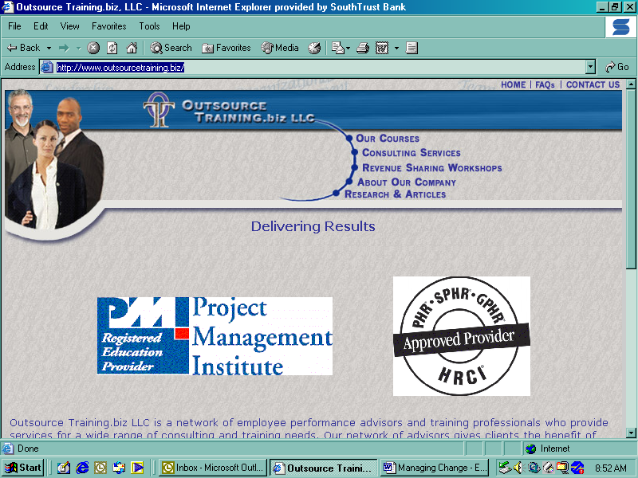
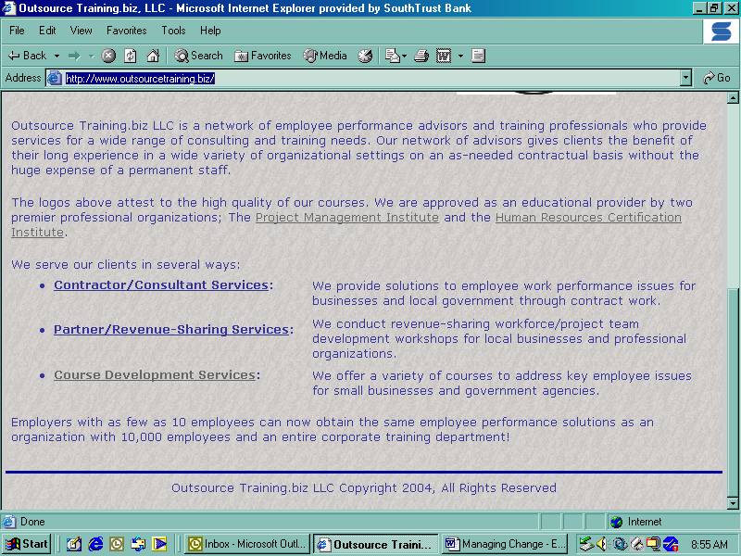
www.outsourcetraining.biz
We provide self-study courses for professional development credit for Project Management, Human Resources, and Engineering professionals.
Contact salesmanager@outsourcetraining.biz
205-706-5228

