Acknowledgments
The instrumental contribution of Genny E. Pond, a former graduate research assistant, Department of Civil and Environmental Engineering, Clarkson University, Potsdam, NY, to the development of the first version of the software is appreciated.
The contributions of Camille Rubeiz, PE, and Douglas Raby of AISI, Michael A Grubb, PE of BSDI, Ltd., Professor Karl H. Frank, PE of the University of Texas at Austin, Edward P. Wasserman, PE, and Henry Pate of the Tennessee Department of Transportation, Ralph Anderson, PE, and Richard Best, Tim Armbrecht, and Paul Johnson of the Illinois Department of Transportation, William Rogers, PE, Robert Woodruff, Christian Ray, and Tom Koch of the North Carolina Department of Transportation, Bob Lyon of HNTB, Roger Eaton, PE, and Patti Ritchey of HDR Engineering, Inc., Pittsburgh, PA are gratefully acknowledged.
The development of the software was funded by the AISI Transportation and Infrastructure Committee.

Notice
This manual is to be used as guidance while using AISIsplice software. In no case shall it be used as a substitute for competent professional assistance. The user assumes all liabilities and does so at his/her own risk.

© 2001 American Iron and Steel Institute
All Rights Reserved

Table of Contents
Forward 4
1. Scope of Software 5
2. Software Installation 5
3. License Activation Procedure 6
4. Starting the Program 8
5. Software Input 8
5a. Welcome Screen 14
5b. Loading Input Screen 15
5c. Girder Properties Input Screen 16
5d. Additional Properties Input Screen 17
5e. Splice Properties Input Screen 18
6. Saving Input Data 18
7. Execution of the Software 19
8. Software Output 20
8a. Splice Design Summary Graphics 20
8b. Splice Analysis Summary Graphics 21
8c. Report Output 22
9. Exiting the Software 23
10. Review of Computer Output 23
11. Suggestions for Maximum Economy and Performance 24
Appendix A - Default Values 25
Appendix B - Report Outlines 33
Appendix C - Block Shear Rupture Paths 34
Appendix D - Software Limitations 35
Appendix E - References 36
Appendix F - Sample of Bridge Splices Designed By AISIsplice 37

Forward
In 1999, the American Association of State Highway and Transportation Officials (AASHTO) adopted a new methodology for the design of bolted field splices of flexural steel members. The new methodology was developed in response to the lack of a uniform design methodology for bolted splices, which resulted in confusion and costly splices.
The new methodology was based on the analytical and experimental research program conducted by Firas I. Sheikh-Ibrahim and Karl Frank (1996, 1998, 2001) at the University of Texas at Austin. In the new methodology, two approaches for splice designs were justified. In the first one, the web is designed to resist its share of the moment, and the flange splices to resist the moment not resisted by the web. In the second approach, the flange splices are designed to resist the total design moment, and the web splice to resist only the eccentric shear, which is applied at the centerline of the splice.
Even though the two aforementioned approaches were found acceptable from a resistance standpoint, Sheikh-Ibrahim and Frank recommended that the second approach be followed to yield the most cost-effective splices.
In a step towards obtaining cost-effective splices, AASHTO adopted the first approach as the primary design method, since a similar approach has been used in bridge design practice, and has been incorporated in AASHTO for quite a long time. Therefore, AASHTO developed their 99 Interim such as to illustrate the first design methodology in sufficient details, and briefly touch on the second approach as an alternate method.
Since significant changes have been incorporated in AASHTO, the AISIsplice software was developed to help designers understand the new design methodology, and produce cost-effective splices. The software, in its current version, is limited to the first design approach mentioned above, but it is anticipated that it will incorporate the second design approach in the near future.

Firas I. Sheikh-Ibrahim, PhD, PE

1. Scope of Software
AISIsplice is a tool for the analysis and design of bolted field splices for straight, right, I-shaped, steel girders. The analysis and design process is based on the AASHTO LRFD Bridge Design Specifications, Second Edition, 1998, including the 1999 interim.
In the design mode, the software sizes and optimizes the splice plates and bolts. In the analysis mode, the software determines the adequacy of given splice plates and bolts. For both modes, performance ratios (load/resistance) for all splice components are determined.

2. Software Installation
AISIsplice runs under Microsoft® Windows95/NT®, or higher, on IBM compatible personal computers. A free hard-disk space of 8 MB is recommended, along with a minimum of 8 MB memory (16 MB preferred). EGA, VGA or a high-resolution, color graphics board and mouse are required. Small fonts should be selected for the computer’s display font size setting.
AISIsplice should be installed and run from the hard drive for efficient operation. To install AISIsplice on the hard drive:
- Insert CD in the CD ROM drive. (It is assumed that the D: drive will be used. If another drive is used instead, substitute the appropriate letter in Step 3.)
- Click Start on the Windows taskbar and choose Run...
- Type D:SETUP in the text box and click OK.
- Follow the instructions in each succeeding window until the installation is completed, then click Finish.
AISIsplice will automatically appear in the Programs menu and can be used to access the software as described subsequently. To access the software easily, you may wish to create a Shortcut AISIsplice Icon and drag it to the desktop.

3. License Activation Procedure
AISIsplice has a 30-day, ready-to-try license. You can install it on any computer, and you are entitled to distribute it to anyone without permission. The software will run for 30 days from the day of installation, and will need re-activation after expiration of the trial license.
After the expiration of the free trial period, the License Configuration screen will appear when you attempt to run the software. If you want to copy the Site Code number to the clipboard, highlight the Site Code and click the right mouse button. When the menu shown below appears, select the Copy option. You will need to use this number when you request your activation code.

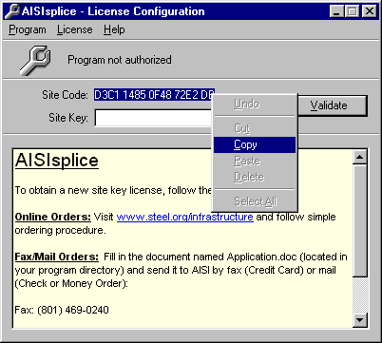

After you have your Site Code ready, follow one of the two procedures explained herein to obtain a new site key license. For online orders, visit www.steel.org/infrastructure and follow simple ordering procedure. For fax or mail orders, fill in the document named Application.doc (located in your program directory) and fax it to AISI at 801-469-0240 (Credit Card), or mail it to (Check or Money Order):

Transportation and Infrastructure Group
American Iron and Steel Institute
1101 17th Street NW Suite 1300
Washington, DC 20036
When you receive your activation code type it, or paste it into the Site Key box shown below and then click the Validate button.
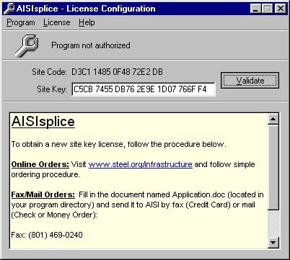

The software will then check your Site Code and the message shown below will appear to prompt you that you are licensed to run the software.
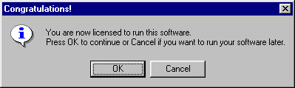
After you click the OK button, the License Flash screen shown below will appear. This screen will also appear every time you run the software. Note that this screen informs you of the duration of your remaining license. While the License Flash screen is visible, you can activate the License Configuration screen by hitting the Enter button on your keyboard.


4. Starting the Program

To start AISIsplice, click Start on the Windows taskbar, point to Programs folder, then AISIsplice folder (it is assumed herein that the default folder was not altered during the installation of the software), and then click AISIsplice. The software will open the Welcome Screen.
If a shortcut was created on the desktop, double-click the shortcut icon, and the software will open the Welcome Screen.

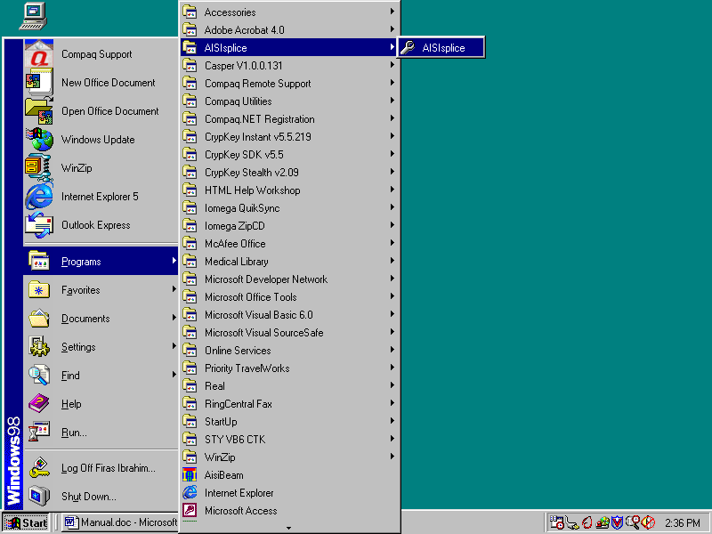

5. Software Input
When AISIsplice is opened, the Welcome screen will appear. AISIsplice was designed using a “Wizard” approach. Input Screens are sequentially ordered, and the user is allowed to move forward and backward from each screen by clicking the Next and Back buttons, respectively. When the information is completely entered for a given screen, the user should click the Next button. The user will either be allowed to progress to the next screen, or will be directed to enter incomplete, or fix inaccurate input values. The Back button may be clicked at any time, to revise previously entered values.
The wizard approach was used to minimize the use of menu systems. However, a minimal menu system is provided including the following:
File menu:

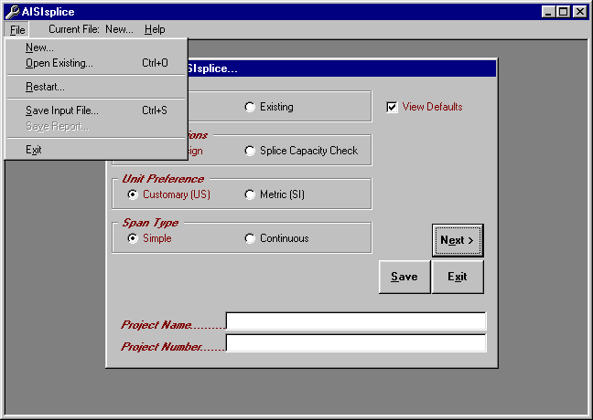
The File menu includes the following options:
New - allows the user to create a new input file.
Open Existing - allows the user to open and revise a previously saved input file.
Restart - allows the user to return to the Welcome Screen at any time.
Save Input File - allows saving the current input file.
Save Report - allows saving the output report created during program execution (only available from output screens).
Exit - allows the user to quit the program.
Current File bar:
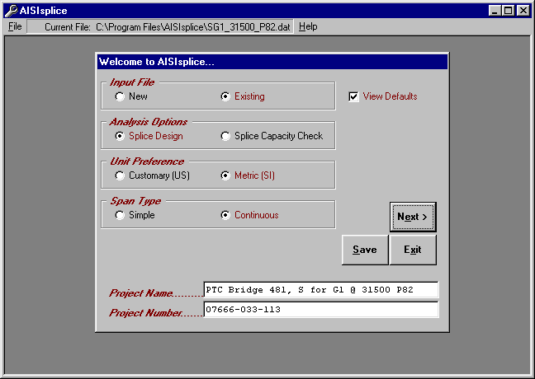
This Current File bar informs the user of the path/filename of the current input file.

Help menu:
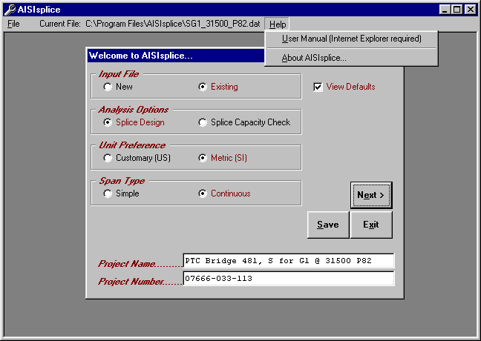
Two options are available from within the Help menu; User Manual and About AISIsplice options.

User Manual:
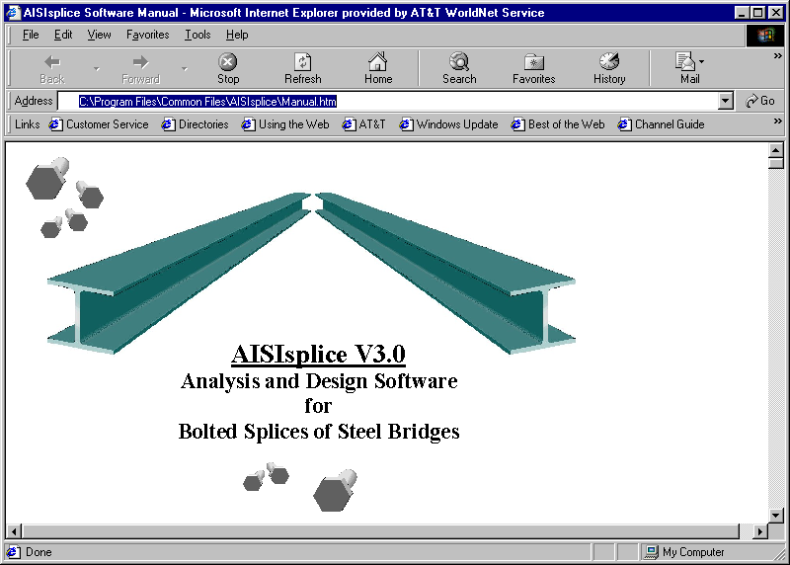
The User Manual menu option enables you to view the User Manual from within AISIsplice. At this time, the online User Manual can be viewed using Internet Explorer only. If you have problem with your Internet browser or have a different browser, you can view the User Manual using Word. The User Manual is named Manual.doc and is placed in your program directory, and on the distribution CDROM.

About AISIsplice:
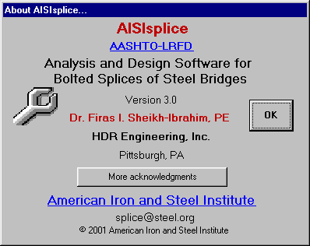
The About AISIsplice screen contains information about AISIsplice, along with hyperlinks to AASHTO, RCSC, and AISI web pages.

5a. Welcome Screen
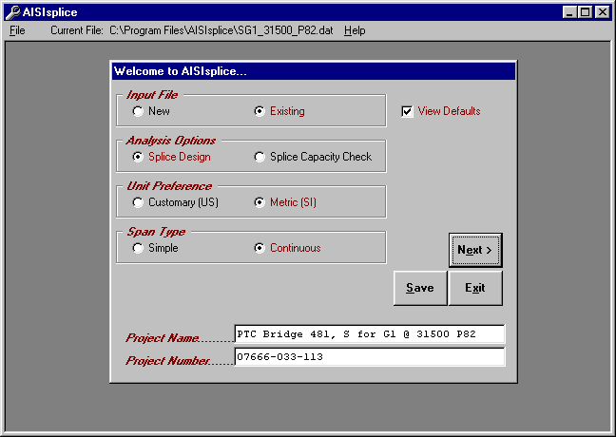
The Welcome screen prompts the user to create, open, and revise an input file. This is the starting point for any design or analysis. It has the following options:
- New - click to create a new input file.
- Existing - click to revise an existing input file. If you already have an existing input file open and wish to open a different one, double-click on this option.
- Splice Design - click to have the software design a splice for the given loading and girder properties.
- Splice Capacity Check - click to have the software check the adequacy of a given splice for given loading and girder properties.
- Customary (US) or Metric (SI) - click to select the units system of choice.
- Simple or Continuous - click to indicate the type of bridge span under consideration.
- Project Name - (optional) allows the user to type a project name in the box provided (limited to 40 characters in length).
- Project Number - (optional) allows the user to type a project number in the box provided (also limited to 40 characters in length).
- View Defaults - when checked, allows the user to view and alter file default values (refer to Appendix A for more information on AISIsplice default values screens).
To develop a new input file, click the New option and select the appropriate Welcome screen options. If you wish to create user-specific defaults, click to place a check mark in the View Defaults box (refer to Appendix A). When finished, click the Next button to proceed to the next screen.
To open or revise an existing file, click the Existing option. In order to provide software guidance, an input file is distributed with the AISIsplice software. The file, which is called “SG1_31500_P82.dat”, will be used in this manual as an example of a software-generated splice design. The example is for a splice located near the dead-load contra-flexure point. The loadings in the example are those of a splice that was designed by HDR Engineering-Pittsburgh for a two-span continuous, 20 degree-skewed, Slab-on-I-girders composite bridge on the Pennsylvania Turnpike in Somerset County, Pennsylvania. To open SG1_31500_P82.dat, click the Existing option. When asked to save the current file, click No. When the Open dialog box appears, click the file named SG1_31500_P82.dat (making sure the appropriate directory is accessed) and then click Open. After SG1_31500_P82.dat is opened, the Welcome screen will look like the one shown above. When you are ready, click Next to continue.

5b. Loading Input Screen
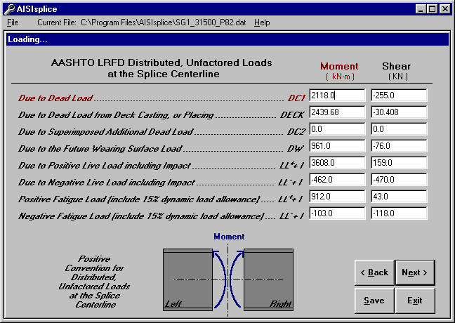

The Loading screen enables the user to enter the unfactored moments and shears that are applied at the centerline of the splice. The positive convention is denoted on the elevation graphic. Negative moments are not accepted for simple-span bridges.
If the SI units system is chosen, moments and shears should be given in kN-m and kN, respectively. These values should be given in k-ft and kips if the US units system is chosen. When finished, click the Next button.

5c. Girder Properties Input Screen
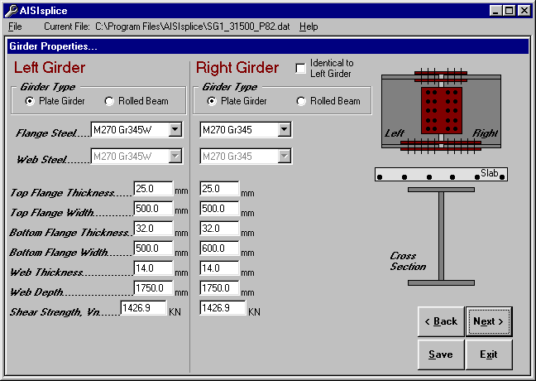
The Girder Properties screen allows the user to enter the dimensions, material properties, and shear strengths of the two adjoined girders. Select either Rolled Beams or Plate Girders. Click to place or remove the check mark in the Identical to Left Girder box (right girder properties are filled automatically if checked). Refer to the cross section graphic for clarification on selected items. Enter each girder’s nominal shear resistance as per AASHTO 6.10.7. Click Next to continue.

5d. Additional Properties Input Screen
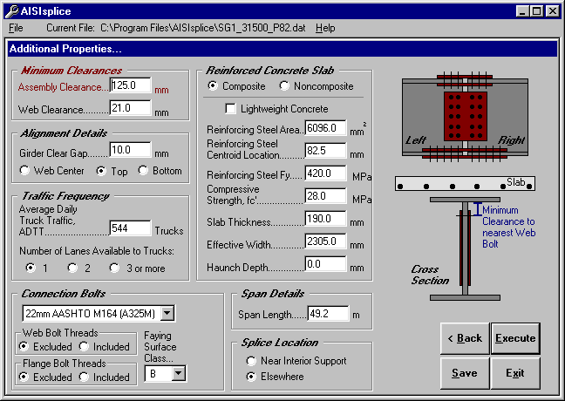
The Additional Properties screen enables the user to specify minimum clearances (for design) or number of splice plates (for analysis), alignment details, traffic frequency, and connection bolt properties. The user also describes the reinforced concrete slab, if composite design is chosen. The user also specifies the span length, and, when applicable, the splice location. For additional information, refer to the graphics and/or tool tips.
Click Composite Design to utilize the slab’s strength or Noncomposite Design to ignore it. For composite designs with lightweight concrete, click to place a check mark in the LWC box. Enter zero for the value of Reinforcing Steel Area when the concrete slab’s reinforcing steel is not utilized. However, when the bars are utilized in the resistance calculations, enter a combined area and respective centroid for an equivalent single row of steel bars.
When finished entering the data, click the Execute button to perform the design or analysis process.

5e. Splice Properties Input Screen
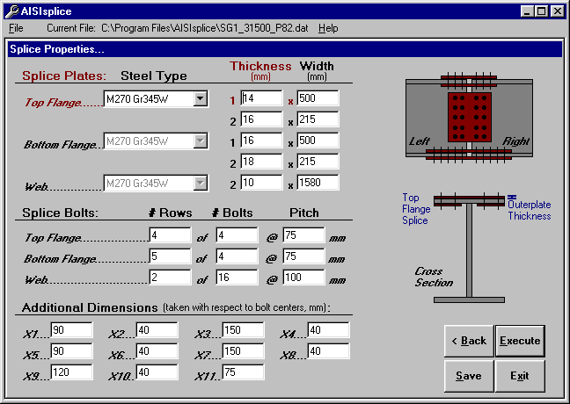
The Splice Properties screen appears only during splice analysis. This screen includes the material properties and sizes of the top and bottom flange and web splice plates. The screen also includes the number, spacing, and pattern of connection bolts.
For clarification on selected items, refer to the cross section graphic. When finished entering data, click the Execute button to perform the analysis.
Since the Splice Properties screen is specific to analysis progressions, it will not appear in the progression of Example SG1_31500_P82.dat, which is included in this manual and the installation files. However, after the software design process is completed, the generated design can be modified and then re-evaluated by accessing the splice properties screen via the Adjust Design button (as discussed in section 7a).

6. Saving Input Data
Before execution of the software, it is recommended that the input file be saved. If a new input file has not been saved before the Execute button is clicked, the user will be prompted to save it. The user will also be prompted to save the current input file before opening an existing file, creating a new file, or exiting the program.

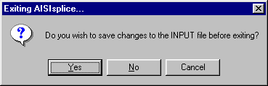
When prompted, click Yes to save the file as shown, No to proceed without saving, and Cancel to ignore the previous action.

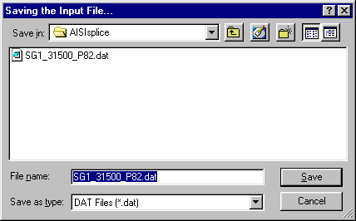
In order to save an input file, one of two methods may be used. The Save button may be clicked on any screen or Save Input File selected from the file menu.
In either case, the Save As dialog box, which is shown to the right, appears. The user may enter a new filename or update an existing file. Select the appropriate directory, folder, file type and filename and then click the Save As dialog box’s Save button.

7. Execution of the Software
After entering the required input values, and after progressing through the applicable screen sequence, execution of the software may be initiated by clicking the Execute button found at the bottom right of the screen (in the usual location of the Next button). Upon completion of the analysis or design, the output graphic screen appears (shown in section 7a).
If either girder is determined inadequate to sustain the given construction, fatigue, strength, or service loads, the program will terminate. A warning, including information as to the nature of the inadequacy, will be given. If the user feels this warning message was reached in error, the generated output report, written to the point of termination, can be viewed and may contain additional, helpful information.

8. Software Output
The software output consists of scaled graphics and a detailed report. Graphic illustrations include the elevation and cross section views of the splice and adjoined girders. Graphical output includes splice dimensions, bolt details, a summary of required filler plates, and splice component performance ratios.

8a. Splice Design Summary Graphics
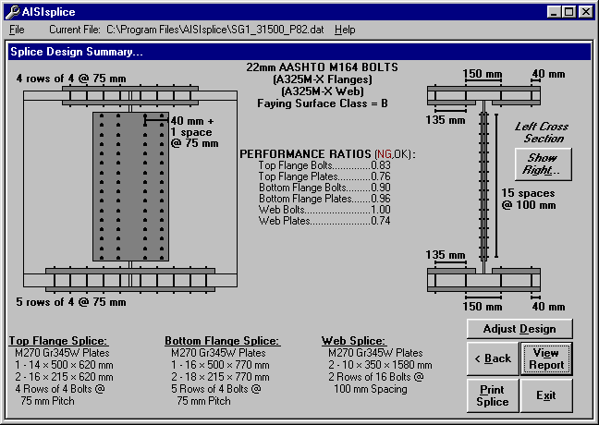
When designing a splice, the Splice Design Summary screen appears. This screen contains graphical output of splice details, required filler plates and their locations, girder cross sections and elevation views, properties of the flange and web connection bolts, faying surface class, and performance ratios.
If the two adjoined girders are different in size, the left girder cross section will be visible by default. However, by clicking the Show Right button on the right of the screen, the right girder will be displayed.
Generated performance ratios for each splice component are based on the ratio of factored load to the available factored resistance. A performance ratio exceeding unity indicates a violation of the 1999 AASHTO-LRFD Specifications, and thus, compels the user to adjust the splice properties, accordingly (i.e. thicken splice plates, add more bolts, etc.). Due to the improbability of block shear rupture modes controlling the design, their performance ratios are shown on this screen only when their values exceed unity.
The user may print the graphics and given properties by clicking the Print Splice button at the bottom of the screen. The report text (shown in 7c) may be viewed by clicking the View Report button.
A useful feature of AISIsplice is the Adjust Design button. After a splice design is generated by the software, the user may modify the design to his/her preference. When this button is clicked, all properties of the designed splice are loaded into the Splice Analysis screen (as shown in section 4e), and the mode is changed from design to capacity check. The user is sent to the Splice Analysis screen to change selected properties of the splice. When the user selects the Execute button at the bottom of the Splice Analysis screen, the splice will be analyzed and the Splice Analysis Summary screen will appear (shown in section 7b).

8b. Splice Analysis Summary Graphics
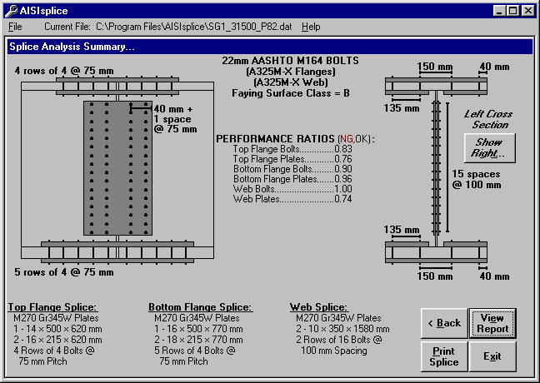
The Splice Analysis Summary screen includes all components of the Splice Design Summary screen, with the exception of the Adjust Design button (since an analysis is performed instead of design, thus the Back button may be used). The software also informs the user of any given spacing which does not satisfy the provisions of AASHTO 6.13.2.6.

8c. Report Output
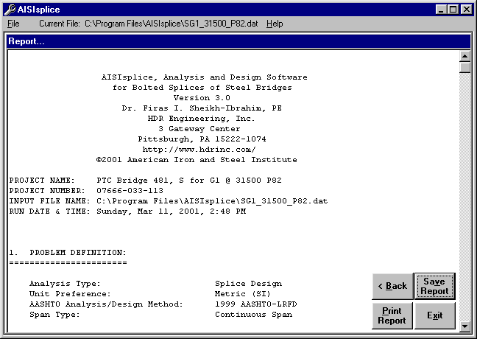
The report generated during the software execution can be viewed by clicking the View Report button on the graphical output screen. Once the Report screen is displayed, the user may use the scrollbar on the right of the Report screen, to easily view and navigate through the report.
To save the report, click the Save Report button on the screen, or select Save Report from the file menu. Then, follow the procedure given in section 5. When naming an output file, do NOT use the same extension of the input files, to avoid overwriting the input file. The report may be opened with any text-editing program.
By clicking the Print Report button, the report will be printed by sending it to the default printer. Likewise, the report may also be printed using any text-editing program.
The format of the report will vary slightly depending on whether a capacity check or design is performed (refer to Appendix B for report outlines).

9. Exiting the Software
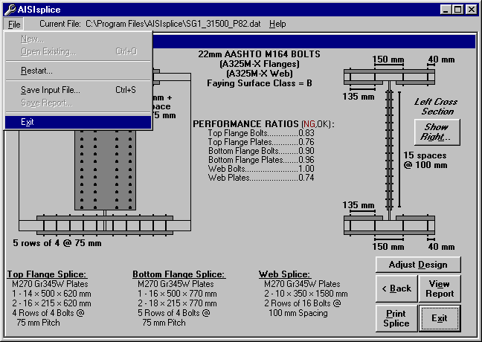
There are several methods to exit the software. From any screen, the user may click the Exit button at the bottom of the screen, or select Exit from the file menu. The user may also click the close button in the upper right corner of the program’s window. The user will be prompted to save the current input file before the program closes.
To avoid having problems, losing data, or corrupting input files, always exit the software by one of these three methods.

10. Review of Computer Output
Since the user assumes all liabilities, he/she user should review the computer output carefully and thoroughly, to verify the analysis and design performed by the software.
The first section of the report lists all given input values and should be reviewed by the user in order to verify the accuracy of the entered input used by the software. If the problem definition contains erroneous input values, then succeeding calculations and conclusions are invalid.
At each limit state, the flange design forces are calculated and written to the report. These values should be reviewed by the user to insure that the flange resistance is not exceeded. Although flange stresses are checked by the software, it is important for the designer to know the efficiency of each component. Also the user should review the report section titled “3. SUMMARY OF AASHTO DESIGN FORCES”. This section gives all limit state design forces, which are used to determine the required strength of a splice.

11. Suggestions for Maximum Economy and Performance
Several steps may be taken to reduce the cost of a splice:
- When using AISIsplice in the design mode, utilize the Adjust Design button feature. Modify splice properties to meet the needs of the project and the inventory of the fabricator.
- When using AISIsplice in the analysis mode, try to optimize performance ratios by selectively changing splice properties. Keep the difference between inner and outer plate areas within the specified percentage, (refer to Appendix A) in order to equally distribute the force between the splice plates and, thus, decrease the number of required bolts. Compare your design with the AISIsplice automated design, and select the least-cost splice.
- It is recommended to use the faying surface class which will be present on the girders’ surfaces. Using a faying surface with a smaller surface condition factor (AASHTO 6.13.2.8) than what is actually present may cause overly conservative splice designs. Blast cleaned surfaces, or surfaces with Class B coatings, should be designed and analyzed using a class B faying surface to obtain cost-effective splices.
- Whenever possible, opt to have the bolt threads excluded from the shear planes in the flange and web splices.
- When bearing controls the design of the web bolts, increase the edge distance slightly to increase the bearing resistance, and thus avoid using additional web bolts.
- Since bolted splices are expensive to fabricate, make the use of all field splices optional, to give the fabricator the option of selecting a least-cost alternative.

Appendix A - Default Values
The Default Values screen allows the user to view all, and alter some of the AASHTO load factors, resistance factors, bolt and splice details, load modifiers, and minimum design loads. This is an optional portion of any analysis or design progression, and will not be shown unless the View Defaults box is checked on the Welcome Screen. Click the appropriate tab in order to change any of the default values used for current input file calculations.
The Reset Defaults button in the Default Values screen allows the user to set all default values to their initial software preset values, after having been altered.
The Example “SG1_31500_P82.dat” input file uses altered default values, and will be shown in this section. The load factors used in the example are those of 1996 PennDOT’s DM4 for the P82 permit vehicle. This shows that the software can be used to utilize state specific load factors.

Load Factors Tab:
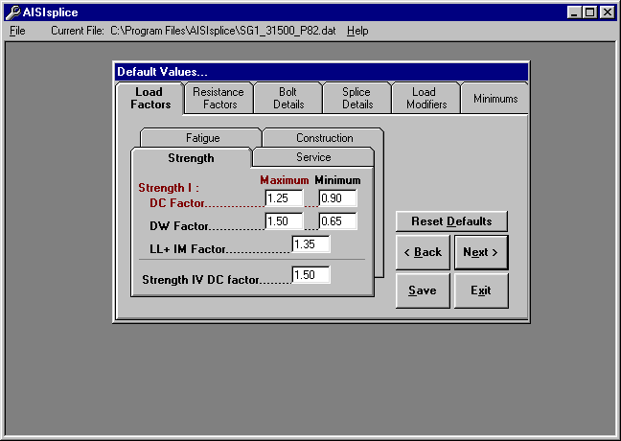
Access this tab to alter load factors for the construction, fatigue, service, and strength limit states. System defaults are taken from AASHTO 3.4.1 and 3.4.2. Maximum load factors must be greater than minimum load factors and less than 3.0 (selected arbitrarily), while minimum load factors may not be less than zero. In order to conservatively neglect wearing surface loads which oppose the live load moment, the user may elect to use a minimum wearing surface factor, DW, equal to zero.

Resistance Factors Tab:
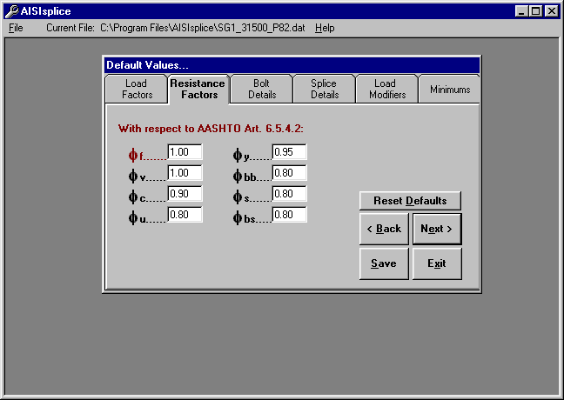

Click this tab in order to modify resistance factors (such as those for tensile gross section yielding, plate bearing, block shear, etc.) given by AASHTO 6.5.4.2. Resistance factors which are less than 0.50 or greater than 1.0 will not be accepted by the software.

Bolt Details Tab:
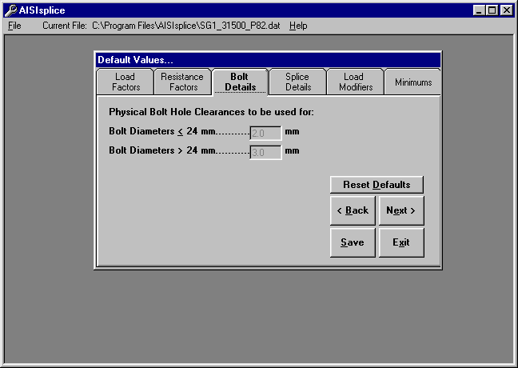
The Bolt Details tab shows the user the bolt hole clearances used (shown only for the SI units system).
Splice Details Tab:
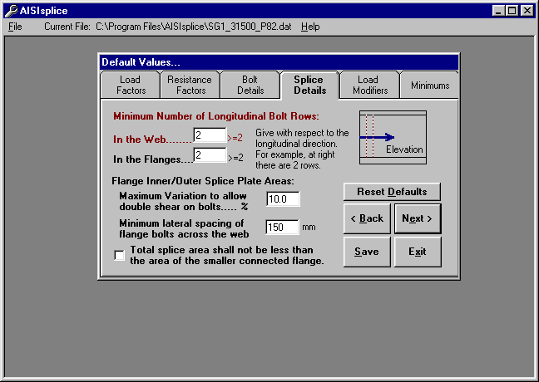
Click the Splice Details tab to set minimum limits on the number of required longitudinal flange and web bolt rows (the software will not accept values less than 2).
In order to eliminate the effects of eccentric connections, the maximum variation between the areas of the inner and outer flange splices is limited to 10%, as specified in AASHTO C6.13.6.1.4c. However, the user may opt to reduce this percentage to as low as 5%.
The software uses a default value of 6 in. (150 mm) for the lateral distance between the flange bolts closest to the web, lying on each side of the web. This generous value, which can be altered by the user as needed, is used in the design mode to allow for easy construction.
Finally, the default values section allows the user to require the flange splice plates to have, as a minimum, the area of the smaller connected flange.
Load Modifiers Tab:
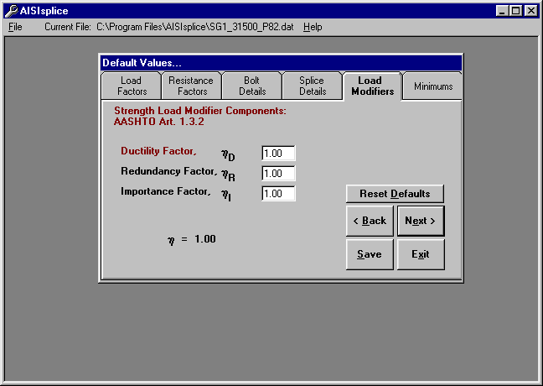
The value for the load modifier is dependent on factors relating to component and connection ductility, member redundancy, and operational importance of the bridge. The software default value for any load modifier is 1.0.
The factors for ductility, redundancy and importance are determined by the guidelines set forth in AASHTO 1.3.3, 1.3.4, and 1.3.5, respectively.

Minimums Tab:
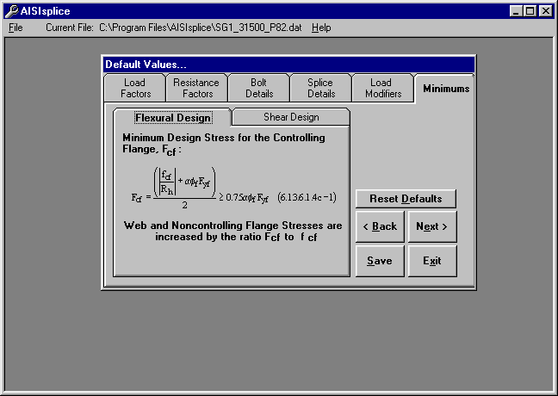

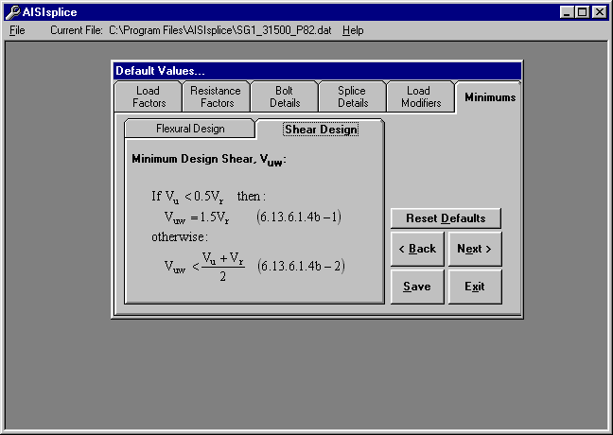
In order to comply with AASHTO 6.13.6.1.4c and 6.13.6.1.4b, flexural and shear design minimums should be used to further proportion flange and web design forces. The software applies flexural and shear design minimums, with respect to the 1999 Interim to the AASHTO LRFD Specifications.

Flexural minimums are applied to the girder, referred to as the critical girder, with the least non-composite moment of inertia of the two adjoined girders. Shear minimums are applied to the girder having the smaller shear resistance. The critical girder is used to determine section properties, as well as design stresses.

Appendix B - Report Outlines
Design Report Format
1. PROBLEM DEFINITION
2. DESIGN LIMIT STATES
2.1. During Construction
2.2. Fatigue Limit State
2.3. Strength Limit State
2.3.1a For POSITIVE Moment
2.3.1b For NEGATIVE Moment (if applicable)
2.3.2. For Shears
2.3.3. Strength Design Forces
2.4. Service Limit State
2.4.1a For POSITIVE Moment
2.4.1b For NEGATIVE Moment (if applicable)
2.4.2. For Shears
2.4.3. Service Design Forces
3. SUMMARY OF AASHTO SPLICE DESIGN FORCES
4. SPLICE DESIGN
4.1. Top Flange Splice Design
4.1.1. Plate Design
4.1.2. Bolt Design
4.1.3. Block Shear Rupture Check (if applicable)
4.2. Bottom Flange Splice Design
4.2.1. Plate Design
4.2.2. Bolt Design
4.2.3. Block Shear Rupture Check (if applicable)
4.3. Web Splice Design
4.3.1. Bolt Design
4.3.2. Plate Design
4.3.3. Block Shear Rupture Check (if applicable)
5. SUMMARY
PERFORMANCE RATIOS
SPLICE DIMENSION SUMMARY
FILLER SUMMARY (if applicable)
Analysis Report Format
I. SPLICE ANALYSIS SUMMARY
1. Top Flange Splice
2. Bottom Flange Splice
3. Web Splice
1. PROBLEM DEFINITION
2. DESIGN LIMIT STATES
2.1. During Construction
2.2. Fatigue Limit State
2.3. Strength Limit State
2.3.1a For POSITIVE Moment
2.3.1b For NEGATIVE Moment (if applicable)
2.3.2. For Shears
2.3.3. Strength Design Forces
2.4. Service Limit State
2.4.1a For POSITIVE Moment
2.4.1b For NEGATIVE Moment (if applicable)
2.4.2. For Shears
2.4.3. Service Design Forces
3. SUMMARY OF AASHTO SPLICE DESIGN FORCES
4. SPLICE ANALYSIS
4.1. Top Flange Splice Analysis
4.1.1. Plate Analysis
4.1.2. Bolt Analysis
4.1.3. Spacing Limit Analysis
4.1.4. Block Shear Rupture Analysis (if applicable)
4.2. Bottom Flange Splice Analysis
4.2.1. Plate Analysis
4.2.2. Bolt Analysis
4.2.3. Spacing Limit Analysis
4.2.4. Block Shear Rupture Analysis (if applicable)
4.3. Web Splice Analysis
4.3.1. Bolt Analysis
4.3.2. Plate Analysis
4.3.3. Spacing Limit Analysis
4.3.4. Block Shear Rupture Analysis (if applicable)
5. SUMMARY
PERFORMANCE RATIOS
FILLER SUMMARY (if applicable)

Appendix C - Block Shear Rupture Paths
Outer Flange Splice Plate Paths:

V
Path 3
Path 4
Inner Flange Splice Plate Paths:
Girder Flange Paths:
Web Splice Plate Paths:
Path 1
H
H
H
Path 1
Path 6 (Left Girder)
Path 7 (Right Girder)
Path 2b
Path 2a
Path 5b
Path 5a
Girder Web Paths:
Path 8 (Left Girder)
Path 9 (Right Girder)
Path 4 (Left Girder)
Path 5 (Right Girder)
Path 3
Path 2

Appendix D - Software Limitations
AISIsplice designs and analyzes bolted steel girder splices. Designs are limited to three splice plates for each connected flange and two splice plates for the web connection. Analyses must have two web connection splice plates of the same thickness, and one or three flange splice plates, per flange. Splices must be symmetric about the gap centerline for any given component (i.e. the top flange left girder section of the splice is identical to the top flange right girder section). Web splices are centered about the center of the web.
The software is limited to splices of straight, right, homogeneous, steel I-girders of which the top flange is not embedded in the concrete slab, the flanges are parallel, and are not skewed at the location of the splice. Adequate clearance must be provided between splice plates and fillets of rolled beams or welds of plate girders. Bolt patterns are limited to constant pitch, non-staggered bolt patterns.
When thick flange fillers are used, it may be necessary to increase the number of bolts required to develop or extend the filler as per AASHTO 6.13.6.1.5. Therefore, it is possible that the number of flange bolts required on one side of the centerline is greater than the number required on the other side. Because this software is limited to symmetric splice designs, the larger number of required bolts is used for both sides of the gap. It is recommended that the user use a non-symmetric cost-effective splice. However, the user is cautioned that the lesser number of bolts does not necessarily satisfy all other design criteria (i.e. slip resistance, bearing resistance, block shear rupture, etc.) and, therefore, must be checked.

Appendix E - References
- American Association of State Highway and Transportation Officials, “LRFD Bridge Design Specifications,” 1999 Interim, Washington, DC, 1999.
- American Association of State Highway and Transportation Officials, “LRFD Bridge Design Specifications,” Second Edition, Washington, DC, 1998.
- American Institute of Steel Construction, “AISC Database Version 2.0,” Metric and English Units, Chicago, IL, 1994.
- American Institute of Steel Construction, “LRFD Manual of Steel Construction,” Volumes I and II, Chicago, IL, 1994.
- Sheikh-Ibrahim, Firas I., and Frank, Karl H., "The Ultimate Strength of Symmetric Beam Bolted Splices," AISC Engineering Journal, Third Quarter, 1998, pp.106-118.
- Sheikh-Ibrahim, Firas I., and Frank, Karl H., "The Ultimate Strength of Unsymmetric Beam Bolted Splices," AISC Engineering Journal, Second Quarter, 2001, in-print.
- Sheikh-Ibrahim, Firas I., and Frank, Karl H., "Bolted Field Splices for Steel Bridges," ASCE Proceedings of Structures Congress XIV, Volume 1, Chicago, IL, April 1996, pp.290-297.

Appendix F - Sample of Bridge Splices Designed By AISIsplice
- Bridge Name: PTC Bridge B438, Somerset County, Pennsylvania
Project Type: Bridge Replacement/New Construction
Bridge Type: Composite Slab-on-I Steel Girder Bridge
Number of Girders: 5
Girder Spacing: 2.7 m
Skew Angle: 45.00 Degrees
Span Type: Simple Span
Span Length: 56.40 m
Splice Location: 14.52 m
Design Specifications: 1999 AASHTO LRFD + 1996 PennDOT DM4
Owner: Pennsylvania Turnpike Commission
Design Firm: HDR Engineering, Inc.- Pittsburgh
Splice Designer: Jason A. Fuller, P.E.
Designer Quote: “The amount of man-hours saved by using AISIsplice was incredible, but in addition to that, the aggravation of redoing a splice over and over again by hand to make it efficient and cost effective was eliminated. Once we had a viable solution by the program, it was verified by hand and the program was dead on.”

- Bridge Name: Rocky Hollow Bridge, Somerset County, West Virginia
Project Type: Bridge Rehabilitation
Bridge Type: Composite Slab-on-Steel Rolled Beam Girder Bridge
Number of Girders: 4 (dual structures)
Girder Spacing: 9’-0”
Skew Angle: ≈16.00 Degrees
Span Type: 4 Continuous Spans
Span Length: 40 ft – 56 ft – 84 ft – 62 ft
Splice Location: 16 ft back from Pier 2, 18 ft back from Pier 3
Design Specifications: 1999 AASHTO LRFD
Owner: West Virginia Department of Transportation – Division of Highways
Design Firm: HDR Engineering, Inc.- Pittsburgh
Splice Designer: Jason A. Fuller, P.E.
Designer Quote: “AISIsplice simplified the checking of the existing splices and the design of a continuity splice. Once all the input values were calculated, which would be required to do for hand calculations also, it took minutes to run the program instead of hours to do the calculations.”

- Bridge Name: PTC Bridge B481, Somerset County, Pennsylvania
Project Type: Bridge Replacement/New Construction
Bridge Type: Composite Slab-on-I Steel Girder Bridge
Number of Girders: 5
Girder Spacing: 2.7 m
Skew Angle: 69.52 Degrees
Span Type: 2 Continuous Spans
Span Length: 49.16 m - 49.16 m
Splice Location: 31.5 m, 66.8 m
Design Specifications: 1999 AASHTO LRFD + 1996 PennDOT DM4
Owner: Pennsylvania Turnpike Commission
Design Firm: HDR Engineering, Inc.- Pittsburgh
Splice Designer: Firas I. Sheikh-Ibrahim, Ph.D.
Designer Quote: “I received numerous positive feedback, but I did not appreciate AISIsplice until I had to use it to design the splices for PTC Bridge B481. AISIsplice produced cost-effective splices in a relatively short time. The use of AISIsplice helped cut the cost of materials and design man-hours.”

- Bridge Name:
Project Type:
Bridge Type:
Number of Girders:
Girder Spacing:
Skew Angle:
Span Type:
Span Length:
Splice Location:
Design Specifications:
Owner:
Design Firm:
Splice Designer:
Designer Quote:

If you would like to be included in future AISIsplice publications, please fill in the items above and email them to AISI.

